StudentProfileServiceTest

CreateTests
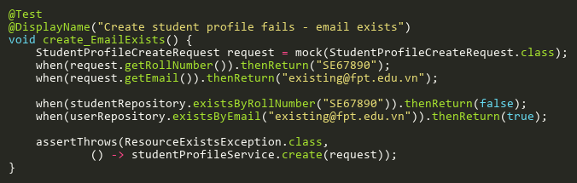
Figure: create_EmailExists
Reference: Sheet "STPST_create", Test Case TC03

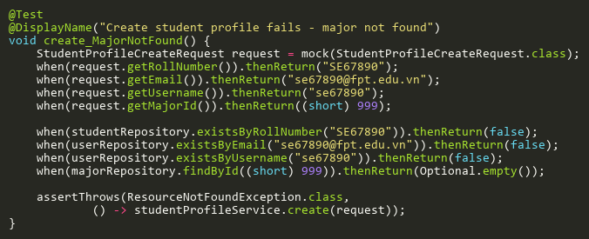
Figure: create_MajorNotFound
Reference: Sheet "STPST_create", Test Case TC05

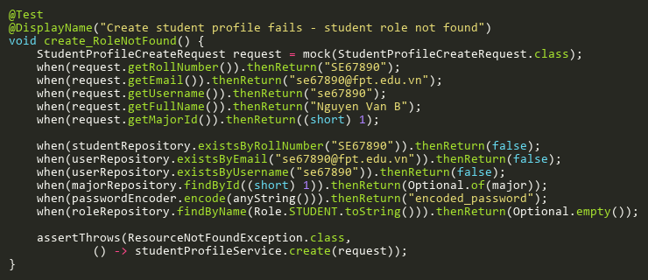
Figure: create_RoleNotFound
Reference: Sheet "STPST_create", Test Case TC06

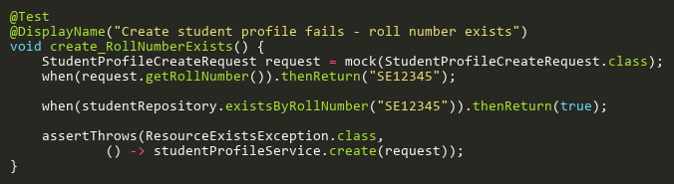
Figure: create_RollNumberExists
Reference: Sheet "STPST_create", Test Case TC02

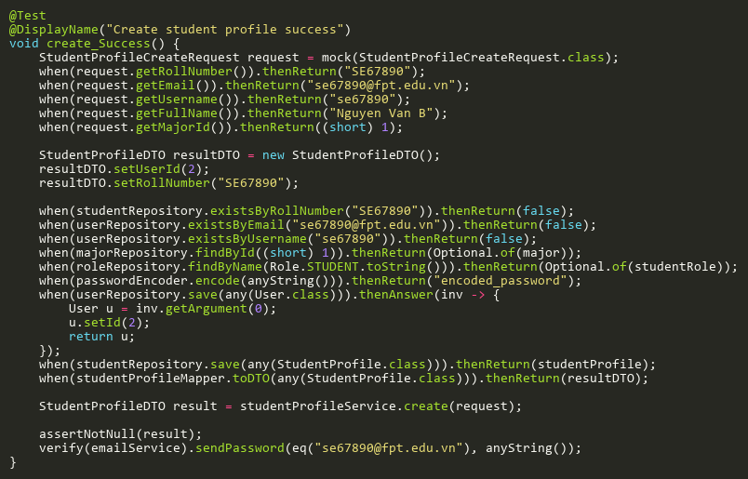
Figure: create_Success
Reference: Sheet "STPST_create", Test Case TC01

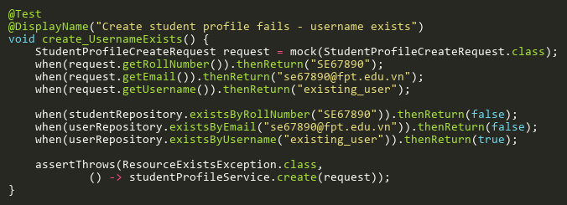
Figure: create_UsernameExists
Reference: Sheet "STPST_create", Test Case TC04

DeleteTests
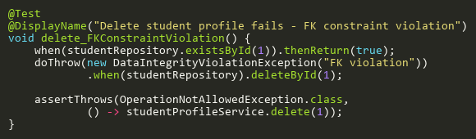
Figure: delete_FKConstraintViolation
Reference: Sheet "STPST_delete", Test Case TC03

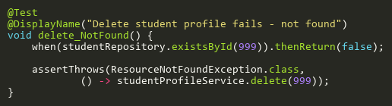
Figure: delete_NotFound
Reference: Sheet "STPST_delete", Test Case TC02

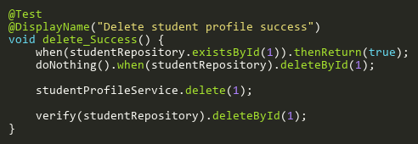
Figure: delete_Success
Reference: Sheet "STPST_delete", Test Case TC01

FindByIdTests
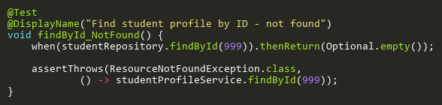
Figure: findById_NotFound
Reference: Sheet "STPST_findById", Test Case TC02

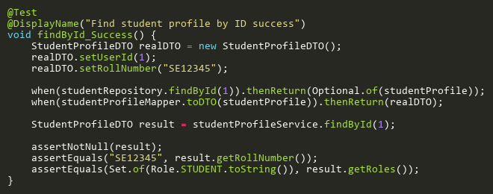
Figure: findById_Success
Reference: Sheet "STPST_findById", Test Case TC01

SearchBySemesterIdTests
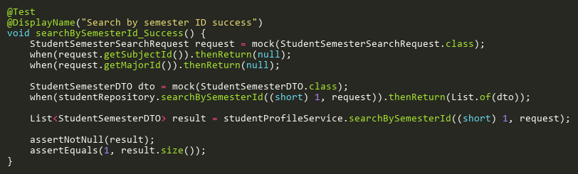
Figure: searchBySemesterId_Success
Reference: Sheet "STPST_searchBySem", Test Case TC01

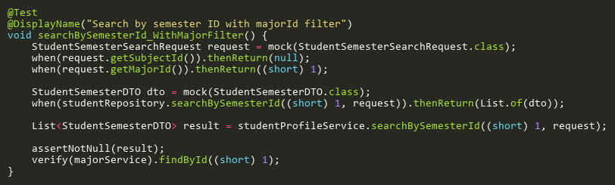
Figure: searchBySemesterId_WithMajorFilter
Reference: Sheet "STPST_searchBySem", Test Case TC02

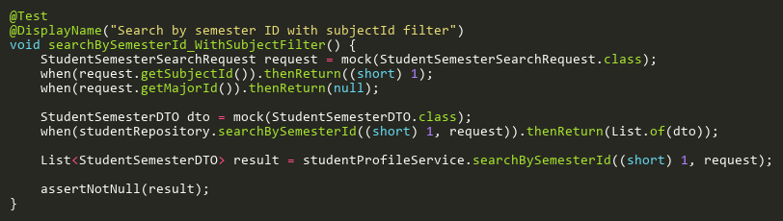
Figure: searchBySemesterId_WithSubjectFilter
Reference: Sheet "STPST_searchBySem", Test Case TC03

UpdateTests
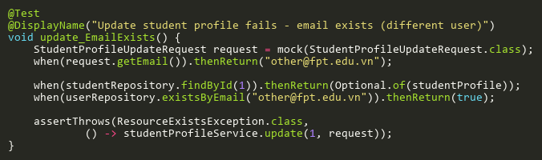
Figure: update_EmailExists
Reference: Sheet "STPST_update", Test Case TC03

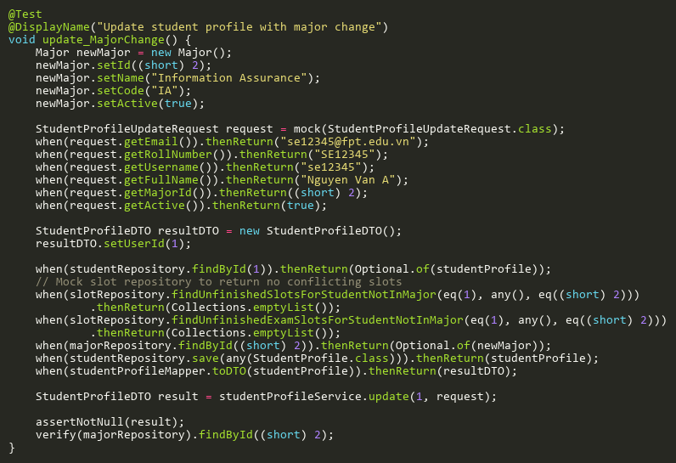
Figure: update_MajorChange
Reference: Sheet "STPST_update", Test Case TC06

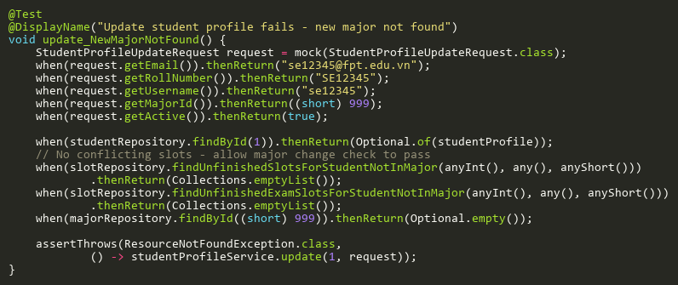
Figure: update_NewMajorNotFound
Reference: Sheet "STPST_update", Test Case TC07

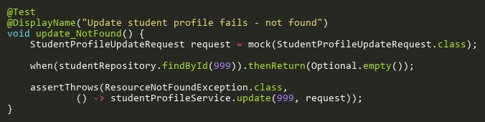
Figure: update_NotFound
Reference: Sheet "STPST_update", Test Case TC02

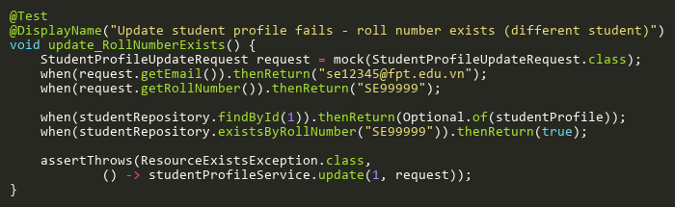
Figure: update_RollNumberExists
Reference: Sheet "STPST_update", Test Case TC04

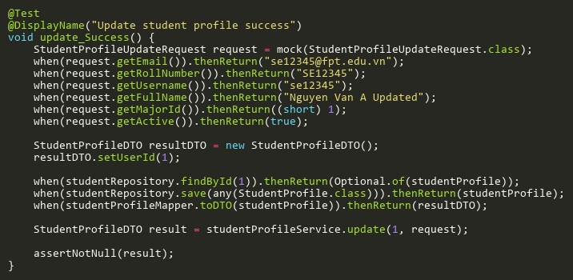
Figure: update_Success
Reference: Sheet "STPST_update", Test Case TC01

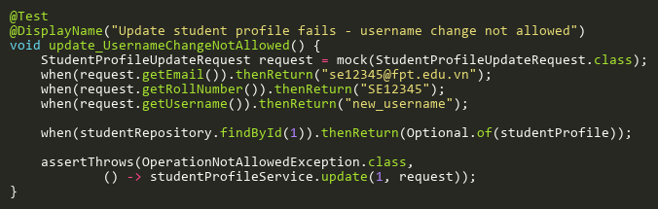
Figure: update_UsernameChangeNotAllowed
Reference: Sheet "STPST_update", Test Case TC05

