SubjectServiceTest

CreateTests
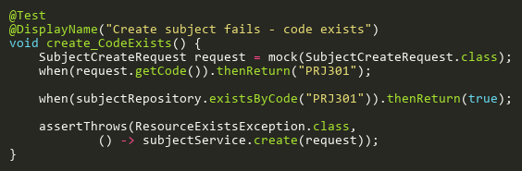
Figure: create_CodeExists
Reference: Sheet "SBST_create", Test Case TC02

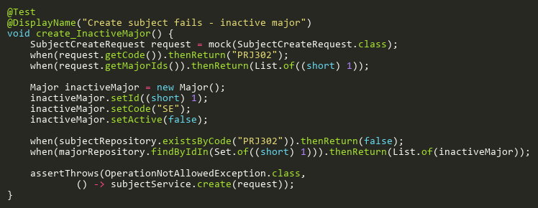
Figure: create_InactiveMajor
Reference: Sheet "SBST_create", Test Case TC06

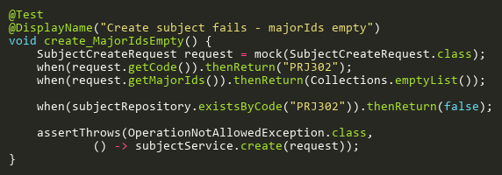
Figure: create_MajorIdsEmpty
Reference: Sheet "SBST_create", Test Case TC04

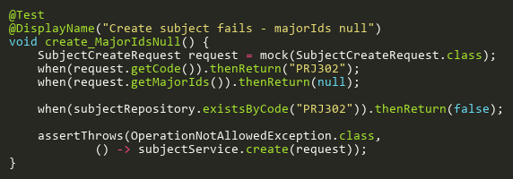
Figure: create_MajorIdsNull
Reference: Sheet "SBST_create", Test Case TC03

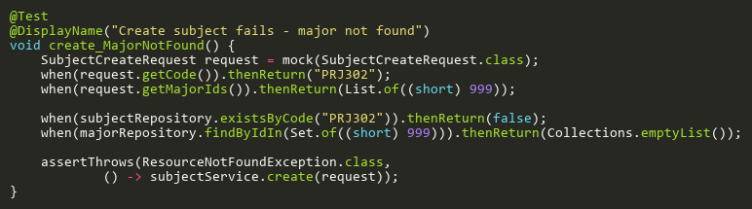
Figure: create_MajorNotFound
Reference: Sheet "SBST_create", Test Case TC05

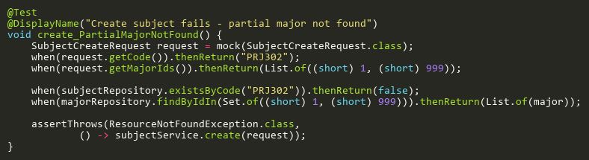
Figure: create_PartialMajorNotFound
Reference: Sheet "SBST_create", Test Case TC07

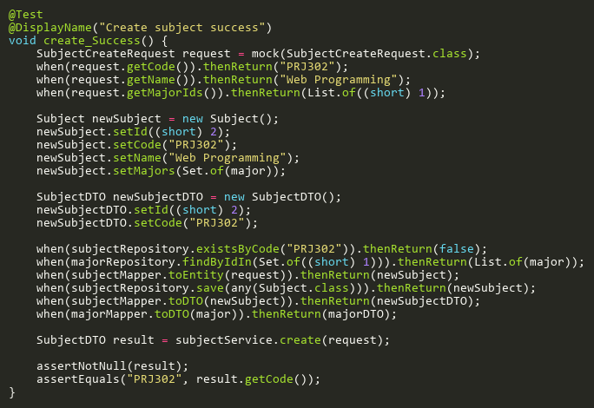
Figure: create_Success
Reference: Sheet "SBST_create", Test Case TC01

DeleteTests
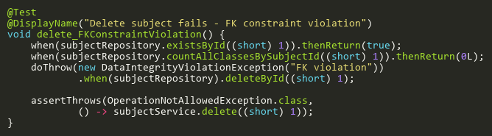
Figure: delete_FKConstraintViolation
Reference: Sheet "SBST_delete", Test Case TC04

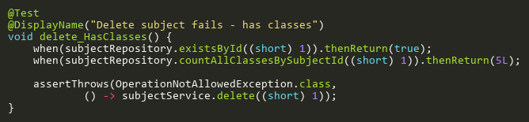
Figure: delete_HasClasses
Reference: Sheet "SBST_delete", Test Case TC03

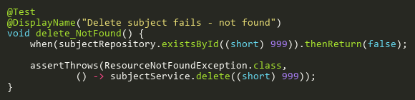
Figure: delete_NotFound
Reference: Sheet "SBST_delete", Test Case TC02

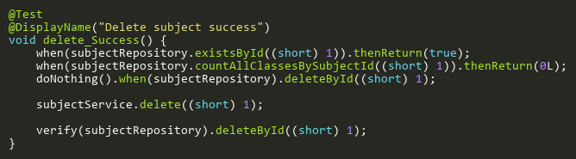
Figure: delete_Success
Reference: Sheet "SBST_delete", Test Case TC01

FindByIdTests
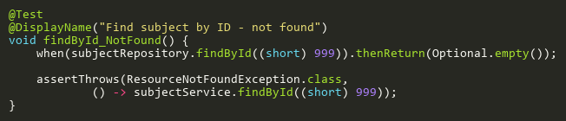
Figure: findById_NotFound
Reference: Sheet "SBST_findById", Test Case TC02

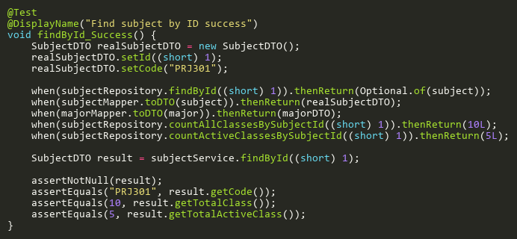
Figure: findById_Success
Reference: Sheet "SBST_findById", Test Case TC01

UpdateTests
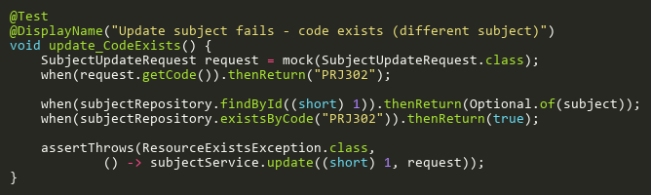
Figure: update_CodeExists
Reference: Sheet "SBST_update", Test Case TC03

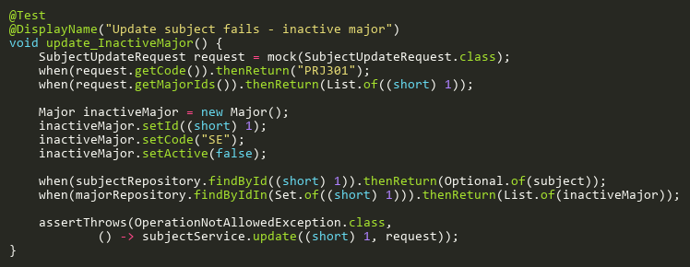
Figure: update_InactiveMajor
Reference: Sheet "SBST_update", Test Case TC07

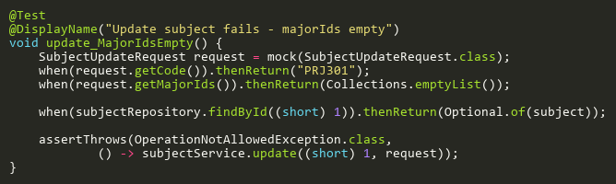
Figure: update_MajorIdsEmpty
Reference: Sheet "SBST_update", Test Case TC05

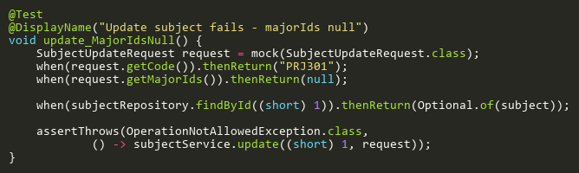
Figure: update_MajorIdsNull
Reference: Sheet "SBST_update", Test Case TC04

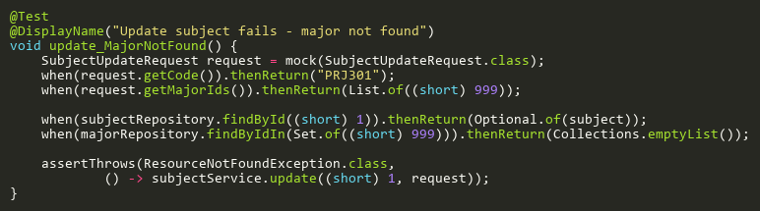
Figure: update_MajorNotFound
Reference: Sheet "SBST_update", Test Case TC06

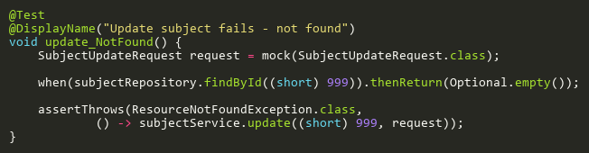
Figure: update_NotFound
Reference: Sheet "SBST_update", Test Case TC02

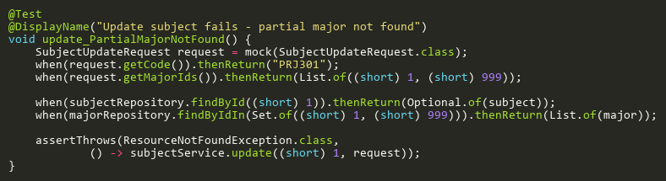
Figure: update_PartialMajorNotFound
Reference: Sheet "SBST_update", Test Case TC08

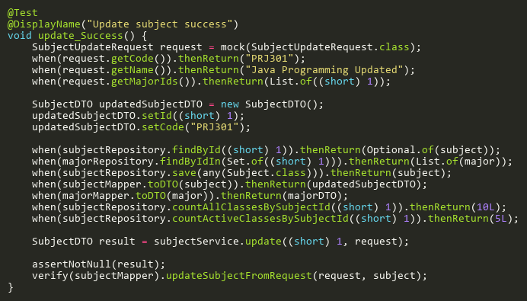
Figure: update_Success
Reference: Sheet "SBST_update", Test Case TC01

