SupervisorDashboardServiceTest

GetDashboardDataTests
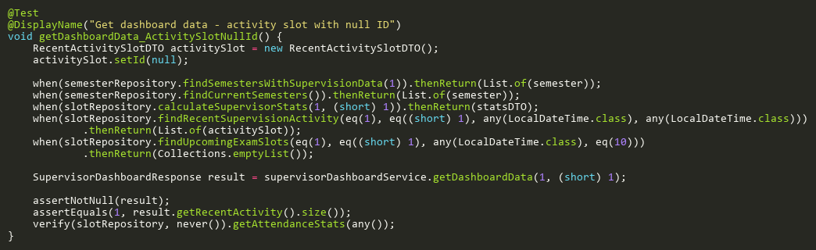
Figure: getDashboardData_ActivitySlotNullId
Reference: Sheet "SVDST_getDashboard", Test Case TC18

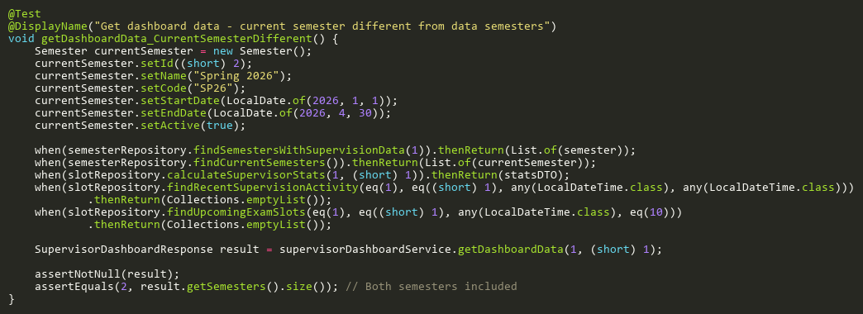
Figure: getDashboardData_CurrentSemesterDifferent
Reference: Sheet "SVDST_getDashboard", Test Case TC20

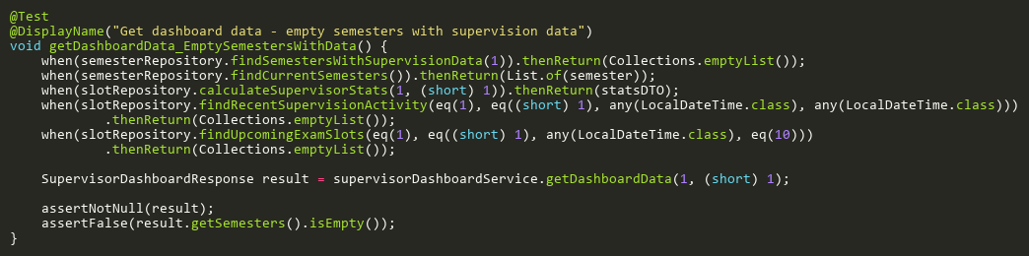
Figure: getDashboardData_EmptySemestersWithData
Reference: Sheet "SVDST_getDashboard", Test Case TC08

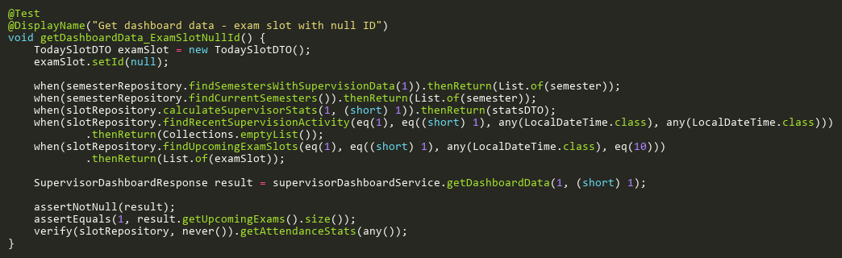
Figure: getDashboardData_ExamSlotNullId
Reference: Sheet "SVDST_getDashboard", Test Case TC19

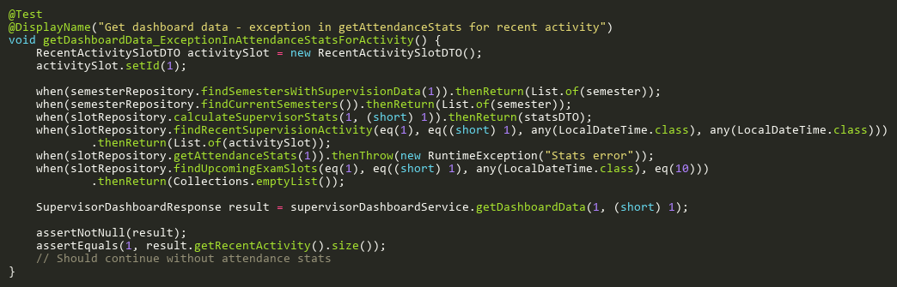
Figure: getDashboardData_ExceptionInAttendanceStatsForActivity
Reference: Sheet "SVDST_getDashboard", Test Case TC16

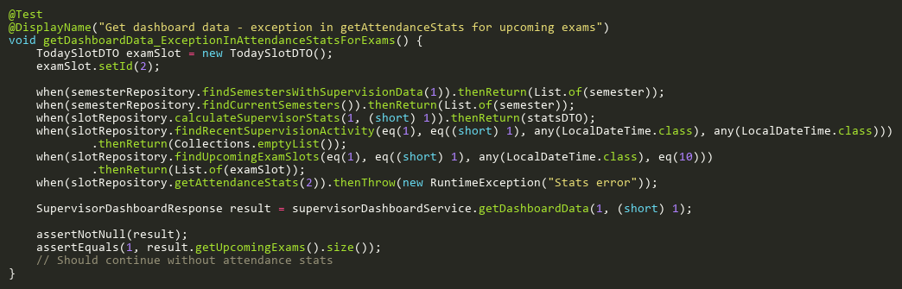
Figure: getDashboardData_ExceptionInAttendanceStatsForExams
Reference: Sheet "SVDST_getDashboard", Test Case TC17

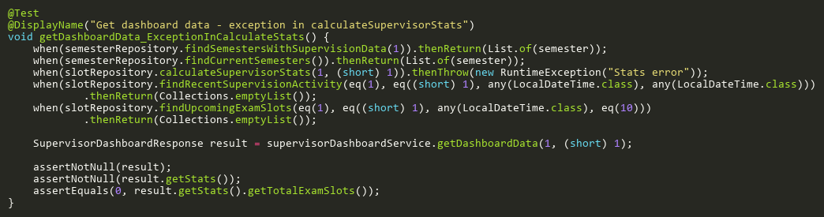
Figure: getDashboardData_ExceptionInCalculateStats
Reference: Sheet "SVDST_getDashboard", Test Case TC11

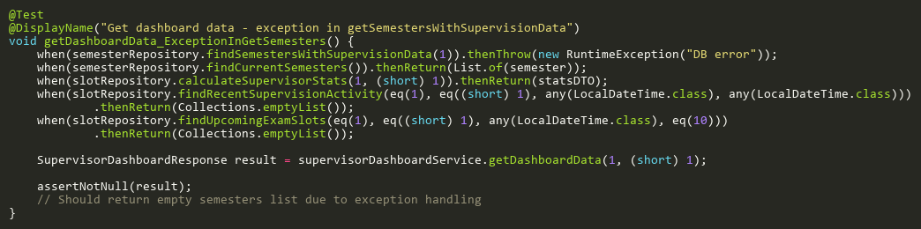
Figure: getDashboardData_ExceptionInGetSemesters
Reference: Sheet "SVDST_getDashboard", Test Case TC10

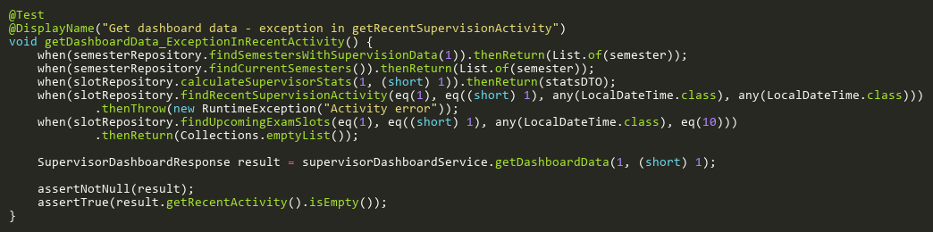
Figure: getDashboardData_ExceptionInRecentActivity
Reference: Sheet "SVDST_getDashboard", Test Case TC12

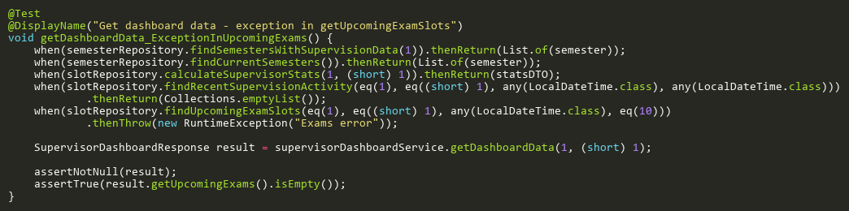
Figure: getDashboardData_ExceptionInUpcomingExams
Reference: Sheet "SVDST_getDashboard", Test Case TC13

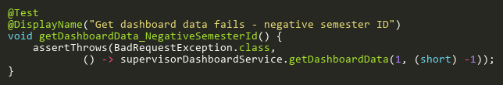
Figure: getDashboardData_NegativeSemesterId
Reference: Sheet "SVDST_getDashboard", Test Case TC07

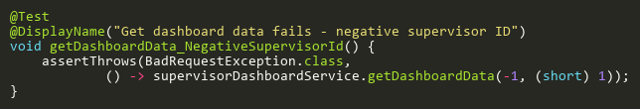
Figure: getDashboardData_NegativeSupervisorId
Reference: Sheet "SVDST_getDashboard", Test Case TC05

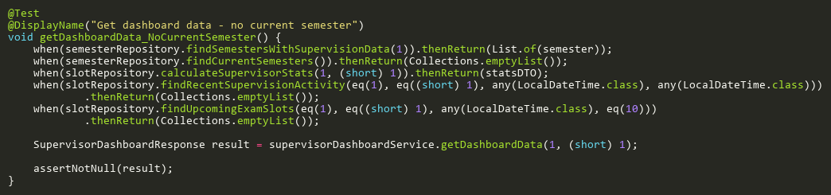
Figure: getDashboardData_NoCurrentSemester
Reference: Sheet "SVDST_getDashboard", Test Case TC09

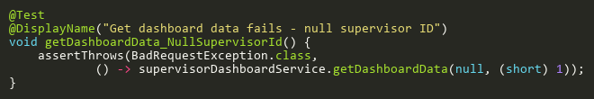
Figure: getDashboardData_NullSupervisorId
Reference: Sheet "SVDST_getDashboard", Test Case TC03

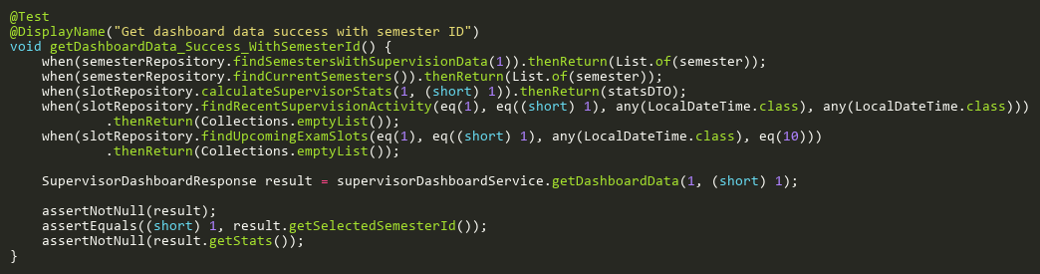
Figure: getDashboardData_Success_WithSemesterId
Reference: Sheet "SVDST_getDashboard", Test Case TC01

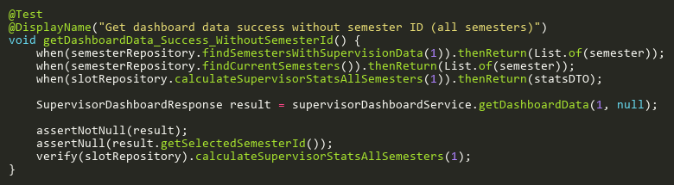
Figure: getDashboardData_Success_WithoutSemesterId
Reference: Sheet "SVDST_getDashboard", Test Case TC02

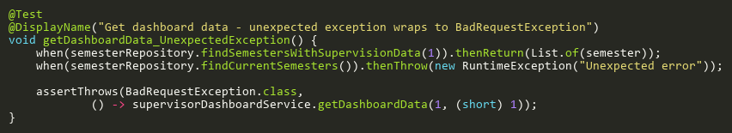
Figure: getDashboardData_UnexpectedException
Reference: Sheet "SVDST_getDashboard", Test Case TC21

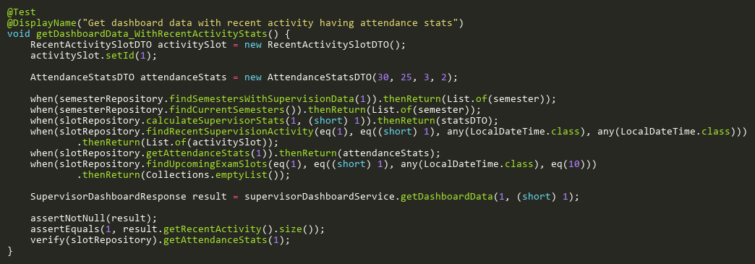
Figure: getDashboardData_WithRecentActivityStats
Reference: Sheet "SVDST_getDashboard", Test Case TC14

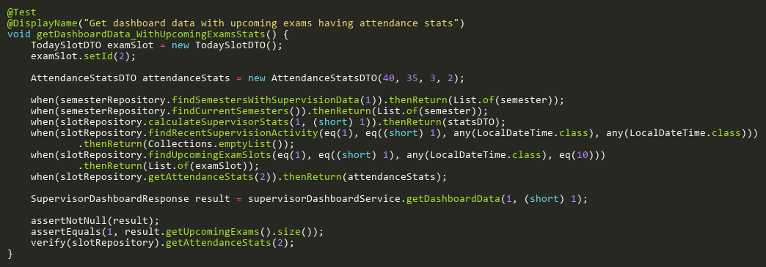
Figure: getDashboardData_WithUpcomingExamsStats
Reference: Sheet "SVDST_getDashboard", Test Case TC15

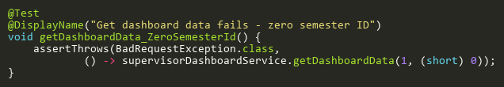
Figure: getDashboardData_ZeroSemesterId
Reference: Sheet "SVDST_getDashboard", Test Case TC06

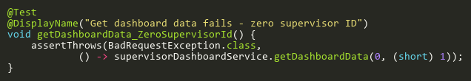
Figure: getDashboardData_ZeroSupervisorId
Reference: Sheet "SVDST_getDashboard", Test Case TC04

