ZipFileServiceTest

ExtractZipToTempTests
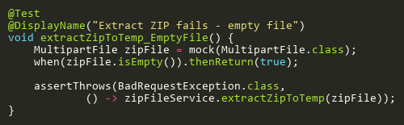
Figure: extractZipToTemp_EmptyFile
Reference: Sheet "ZFST_extractZip", Test Case TC03

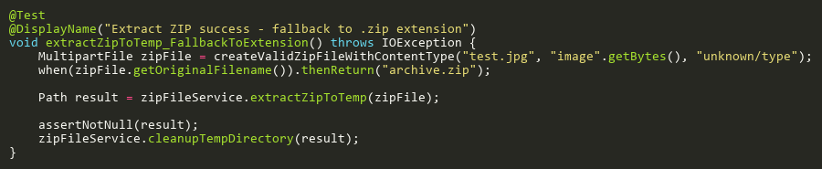
Figure: extractZipToTemp_FallbackToExtension
Reference: Sheet "ZFST_extractZip", Test Case TC09

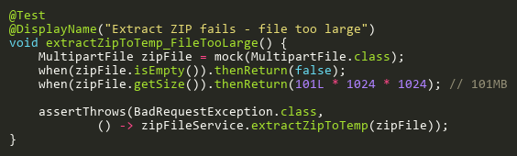
Figure: extractZipToTemp_FileTooLarge
Reference: Sheet "ZFST_extractZip", Test Case TC04

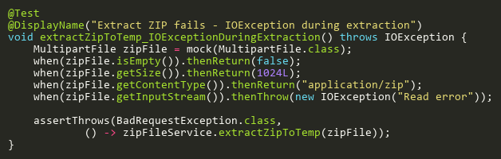
Figure: extractZipToTemp_IOExceptionDuringExtraction
Reference: Sheet "ZFST_extractZip", Test Case TC13

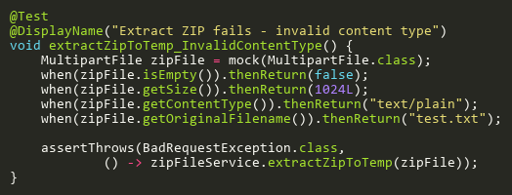
Figure: extractZipToTemp_InvalidContentType
Reference: Sheet "ZFST_extractZip", Test Case TC05

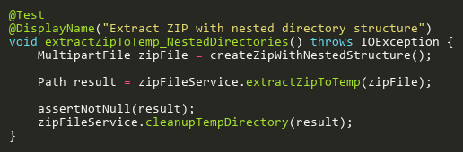
Figure: extractZipToTemp_NestedDirectories
Reference: Sheet "ZFST_extractZip", Test Case TC14

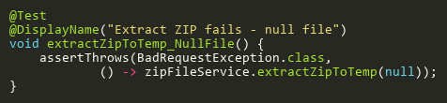
Figure: extractZipToTemp_NullFile
Reference: Sheet "ZFST_extractZip", Test Case TC02

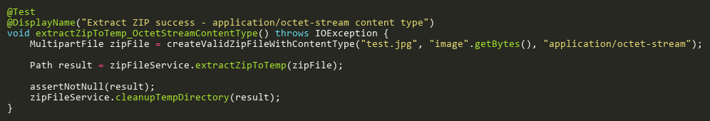
Figure: extractZipToTemp_OctetStreamContentType
Reference: Sheet "ZFST_extractZip", Test Case TC08

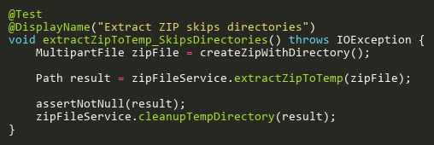
Figure: extractZipToTemp_SkipsDirectories
Reference: Sheet "ZFST_extractZip", Test Case TC10

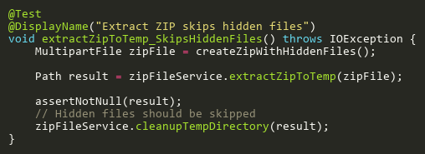
Figure: extractZipToTemp_SkipsHiddenFiles
Reference: Sheet "ZFST_extractZip", Test Case TC11

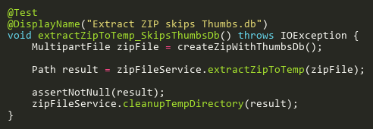
Figure: extractZipToTemp_SkipsThumbsDb
Reference: Sheet "ZFST_extractZip", Test Case TC12

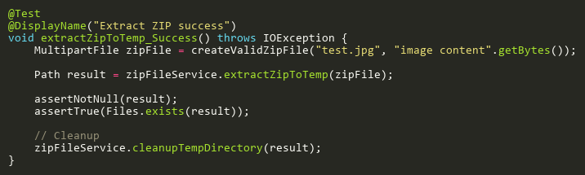
Figure: extractZipToTemp_Success
Reference: Sheet "ZFST_extractZip", Test Case TC01

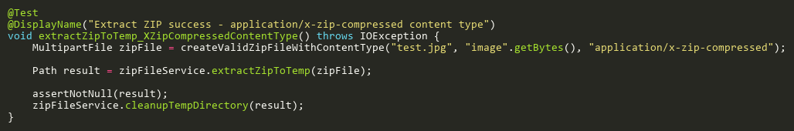
Figure: extractZipToTemp_XZipCompressedContentType
Reference: Sheet "ZFST_extractZip", Test Case TC06

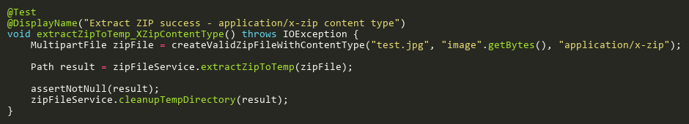
Figure: extractZipToTemp_XZipContentType
Reference: Sheet "ZFST_extractZip", Test Case TC07

IsImageFileTests
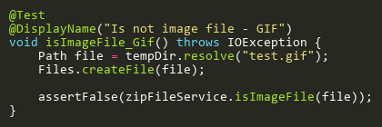
Figure: isImageFile_Gif
Reference: Sheet "ZFST_isImageFile", Test Case TC07

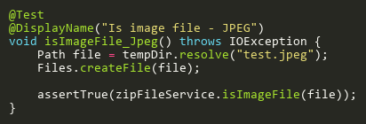
Figure: isImageFile_Jpeg
Reference: Sheet "ZFST_isImageFile", Test Case TC02

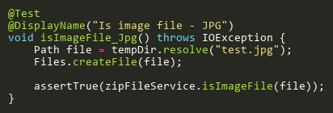
Figure: isImageFile_Jpg
Reference: Sheet "ZFST_isImageFile", Test Case TC01

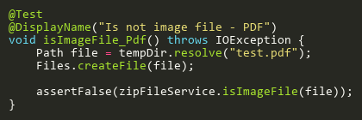
Figure: isImageFile_Pdf
Reference: Sheet "ZFST_isImageFile", Test Case TC06

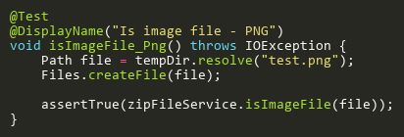
Figure: isImageFile_Png
Reference: Sheet "ZFST_isImageFile", Test Case TC03

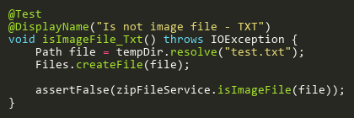
Figure: isImageFile_Txt
Reference: Sheet "ZFST_isImageFile", Test Case TC05

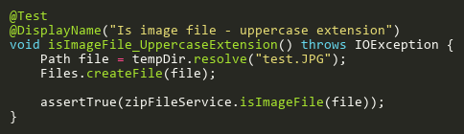
Figure: isImageFile_UppercaseExtension
Reference: Sheet "ZFST_isImageFile", Test Case TC04

