AttendanceRecordServiceTest

ApplyRescanReviewFlagsAdditionalTests
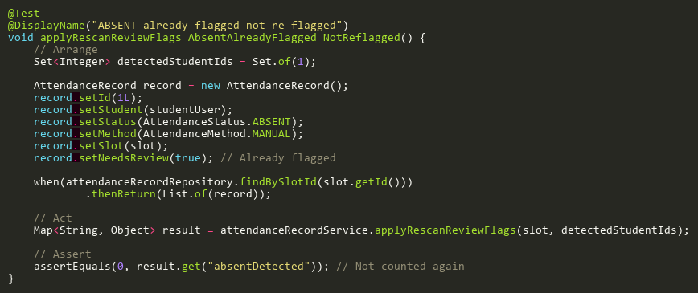
Figure: applyRescanReviewFlags_AbsentAlreadyFlagged_NotReflagged
Reference: Sheet "ARST_reviewFlags", Test Case TC03

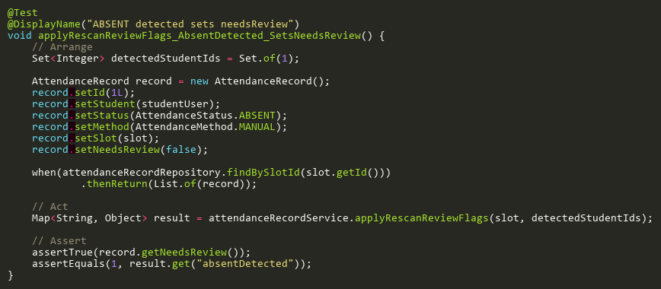
Figure: applyRescanReviewFlags_AbsentDetected_SetsNeedsReview
Reference: Sheet "ARST_reviewFlags", Test Case TC01

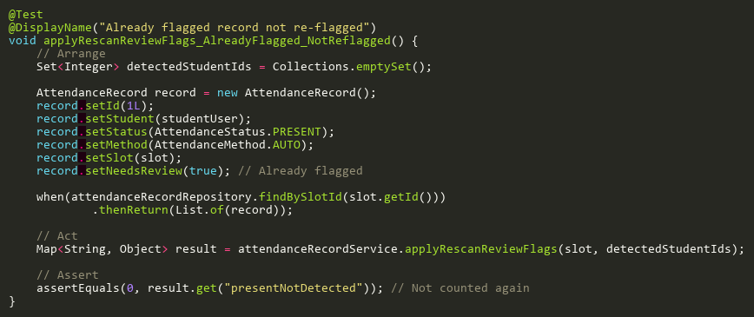
Figure: applyRescanReviewFlags_AlreadyFlagged_NotReflagged
Reference: Sheet "ARST_reviewFlags", Test Case TC02

EvidenceDownloadFailureTests
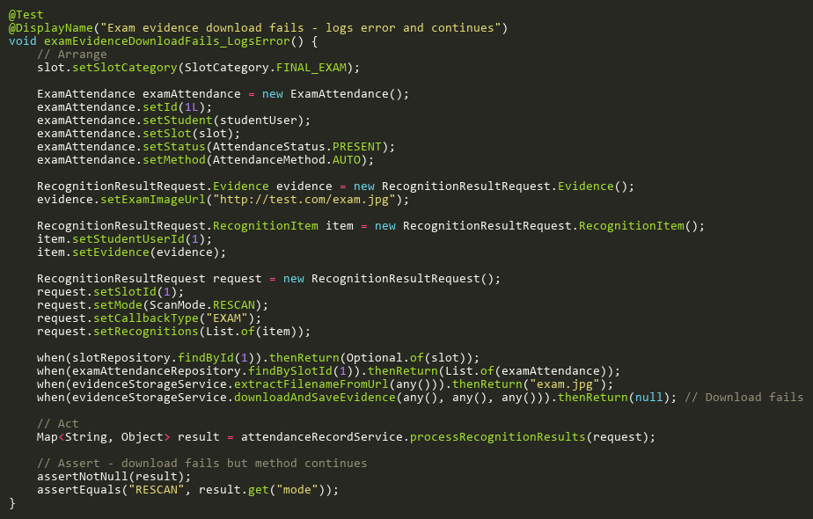
Figure: examEvidenceDownloadFails_LogsError
Reference: Sheet "ARST_evidenceFail", Test Case TC02

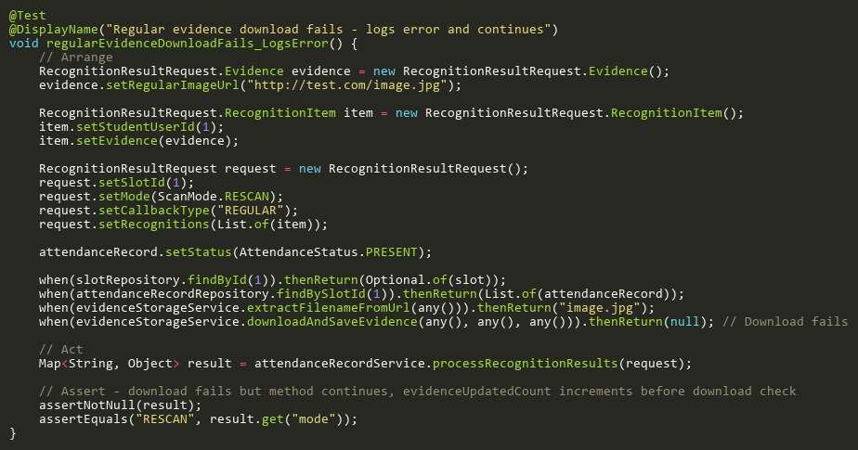
Figure: regularEvidenceDownloadFails_LogsError
Reference: Sheet "ARST_evidenceFail", Test Case TC01

EvidenceStorageTests
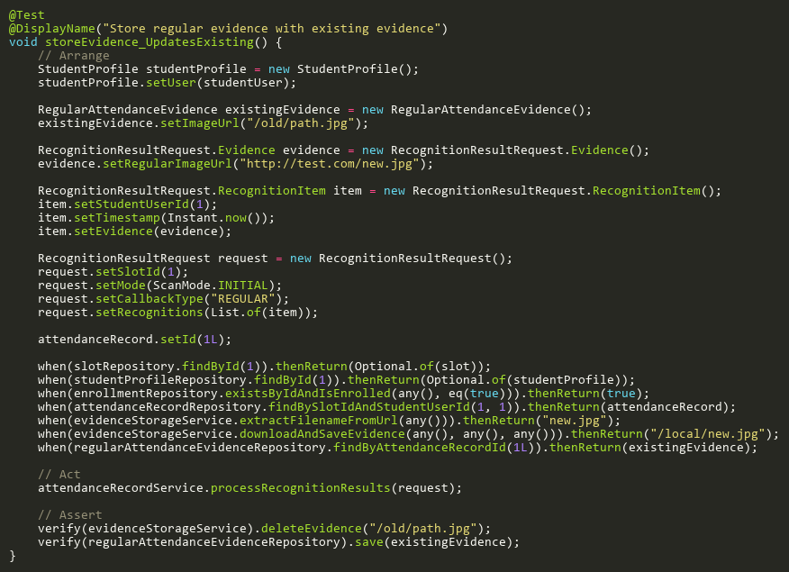
Figure: storeEvidence_UpdatesExisting
Reference: Sheet "ARST_evidenceStore", Test Case TC01

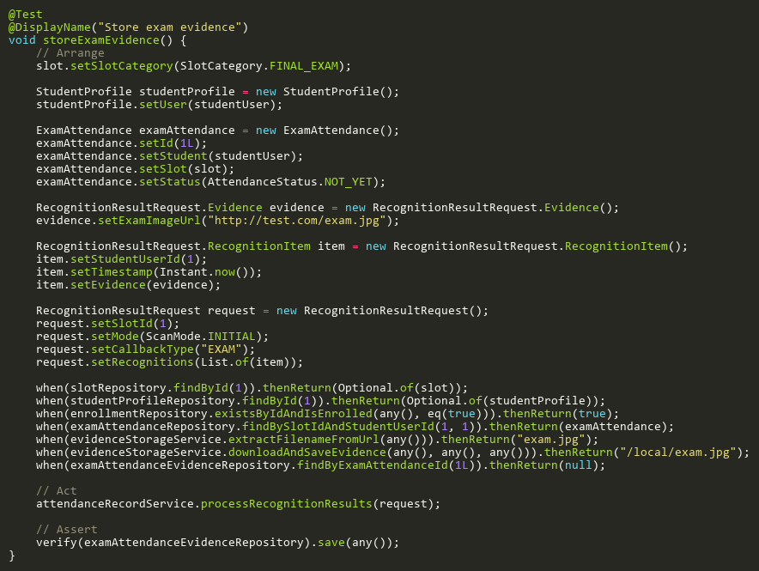
Figure: storeExamEvidence
Reference: Sheet "ARST_evidenceStore", Test Case TC02

ProcessExamRecognitionTests
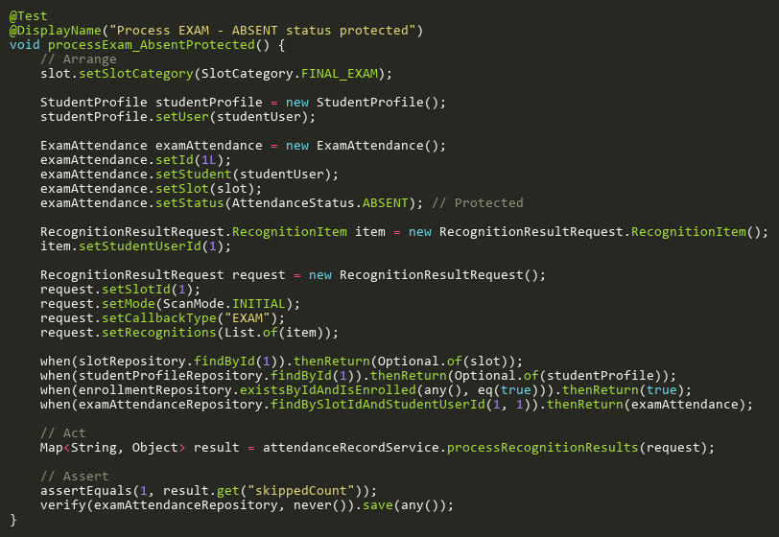
Figure: processExam_AbsentProtected
Reference: Sheet "ARST_processExam", Test Case TC02

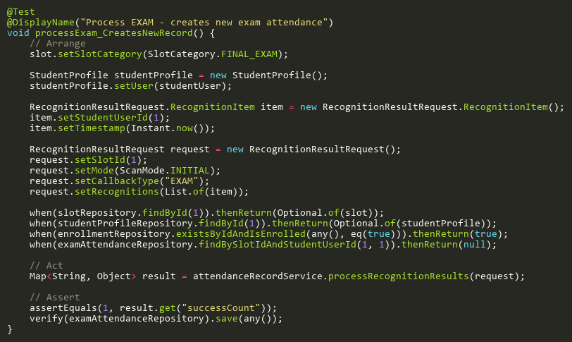
Figure: processExam_CreatesNewRecord
Reference: Sheet "ARST_processExam", Test Case TC03

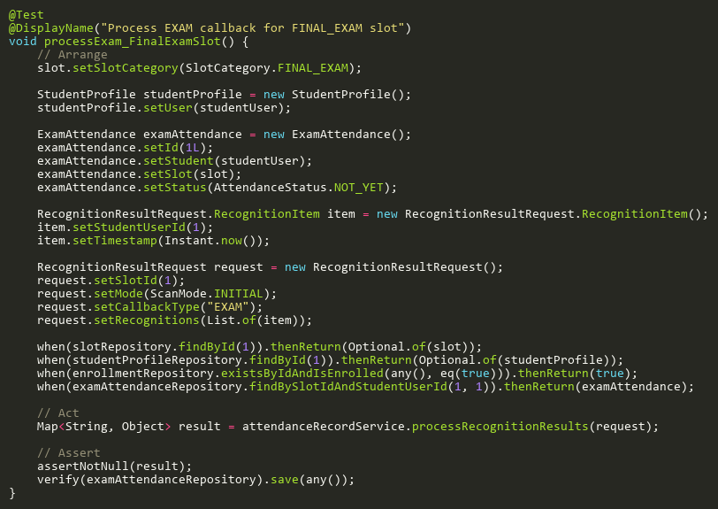
Figure: processExam_FinalExamSlot
Reference: Sheet "ARST_processExam", Test Case TC01

ProcessInitialRecognitionTests
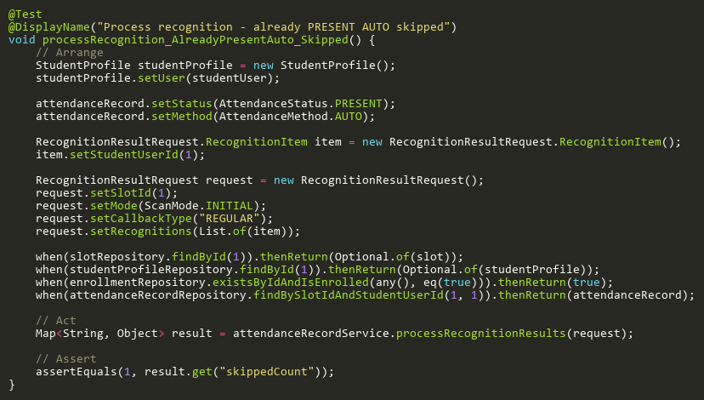
Figure: processRecognition_AlreadyPresentAuto_Skipped
Reference: Sheet "ARST_processInitial", Test Case TC03

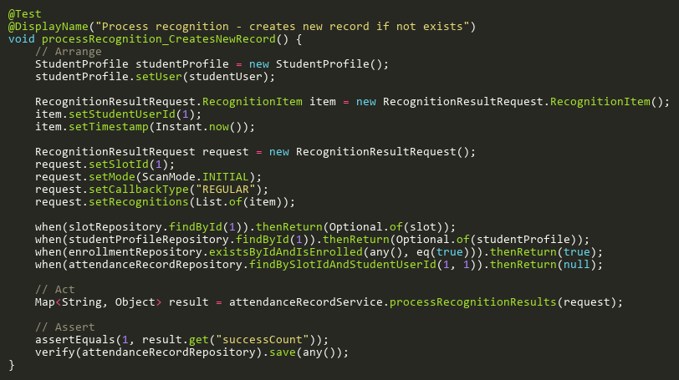
Figure: processRecognition_CreatesNewRecord
Reference: Sheet "ARST_processInitial", Test Case TC04

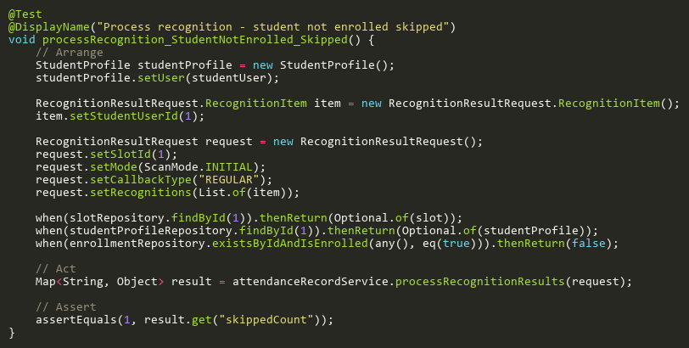
Figure: processRecognition_StudentNotEnrolled_Skipped
Reference: Sheet "ARST_processInitial", Test Case TC02

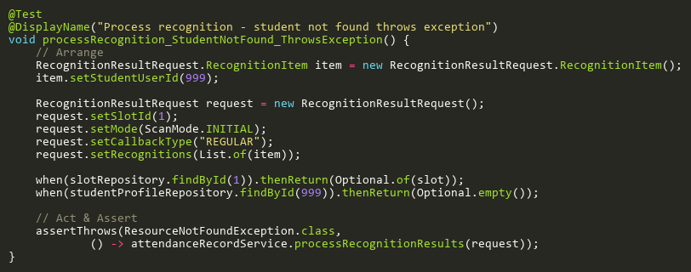
Figure: processRecognition_StudentNotFound_ThrowsException
Reference: Sheet "ARST_processInitial", Test Case TC05

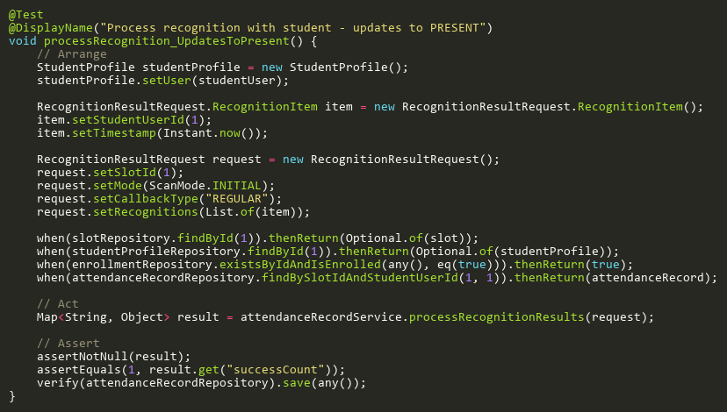
Figure: processRecognition_UpdatesToPresent
Reference: Sheet "ARST_processInitial", Test Case TC01

ProcessRecognitionAdditionalTests
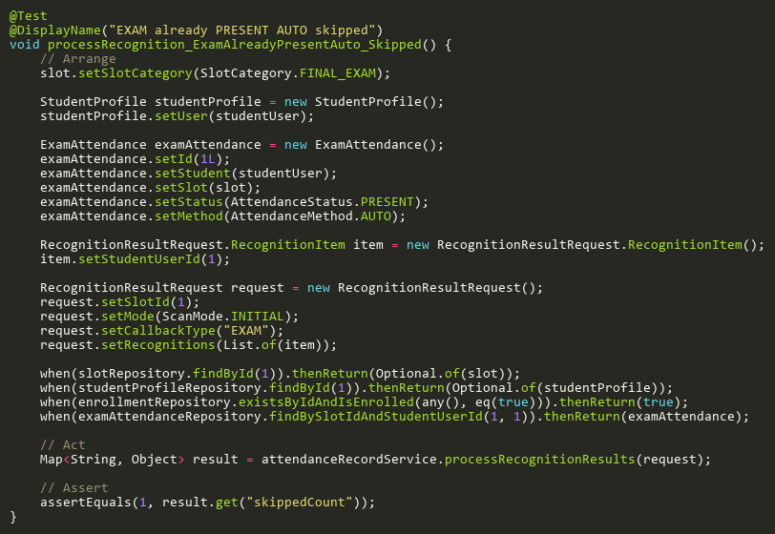
Figure: processRecognition_ExamAlreadyPresentAuto_Skipped
Reference: Sheet "ARST_processAdd", Test Case TC02

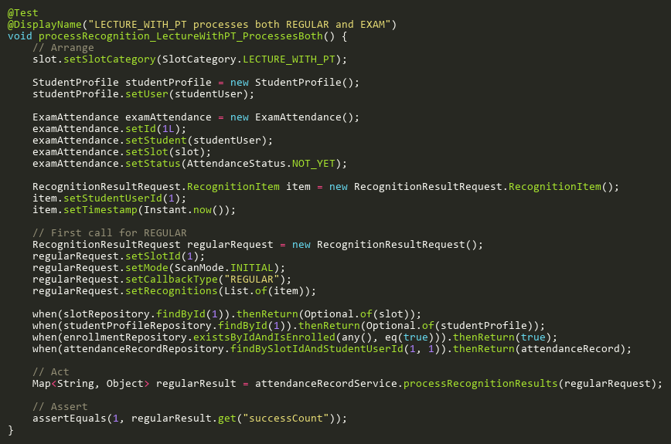
Figure: processRecognition_LectureWithPT_ProcessesBoth
Reference: Sheet "ARST_processAdd", Test Case TC03

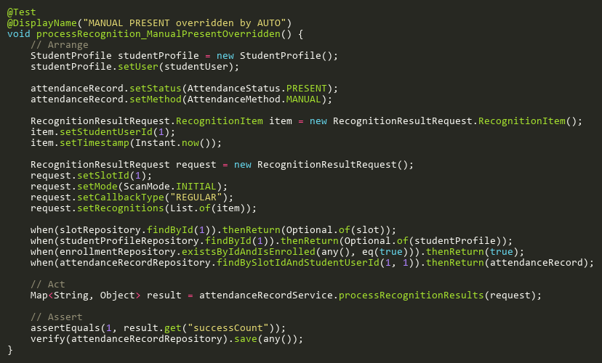
Figure: processRecognition_ManualPresentOverridden
Reference: Sheet "ARST_processAdd", Test Case TC01

ProcessRescanExamAdditionalTests
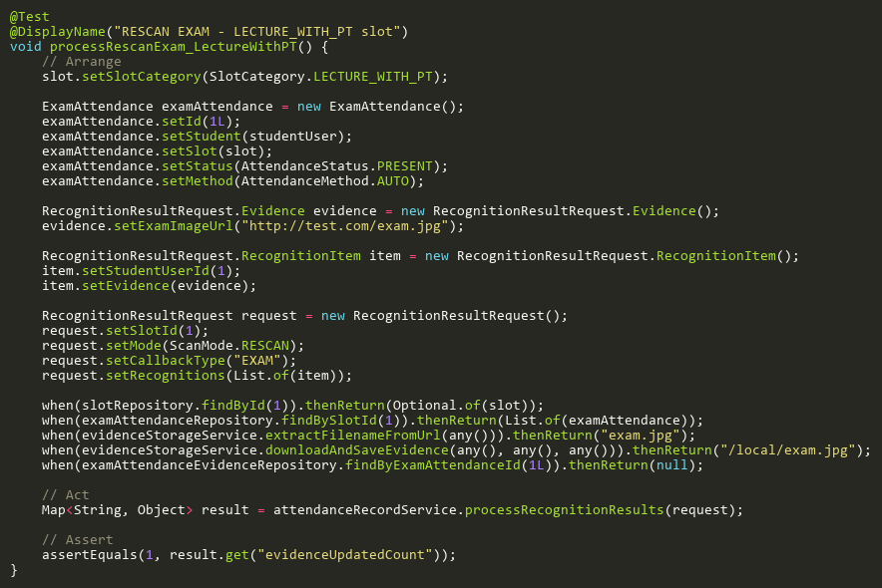
Figure: processRescanExam_LectureWithPT
Reference: Sheet "ARST_rescanExamAdd", Test Case TC04

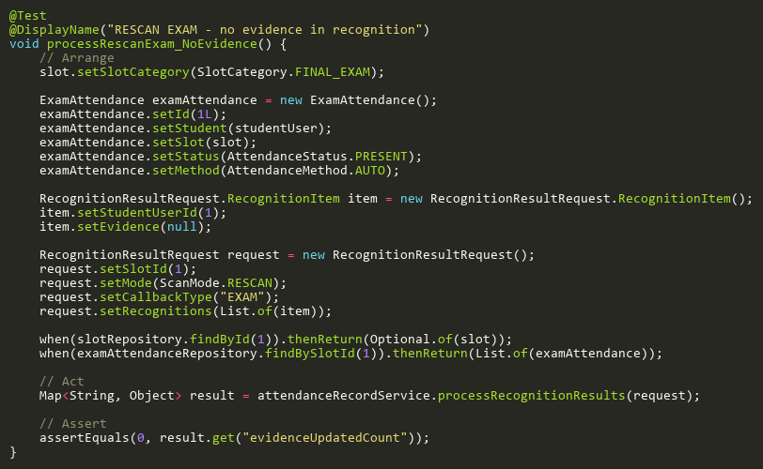
Figure: processRescanExam_NoEvidence
Reference: Sheet "ARST_rescanExamAdd", Test Case TC02

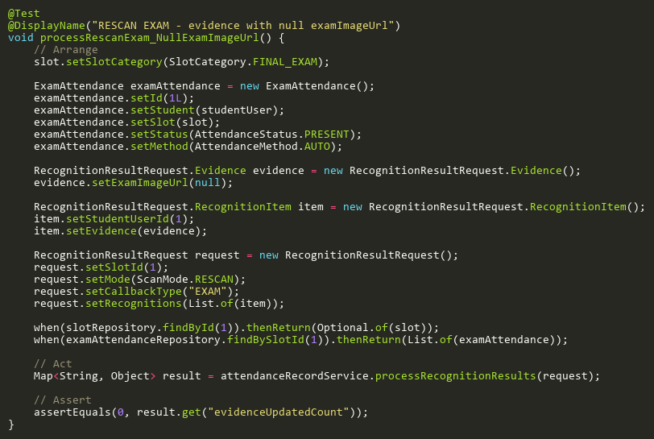
Figure: processRescanExam_NullExamImageUrl
Reference: Sheet "ARST_rescanExamAdd", Test Case TC03

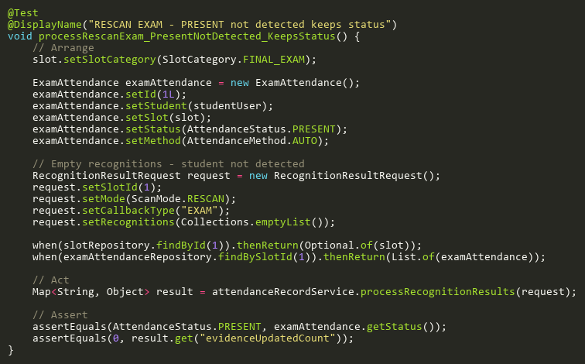
Figure: processRescanExam_PresentNotDetected_KeepsStatus
Reference: Sheet "ARST_rescanExamAdd", Test Case TC01

ProcessRescanExamTests
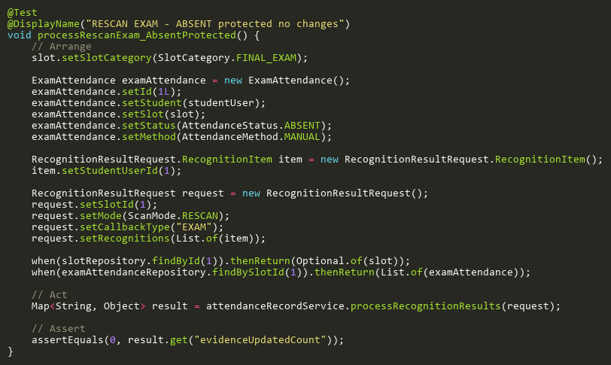
Figure: processRescanExam_AbsentProtected
Reference: Sheet "ARST_rescanExam", Test Case TC03

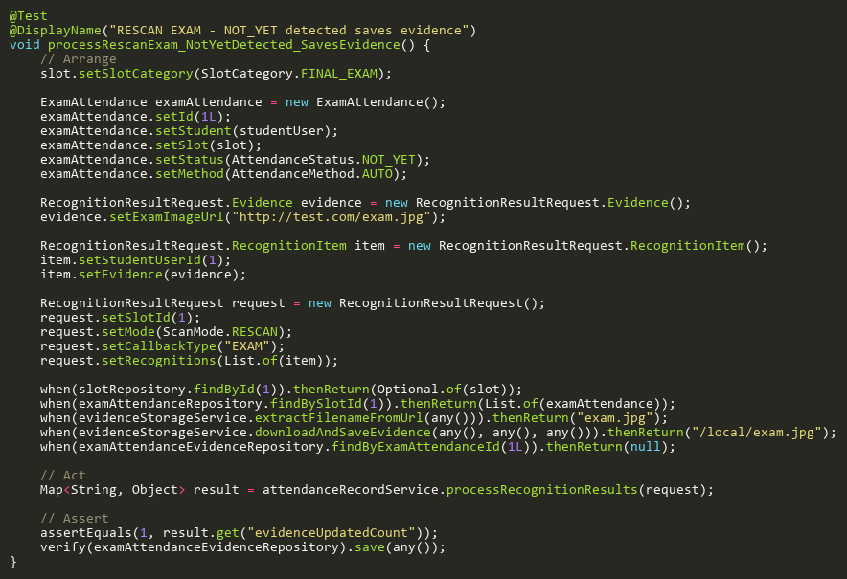
Figure: processRescanExam_NotYetDetected_SavesEvidence
Reference: Sheet "ARST_rescanExam", Test Case TC02

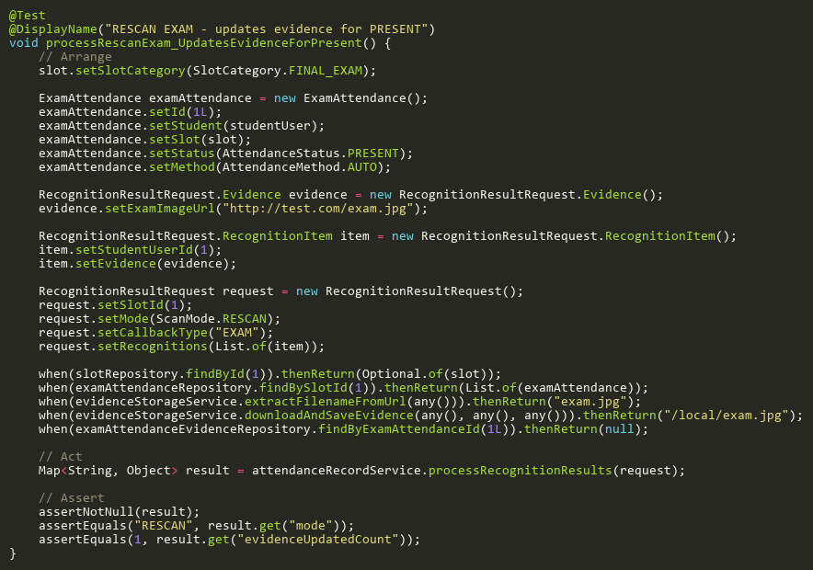
Figure: processRescanExam_UpdatesEvidenceForPresent
Reference: Sheet "ARST_rescanExam", Test Case TC01

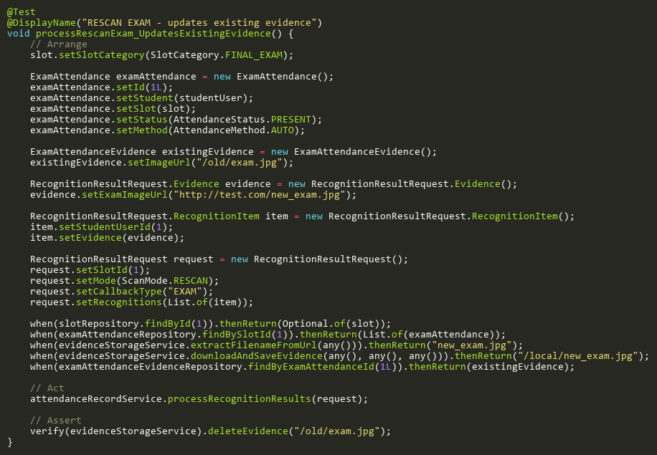
Figure: processRescanExam_UpdatesExistingEvidence
Reference: Sheet "ARST_rescanExam", Test Case TC04

ProcessRescanRecognitionTests
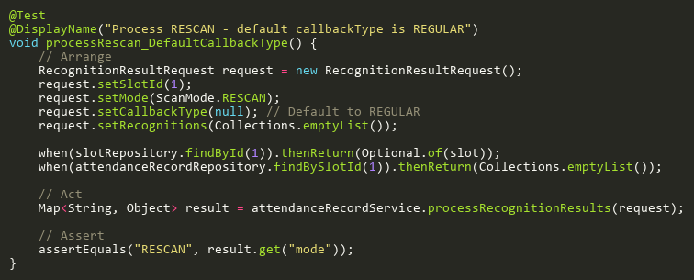
Figure: processRescan_DefaultCallbackType
Reference: Sheet "ARST_processRescan", Test Case TC02

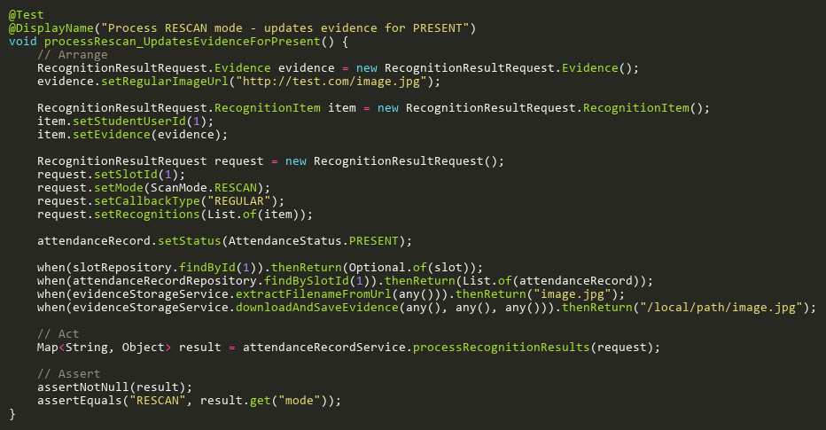
Figure: processRescan_UpdatesEvidenceForPresent
Reference: Sheet "ARST_processRescan", Test Case TC01

ProcessRescanRegularAdditionalTests
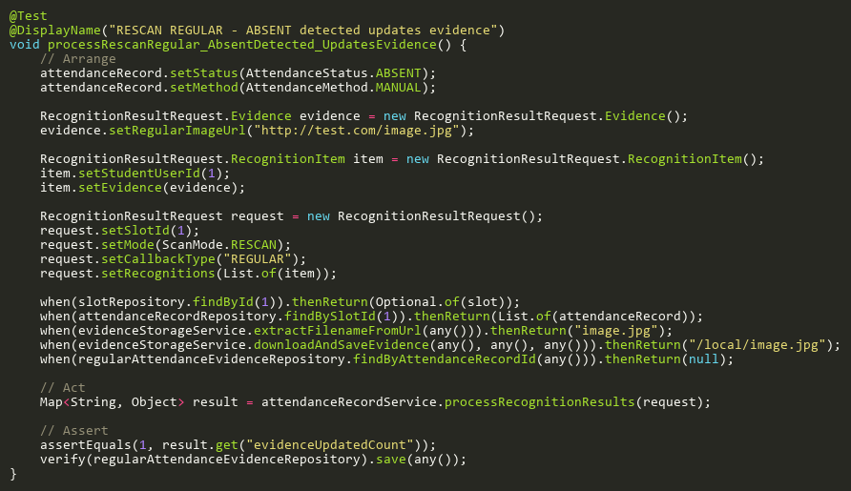
Figure: processRescanRegular_AbsentDetected_UpdatesEvidence
Reference: Sheet "ARST_rescanRegAdd", Test Case TC01

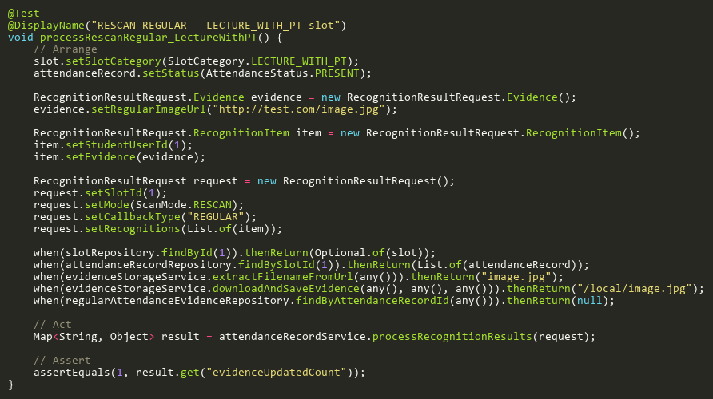
Figure: processRescanRegular_LectureWithPT
Reference: Sheet "ARST_rescanRegAdd", Test Case TC04

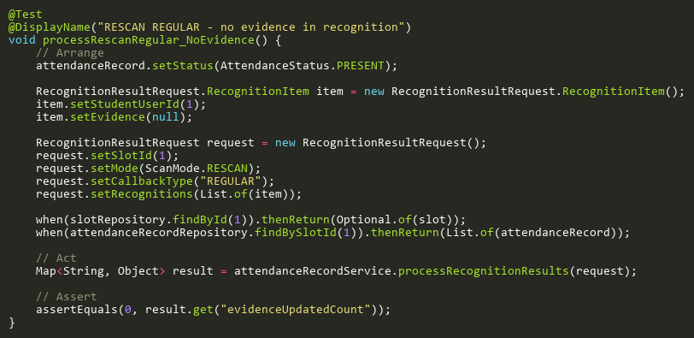
Figure: processRescanRegular_NoEvidence
Reference: Sheet "ARST_rescanRegAdd", Test Case TC05

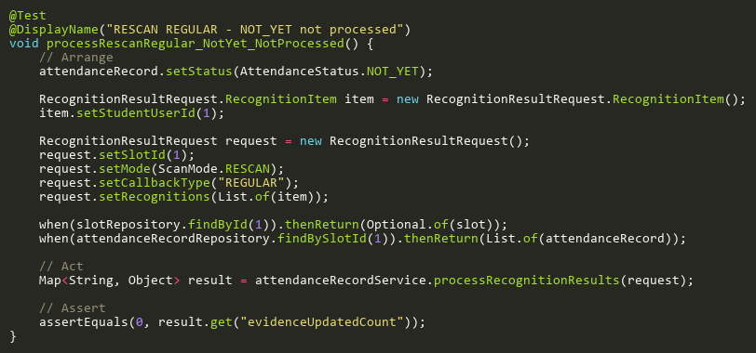
Figure: processRescanRegular_NotYet_NotProcessed
Reference: Sheet "ARST_rescanRegAdd", Test Case TC02

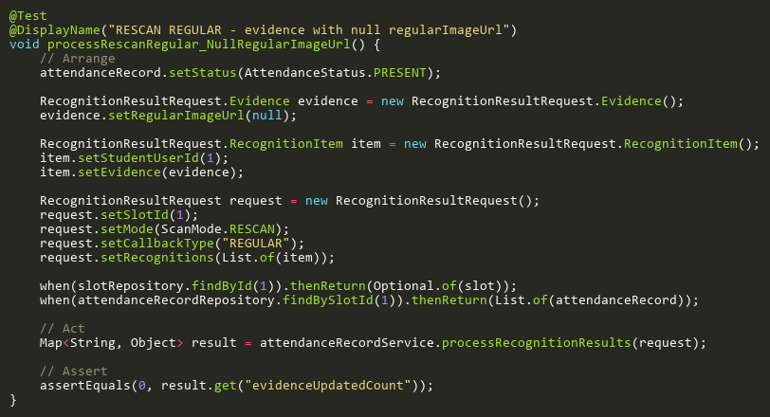
Figure: processRescanRegular_NullRegularImageUrl
Reference: Sheet "ARST_rescanRegAdd", Test Case TC06

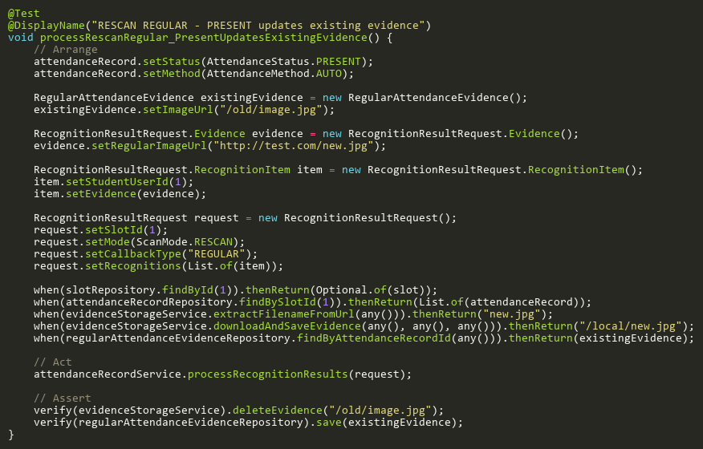
Figure: processRescanRegular_PresentUpdatesExistingEvidence
Reference: Sheet "ARST_rescanRegAdd", Test Case TC03

SsePublishExceptionTests
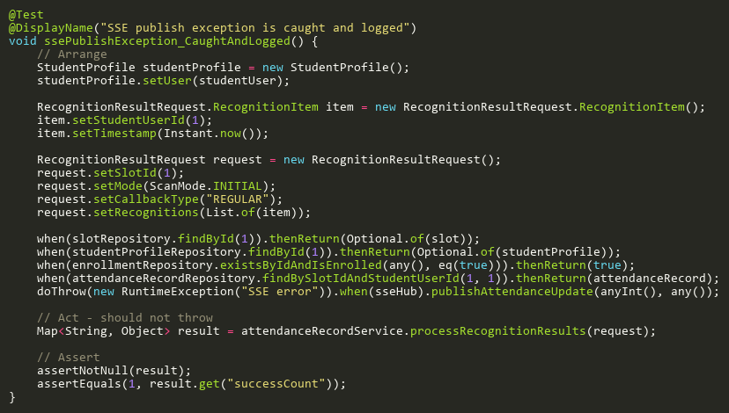
Figure: ssePublishException_CaughtAndLogged
Reference: Sheet "ARST_sseException", Test Case TC01

UpdateStatusAdditionalTests
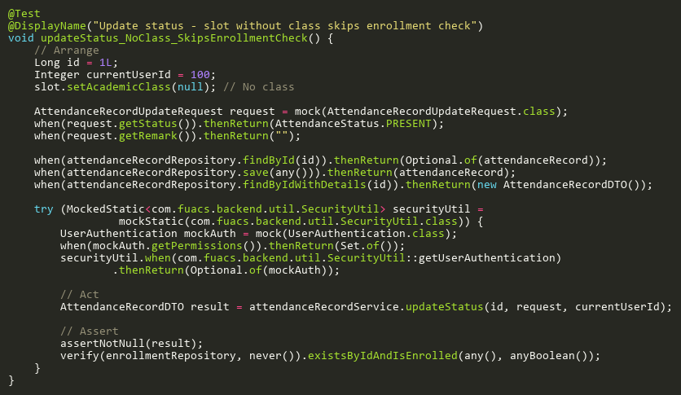
Figure: updateStatus_NoClass_SkipsEnrollmentCheck
Reference: Sheet "ARST_updateStatusAdd", Test Case TC03

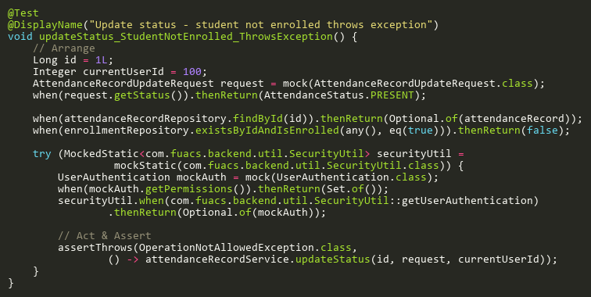
Figure: updateStatus_StudentNotEnrolled_ThrowsException
Reference: Sheet "ARST_updateStatusAdd", Test Case TC02

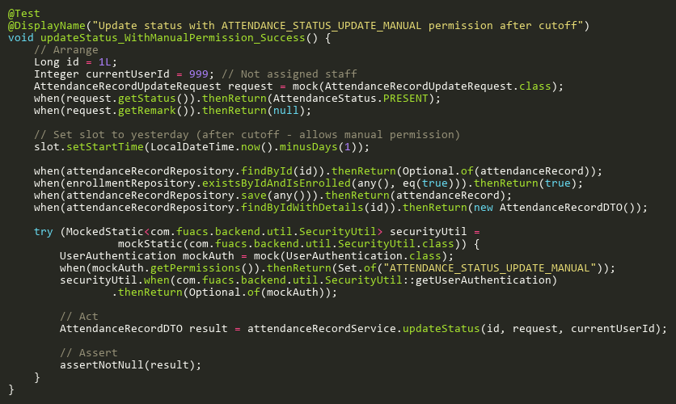
Figure: updateStatus_WithManualPermission_Success
Reference: Sheet "ARST_updateStatusAdd", Test Case TC01

UpdateStatusTests
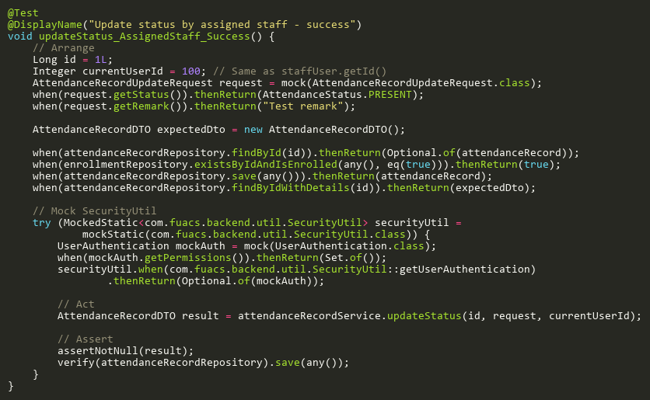
Figure: updateStatus_AssignedStaff_Success
Reference: Sheet "ARST_updateStatus", Test Case TC01

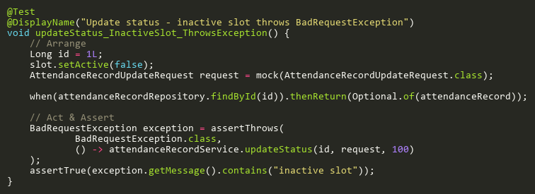
Figure: updateStatus_InactiveSlot_ThrowsException
Reference: Sheet "ARST_updateStatus", Test Case TC03

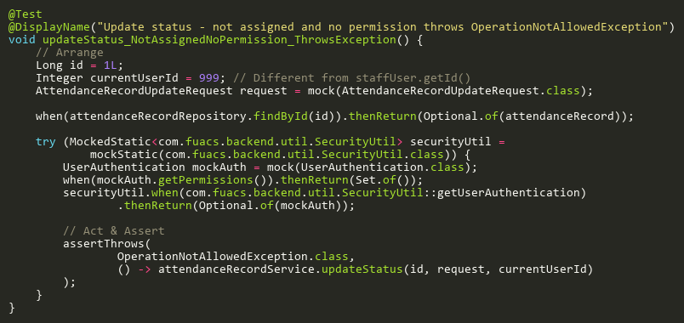
Figure: updateStatus_NotAssignedNoPermission_ThrowsException
Reference: Sheet "ARST_updateStatus", Test Case TC04

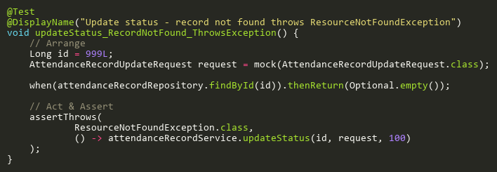
Figure: updateStatus_RecordNotFound_ThrowsException
Reference: Sheet "ARST_updateStatus", Test Case TC02

ValidateEditWindowTests
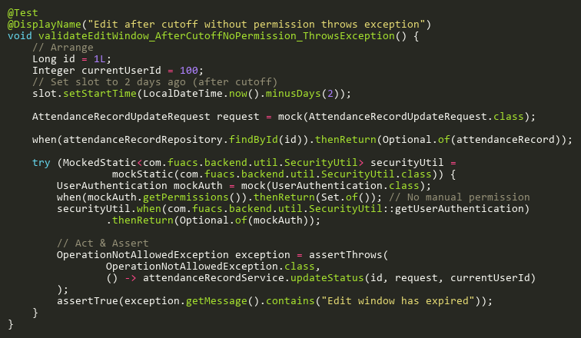
Figure: validateEditWindow_AfterCutoffNoPermission_ThrowsException
Reference: Sheet "ARST_validateEdit", Test Case TC02

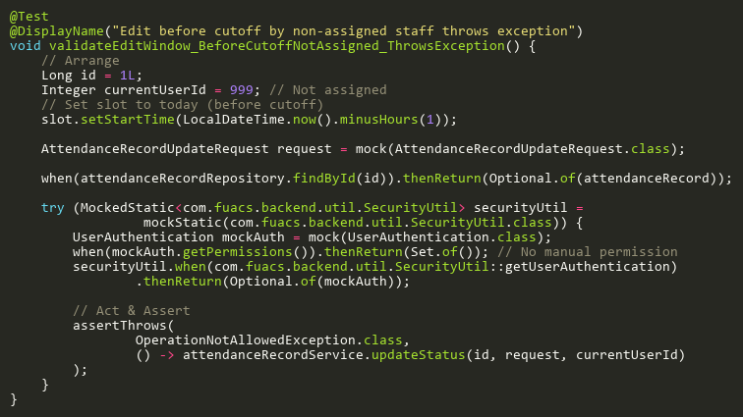
Figure: validateEditWindow_BeforeCutoffNotAssigned_ThrowsException
Reference: Sheet "ARST_validateEdit", Test Case TC03

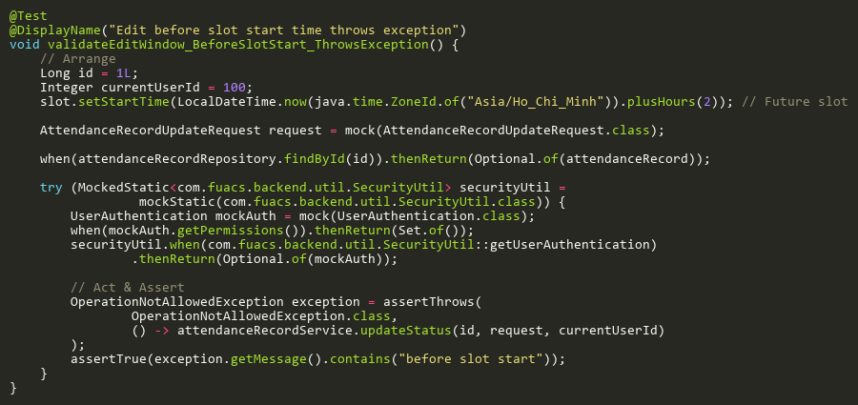
Figure: validateEditWindow_BeforeSlotStart_ThrowsException
Reference: Sheet "ARST_validateEdit", Test Case TC01

