BulkPhotoUploadServiceTest

ProcessBulkUploadTests
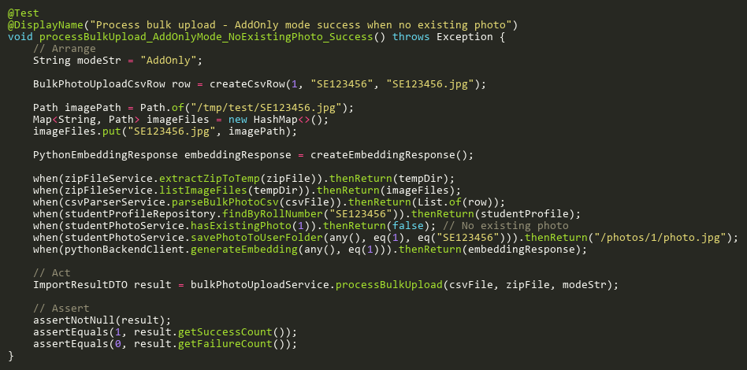
Figure: processBulkUpload_AddOnlyMode_NoExistingPhoto_Success
Reference: Sheet "BPUS_processBulkUpload", Test Case TC11

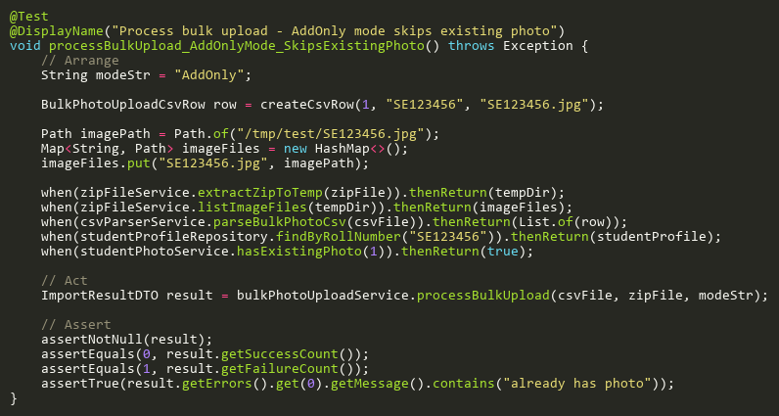
Figure: processBulkUpload_AddOnlyMode_SkipsExistingPhoto
Reference: Sheet "BPUS_processBulkUpload", Test Case TC06

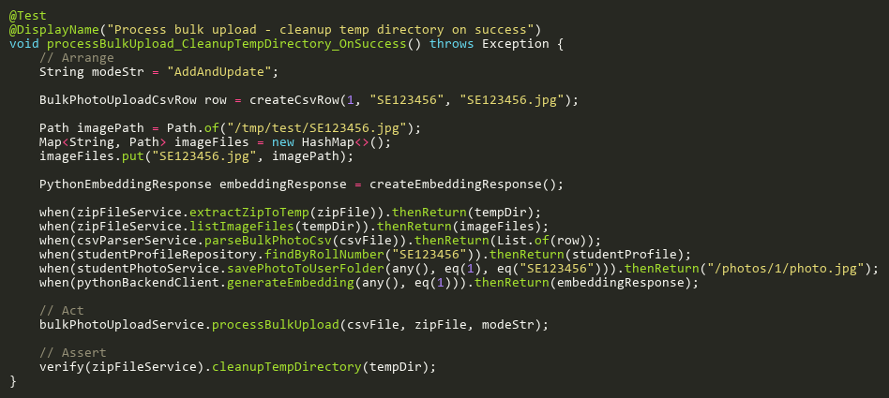
Figure: processBulkUpload_CleanupTempDirectory_OnSuccess
Reference: Sheet "BPUS_processBulkUpload", Test Case TC10

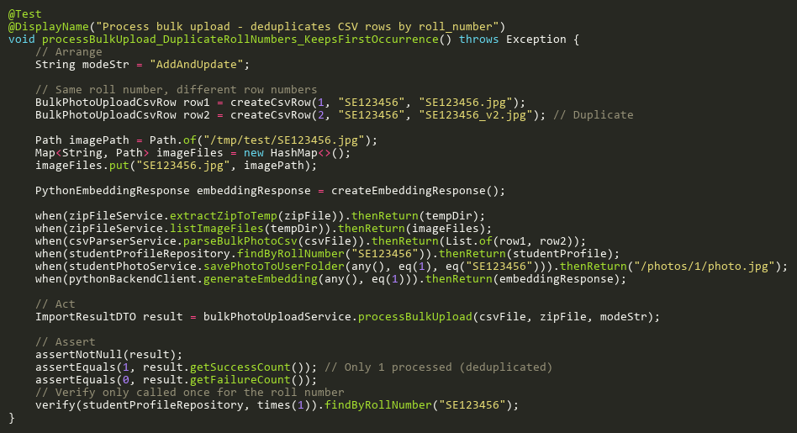
Figure: processBulkUpload_DuplicateRollNumbers_KeepsFirstOccurrence
Reference: Sheet "BPUS_processBulkUpload", Test Case TC08

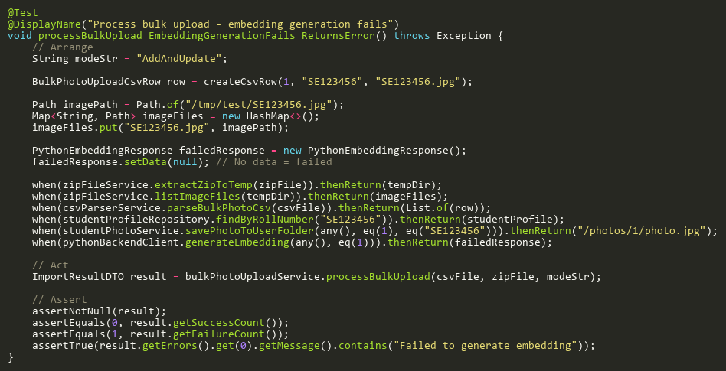
Figure: processBulkUpload_EmbeddingGenerationFails_ReturnsError
Reference: Sheet "BPUS_processBulkUpload", Test Case TC07

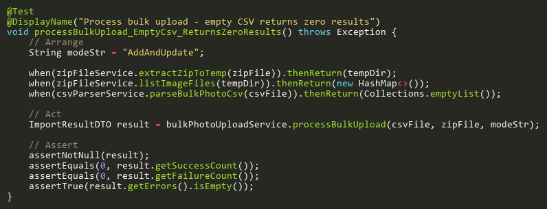
Figure: processBulkUpload_EmptyCsv_ReturnsZeroResults
Reference: Sheet "BPUS_processBulkUpload", Test Case TC12

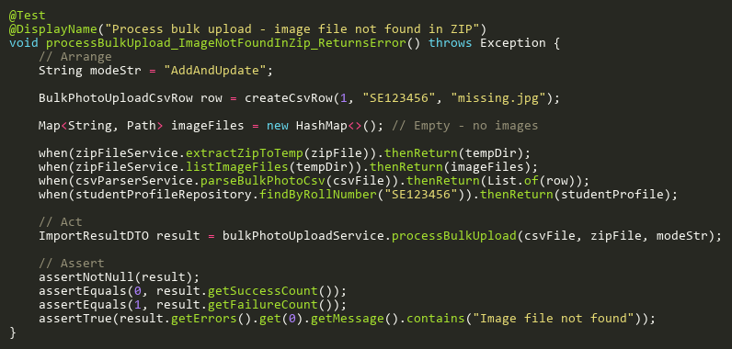
Figure: processBulkUpload_ImageNotFoundInZip_ReturnsError
Reference: Sheet "BPUS_processBulkUpload", Test Case TC05

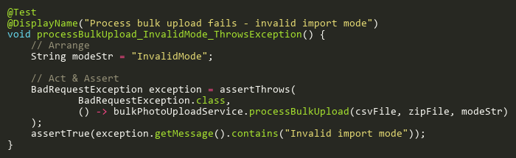
Figure: processBulkUpload_InvalidMode_ThrowsException
Reference: Sheet "BPUS_processBulkUpload", Test Case TC03

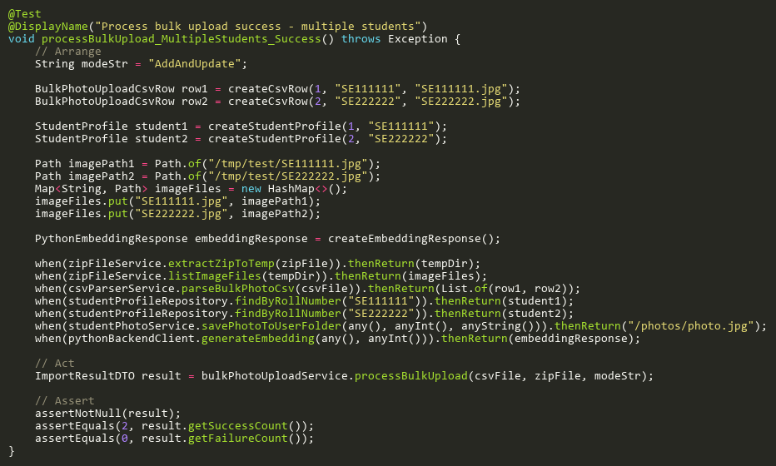
Figure: processBulkUpload_MultipleStudents_Success
Reference: Sheet "BPUS_processBulkUpload", Test Case TC02

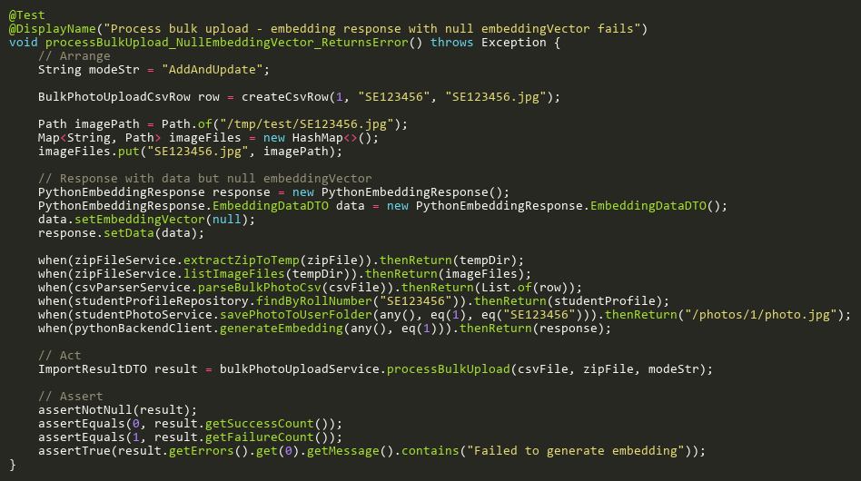
Figure: processBulkUpload_NullEmbeddingVector_ReturnsError
Reference: Sheet "BPUS_processBulkUpload", Test Case TC13

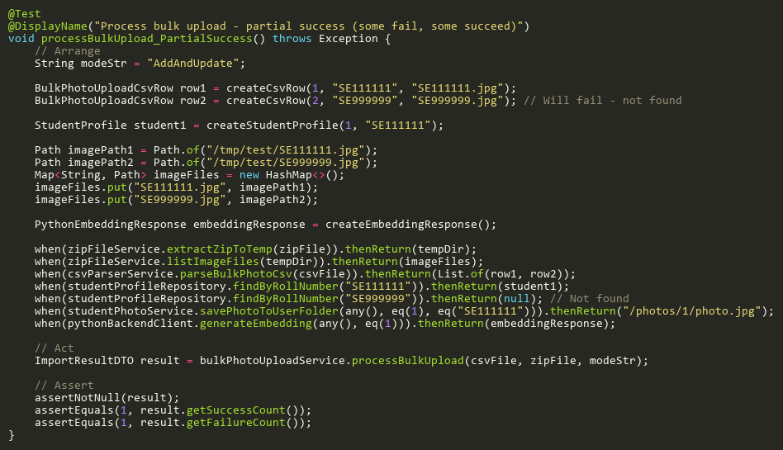
Figure: processBulkUpload_PartialSuccess
Reference: Sheet "BPUS_processBulkUpload", Test Case TC09

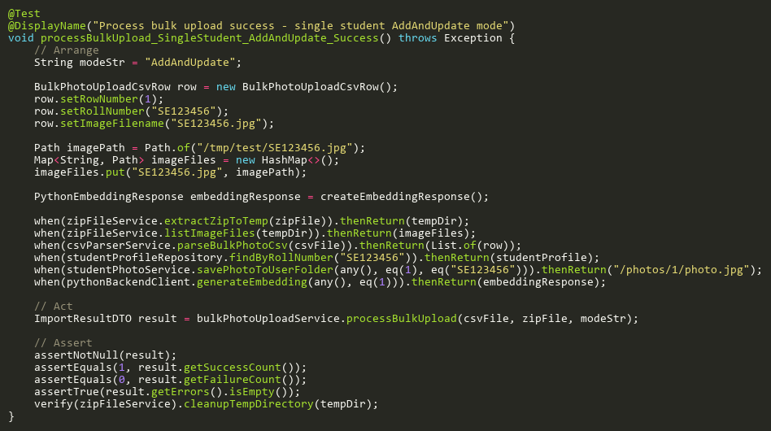
Figure: processBulkUpload_SingleStudent_AddAndUpdate_Success
Reference: Sheet "BPUS_processBulkUpload", Test Case TC01

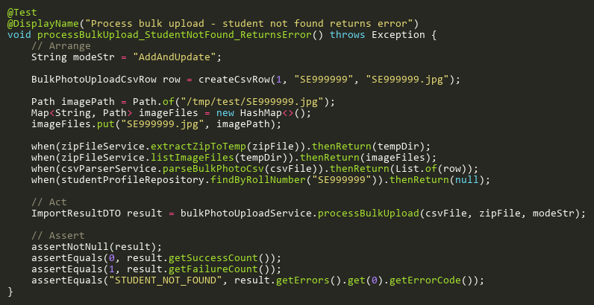
Figure: processBulkUpload_StudentNotFound_ReturnsError
Reference: Sheet "BPUS_processBulkUpload", Test Case TC04

