CameraServiceTest

CreateTests
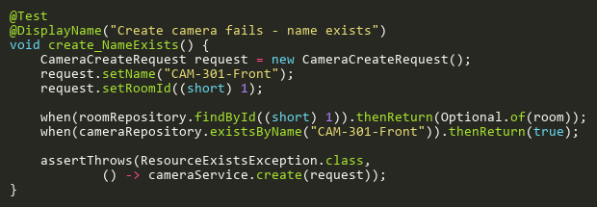
Figure: create_NameExists
Reference: Sheet "CS_create", Test Case TC03

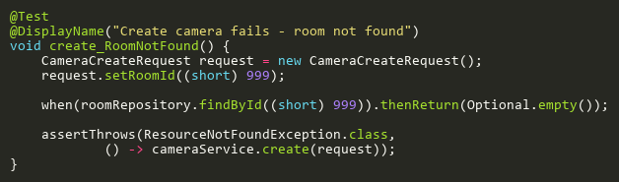
Figure: create_RoomNotFound
Reference: Sheet "CS_create", Test Case TC02

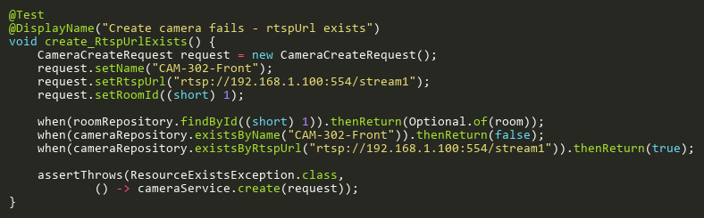
Figure: create_RtspUrlExists
Reference: Sheet "CS_create", Test Case TC04

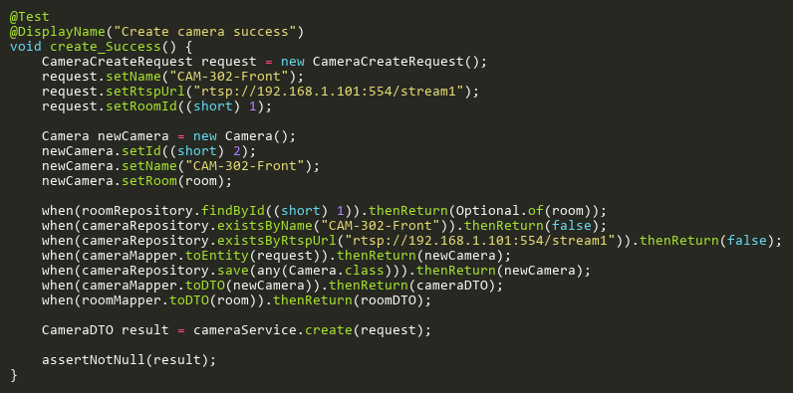
Figure: create_Success
Reference: Sheet "CS_create", Test Case TC01

DeleteTests
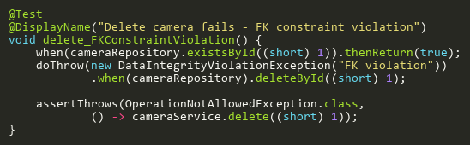
Figure: delete_FKConstraintViolation
Reference: Sheet "CS_delete", Test Case TC03

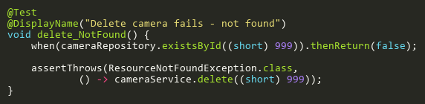
Figure: delete_NotFound
Reference: Sheet "CS_delete", Test Case TC02

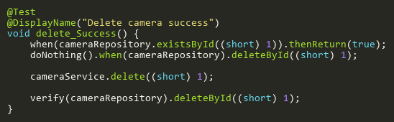
Figure: delete_Success
Reference: Sheet "CS_delete", Test Case TC01

FindByIdTests
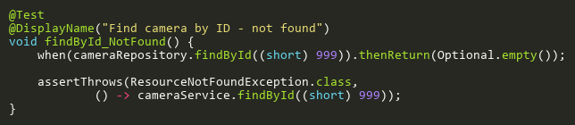
Figure: findById_NotFound
Reference: Sheet "CS_findById", Test Case TC02

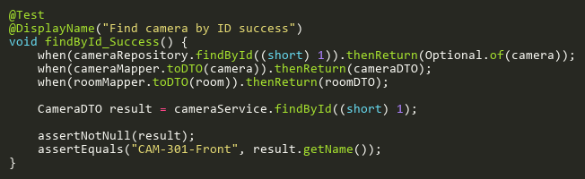
Figure: findById_Success
Reference: Sheet "CS_findById", Test Case TC01

TestConnectionTests
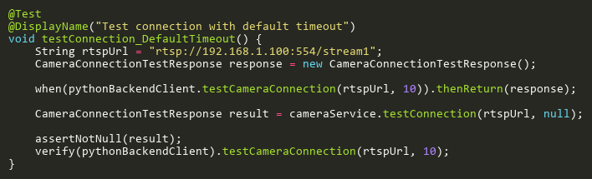
Figure: testConnection_DefaultTimeout
Reference: Sheet "CS_testConnection", Test Case TC02

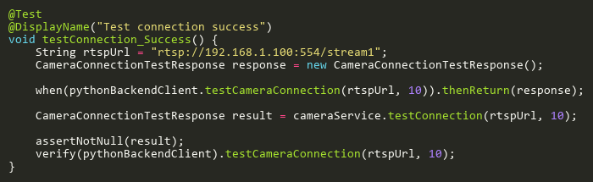
Figure: testConnection_Success
Reference: Sheet "CS_testConnection", Test Case TC01

UpdateTests
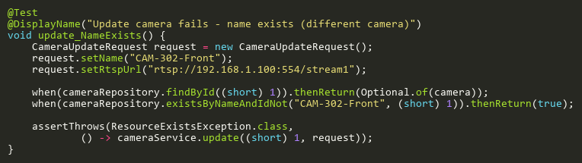
Figure: update_NameExists
Reference: Sheet "CS_update", Test Case TC03

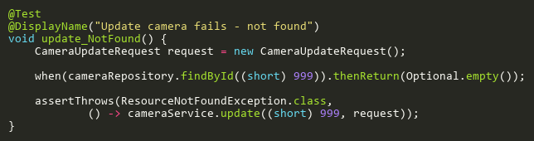
Figure: update_NotFound
Reference: Sheet "CS_update", Test Case TC02

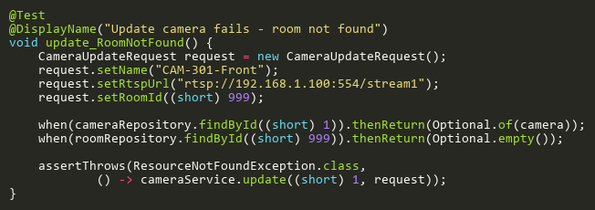
Figure: update_RoomNotFound
Reference: Sheet "CS_update", Test Case TC05

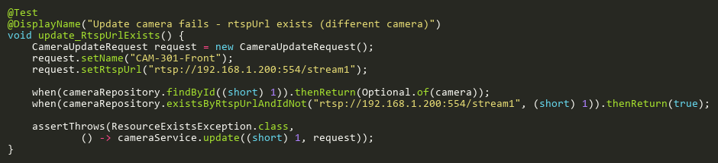
Figure: update_RtspUrlExists
Reference: Sheet "CS_update", Test Case TC04

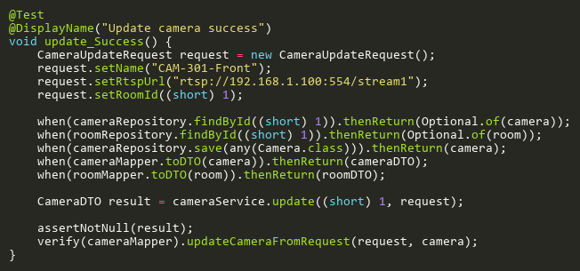
Figure: update_Success
Reference: Sheet "CS_update", Test Case TC01

