ClassServiceTest

CountClassesByStaffIdTests
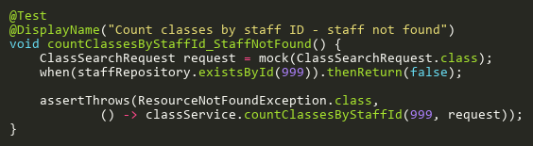
Figure: countClassesByStaffId_StaffNotFound
Reference: Sheet "CLS_countByStaffId", Test Case TC02

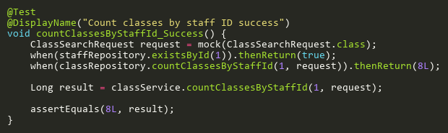
Figure: countClassesByStaffId_Success
Reference: Sheet "CLS_countByStaffId", Test Case TC01

CreateTests
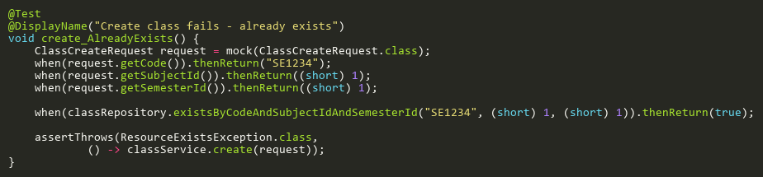
Figure: create_AlreadyExists
Reference: Sheet "CLS_create", Test Case TC02

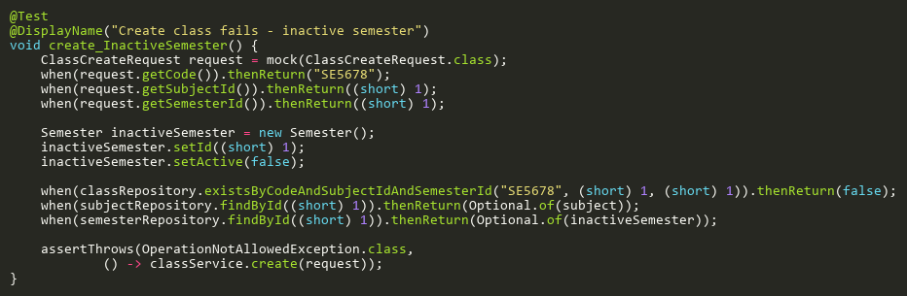
Figure: create_InactiveSemester
Reference: Sheet "CLS_create", Test Case TC06

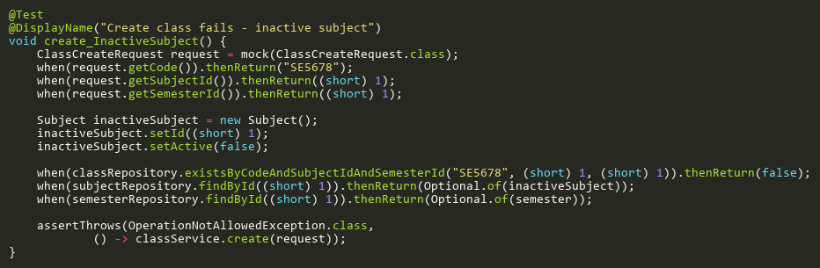
Figure: create_InactiveSubject
Reference: Sheet "CLS_create", Test Case TC05

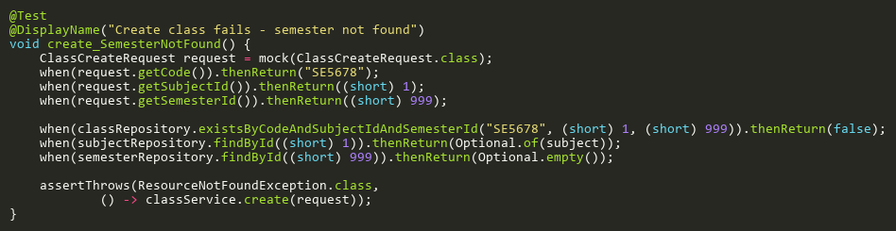
Figure: create_SemesterNotFound
Reference: Sheet "CLS_create", Test Case TC04

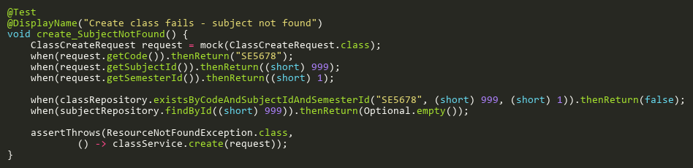
Figure: create_SubjectNotFound
Reference: Sheet "CLS_create", Test Case TC03

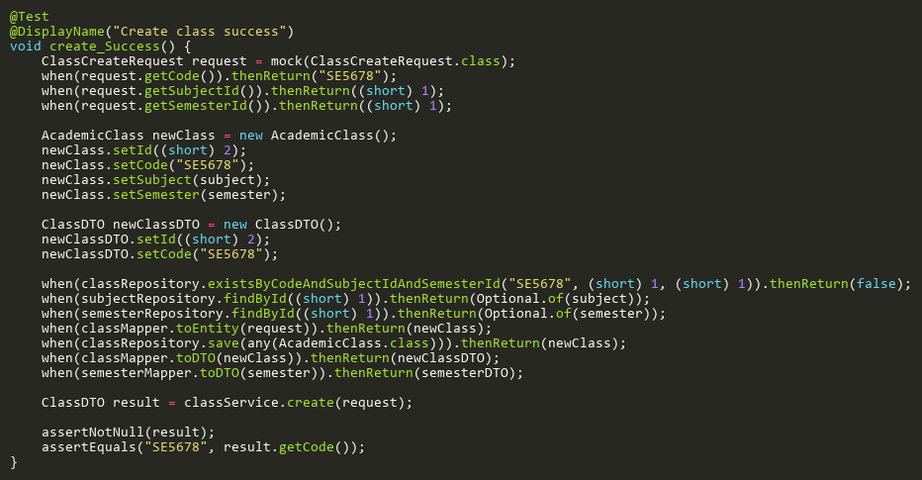
Figure: create_Success
Reference: Sheet "CLS_create", Test Case TC01

DeleteTests
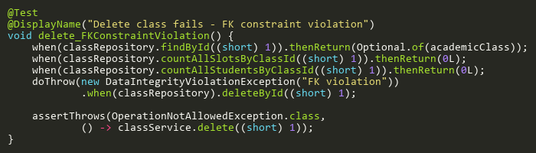
Figure: delete_FKConstraintViolation
Reference: Sheet "CLS_delete", Test Case TC05

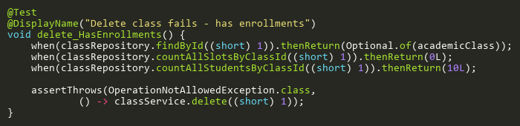
Figure: delete_HasEnrollments
Reference: Sheet "CLS_delete", Test Case TC04

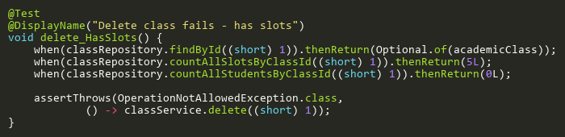
Figure: delete_HasSlots
Reference: Sheet "CLS_delete", Test Case TC03

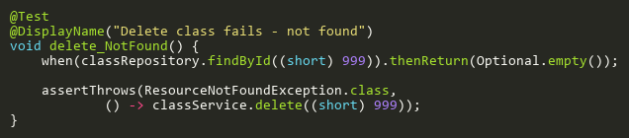
Figure: delete_NotFound
Reference: Sheet "CLS_delete", Test Case TC02

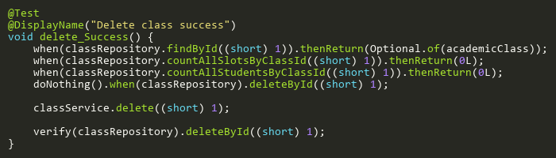
Figure: delete_Success
Reference: Sheet "CLS_delete", Test Case TC01

UpdateTests
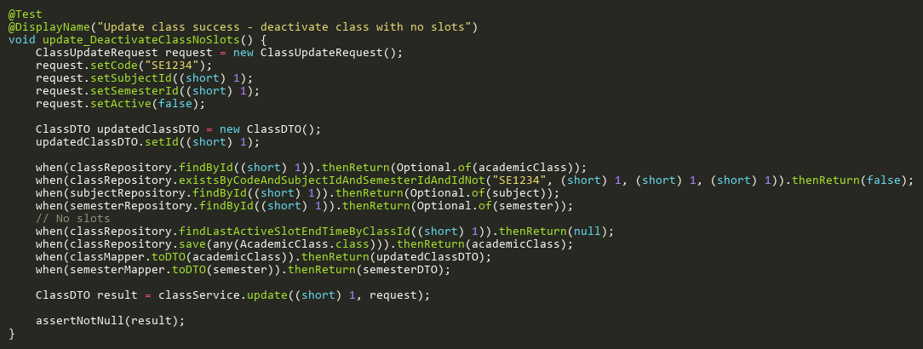
Figure: update_DeactivateClassNoSlots
Reference: Sheet "CLS_update", Test Case TC09

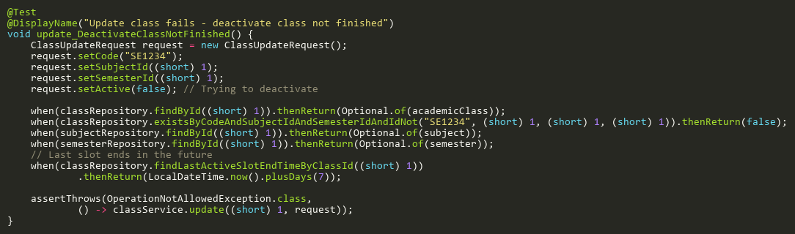
Figure: update_DeactivateClassNotFinished
Reference: Sheet "CLS_update", Test Case TC07

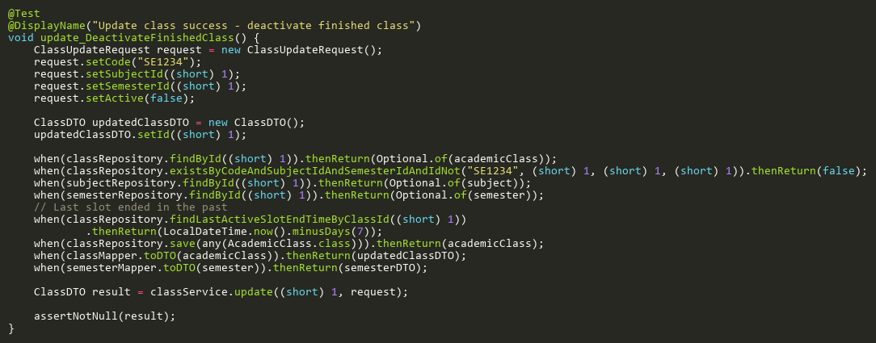
Figure: update_DeactivateFinishedClass
Reference: Sheet "CLS_update", Test Case TC08

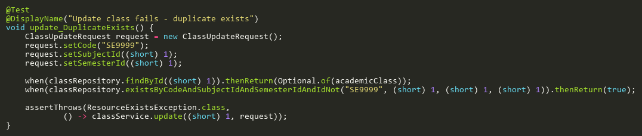
Figure: update_DuplicateExists
Reference: Sheet "CLS_update", Test Case TC03

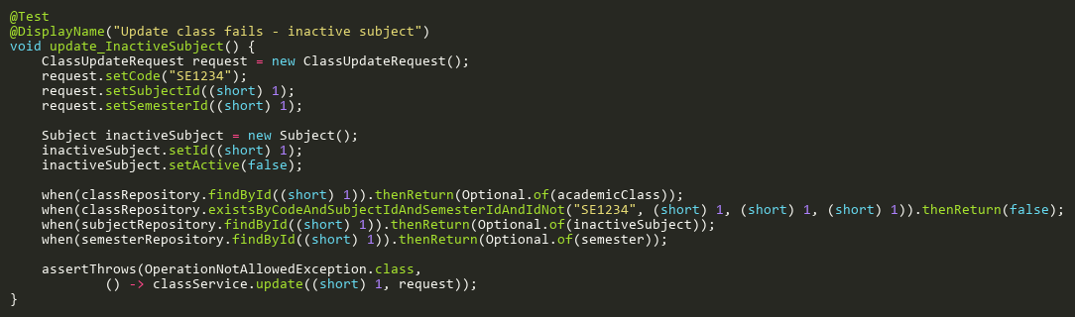
Figure: update_InactiveSubject
Reference: Sheet "CLS_update", Test Case TC06

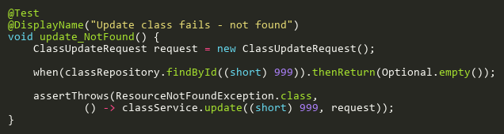
Figure: update_NotFound
Reference: Sheet "CLS_update", Test Case TC02

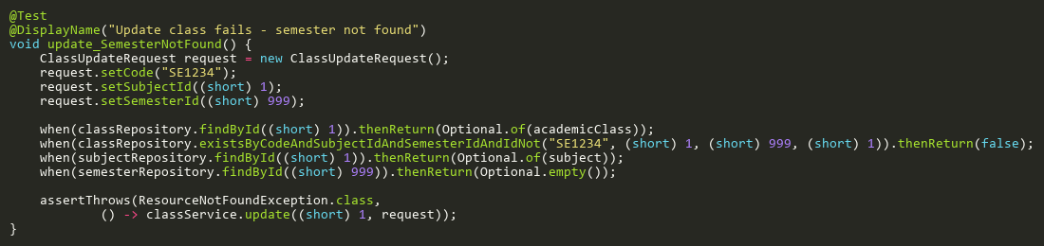
Figure: update_SemesterNotFound
Reference: Sheet "CLS_update", Test Case TC05

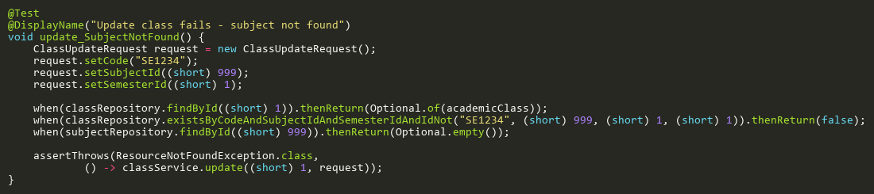
Figure: update_SubjectNotFound
Reference: Sheet "CLS_update", Test Case TC04

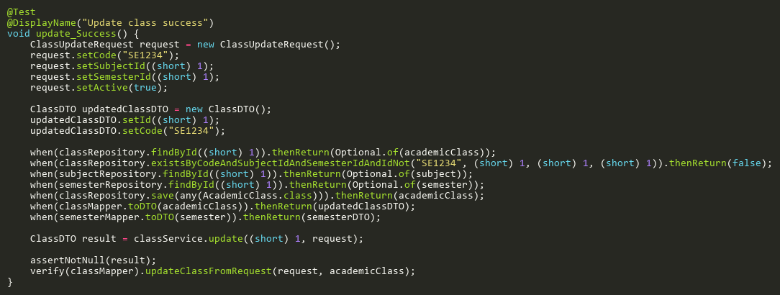
Figure: update_Success
Reference: Sheet "CLS_update", Test Case TC01

