CsvParserServiceTest

AdditionalCoverageTests
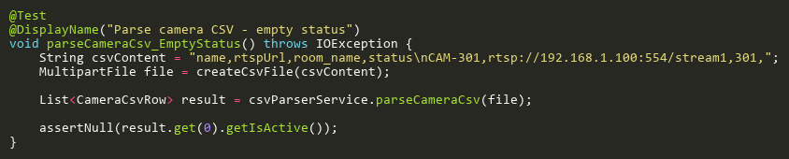
Figure: parseCameraCsv_EmptyStatus
Reference: Sheet "CPSS_statusCoverage", Test Case TC16

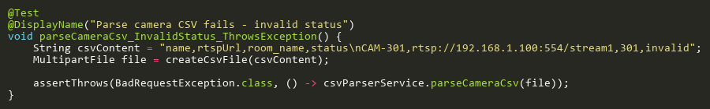
Figure: parseCameraCsv_InvalidStatus_ThrowsException
Reference: Sheet "CPSS_statusCoverage", Test Case TC08

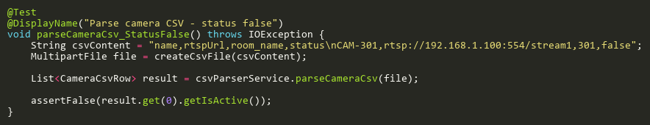
Figure: parseCameraCsv_StatusFalse
Reference: Sheet "CPSS_statusCoverage", Test Case TC07

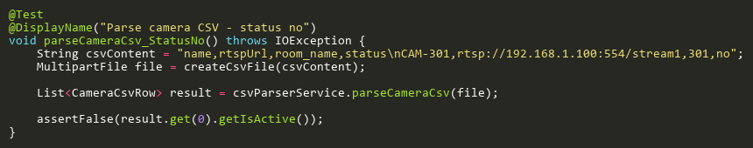
Figure: parseCameraCsv_StatusNo
Reference: Sheet "CPSS_statusCoverage", Test Case TC09

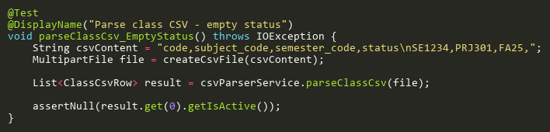
Figure: parseClassCsv_EmptyStatus
Reference: Sheet "CPSS_statusCoverage", Test Case TC17

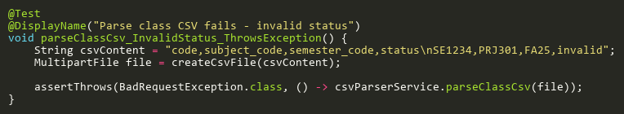
Figure: parseClassCsv_InvalidStatus_ThrowsException
Reference: Sheet "CPSS_statusCoverage", Test Case TC18

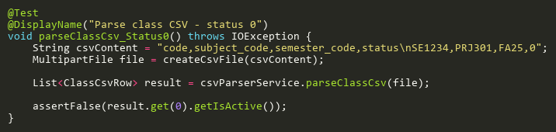
Figure: parseClassCsv_Status0
Reference: Sheet "CPSS_statusCoverage", Test Case TC10

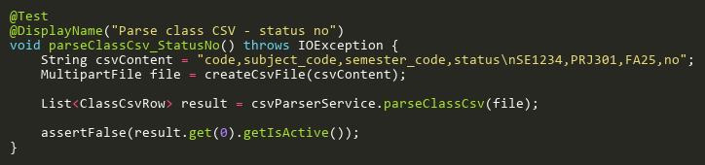
Figure: parseClassCsv_StatusNo
Reference: Sheet "CPSS_statusCoverage", Test Case TC11

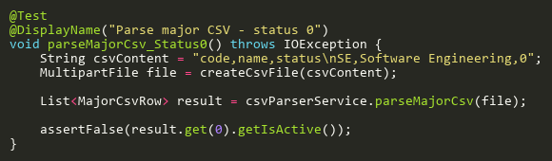
Figure: parseMajorCsv_Status0
Reference: Sheet "CPSS_statusCoverage", Test Case TC02

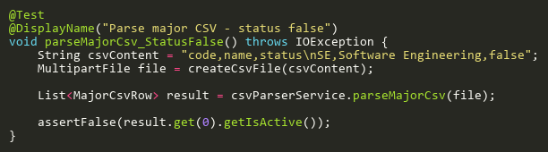
Figure: parseMajorCsv_StatusFalse
Reference: Sheet "CPSS_statusCoverage", Test Case TC01

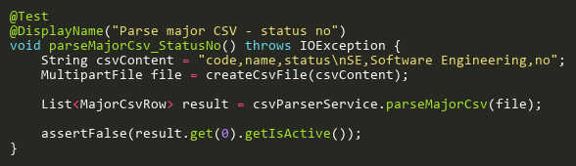
Figure: parseMajorCsv_StatusNo
Reference: Sheet "CPSS_statusCoverage", Test Case TC03

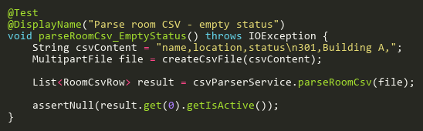
Figure: parseRoomCsv_EmptyStatus
Reference: Sheet "CPSS_statusCoverage", Test Case TC13

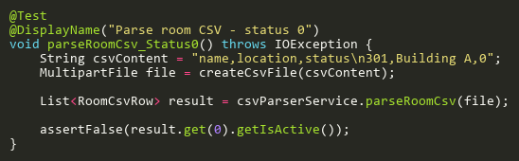
Figure: parseRoomCsv_Status0
Reference: Sheet "CPSS_statusCoverage", Test Case TC05

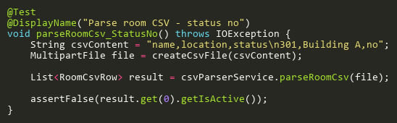
Figure: parseRoomCsv_StatusNo
Reference: Sheet "CPSS_statusCoverage", Test Case TC06

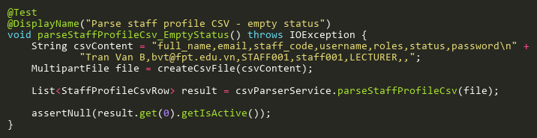
Figure: parseStaffProfileCsv_EmptyStatus
Reference: Sheet "CPSS_statusCoverage", Test Case TC20

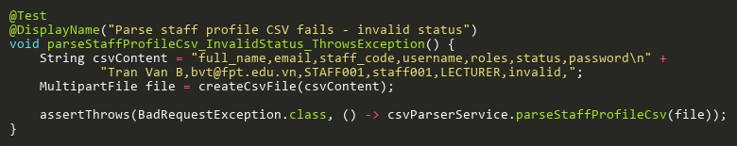
Figure: parseStaffProfileCsv_InvalidStatus_ThrowsException
Reference: Sheet "CPSS_statusCoverage", Test Case TC04

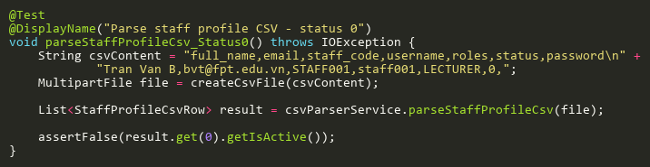
Figure: parseStaffProfileCsv_Status0
Reference: Sheet "CPSS_statusCoverage", Test Case TC23

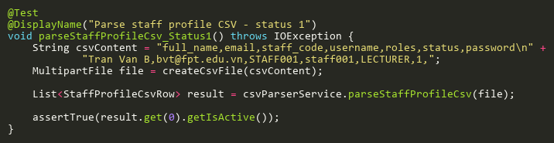
Figure: parseStaffProfileCsv_Status1
Reference: Sheet "CPSS_statusCoverage", Test Case TC24

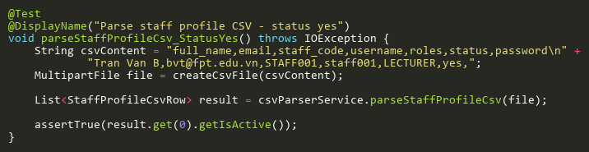
Figure: parseStaffProfileCsv_StatusYes
Reference: Sheet "CPSS_statusCoverage", Test Case TC25

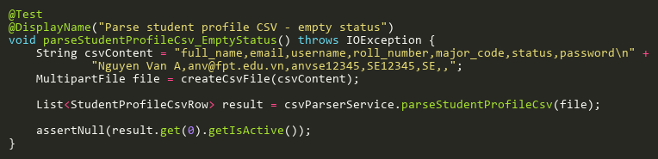
Figure: parseStudentProfileCsv_EmptyStatus
Reference: Sheet "CPSS_statusCoverage", Test Case TC19

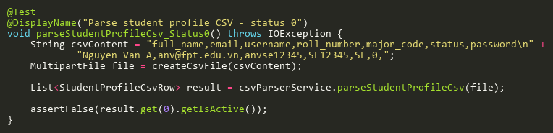
Figure: parseStudentProfileCsv_Status0
Reference: Sheet "CPSS_statusCoverage", Test Case TC21

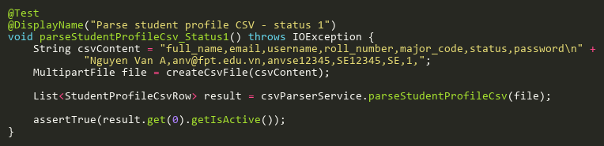
Figure: parseStudentProfileCsv_Status1
Reference: Sheet "CPSS_statusCoverage", Test Case TC26

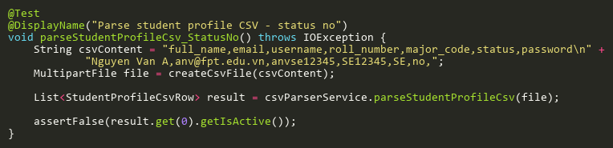
Figure: parseStudentProfileCsv_StatusNo
Reference: Sheet "CPSS_statusCoverage", Test Case TC22

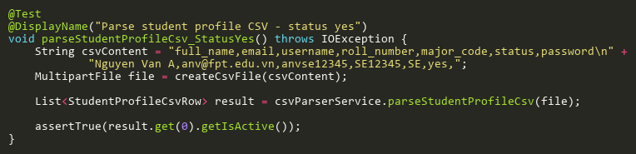
Figure: parseStudentProfileCsv_StatusYes
Reference: Sheet "CPSS_statusCoverage", Test Case TC27

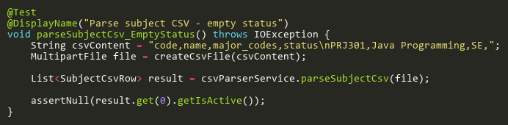
Figure: parseSubjectCsv_EmptyStatus
Reference: Sheet "CPSS_statusCoverage", Test Case TC12

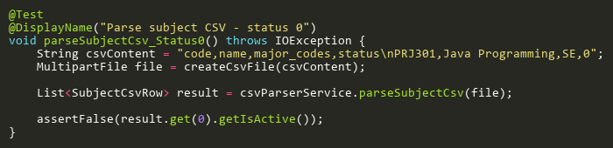
Figure: parseSubjectCsv_Status0
Reference: Sheet "CPSS_statusCoverage", Test Case TC14

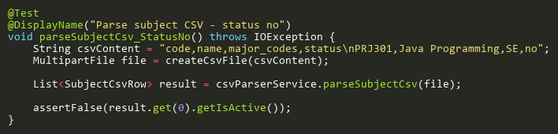
Figure: parseSubjectCsv_StatusNo
Reference: Sheet "CPSS_statusCoverage", Test Case TC15

FileValidationTests
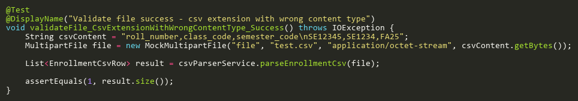
Figure: validateFile_CsvExtensionWithWrongContentType_Success
Reference: Sheet "CPSS_validateFile", Test Case TC05

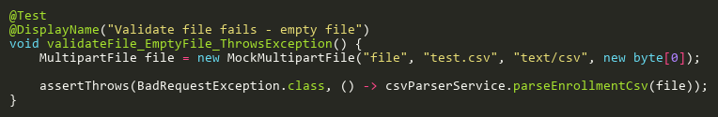
Figure: validateFile_EmptyFile_ThrowsException
Reference: Sheet "CPSS_validateFile", Test Case TC02

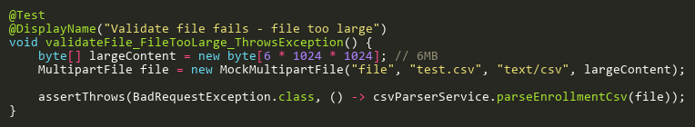
Figure: validateFile_FileTooLarge_ThrowsException
Reference: Sheet "CPSS_validateFile", Test Case TC03

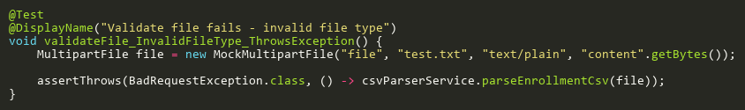
Figure: validateFile_InvalidFileType_ThrowsException
Reference: Sheet "CPSS_validateFile", Test Case TC04

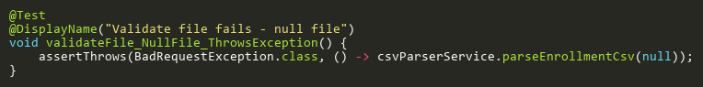
Figure: validateFile_NullFile_ThrowsException
Reference: Sheet "CPSS_validateFile", Test Case TC01

ParseBulkPhotoCsvTests
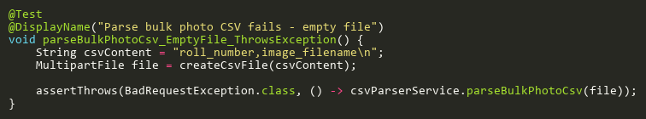
Figure: parseBulkPhotoCsv_EmptyFile_ThrowsException
Reference: Sheet "CPSS_parseBulkPhotoCsv", Test Case TC04

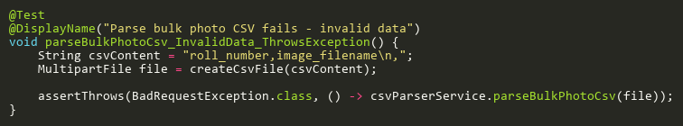
Figure: parseBulkPhotoCsv_InvalidData_ThrowsException
Reference: Sheet "CPSS_parseBulkPhotoCsv", Test Case TC05

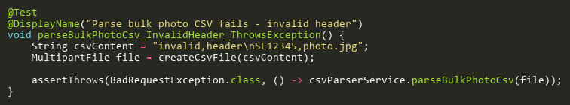
Figure: parseBulkPhotoCsv_InvalidHeader_ThrowsException
Reference: Sheet "CPSS_parseBulkPhotoCsv", Test Case TC02

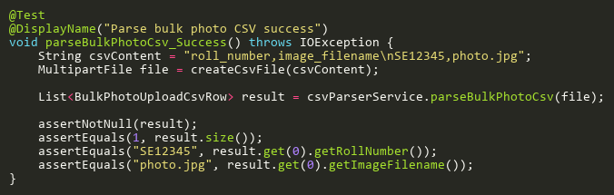
Figure: parseBulkPhotoCsv_Success
Reference: Sheet "CPSS_parseBulkPhotoCsv", Test Case TC01

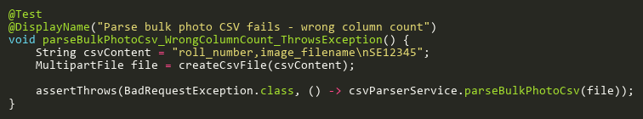
Figure: parseBulkPhotoCsv_WrongColumnCount_ThrowsException
Reference: Sheet "CPSS_parseBulkPhotoCsv", Test Case TC03

ParseCameraCsvTests
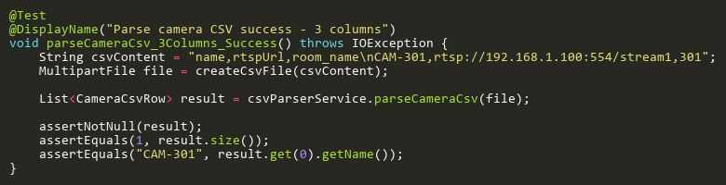
Figure: parseCameraCsv_3Columns_Success
Reference: Sheet "CPSS_parseCameraCsv", Test Case TC01

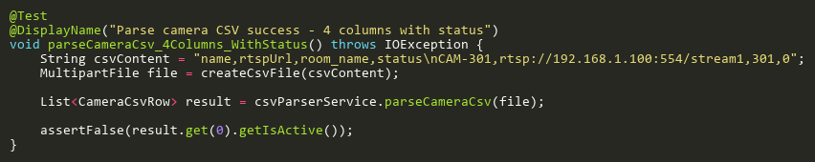
Figure: parseCameraCsv_4Columns_WithStatus
Reference: Sheet "CPSS_parseCameraCsv", Test Case TC02

ParseClassCsvTests
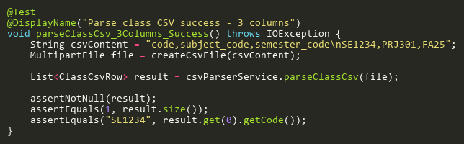
Figure: parseClassCsv_3Columns_Success
Reference: Sheet "CPSS_parseClassCsv", Test Case TC01

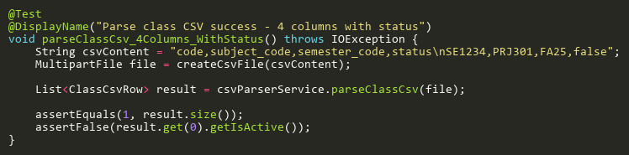
Figure: parseClassCsv_4Columns_WithStatus
Reference: Sheet "CPSS_parseClassCsv", Test Case TC02

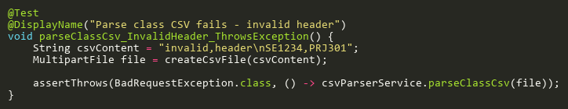
Figure: parseClassCsv_InvalidHeader_ThrowsException
Reference: Sheet "CPSS_parseClassCsv", Test Case TC03

ParseEnrollmentCsvTests
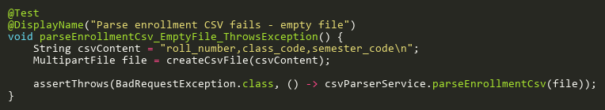
Figure: parseEnrollmentCsv_EmptyFile_ThrowsException
Reference: Sheet "CPSS_parseEnrollmentCsv", Test Case TC03

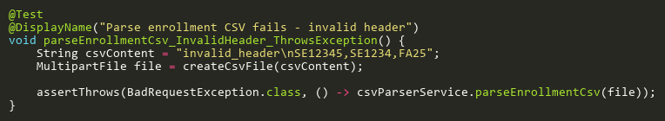
Figure: parseEnrollmentCsv_InvalidHeader_ThrowsException
Reference: Sheet "CPSS_parseEnrollmentCsv", Test Case TC02

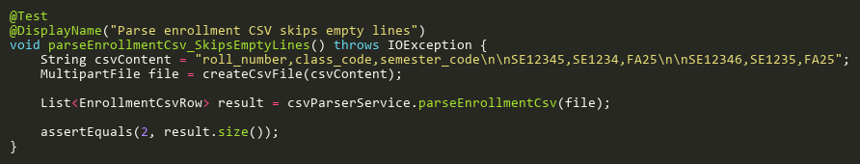
Figure: parseEnrollmentCsv_SkipsEmptyLines
Reference: Sheet "CPSS_parseEnrollmentCsv", Test Case TC05

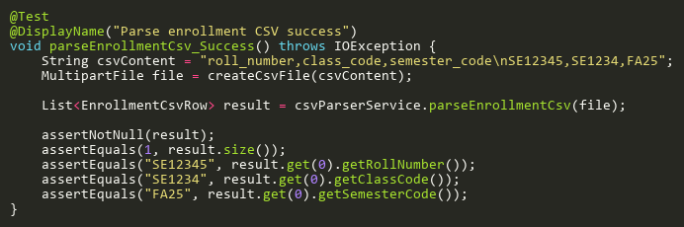
Figure: parseEnrollmentCsv_Success
Reference: Sheet "CPSS_parseEnrollmentCsv", Test Case TC01

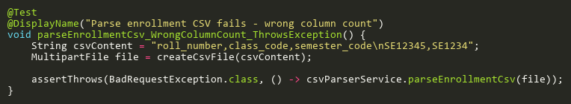
Figure: parseEnrollmentCsv_WrongColumnCount_ThrowsException
Reference: Sheet "CPSS_parseEnrollmentCsv", Test Case TC04

ParseExamSlotParticipantCsvTests
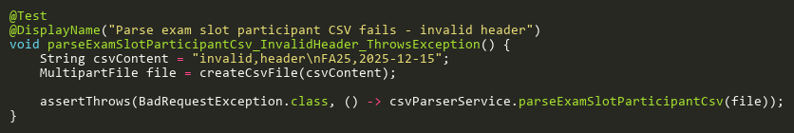
Figure: parseExamSlotParticipantCsv_InvalidHeader_ThrowsException
Reference: Sheet "CPSS_parseExamSlotCsv", Test Case TC02

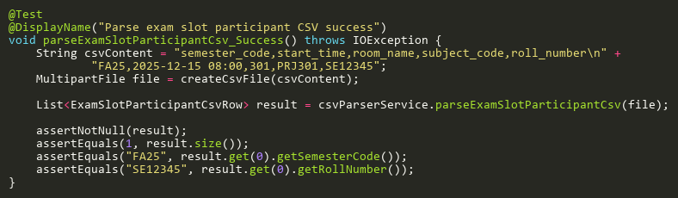
Figure: parseExamSlotParticipantCsv_Success
Reference: Sheet "CPSS_parseExamSlotCsv", Test Case TC01

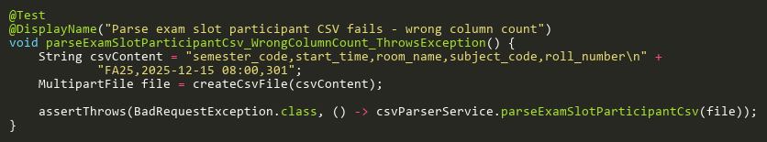
Figure: parseExamSlotParticipantCsv_WrongColumnCount_ThrowsException
Reference: Sheet "CPSS_parseExamSlotCsv", Test Case TC03

ParseMajorCsvTests
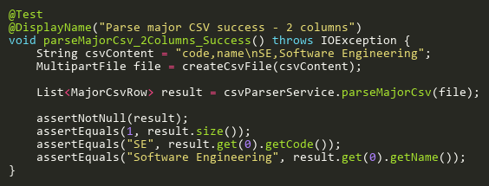
Figure: parseMajorCsv_2Columns_Success
Reference: Sheet "CPSS_parseMajorCsv", Test Case TC01

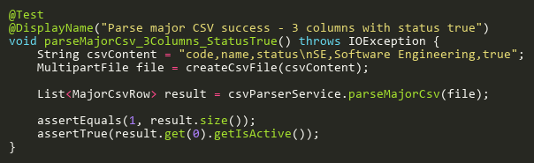
Figure: parseMajorCsv_3Columns_StatusTrue
Reference: Sheet "CPSS_parseMajorCsv", Test Case TC02

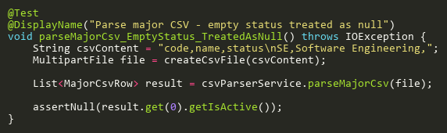
Figure: parseMajorCsv_EmptyStatus_TreatedAsNull
Reference: Sheet "CPSS_parseMajorCsv", Test Case TC06

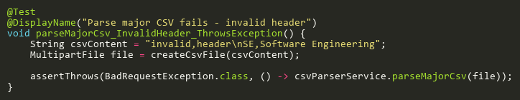
Figure: parseMajorCsv_InvalidHeader_ThrowsException
Reference: Sheet "CPSS_parseMajorCsv", Test Case TC07

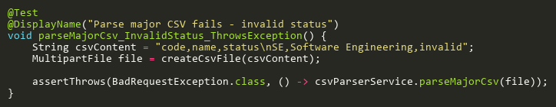
Figure: parseMajorCsv_InvalidStatus_ThrowsException
Reference: Sheet "CPSS_parseMajorCsv", Test Case TC05

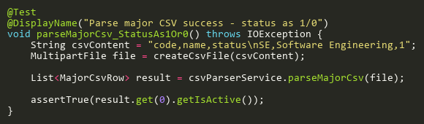
Figure: parseMajorCsv_StatusAs1Or0
Reference: Sheet "CPSS_parseMajorCsv", Test Case TC03

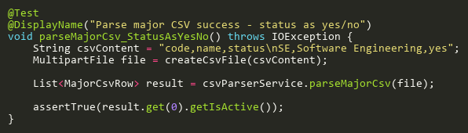
Figure: parseMajorCsv_StatusAsYesNo
Reference: Sheet "CPSS_parseMajorCsv", Test Case TC04

ParseRoomCsvTests
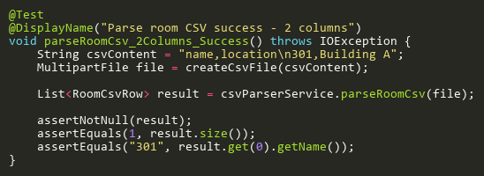
Figure: parseRoomCsv_2Columns_Success
Reference: Sheet "CPSS_parseRoomCsv", Test Case TC01

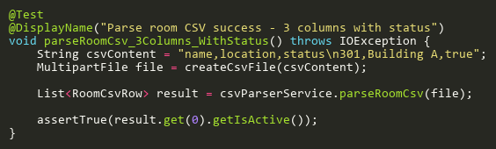
Figure: parseRoomCsv_3Columns_WithStatus
Reference: Sheet "CPSS_parseRoomCsv", Test Case TC02

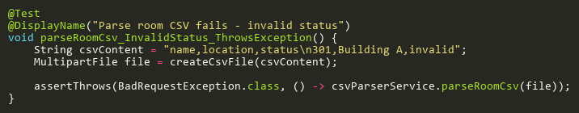
Figure: parseRoomCsv_InvalidStatus_ThrowsException
Reference: Sheet "CPSS_parseRoomCsv", Test Case TC03

ParseSemesterCsvTests
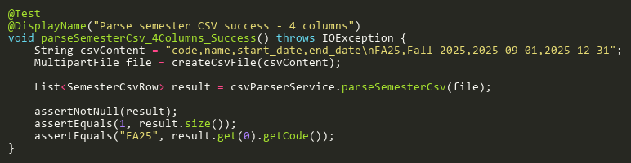
Figure: parseSemesterCsv_4Columns_Success
Reference: Sheet "CPSS_parseSemesterCsv", Test Case TC01

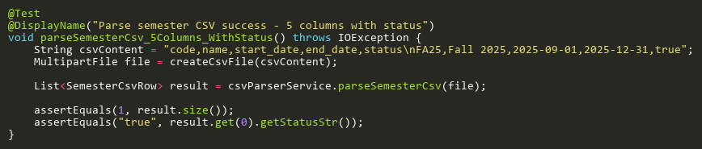
Figure: parseSemesterCsv_5Columns_WithStatus
Reference: Sheet "CPSS_parseSemesterCsv", Test Case TC02

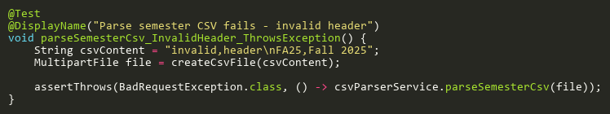
Figure: parseSemesterCsv_InvalidHeader_ThrowsException
Reference: Sheet "CPSS_parseSemesterCsv", Test Case TC03

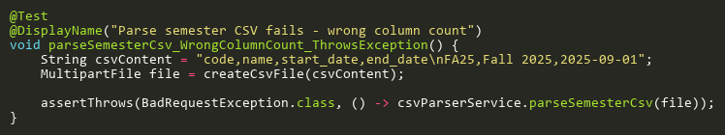
Figure: parseSemesterCsv_WrongColumnCount_ThrowsException
Reference: Sheet "CPSS_parseSemesterCsv", Test Case TC04

ParseStaffProfileCsvTests
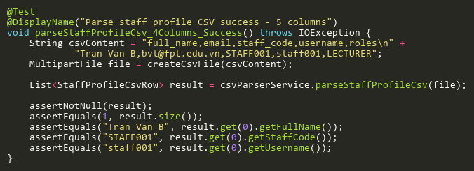
Figure: parseStaffProfileCsv_4Columns_Success
Reference: Sheet "CPSS_parseStaffCsv", Test Case TC01

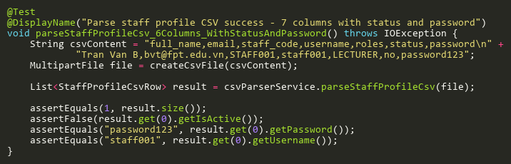
Figure: parseStaffProfileCsv_6Columns_WithStatusAndPassword
Reference: Sheet "CPSS_parseStaffCsv", Test Case TC02

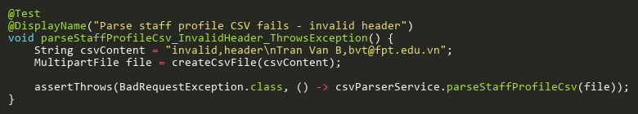
Figure: parseStaffProfileCsv_InvalidHeader_ThrowsException
Reference: Sheet "CPSS_parseStaffCsv", Test Case TC03

ParseStudentProfileCsvTests
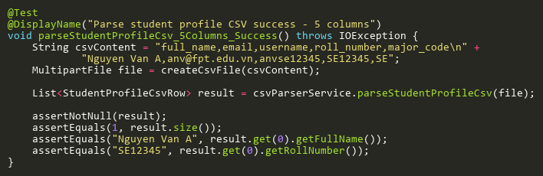
Figure: parseStudentProfileCsv_5Columns_Success
Reference: Sheet "CPSS_parseStudentCsv", Test Case TC01

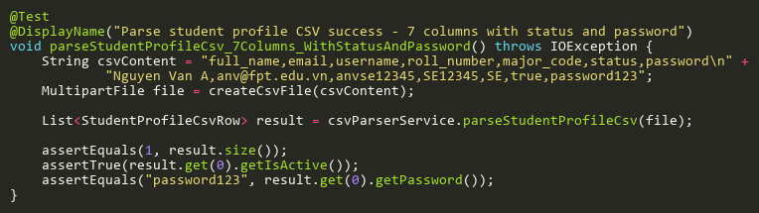
Figure: parseStudentProfileCsv_7Columns_WithStatusAndPassword
Reference: Sheet "CPSS_parseStudentCsv", Test Case TC02

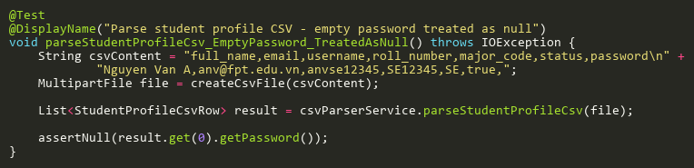
Figure: parseStudentProfileCsv_EmptyPassword_TreatedAsNull
Reference: Sheet "CPSS_parseStudentCsv", Test Case TC03

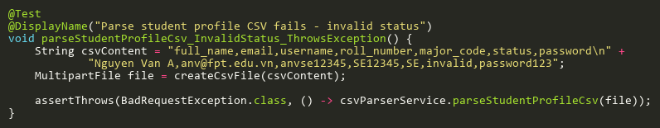
Figure: parseStudentProfileCsv_InvalidStatus_ThrowsException
Reference: Sheet "CPSS_parseStudentCsv", Test Case TC04

ParseSubjectCsvTests
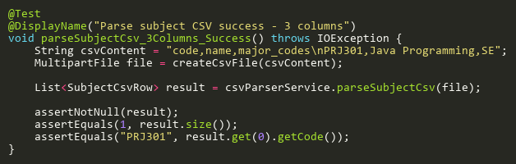
Figure: parseSubjectCsv_3Columns_Success
Reference: Sheet "CPSS_parseSubjectCsv", Test Case TC01

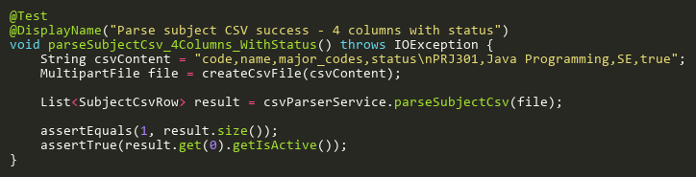
Figure: parseSubjectCsv_4Columns_WithStatus
Reference: Sheet "CPSS_parseSubjectCsv", Test Case TC02

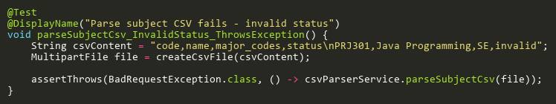
Figure: parseSubjectCsv_InvalidStatus_ThrowsException
Reference: Sheet "CPSS_parseSubjectCsv", Test Case TC04

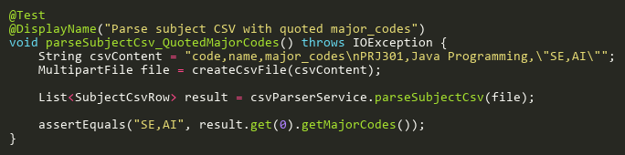
Figure: parseSubjectCsv_QuotedMajorCodes
Reference: Sheet "CPSS_parseSubjectCsv", Test Case TC03

ValidateRowTests
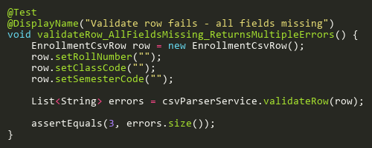
Figure: validateRow_AllFieldsMissing_ReturnsMultipleErrors
Reference: Sheet "CPSS_validateRow", Test Case TC03

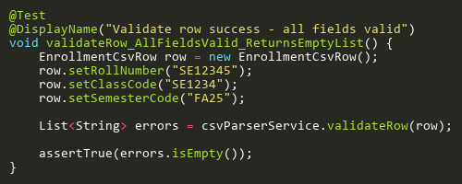
Figure: validateRow_AllFieldsValid_ReturnsEmptyList
Reference: Sheet "CPSS_validateRow", Test Case TC01

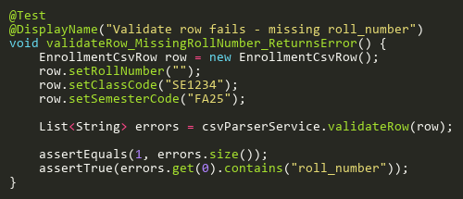
Figure: validateRow_MissingRollNumber_ReturnsError
Reference: Sheet "CPSS_validateRow", Test Case TC02

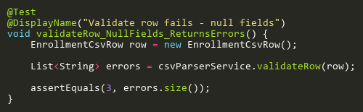
Figure: validateRow_NullFields_ReturnsErrors
Reference: Sheet "CPSS_validateRow", Test Case TC04

