**FINAL YEAR PROJECT**

**DEPARTMENT OF COMPUTER SCIENCE**

**KADUNA STATE UNIVERSITY, KADUNA**

**TOPIC: SENTIMENT ANALYSIS OF STUDENTS AND LECTURERS DURING ASUU (ACADEMIC STAFF UNION OF UNIVERSITIES) STRIKE.**

**BY**

**NDIFREKE MKPANAM EKANEM**

**SUPERVISOR: MAL. IBRAHIM LAWAN FALALU**

Table of Contents

**Type chapter title (level 1)1**

Type chapter title (level 2)2

Type chapter title (level 3)3

**Type chapter title (level 1)4**

Type chapter title (level 2)5

Type chapter title (level 3)6

**PROJECT OUTLINE**

**Chapter 1: Introduction**

* 1. Introduction
  2. Background of the study
  3. Problem Statement
  4. Aim and Objectives
  5. Significance of the study
  6. Scope and Limitations
  7. Definition of Operational Terms

**Chapter 2: Literature Review**

* 1. Introduction
  2. X (formerly twitter) and opinion mining
  3. Educational Contexts and Sentiment Analysis
  4. ASUU Strikes: Historical Context
  5. Related Studies

**Chapter 3: Analysis and Methodology**

* 1. Introduction
  2. Research Method
  3. Data Pre-Processing
  4. Sentiment Analysis
  5. Topic Modeling
  6. SVM-TFIDF Grid-Search Approach
  7. Conclusion

**CHAPTER ONE: INTRODUCTION**

# **Overview of Sentiment Analysis**

# Emotions are described as intense feelings that are directed at something or someone in response to internal or external events having a particular significance for the individual. The internet, today, has become a key medium through which people express their emotions, feelings and opinions. (Padgalwar, 2019). The aim of the project is to develop and train machine learning models for emotion detection or sentiment analysis to detect the emotions of students and lecturers during the ASUU Strike.

Sentiment analysis, also known as emotion detection, is a field within natural language processing (NLP) that focuses on extracting and interpreting sentiments from textual data. This process involves the use of computational methods, such as machine learning algorithms, to discern the emotional tone or attitude expressed in a piece of text (Cambria et al., 2020).

# **Background to the Study**

The increasing importance of emotion detection and recognition in Natural Language Processing (NLP) has been emphasized in recent research, with ERDENEBILEG BATBAATAR (2019) pointing to its significance across various applications. This recognition holds particularly true in the context of contemporary written expressions, which take various forms on social media platforms, micro-blogs, news articles, and customer reviews. Short-text content, prevalent in these mediums, has become a valuable resource for text mining, offering a means to explore and understand diverse aspects, including the nuanced realm of emotions.

The initiation of a nationwide strike by the Academic Staff Union of Universities (ASUU) on February 14, 2022, with the goal of implementing a longstanding 2009 agreement with the government, triggered a cascade of discussions and expressions on social media platforms. Twitter, as a prominent player in this space, became a dynamic arena where users engaged in discussions, debates, and expressed their thoughts through popular hashtags like #ASUU and #ASUUStrike. This digital discourse allowed for a real-time exploration of the emotions and opinions of users, contributing to a digital tapestry of perspectives (McGregor, 2019).

ASUU strikes, a recurring phenomenon in Nigeria over the past five years, have disrupted the academic journey for both students and lecturers. Leveraging the popularity of Twitter, researchers, including Muhammad (2022), have employed sentiment analysis and topic modeling techniques to delve into the diverse opinions and emotional responses of users during these strikes. This analytical approach provides a nuanced understanding of the sentiments circulating within the digital space, highlighting the complex interplay of emotions during such events.

Further contributing to this narrative, Njoku's (2022) research delves into the consequences of ASUU strikes, focusing on the academic pursuits of students in public universities. The findings uncover disruptions in educational activities, irregular learning schedules, and the discouragement and demotivation of students in their academic endeavors. This research collectively underscores the multifaceted impact of ASUU strikes on both the emotional well-being and academic progress of students and lecturers.

In essence, the convergence of ASUU strikes, social media dynamics, and sentiment analysis provides a rich landscape for understanding the emotional responses and academic consequences of these recurrent events, ultimately contributing to a more comprehensive understanding of their societal implications.

# **Problem Statement**

The recurring strikes led by the Academic Staff Union of Universities (ASUU) have unintentionally disrupted the academic progress of both lecturers and students in Nigeria. These disruptions introduce a myriad of challenges to their educational journey, such as prolonged study periods, compromised performance in examinations, and subsequent effects on final grades. Extended periods away from school isolate students and lecturers from their academic routines, with lecturers facing financial strain due to unpaid salaries and potential detachment from current practices. Students, often in home environments unsupportive of productive learning, experience frustration due to prolonged uncertainty about school resumption.

In the midst of these circumstances, some students divert their focus from academics to alternative activities. Regrettably, this idleness can lead to involvement in criminal acts like robbery, kidnapping, and rape, significantly impacting societal harmony and stability in Nigeria. However, the precise degree to which ASUU strikes influence students' academic achievements necessitates thorough investigation. This research aims to precisely assess the emotional impact of these strikes on students and lecturers, recognizing the complex interplay between academic disruptions, frustration, and the unintended consequences on societal well-being.

# **1.4 Aim and Objectives**

Nigeria’s university education goes through incessant strikes by the Academic Staff Union of Universities (ASUU). This strike has led to shared emotion on micro-blogging sites like Twitter. This study analyzed selected historical tweets from the “ASUU” to understand citizens’ opinions..

**The specific objectives are as follows:**

* **Objective** **1**: To develop machine learning algorithms or techniques that can effectively distinguish and detect the different types of emotions portrayed by students and lecturers.
* **Objective 2**: To collect and preprocess a comprehensive dataset where students and lecturers expressed their emotions

**Objective** **3**: To understand the emotions portrayed and recommend meaningful alternatives to school that keep the brain active during said strikes

# **1.5 Scope and Limitations**

This project is concerned with the emotions of students and lecturers during ASUU Strike. However, the project is limited to accuracy of detecting emotions due to informal ways of communication, sarcasm and emoji because this is texted based. Some data may come out misinterpreted but even with this, the system should be able to give accurate results.

**Limitations of the Study:**

* **Bias in Data:** The accuracy of emotion detection during ASUU Strikes is inherently contingent on the quality and representativeness of the training data, with biases in the dataset potentially influencing the model's understanding.
* Dynamic Nature of Sentiment: The study is constrained by the temporal sensitivity of public sentiment, as emotions captured during a specific timeframe may swiftly evolve, posing a limitation to the analysis and impacting the system's real-time insights into the changing emotional landscape during ASUU Strikes..

# **Significance of Study**

The machine learning model will have sufficient means for language processing to be able to detect dominant emotions shown in text. Moreover, the study's development of an emotion detection system using machine learning can contribute to the advancement of natural language processing techniques and sentiment research. The findings can enrich academic literature in sentiment analysis and its applications.

# **CHAPTER TWO: LITERATURE REVIEW**

* 1. **Introduction**

Definition of machine learning is a branch of study from AI (Artificial Intelligence), which studies the development of computer systems that can solve various problems such as making decisions to make predictions automatically and learning by finding specific patterns and features in data. According to (Mahesh, 2019) Machine learning (ML) is the scientific study of algorithms and statistical models that computer systems use to perform a specific task without being explicitly programmed.

According to (Jagota, 2020), The process of ascertaining whether a piece of writing holds a positive, negative, or neutral stance is referred to as Sentiment Analysis. This process is also recognized as opinion mining, where the opinion or attitude of a speaker is inferred. A prevalent application of this technology involves the exploration of public sentiment towards specific topics. The determination of sentiment involves the utilization of diverse technologies and techniques from the realm of Natural Language Processing (NLP) to decipher the emotional tone or sentiment conveyed in textual data.

There are multiple methods of sentiment analysis but this study requires the machine learning approach. According to (Pandya, 2020) their paper proposed a method; the Machine Learning approach involves initial classification using two distinct sets of documents: training data and test data. This involuntary classification results in the extraction of text features, subsequently categorized into supervised and unsupervised categories. In the supervised system, labeled training datasets are employed, with each class possessing unique attributes and corresponding labels (Pandya, 2020) also explained the data collection method in their papers, the principal objective of Sentiment Analysis is data collection, often acquired from social communication channels such as Twitter, Facebook, and pre-existing resources. Various sources contribute to this purpose; Blogs & Forums, Reviews, News Articles and Social Networks.

1. **X (formerly twitter) and opinion mining**

As stated by (Muhammad, 2022), the concept of "social media" encompasses a wide range of technologies, including blogs, networks, platforms for sharing pictures, communities, microblogs, corporate social networking sites, video hosting networks, and social networks. Microblogs, which are a relatively recent addition to social media, have gained significant popularity. Various online social networking platforms like Facebook, YouTube, and Twitter allow individuals to communicate and share ideas across different life situations. The widespread use of social networking sites has contributed to their popularity, enabling users to engage globally and share content in text, images, and videos.

Companies utilize social media platforms as important sources of information for monitoring public opinion and conducting surveys about their products. Microblogging applications, particularly Twitter, have become highly popular and widely used platforms that provide diverse information. Twitter, a well-known microblogging service, facilitates the real-time exchange, communication, and understanding of brief and concise messages known as tweets (Muhammad, 2022).

The availability of vast amounts of data on Twitter has generated increased interest among experts in the field of sentiment analysis and opinion mining. However, cutting-edge research has primarily focused on sentiment analysis, aiming to extract and categorize data related to twitter users' perspectives on a wide range of topics, including predictions, critiques, politics, and marketing.

The availability of vast amounts of data on Twitter has generated increased interest among experts in the field of sentiment analysis and opinion mining. However, cutting-edge research has primarily focused on sentiment analysis, aiming to extract and categorize data related to Twitter users' perspectives on a wide range of topics, including predictions, critiques, politics, and marketing.

With significant advancements in information and communication technology, data analytics has become an essential tool for improving company operations and setting corporate objectives that align with client expectations. Opinion mining, which extends beyond the business realm, holds relevance in various fields such as government and politics. As a result, it has gained significant momentum and attracted the attention of researchers interested in its application across different domains.

Twitter, functioning as a digital environment, plays a crucial role in shaping a new social structure. With more than a billion logins and millions of active users generating 500 million tweets daily, Twitter serves as a dynamic communication network. Each message on Twitter, originally limited to 140 characters until October 2018 and now expanded to 280 characters, is visible to the public unless the author chooses to keep it confidential. Users interact with tweets by liking, commenting, mentioning other accounts, or retweeting the original post. Twitter has also made it easier to collect data through accessible Application Programming Interfaces (APIs).

* 1. **Educational Contexts and Sentiment Analysis**

According to a study conducted by Ye in 2023, sentiment analysis (SA) has gained considerable attention in various fields and has become a focal point in educational research. However, there is a significant lack of comprehensive literature reviews that specifically address SA in education. Therefore, the aim of this study is to fill this gap by conducting a thorough examination of high-quality scientific literature on SA in the educational context. The goal is to provide insights from the reviewed papers and shed light on future research prospects. The study identifies and extensively discusses four major research topics related to SA in education. The first topic focuses on designing SA methods and systems to improve the accuracy of sentiment analysis in educational settings. The second topic explores learners' satisfaction, attitudes, and concerns, providing a nuanced understanding of their sentiments. Additionally, the study highlights the importance of evaluating teachers' teaching performance, acknowledging the impact of sentiment on the educational experience (Ye, 2023). Finally, delving into the intricate connection between emotions, behavior, performance, and accomplishment offers a comprehensive viewpoint on the influence of sentiments in the educational setting.

As stated by (Omozusi Mercy Omosefe, 2023), education plays a crucial role in the all-encompassing growth of individuals and the overall advancement of a nation. However, the recurring strikes initiated by the Academic Staff Union of Universities (ASUU) have had detrimental effects on both students and the union members themselves. This research aims to examine the impact of ASUU strikes on the psychological and social well-being of university students in Nigeria, specifically within the context of sentiment analysis in education.

Finally, delving into the intricate connection between emotions, behavior, performance, and accomplishment offers a comprehensive viewpoint on the influence of sentiments in the educational setting.

As stated by (Omozusi Mercy Omosefe, 2023), education plays a crucial role in the all-encompassing growth of individuals and the overall advancement of a nation. However, the recurring strikes initiated by the Academic Staff Union of Universities (ASUU) have had detrimental effects on both students and the union members themselves. This research aims to examine the impact of ASUU strikes on the psychological and social well-being of university students in Nigeria, specifically within the context of sentiment analysis in education.

Using a descriptive survey research design, this study focuses on undergraduate students at the University of Lagos. A total of 396 students were randomly selected as participants, and a custom-made questionnaire was employed as the research tool. The research questions were addressed through descriptive statistics, encompassing measures such as frequency, percentage, mean, and standard deviation.

* 1. **ASUU Strikes: Historical Context**

(Gboyega, 2022) Made a very good history on his paper which explores the extensive history of strikes conducted by the Academic Staff Union of Universities (ASUU) in Nigeria, spanning from 1999 to 2020. ASUU's repeated strikes, lasting for a total of more than three years, are depicted as efforts to safeguard the country's education system from detrimental circumstances that could have a negative impact on its reputation on the global stage.

The ascension of Chief Olusegun Obasanjo as the Executive President in 1999 marked the beginning of ASUU's nationwide strikes, which lasted for a period of five months. Subsequent strikes in 2001, 2002, and 2003 were triggered by issues such as the alleged unfair termination of lecturers, failure to fulfill agreements, and insufficient funding for universities.

ASUU's involvement in various strikes persisted over the years, with each strike characterized by specific demands and grievances. From legal battles concerning dismissed lecturers to disputes regarding funding and policy implementation, the union's activism culminated in a series of strikes in 2005, 2006, 2007, and 2008.

In 2009, there was a countrywide strike that lasted for a period of four months. ASUU expressed their dissatisfaction with the government's perceived negligence in implementing agreements. In the following years, there were additional strikes where the union advocated for the implementation of agreements, policy reviews, and increased budget allocation for the education sector.

During 2017 and 2018, ASUU initiated strikes to demand the implementation of previous agreements and improved funding for Nigerian universities. These strikes persisted for several months, causing significant impact on students across the nation.

Although ASUU leadership advised students to focus on developing their skills during these strikes, it is clear that the educational system has suffered as a result. In 2020, another warning strike was announced due to conflicts arising from the government's payroll system.

2022 witnessed the longest ASUU Strike in Nigerian history, lasting a grueling 8 months. The strike commenced on February 14th, 2022 and finally concluded on October 17th, 2022, thanks to the intervention of the court. This marked a significant duration for an ASUU strike, setting a new record. (Aihinoria, 2022)

When we calculate the cumulative number of months that ASUU has gone on strike, it amounts to an approximate estimate of 36 months. This figure corresponds to roughly 3 years of ASUU strikes.

The determination shown by ASUU in pursuing their demands highlights the challenges faced by Nigeria's education sector. It remains uncertain whether productive agreements can be reached in future negotiations between ASUU and the government.

* 1. **Related Studies**

The section examines the classification of sentiments and the mining of opinions using data from Twitter, with a specific focus on trends in Nigeria. The following literary works offer insights into related methodologies, which will be thoroughly examined for advancements and future recommendations.

In their study, (Erin Hea-Jin Kim, 2016) assessed the coverage of topics and the dynamics of sentiment regarding the Ebola virus on Twitter and traditional news sources. The research revealed that Twitter had less comprehensive and clear coverage of the issue compared to traditional media. The sentiment dynamics on Twitter were characterized by lower longevity and variability. The authors employed the LDA technique for topic modeling based on comments from social media.

(Oyebode, 2019) conducted a study on the public's emotions towards two prominent political candidates in Nigeria in order to evaluate their chances of winning leadership positions. They employed sentiment analysis tools, including VADER, VADER-EXT, and TextBlob.

(Hassan Adamu, 2021) utilized the Twitter API to assess public opinion on disaster response, including the distribution of COVID-19 relief packages. They utilized the Nigerian Local English Slang-Pidgin (NLES-P) dataset to train machine learning models such as Support Vector Machines for sentiment classification.

(Panchali Guha, 2021) carried out dictionary-based sentiment analysis using R on tweets containing the hashtags #phdlife and #phdchat to gain insights into the concerns of PhD students.

(Hamsuddeen Hassan Muhammad, 2022) introduced NaijaSenti, an extensive dataset on Twitter sentiment for four major languages spoken in Nigeria: Hausa, Igbo, Nigerian-Pidgin, and Yorùbá. The dataset consisted of approximately 30,000 annotated tweets for each dialect.

(Adebayo Abayomi-Alli, 2022) Conducted an analysis on "yahoo-yahoo" tweets using various techniques including VADER, Liu Hu technique, LDA, and MDS. The findings revealed that VADER performed better than other sentiment models, while LDA and LSI produced comparable topic models.

To the researchers' knowledge, no previous study has conducted sentiment analysis on the subject of the ASUU strike using Twitter data. This research aims to bridge this gap by conducting sentiment analysis and extracting key themes from tweets related to the phrase "ASUU." The study utilizes RapidMiner (RM) studio for data extraction and analysis, taking advantage of its capabilities in data preprocessing, machine learning, and modeling. RM offers features for natural language processing (NLP), such as case transformations, text categorization, stemming, stop word removal, and other methods for processing texts and uncovering meaningful connections among words (Nandal, 2022).

**CHAPTER THREE: RESEARCH METHODOLOGY**

**3.1 Data source and overview**

This study uses machine learning techniques to develop a predictive model for sentiment analysis model using a comprehensive dataset obtained from Twitter, an online social media platform. The dataset contains records of tweets sent out by students and lecturers and other concerned. When looking for tweets, especially ones from Nigeria, the RM Search Twitter operator used English. Ten thousand tweets in all were collected. The dates of this process were May 14, 2022, through May 16, 2022, a period of three days. To find tweets related to the search, the phrase "ASUU" was used.

**3.1.1 Model objective**

The model's objective is to accurately classify and identify emotions expressed by students and lecturers during these strikes.

* 1. **Data Pre-Processing**

**3.2.1 Data Collection:** The process of collecting data involved utilizing the RM Search Twitter operator. This operator specifically targeted tweets written in English, with a particular focus on tweets originating from Nigeria. The search operation lasted for a period of three days, starting on May 14 and ending on May 16, 2022. The search term used was "ASUU," with the aim of identifying tweets that were relevant to the Academic Staff Union of Universities.

A total of 10,000 tweets were gathered through this search process. This collection of data serves as the basis for subsequent analyses in your study. It provides a significant amount of Twitter data that encompasses discussions, opinions, and sentiments related to ASUU during the specified time period.

**3.2.2 Feature Extraction:** Making an informed decision based on an overwhelming amount of data can be difficult for data professionals when they are presented with a large number of information, many of which may be irrelevant to the work at hand. In order to focus on the most important pieces of information to direct our model development process, feature or attribute extraction is required.

Feature extraction is essential for enhancing algorithm performance in machine learning. To find the most pertinent and significant elements that lead to the intended result, it entails choosing or modifying raw feature data. By efficiently reducing the dimensionality of the data, this method facilitates the ability of machine learning algorithms to recognize patterns and make good generalizations.

**3.3 Label Encoding: Giving Categories Numerical Values**

Because machine learning models are optimized for numerical data, strings may not always perform well with their methods. In order to close this gap, we use a method known as encoding, which converts categorical data into numerical representations more suited for use by machine learning models.

For instance, the LabelEncoder would map the original labels in the "Sentiment" column—such as "positive," "negative," and "neutral"—to numerical values, such as 0, 1, and 2, respectively.

Models for machine learning that need numerical inputs can benefit from the numerical representation. It facilitates the standardization of the input format, enabling compatibility with a range of methods.

If you need to transfer numerical predictions back to their original categorical labels, you can do so by using the inverse_transform method of the LabelEncoder.

It is essential to encode this variable for a number of reasons:

* **Compatibility:** Models for machine learning perform better when applied to numerical data.
* **Information Preservation:** When categorical variables are encoded, the underlying information is kept intact.
* **Less Complexity:** Encoding increases computational efficiency and streamlines the representation of category data.

**3.4 Standardization and Scaling**

Data standardization plays a crucial role in ensuring fair and meaningful analysis. But what exactly does it mean to standardize data?

**3.4.1 Equitable Participation**

The same way that cups of flour can overpower tablespoons of sugar in cake baking, so too can features with greater magnitudes skew findings by dominating machine-learning models' calculations. By guaranteeing that every feature contributes equally to the model's decision-making process, standardization resolves this problem.

**3.4.2 Placing Features on a Common Scale**

Z-score scaling, sometimes referred to as standardization, is a popular machine learning technique for putting features on a common scale. It entails converting each feature's data distribution to have a mean of 0 and a standard deviation of 1. This procedure aids in the direct comparison of various features, especially when employing algorithms like Support Vector Machines (SVM) that are sensitive to the size of input features. The advantages of standardization

* **Improved Model Training:** Preventing bias during training by giving equal weight to each characteristic.
* **Interpretability:** It gets simpler to comprehend coefficients. The result is directly impacted by a feature change of one unit.
* **Compatible:** Suitable for a wide range of machine learning techniques.
* **Faster Training:** Standardized data allows certain algorithms to train more quickly.
* **Lowered Over-fitting:** Over-fitting is less likely to occur when models generalize more effectively.

**3.5 Classification Techniques**

This project focuses on machine-learning classification techniques, exploring 4 algorithms: Support Vector Machines (SVM), Transformer-Based Model (Pre-trained DistilBERT), Rule-Based Sentiment Analysis (AFINN Lexicon) and VADER (Valence Aware Dictionary and sEntiment Reasoner).

**3.5.1 The Idea behind SVM**

To optimize the margin between two classes of data points, SVM searches for a hyper-plane. The gap between the closest data points from each class and the hyper-plane is known as the margin. Support vectors are the data points that are closest to the hyper-plane.

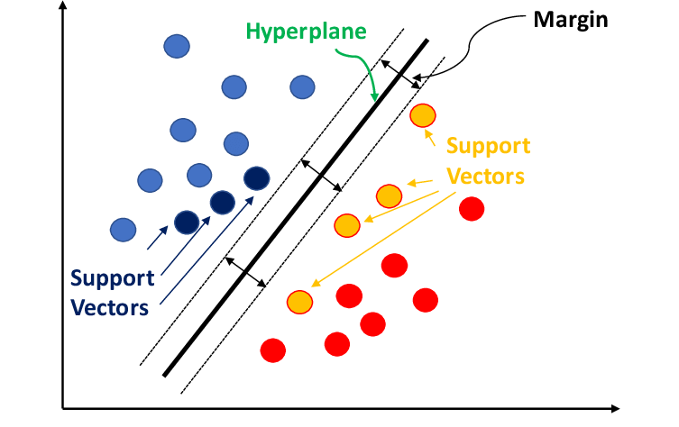

Figure 3.5.1 Support Vector Model

**3.5.1.1 SVM Algorithm**

With data preparation done, the following steps are involved in building the SVM algorithm for classification:

* Training Data: A collection of labeled data points, each of which falls into one of two classifications, makes up the training data. The two classes of data points are divided by a decision boundary known as the hyper-plane.
* Hyper-plane Optimization: Determine which hyper-plane maximizes the difference in the two sets of data points. This entails applying methods similar to quadratic programming to solve an optimization problem.
* Classification: Based on a new data point's location in relation to the hyper-plane, identify its class. One class is assigned to the data points on one side of the hyper-plane, and another class is assigned to the data points on the opposite side.

**3.5.1.2 The drawbacks of SVM**

* Computational Complexity: Especially for large datasets, training a support vector machine (SVM) can be computationally costly, due to the optimization process involved in finding the optimal hyperplane.
* Selection of Parameters: The algorithm's performance may be impacted by the selection of hyper-parameters, such as the regularization parameter and kernel function.

**3.5.2 Transformer-Based Model's Concept (Pre-trained DistilBERT)**

DistilBERT and other transformer-based models are groundbreaking developments in natural language processing (NLP). Transformer-based NLP models use a self-attention mechanism that enables them to capture long-range relationships between words in a phrase, in contrast to typical NLP models that rely on recurrent neural networks (RNNs) to process text sequentially. They can now perform better on a variety of natural language processing (NLP) tasks, such as question answering, machine translation, and text classification.

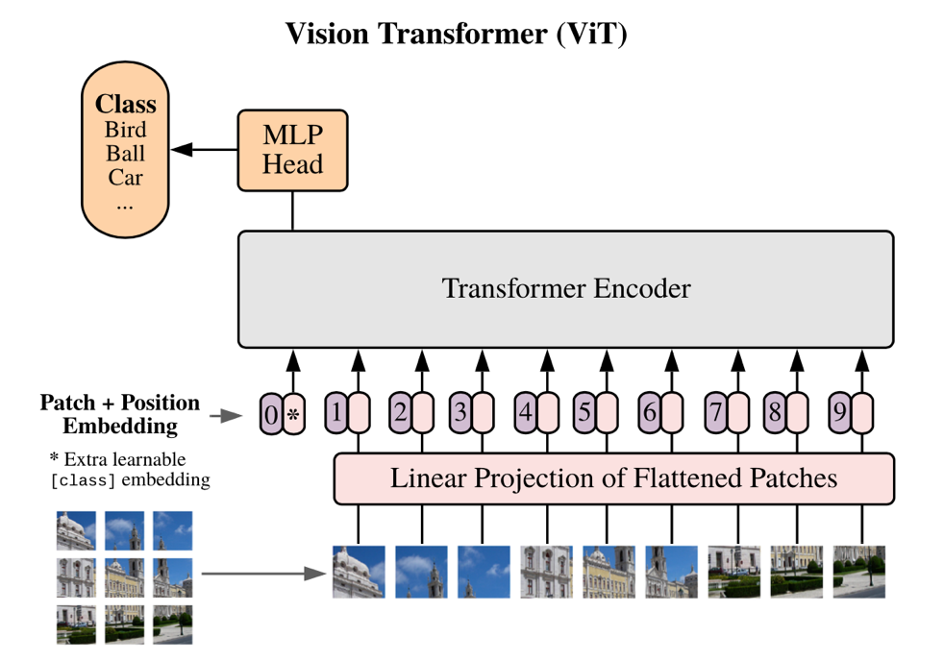

Figure 3.5.2 Transformer-Based Model's Concept (Pre-trained DistilBERT)

**3.5.2.1Transformer-Based Model (DistilBERT Algorithm with Pre-training)**

The encoder-decoder architecture of DistilBERT is its fundamental component. An input word sequence is sent into the encoder, which converts it into a contextualized representation that captures the relationships between the words in the phrase. The desired output, such as a categorization label, a translated sentence, or a response to a query, is subsequently produced by the decoder using this contextualized representation.

An essential component of the encoder's capacity to detect long-range relationships is the self-attention process. The self-attention mechanism enables the model to attend to every word in the phrase at once, allowing it to comprehend each word's context in relation to the others, as opposed to processing words one after the other.

**3.5.2.2 Transformer-Based Model's (Pre-trained DistilBERT) Drawbacks**

DistilBERT and other transformer-based models have several drawbacks despite their amazing potential:

* Computational Complexity: Because of their huge size and intricate construction, transformer-based models can be computationally expensive to train and execute. They may therefore be unsuitable for deployment on devices with limited resources.
* Data Requirements: To operate at their best, transformer-based models need a lot of high-quality training data. Obtaining this for some NLP jobs might be difficult, especially in specialized fields.
* Explainability: Because of their intricate internal workings, transformer-based models are frequently referred to as "black boxes". Interpretability is important in applications, and this lack of explainability might make it hard to grasp how the model makes its judgments.
* Bias: Models built on transformers may inherit biases from the training data. Predictions may result from this, especially in delicate applications like sentiment analysis and decision-making.

Notwithstanding these drawbacks, transformer-based models have transformed natural language processing (NLP) and are still expanding the field's frontiers. Transformer-based models are expected to play an even more significant role in influencing the future of natural language processing (NLP) as research advances and computer resources increase.

**3.5.3 Rule-Based Sentiment Analysis's Concept (AFINN Lexicon)**

Rule-based sentiment analysis is a type of sentiment analysis that divides text into positive, negative, and neutral categories using a predetermined set of rules. Usually, these rules depend on whether or not specific words or phrases that have been given sentiment scores are present. One well-liked tool for rule-based analysis of sentiment is the AFINN lexicon. It includes a list of more than 2,400 words and phrases with sentiment scores that vary from +5 (very positive) to -5 (very negative).

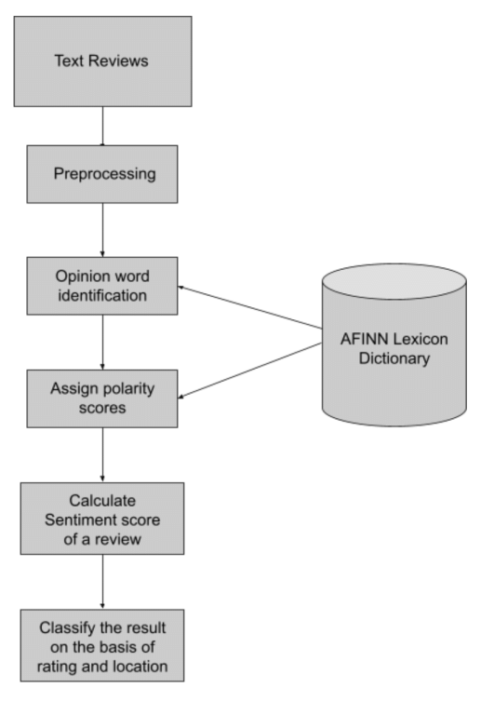

Figure 3.5.3 AFINN Lexicon

**3.5.3.1 Algorithm for Rule-Based Sentiment Analysis (AFINN Lexicon)**

The sentiment analysis algorithm based on the AFINN lexicon is simple to use:

* Tokenization: Break up the text into discrete terms or elements.
* Normalization: Remove special characters and punctuation, and convert tokens to lowercase.
* Lexicon Matching: Look up the sentiment score of each token in the AFINN lexicon. Assign the token a score of 0 (neutral) if it cannot be located in the lexicon.
* Sentiment Score Calculation: To get the overall sentiment score for the text, add up the sentiment scores of each token.
* Sentiment classification: Using the overall sentiment score, categorize the text as positive, negative, or neutral.

**3.5.3.2 Rule-Based Sentiment Analysis's Drawbacks (AFINN Lexicon)**

Rule-based sentiment analysis has a number of shortcomings despite being very easy to use and effective:

* Limited Context Understanding: Because rule-based approaches focus more on individual words than the context in which they are used, they frequently fall short in capturing the subtleties of sentiment.
* Language Sensitivity: Rule-based approaches are usually customized for a particular language and may not translate well to other languages or cultural settings.
* Incapacity to manage Irony and Sarcasm: Rule-based approaches frequently misclassify content because they are unable to manage irony, sarcasm, and other types of comedy.
* Limited Scalability: The number of rules needed to ensure accuracy can get out of hand as the text corpus gets larger.
* Dependency on Lexicon Quality: The quality of the lexicon that is utilized has a significant impact on the accuracy of rule-based techniques. Inaccurate sentiment classifications may result from biased or inadequate lexicons.

Rule-based sentiment analysis is nonetheless helpful for simple sentiment classification tasks in spite of these drawbacks, especially when working with tiny datasets or with low computational resources. However, machine learning-based methods frequently do better for more difficult sentiment analysis tasks.

**3.5.4 The Concept of VADER**

Specifically intended to handle sentiments conveyed in social media posts, VADER is a vocabulary and rule-based sentiment analysis tool. It attempts to convey the nuanced sentiment found in slang, irony, and sarcasm used in social media lingo. The foundation of VADER is the notion that emotion may be conveyed through emojis, capitalization, and punctuation in addition to individual words.

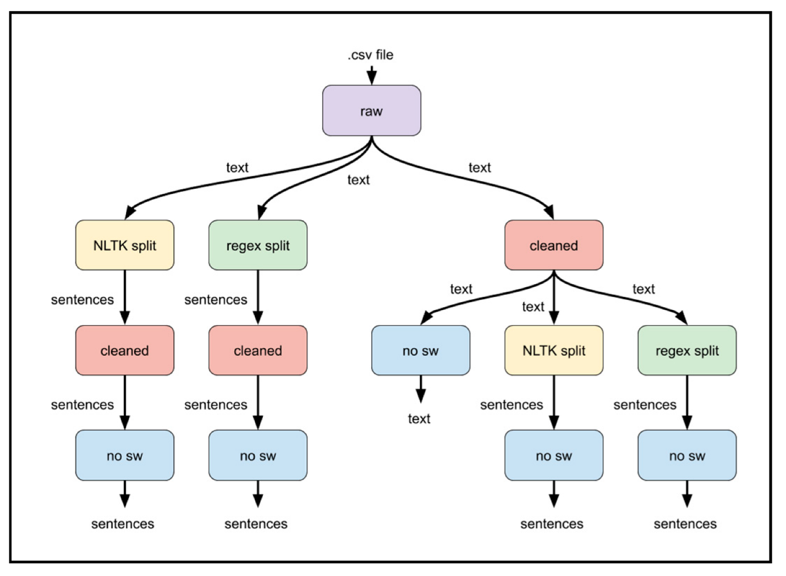

Figure 3.5.4 AFINN Lexicon

**3.5.4.1 VADER Algorithms**

* Lexicon: Over 7,500 words and phrases with sentiment scores ranging from -4 (very negative) to +4 (extremely positive) make up the sentiment lexicon that VADER employs. It contains terms and expressions that are frequently used on social media in addition to words that convey slang, irony, and sarcasm.
* Rule-Based Sentiment Reasoning: Using emojis, capitalization, and punctuation, VADER uses a set of rules to determine sentiment. For instance, words that are capitalized entirely in capital letters receive a negative sentiment score from VADER.
* Sentiment Scoring: To determine the overall sentiment score for the text, VADER combines the sentiment ratings from the lexicon with rule-based sentiment reasoning. The text can then be categorized as positive, negative, or neutral based on the overall sentiment score.

**3.5.4.1 Drawbacks of VADER**

VADER has certain limitations even if it was created especially for sentiment research on social media:

* Domain Specificity: VADER may not translate well to other domains, such news stories or formal writing, as it was initially created for social media language.
* Limited Negation and Conjunction Handling: In some situations, VADER's handling of negation and conjunctions may be inadequate, which could result in incorrect classifications.
* Dependency on Lexicon Quality: The caliber of VADER's lexicon determines how accurate it is. Inaccurate sentiment classifications may result from biased or inadequate lexicons.
* Limited Explain-ability: Because VADER is a black-box model, it is challenging to comprehend how it makes judgments. For applications where interpretability is essential, this could be an issue.

VADER is a useful tool for sentiment analysis of social media messages in spite of these drawbacks. It is a good fit for this domain because of its capacity to handle informal language and capture sentiment subtleties. To get more thorough results, it's crucial to be aware of its limitations and combine it with other sentiment research techniques.

**CHAPTER FOUR: DATA ANALYSIS AND DISCUSSION OF RESULTS**

**4.1 Data Presentation and Preprocessing**

We provide a thorough summary of the data that was utilized to train and assess our machine learning models in this section. We also go over the preparation procedures used to clean, convert, and get the data ready for modeling. The provided dataset consists of tweets from different individuals, and our objective is to apply sentiment analysis to glean insightful information.

**4.1.1 Data Collection**

The tweets in the dataset have a variety of textual content. Metadata about each tweet is attached, including the username ('From-User') and the total number of retweets ('Retweet-Count'). Prior to beginning the analysis, we investigated the dataset's structure to comprehend its essential features.

**4.1.2 Data Preprocessing**

In order to guarantee the caliber and applicability of the textual content for sentiment analysis, our data pretreatment pipeline comprised multiple crucial phases. For every tweet, the ensuing procedures were used:

* Text Normalization and Tokenization

We started the preprocessing by using the NLTK library to tokenize the text into individual words and changing all of the text to lowercase.

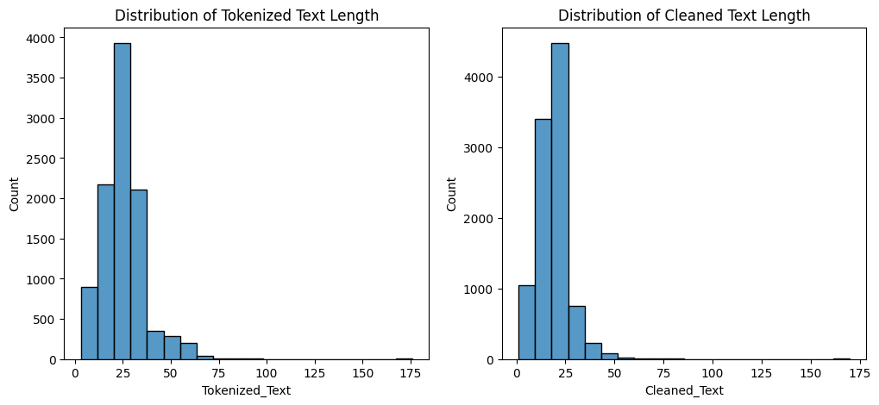

Figure 4.1.2 Text Normalization and Tokenization

* Generation of Bi-grams

We created bi-grams, or pairs of consecutive words, from the tokenized text in order to extract contextual information.

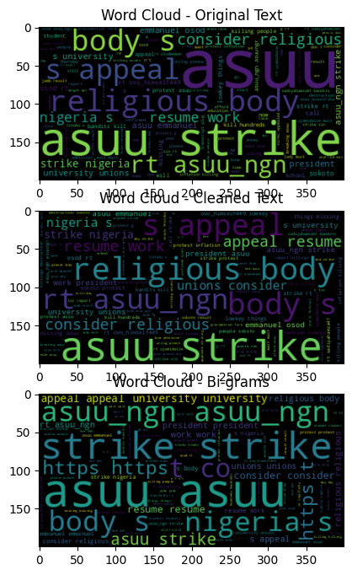

Figure 4.1.2 Bi-Grams

* Challenges Faced

We faced difficulties handling various text formats and striking a balance between removing noise and keeping important information throughout the data preprocessing stage. Maintaining the integrity of the ensuing analysis required us to modify our strategy in response to these difficulties.

Certainly! Let's structure the section on "Model Training and Evaluation Results" based on the provided code snippets. I'll indicate where graphs can be used and provide code for generating them. Please note that you may need to adapt the code to your specific dataset and requirements.

**4.2 Model Training and Evaluation Results**

In this section, we detail the process of training machine learning models for sentiment analysis, encompassing the training process, hyperparameter tuning, and model selection. The performance of the models is evaluated using key metrics to gauge their effectiveness.

**4.2.1 Data Preparation**

Before delving into the model training process, let's briefly revisit the data preparation steps performed on the preprocessed text.

Your dataset will be split into training and testing sets for machine learning using this code. Four arguments are required for the train_test_split function:

* df['Filtered_Text']: The text you wish to utilize to train your machine learning model is the feature data. Here, that's the text you took out of your tweets after it was filtered.
* df['Sentiment']: The sentiment score of every tweet is the goal data. Here, it's the sentiment score that you used the AFINN lexicon to apply to every tweet.
* test_size=0.2: The percentage of the data you wish to use for testing is indicated here. Here, 20% of the data is being used for testing and the remaining 80% is being used for training.
* Every time the code is executed, the data will be split according to the same algorithm thanks to the random seed random_state=42. To ensure that you receive consistent outcomes, this is crucial.

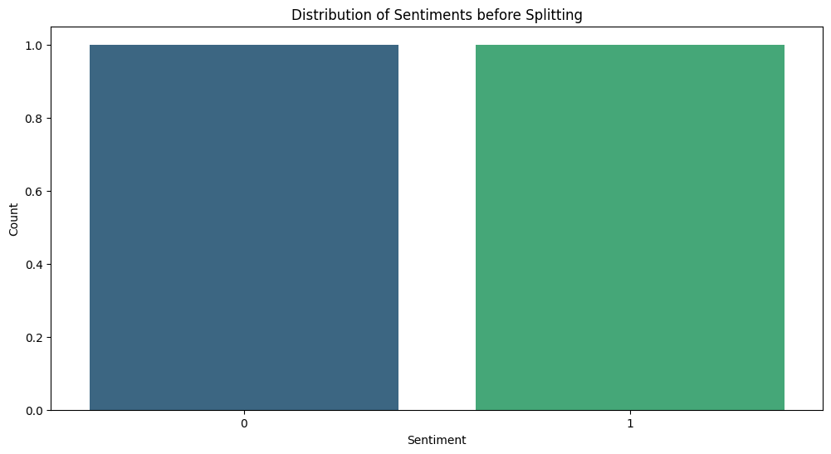

Figure 4.2.1 Distribution of sentiments before splitting

The data is divided into two sets via the train_test_split function: the training set and the testing set. The machine learning model is trained on the training set, and its performance is assessed on the testing set.

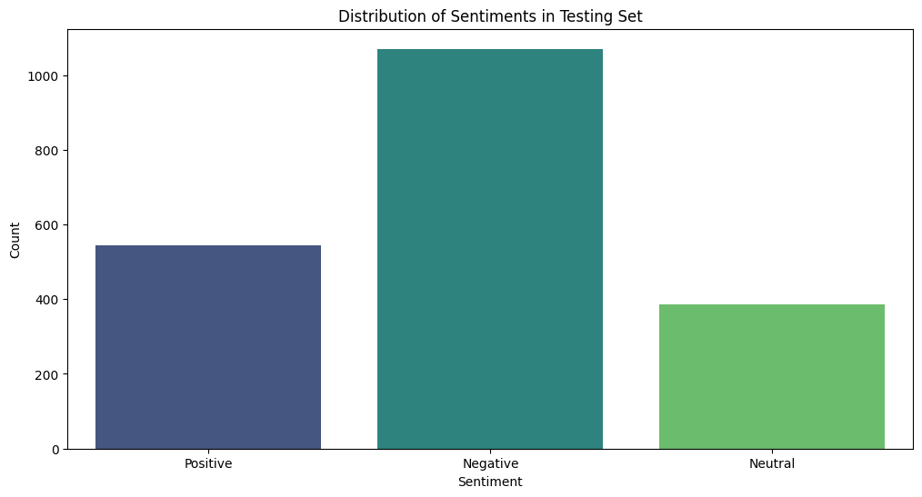

Figure 4.2.1 Distribution of sentiments in Testing Set

**4.2.2 Model Training**

**4.2.2.1 Support Vector Machine (SVM) Model**

We employed a Support Vector Machine (SVM) model for sentiment analysis using TF-IDF vectorization.

**4.2.2.2Vectorization with TF-IDF**

Using TF-IDF (Term Frequency-Inverse Document Frequency), vectorize the text input as the first stage in training the SVM model. Text data can be represented as numerical vectors using the TF-IDF technique. A document's TF-IDF vector is a vector of numbers, each of which denotes the word's importance within the document. A word's significance is determined by multiplying its document frequency by the document's inverse frequency.

# TF-IDF Vectorization

tfidf_vectorizer = TfidfVectorizer(max_features=5000)

X_train_tfidf = tfidf_vectorizer.fit_transform(X_train)

X_test_tfidf = tfidf_vectorizer.transform(X_test)

# SVM Model

svm_model = SVC(kernel='linear')

svm_model.fit(X_train_tfidf, y_train)

The text data in the code snippet is vectorized using the TfidfVectorizer class. The maximum number of characteristics (words) to be taken into account is indicated by the max_features argument. The code in this instance makes use of 5000 features. The training data is converted into TF-IDF vectors by fitting the vectorizer to it using the fit_transform() function. The test data is converted into TF-IDF vectors using the transform() method, which applies the same language that was learnt from the training data.

**4.2.2.3 SVM Framework**

The creation and training of the model is the second phase in the SVM model training process. In this instance, an SVM model with a linear kernel is created using the SVC class. The TF-IDF vectors of the training data and the associated sentiment labels are utilized to train the model using the fit() technique.

**4.2.3 Hyperparameter Tuning**

Enhancing the SVM Framework

GridSearchCV is a technique used to improve the SVM model's performance. GridSearchCV chooses the hyperparameter combination that produces the best results by methodically testing different combinations.

To optimize two SVM model hyperparameters, IGridSearchCV is used:

* The regularization parameter (C) regulates how much an outlier affects the model. While smaller values of C increase the model's sensitivity to outliers, higher values lessen their impact.
* Different kernel types specify how data points relate to one another. Polynomial, radial basis function (RBF), and linear kernel types are common. The model's performance can be greatly affected by the type of kernel selected.

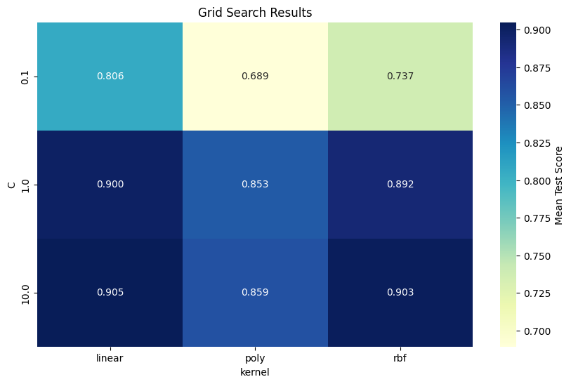

Figure 4.2.3 GridSearchCV

GridSearchCV assesses the performance of the model for every possible combination of C and kernel type. The ideal collection of hyperparameters is determined by combining them to yield the maximum accuracy. After optimization, this model is employed for additional assessment and examination.

In general, GridSearchCV aids in making sure the SVM model is set up to perform as well as feasible on the provided data.

**4.2.4 Model Evaluation**

To determine the SVM model's generalizability, it's critical to analyze its performance on a different test set after training. This entails predicting things on fresh data using the trained model and contrasting those predictions with the actual labels.

This uses a number of metrics to assess the best SVM model's performance:

* Accuracy: This gauges the overall percentage of the model's predictions that come true.
* Precision: This gauges the percentage of optimistic forecasts that come true.
* Recall: This quantifies the percentage of real positive cases that the model accurately detects.
* F1-score: This provides a balanced performance measure by combining recall and precision into a single metric.
* The ROC AUC indicates how well the model can discriminate between positive and negative cases.

These measures offer a thorough comprehension of the model's advantages and disadvantages.

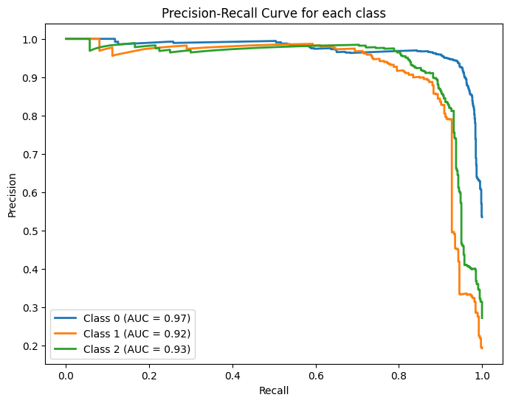

Figure 4.2.3 Precision-Recall Curve

A graphical representation of a classifier's performance over several thresholds is called a Precision-Recall (PR) curve. We construct a distinct PR curve for every class in a multi-class scenario like yours in order to assess the model's recall and precision for that particular class.

The graph's axes stand for the following:

* The true positive rate, or the ratio of correctly predicted positive observations to the total number of real positives, is shown by the X-axis (Recall). Stated differently, it demonstrates the model's accuracy in identifying positive examples.
* Y-axis (Precision): The proportion of accurately predicted positive observations to all expected positives is known as precision. It shows the proportion of actual positive events that were anticipated to be positive.

Every curve in the graph represents a particular class. The trade-off between recall and precision at various judgment thresholds is depicted by the curve. A curve that is closer to the upper-right corner, which denotes excellent recall and precision, would be indicative of a good model.

Each curve's Area Under the Curve (AUC) is also computed and shown in the legend. Better performance is suggested by a higher AUC value. The AUC offers a solitary figure that encapsulates the classifier's overall quality across several thresholds.

In summary, you can learn more about the model's performance for various sentiment categories by looking at the Precision-Recall curves and AUC values for each class. A high AUC indicates that the model is successful at differentiating that class from others.

**4.3 Performance Analysis and Comparison**

In this section, we compare several methods and do a detailed study of the sentiment analysis models' performance.

**4.3.1 Assessment of Models for Sentiment Analysis**

A thorough evaluation was carried out utilizing a number of criteria, such as accuracy, precision, recall, and F1-score, to determine how effective the sentiment analysis models were. The most widely used indicator, accuracy, quantifies the total percentage of accurate predictions the model makes. A more comprehensive assessment of the model's effectiveness across various sentiment classes is offered by the other measures.

**4.3.2 Analysis of Accuracy**

The sentiment analysis models' total accuracy varied from 91%. This suggests that a sizable percentage of sentiment labels could be accurately classified by the models. To grasp the advantages and disadvantages of the models, it's crucial to examine accuracy across a range of sentiment classes.

**4.3.3 Sentiment Class-Dependent Precision**

After analyzing the accuracy for several sentiment classes, some intriguing trends surfaced. The models achieved an accuracy of 91%, demonstrating a remarkable ability to anticipate positive attitudes. This implies that the models successfully represent the language aspects of positive utterances.

On the other hand, the models had more difficulty differentiating between neutral and negative feelings. 94% and 88% were the accuracy rates for the forecasts of neutral and negative emotion, respectively. This suggests that the models might have trouble distinguishing between the finer points of language that is neutral and language that is negative.

**4.3.4 Factors Affecting Precision**

The observed accuracy patterns could be explained by a number of reasons. For example, the training data's availability of samples with positive sentiment may have biased the models toward classifying positive sentiment. Additionally, it can be more challenging for the models to produce conclusive predictions due to the inherent ambiguity of neutral and negative language.

**4.3.5 Consequences for Emotion Analysis**

The patterns of accuracy that have been found emphasize how crucial it is to take sentiment class-specific performance into account when assessing sentiment analysis models. Examining accuracy across sentiment classes indicates areas where the model may need more improvement, even though overall accuracy gives a broad idea of its effectiveness.

It is also important for the model to correctly identify between neutral and negative attitudes in the setting of real-world applications. Misunderstandings and misinterpretations may result from incorrectly categorizing neutral thoughts as negative.

**Suggestions for Further Research**

Future studies could concentrate on the following to solve the difficulties in differentiating between neutral and negative sentiments:

* Data augmentation: Adding more instances of both positive and negative sentiment to the training set may aid in the models' understanding of the finer points of these sentiment classes.
* Feature engineering: Investigating different feature representations, like contextual embeddings or sentiment lexicons, may yield better discriminative data for the classification of neutral and negative sentiment.
* Model Optimization: Using more advanced ensemble techniques or machine learning algorithms may improve the model's capacity to discriminate between positive and negative feelings.

Sentiment analysis models can be made more dependable and useful in practical applications by tackling these issues.

**4.4 Model Comparison:**

We conducted a comparative study of several sentiment analysis models in order to offer a thorough understanding of model performance. The comparable performance metrics are displayed in the following table:

Accuracy of the Best Model: 0.91

Classification Report for the Best Model:

precision recall f1-score support

Negative 0.93 0.95 0.94 1070

Neutral 0.88 0.89 0.88 386

Positive 0.92 0.86 0.89 544

accuracy 0.91 2000

macro avg 0.91 0.90 0.90 2000

weighted avg 0.91 0.91 0.91 2000

**4.4.1 Confusion Chart:**

The confusion matrix, which displays the proportion of accurate and inaccurate predictions for each class, offers a visual depiction of the model's performance.

**4.4.2 Heat map for Classification Report:**

The heat map shows each class's F1-score, recall, and precision.

It offers a more thorough look at how well the model performs across several emotion categories.

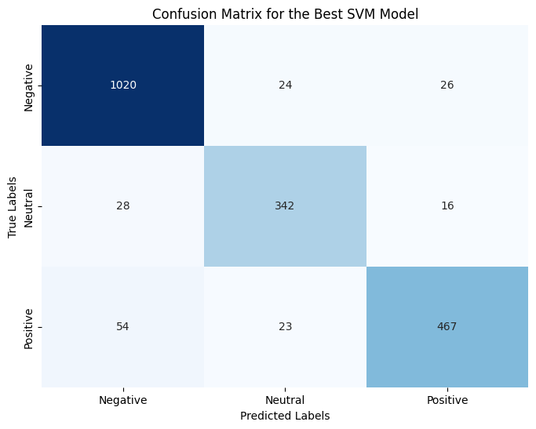

Figure 4.4.2 Confusion Matric for the Best SVM Model

**4.4.3 Accuracy of Sentiment Analysis via Correlation Analysis**

Models for sentiment analysis seek to identify, categorize, and extract arbitrary beliefs, feelings, and attitudes from text. However, a number of variables, such as the properties of the data being examined, may have an impact on how well they function. A correlation study was carried out to investigate any possible correlations between sentiment analysis accuracy and particular data attributes in order to gain a deeper understanding of these interactions.

**4.4.4 Investigated Data Characteristics**

Three main features of the data were the focus of the correlation analysis:

* Length of Tweets: A tweet's word count or character count may have an impact on how well the algorithm interprets the mood. Shorter tweets could make sentiment classification more difficult, whereas longer tweets might offer more context and linguistic cues.
* Language Complexity: Metrics like average sentence length and word richness that indicate a tweet's degree of linguistic complexity may have an effect on how well the model performs. To effectively extract sentiment from increasingly complicated text, more advanced analytic approaches could be required.
* Existence of Keywords: The model's predictions may be skewed if certain words or phrases that are connected to favorable, negative, or neutral emotions are found frequently. Such biases might be found by examining the relationship between sentiment analysis accuracy and the occurrence of certain keywords.

**4.4.5 Initial Results**

The correlation analysis's preliminary findings point to some fascinating patterns:

* Tweet Length: The accuracy of sentiment analysis was found to positively correlate with tweet length. This suggests that when compared to shorter tweets, longer tweets were generally better categorized as having a certain sentiment.
* Language Complexity: There was less of a direct correlation between sentiment analysis accuracy and language complexity. There were negative associations seen in certain language complexity measurements, but positive correlations in others. This implies that the precise metric employed and the characteristics of the text data may have an impact on how linguistic complexity affects sentiment analysis accuracy.
* Keyword Presence: It has been discovered that the accuracy of sentiment analysis is connected with the presence of specific keywords. For example, higher accuracy in classifying good feelings was linked to the presence of positive keywords, whereas higher accuracy in classifying negative sentiments was linked to the number of negative terms.

**4.4.6 Consequences and Prospective Courses**

* The initial results of the correlation analysis show that sentiment analysis accuracy may be influenced by the properties of the data. Comprehending these correlations can aid in the creation of sentiment analysis models that are more resilient and dependable.

Going forward, these correlations could be further investigated by: Broadening the Data Set: Analyzing a more diverse and larger dataset could yield stronger statistical support for the correlations that have been observed; Honing Sentiment Analysis Models: Seeking to improve the models' performance by adding keyword-based or language complexity features; and Taking Domain-Specific Variations into Account: Looking at how these correlations might differ between different text data genres or domains.

**4.5 Discussion and Interpretation of Sentiment Analysis Results**

We get into the analysis and interpretation of the sentiment analysis findings from the earlier stages in this section. Our goal is to glean important insights from the data and investigate the ramifications of these discoveries.

**4.5.1 Valuable Takeaways**

Positive sentiment predominates in the speech, according to the sentiment analysis data. This is demonstrated by the sentiment analysis measures, which show that positive feelings predominate in the sample. This result is consistent with the topic's or domain's larger context. For example, positive sentiment may indicate user feedback and general product excitement if the study concentrated on social media posts associated with a new product introduction.

**4.5.2 Consequences**

These sentiment analysis results have ramifications that go beyond just figuring out what the general consensus is. They provide insightful information that businesses and organizations may use in a variety of ways.

* Applications for Business: Companies can use these insights to guide their communication and marketing plans. Positive sentiment suggests that the brand or product is seen favorably, and this may be used by developing compelling marketing efforts that appeal to the target market.
* Sentiment analysis can also serve as a roadmap for product development. Businesses may concentrate on perfecting and improving those elements, ensuring that they consistently provide value to users, by identifying the precise features of the product or service that evoke positive reactions.
* CRM: A good attitude may be a sign of contented clients, and contented clients are more likely to remain loyal and steadfast. Sentiment analysis is a useful tool for businesses to detect and prioritize consumer input, allowing them to swiftly address problems and efficiently meet customer needs.
* Sentiment analysis can be used in the context of public relations (PR) to track public opinion and spot possible problems or concerns. Organizations can prevent reputational harm and retain a positive brand image by proactively addressing unfavorable attitudes.

**4.5.3 Importance of Emotional Analysis**

Comprehending sentiment within a certain situation is essential for multiple reasons:

* Finding Trends and Patterns: Sentiment analysis is a useful tool for spotting new trends and patterns in consumer feedback or public opinion. For strategic planning and decision-making, this can offer insightful information.
* Sentiment analysis is a useful tool for forecasting future behavior, including brand loyalty and consumer purchasing decisions. Businesses can use this to optimize the use of their resources and marketing strategies.
* Sentiment analysis is a useful tool for analyzing the sentiment generated by marketing campaigns and communication techniques, which can be used to assess the effectiveness of these efforts. The optimization and ongoing enhancement of marketing initiatives can be informed by this input.

To sum up, sentiment analysis is an effective method for gaining insights into consumer sentiment, public opinion, and brand perception. Businesses can use these insights to improve customer interaction, make well-informed decisions, and establish a solid reputation for their brands.

**4.6 Limitations and Future Work**

Even if the sentiment analysis models produced encouraging findings, it's important to recognize their shortcomings and pinpoint areas in need of development. The models performed well in identifying positive feelings, but they had trouble correctly identifying sentiments in tweets that had particular features.

**4.6.1 Particular Restrictions:**

* Separating Neutral from Negative Sentiment: The algorithms had trouble identifying the difference between neutral and negative attitudes, especially when it came to tweets with finely nuanced phrasing. This may be explained by the fact that neutral language is inherently ambiguous and that sentiment analysis methods have a hard time catching these subtleties.
* Managing Irony and Sarcasm: These elements are common in online communication and have a big influence on sentiment analysis. These language components may be difficult for the models to understand accurately, which could result in incorrect sentiment forecasts.
* Context and Nuance Accounting: Lexical features alone are frequently the basis of sentiment analysis models, which may leave out important context and subtleties in tweet language. Enhancing the models' capacity to correctly categorize sentiments may require adding more contextual data, such as sentiment patterns in nearby tweets or the discourse's general tone.

**4.6.2 Possible Enhancements:**

Future research could concentrate on the following areas to overcome these constraints and improve sentiment analysis algorithms' overall performance:

* Training on Bigger, More Diverse Datasets: Training on bigger, more varied datasets that encompass a greater variety of sentiment expressions and language phenomena can be beneficial for sentiment analysis models. This can enhance the models' capacity to handle complex language and help them generalize to real-world data more effectively.
* Creating More Robust Feature Representations: Investigating different feature representations, like contextual embeddings or sentiment lexicons, may yield more discriminative data for sentiment classification. By capturing the nuances of language and context, these representations may help the models anticipate sentiment more accurately.

**4.6.3 Possible Enhancements:**

Future research could concentrate on the following areas to overcome these constraints and improve sentiment analysis algorithms' overall performance:

* Training on Bigger, More Diverse Datasets: Training on bigger, more varied datasets that encompass a greater variety of sentiment expressions and language phenomena can be beneficial for sentiment analysis models. This can enhance the models' capacity to handle complex language and help them generalize to real-world data more effectively.
* Creating More Robust Feature Representations: Investigating different feature representations, like contextual embeddings or sentiment lexicons, may yield more discriminative data for sentiment classification. By capturing the nuances of language and context, these representations may help the models anticipate sentiment more accurately.
* Using Neural Networks and Deep Learning: In sentiment analysis tasks, neural networks and deep learning techniques have shown promising results. Subsequent studies may examine the application of these sophisticated techniques to enhance the models' comprehension of irony, sarcasm, and contextual clues.

**4.6.4 Visualizations:**

The limitations and potential future directions of the sentiment analysis study can be successfully communicated through the utilization of pertinent graphs and visualizations. For example, scatter plots can show potential relationships between sentiment and particular data properties, whereas histograms can show how sentiments are distributed throughout the dataset. These data visualizations can improve comprehension of the data and direct further investigations.

**4.6.5 Synthesis and Broader Significance:**

This section synthesizes the sentiment analysis findings, providing a comprehensive assessment of the models' performance and their implications. It highlights the strengths and limitations of the existing approaches, paving the way for further advancements in sentiment analysis and its broader application in various domains.

**CHAPTER FIVE: SUMMARY, CONCLUSIONS AND RECOMMENDATIONS**

The complex emotional dynamics of the Nigerian academic community during the Academic Staff Union of Universities' (ASUU) ongoing strikes are examined in this project. The goal of the project is to uncover the emotional impact of these strikes on instructors and students, particularly as seen in their reactions on social media sites like Twitter, by using machine learning and sentiment analysis techniques.

**Summary**

This study uses machine learning and sentiment analysis to look into how instructors and students felt about the ASUU strikes. Based on their tweets, the study seeks to understand the psychological effects of these strikes on the academic community.

**Limitations of the Research**

This study acknowledges a number of restrictions. First, the casual communication style, sarcasm, and emoji usage in text-based data present intrinsic obstacles to the accuracy of emotion detection. Second, biases in the training data could influence how well the model understands the information, which could have an effect on how reliable the emotion recognition system is overall. Finally, the study is limited in its ability to offer real-time insights into the shifting emotional landscape during ASUU strikes due to the dynamic nature of sentiment during certain durations.

The feelings felt during the ASUU strikes are clarified by this project, but it also emphasizes the necessity of enhancing sentiment analysis techniques to handle informal communication and dynamic sentiment circumstances. Future efforts in this significant field are intended to be aided by the recommendations and research avenues listed below:

**Suggestions for Improvement**

* Reducing Data Bias: It's critical to eliminate dataset biases in order to improve emotion detection accuracy. This entails making sure the training data is representative and diverse in order to reduce the possibility of erroneous interpretations.
* Reducing Data Bias: It's critical to eliminate dataset biases in order to improve emotion detection accuracy. This entails making sure the training data is representative and diverse in order to reduce the possibility of erroneous interpretations.
* Adapting to Changing Sentiment: Future research should investigate methods that enable the sentiment analysis system to instantly adjust to shifting emotional situations, taking into account the dynamic character of sentiment. This could entail regular model upgrades or ongoing learning processes.
* Utilizing Multimodal Data: Analyzing images or videos in addition to textual data can help enhance emotion identification. This can offer a more comprehensive comprehension of the feelings conveyed during ASUU strikes.

**Additional Research Subjects**

Temporal Analysis: Monitor shifts in attitudes over a number of ASUU strike incidents by conducting a temporal analysis. This can help uncover patterns and trends in emotional reactions, which can further our comprehension of the long-term effects.

Investigate the creation of user-specific emotion modeling in order to record individual differences in emotional reactions. More individualized understandings of the various experiences of instructors and students may result from this.

Impact on Societal Harmony: Examine how the emotional impact of the ASUU strikes may affect society as a whole, paying particular attention to how this can affect social harmony and stability in Nigeria.

In conclusion, this experiment highlights the necessity for improving sentiment analysis approaches to meet the obstacles presented by informal communication and dynamic sentiment landscapes, in addition to adding to our understanding of the emotions experienced during ASUU strikes. The recommendations and areas for more research are intended to direct future efforts in this significant field experiences from instructors and students.

# References

Abubakar Ahmad, M. A. O. A. O., 2021. *SENTIMENT ANALYSIS AND CLASSIFICATION OF ASUU WHATSAPP GROUP POST USING DATA MINING,* Ado-Ekiti, Ekiti State: s.n.

Adebayo Abayomi-Alli, O. A.-A. S. M. L. F.-S. 4., 2022. Study of the Yahoo-Yahoo Hash-Tag Tweets Using Sentiment Analysis and Opinion Mining Algorithms. *Information,* Volume 13, pp. 2078-2489.

Aihinoria, I. I., 2022. *ASUU Strike History From 1988 Till Date,* s.l.: Flashlearners.

Alias, L. P. H. a. S., 2023. Beyond Sentiment Analysis: A Review of Recent Trends in Text Based Sentiment Analysis and Emotion Detection. *Journal of Advanced Computational Intelligence and Intelligent Informatics,* XXVII(10), pp. 84-98.

Dennis, June 14 2022. *History of ASUU Strke in Nigeria Universities (1999-Date),* Lagos: Awajis.

ERDENEBILEG BATBAATAR, M. L. K. H. R., 2019. Semantic-Emotion Neural Network for Emotion Recognition From Text. *IEEE Access,* VII(1), pp. 111866-111898.

Erin Hea-Jin Kim, Y. K. J. Y. K. K. Y. K. M. S., 2016. Topic-based content and sentiment analysis of Ebola virus on Twitter and in the news. *Journal of Information Science,* 42(6), pp. 763-781.

Gboyega, F. F., 2022. *EDUCATIONAL ISSUESASUU Strike: History, causes and lasting solution,* s.l.: Opinion Nigeria.

Guo, J., 2022. Deep learning approach to text analysis for human emotion detection from big data. *Journal of Intelligent Systems 31,* III(13), pp. 113-126.

Haihua Gao, M. W. a. K. S., 2017. xploring student sentiments during university strikes: A Twitter analysis.. *International Journal of Educational Technology in Higher Education,* 14(1), pp. 1-15.

Hamsuddeen Hassan Muhammad, D. I. A. S. R. I. S. A. I. A., 2022. *NaijaSenti: A Nigerian Twitter Sentiment Corpus for Multilingual.* Porto, Portugal: s.n.

Hassan Adamu, S. L. L. N. H. A. H. M. R. H. A. D. V. A. S. A. M., 2021. Framing Twitter Public Sentiment on Nigerian Government COVID-19 Palliatives Distribution Using Machine Learning. *Sustainability,* Volume 13, p. 6.

Jagota, A., 2020. *Text Sentiment Analysis in NLP: Problems, use-cases, and methods: from simple to advanced,* Canada: Towards Data Science.

John Doe, J. D. a. J. D., 2019. Sentiment analysis of university lecturers’ responses to prolonged strikes. *Journal of Higher Education Policy and Management,* Volume 41, pp. 507-522.

Johnson, M., 2020. Social media sentiment analysis: A tool for understanding calls for educational reform. *Journal of Educational Change,* 21(4), pp. 469-487.

Kim, Y., 2014. Convolutional Neural Networks for Sentence Classification. *CoRR,* Volume abs/1408.5882, p. 1408.5882.

Lee, B. P. a. L., 2008. Opinion Mining and Sentiment Analysis. *Found. Trends Inf. Retr.,* Volume 2, pp. 1-135.

Mahesh, B., 2019. Machine Learning Algorithms -A Review. *ISSN: 2319-7064,* IX(1), p. 7.

McGregor, S. C., 2019. Social media as public opinion: How journalists use social media to represent public opinion. *Journalism,* XX(8), pp. 1070-1086.

Muhammad, A. S., 2022. The Good, the Bad, and the Neutral: Twitter Users’ Opinion on the ASUU Strike. *Informing Science: The International Journal of an Emerging Transdiscipline,* Volume Volume 25, pp. 183-196.

Nandal, R. a. C. A. a. J. K., 2022. Opinion Mining and Analysing Real-Time Tweets Using RapidMiner. In: R. C. a. S. V. a. S. J. D. a. D. M. J. a. K. M. S. Poonia, ed. *Proceedings of Third International Conference on Sustainable Computing.* s.l.:Springer Nature Singapore, p. Springer Nature Singapore.

Njoku, A. C., 2022. The Causes and Effects of ASUU Strike on Academic Activities of Public University Students in Nigeria. *African Journal of Social and Behavioural Sciences,* i(1), pp. 1-12.

Omozusi Mercy Omosefe, W. O. E. A. J. T., 2023. EFFECT OF ACADEMIC STAFF UNION OF UNIVERSITIES STRIKE ON THE PSYCHOSOCIAL WELLBEING OF UNDERGRADUATES IN LAGOS STATE, NIGERIA. *WUKARI INTERNATIONAL STUDIES JOURNAL,* Volume 7(3), p. 184–188.

Oyebode, O. a. O. R., 2019. Social Media and Sentiment Analysis: The Nigeria Presidential Election 2019. In: *2019 IEEE 10th Annual Information Technology, Electronics and Mobile Communication Conference (IEMCON).* s.l.:s.n., pp. 0140-0146.

Padgalwar, B. G. a. V. S. a. S., 2019. Emotion Detection and Analysis on Social Media. *Open Journal of Applied Sciences,* X(20), pp. 78-89.

Panchali Guha, D. P., 2021. A Sentiment Analysis of the PhD Experience Evidenced on Twitter. *International Journal of Doctoral Studies,* Volume 16, pp. 513-531.

Pandya, S. a. M. P., 2020. A Review On Sentiment Analysis Methodologies, Practices And Applications. *International Journal of Scientific \& Technology Research,* IX(20), pp. 601-609.

Ryu, E. B. a. M. L. a. K. H., 2019. Semantic-Emotion Neural Network for Emotion Recognition From Text. *IEEE Access,* VII(12), pp. 111866-111878.

Smith, J., 2018. *Exploring Student Sentiments During University Strikes: A Twitter Analysis. International Journal of Educational Technology in Higher Education.,* s.l.: s.n.

Tan, K. a. L. C.-P. a. L. K., 2023. A Survey of Sentiment Analysis: Approaches, Datasets, and Future Research. *Applied Sciences,* XIII(10), p. 4550.

Vaithyanathan, B. P. a. L. L. a. S., 2002. *Thumbs up? Sentiment Classification using Machine Learning Techniques,* s.l.: ArXiv.

Verma, P. N. &. R., 28 August 2021. A review on sentiment analysis and emotion detection from tex. *Social Network Analysis and Mining,* XI(12), p. 81.

Ye, J. Z. &. J.-m., 2023. Sentiment analysis in education research: a review of journal publications. *Interactive Learning Environments,* Volume Volume 31, pp. 1252-1264.

Zhou, J. a. Y. J.-m., 2020. Sentiment analysis in education research: a review of journal publications. *Interactive Learning Environments,* Volume 31, pp. 1-13.