UNIVERSITY OF ARUSHA
A Chartered Seventh-day Adventist Institution of Higher Learning



UNIVERSITY MANAGEMENT INFORMATION SYSTEM

Brief Introduction
University Management Information System is a system designed to handle universities and colleges information. The system is made by integration of the following systems: -
- Registration System
- Admission System (with Automatic Registration Number, according to your Institution format)
- Fee System (Can Invoice a Student to his/her account as well as Payment History)
- Timetable Management System and Venue Management
- Course and Subject Management
- Examination and Results Systems
- User & Groups Management Systems
- Approval Sequence Management System
- Authentication, Authorization and Accounting Services (AAA Services)
- Communication Systems
  - Email Sub System
  - SMS Sub System
  - Local Message Sub System
- Attendance System
- Reports EXCEL/CSV and PDF format
- Transcript Management
Above systems are built on the main system (University Management Information System).
The system was built by careful collecting requirements from various institutions and TCU (Tanzania Commission for Universities). From TCU specifically we used a University Qualification Framework (UQF) Document to make sure it complies with the current Tanzanian requirements.
Most of components of this system have been used at “Kilimanjaro Christian Medical University” in Moshi for three years now, and the system has performed well. The system is expected to be installed at “Mineral Research Institute” in Dodoma, before August 26th this year.

System Screenshots
Let me take you through some of the screenshots of the system. I have tried to use some of the data of your Institution “University of Arusha” for Demonstration purpose only, some data might be correct and others might be wrong.

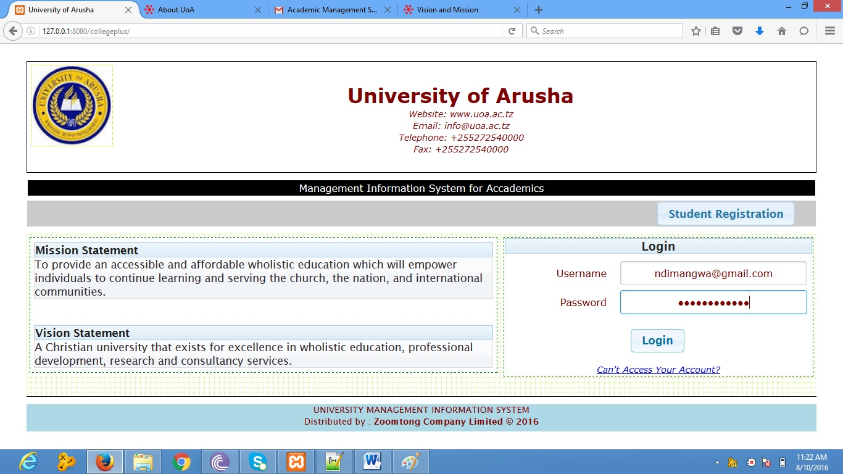
Fig 1: Home Page of the System

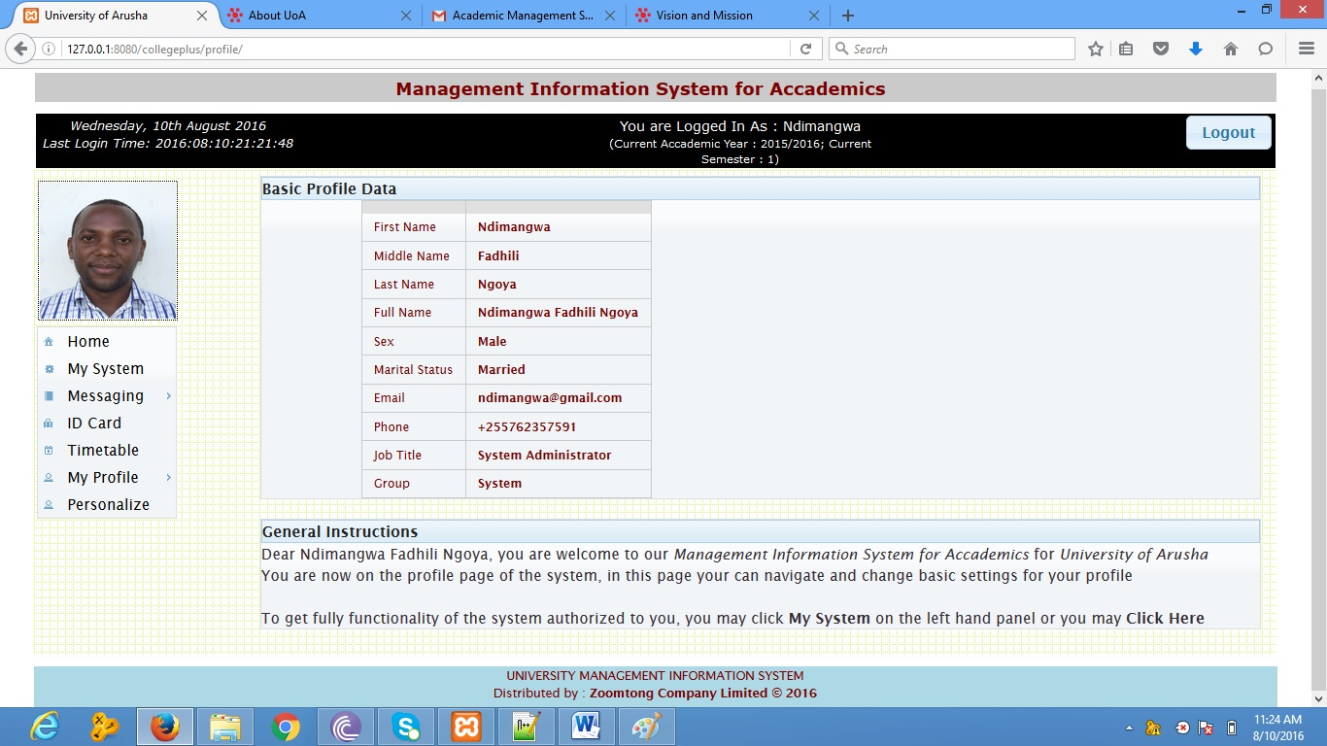
Fig 2: Basic profile page for users
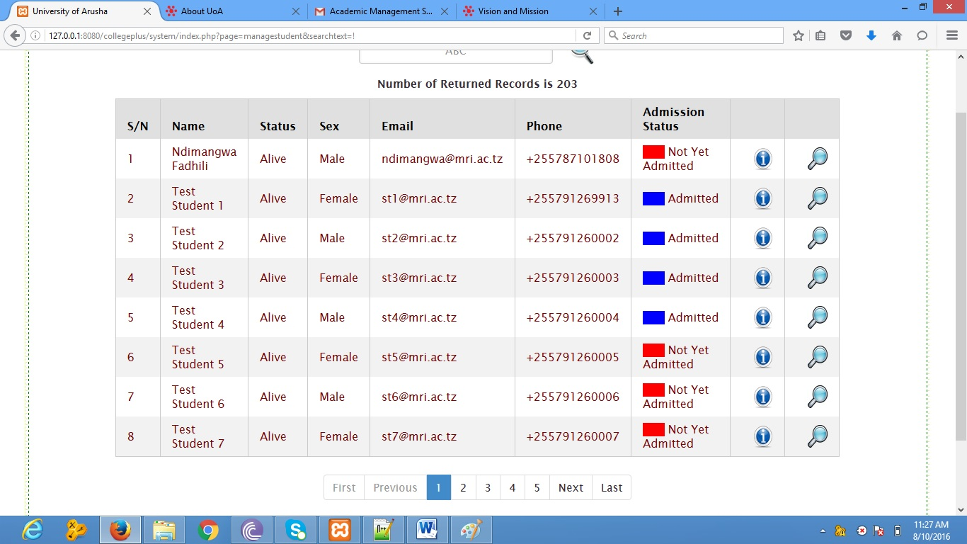
Fig 3: Student Search results

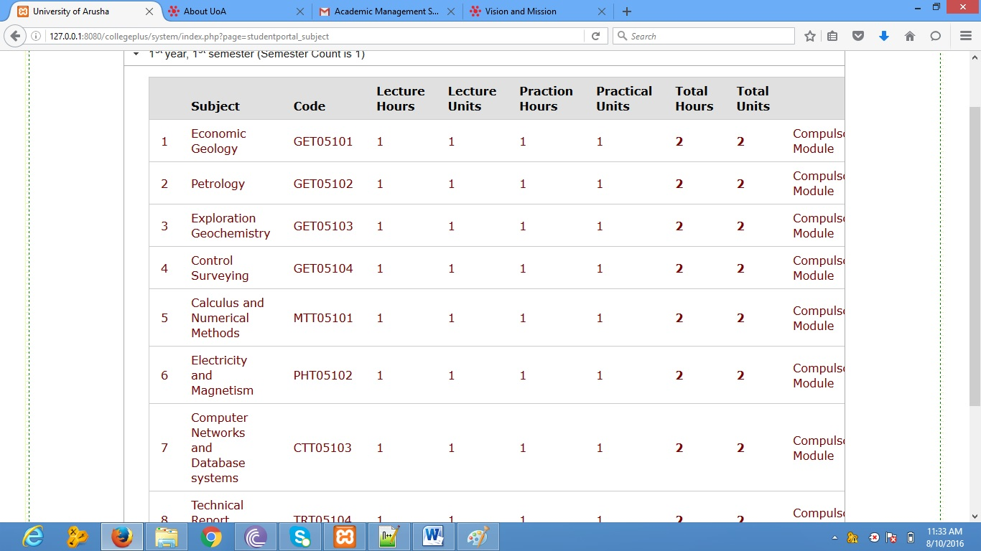
Fig 4: Subjects for students in one of the semesters
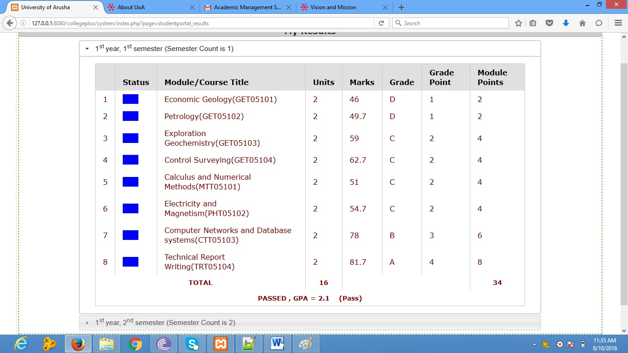
Fig 5: Results for student in one of the semester
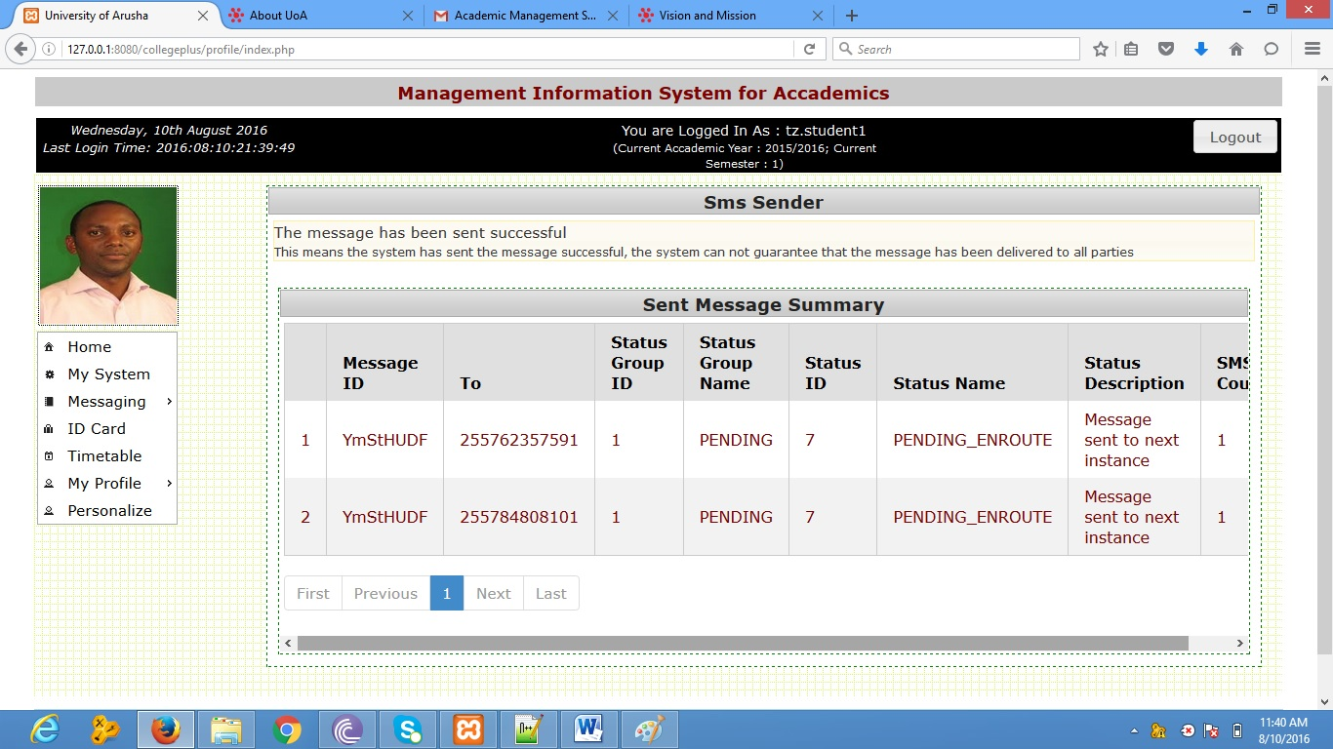
Fig 6: Messaging System

Conclusion
It is my desire and my hope that the University of Arusha will be using the best technology available in this world to smooth it operation.
Our company Zoomtong Company Limited, located in Moshi is willing to install this software to your institution as well as giving a trial, including two years support after sales, we also gives a free virus protection to all our servers.
One behalf of our company, we do request to be given an opportunity to present our product. This product is dynamic, we can add and remove features according to your institution needs.
This document is prepared by Ndimangwa Fadhili, Managing Director and Software Developer at Zoomtong Company Limited
Qualifications:-
- Masters in Computer Applications, Bangalore University 2008 – 2011, India
- Bsc. Telecommunication Engineering, University of Dar es Salaam 2003 – 2007
- Diploma Computer Engineering & Electronics, Graffins College, Nairobi Kenya 2001
Contacts
- Email: ndimangwa@gmail.com
- Phone: +255 787 101 808

