HOSPITAL MANAGEMENT INFORMATION SYSTEM
_{(USER GUIDE MANUAL)}

Client : Mbwambo Super Specialized Hospital
Developed by : Zoomtong Company Limited
ABBREVIATIONS
- HMIS : Hospital Management Information System, sometimes refered to "Health Management Information System"
- LAN : Local Area Network
- UI : User Interface
CHAPTER : OVERVIEW

Introduction
Hospital Management Information System (HMIS) is a web based computer system which manage day to day Hospital information, the key actor of the system being the patient. In other word, HMIS is a computer system which track all movement of the patient while in a hospital, the patient can be out-patient or in-patient. The system also assist the management to get various reports for different services, example of such service is operations, admission, investigations e.t.c. The system also manage financial records.

System Composition
HMIS is a composition of subsytems which can talk to each other, such subsystem are : -
- User Accounts : - Manages System Users, Groups and Job Title. It is also responsible for Authentication to the system, Authorization (grants permission) and Auditing (keep track of user system logs).
- Patient : - This is where the registation of patients being done, searching previous patients. All details of the patient can be found here.
- Finance : - All financial matters are being done in the finance subsystem. This part is responsible for raising invoices, issuing receipts as well as defining services. A service in this system, is referred to hospital services targeting the client.
- Nurse Station : - This subsystem handles most of the activities performed by Nurse Station, mainly being Triage.
- Doctor Consultation : - This part is where the Medical Doctor interacts the most, this part can request any hospital service for the patient, as well as viewing the results of the request.
- Laboratory Examination (Investigation) : - This handles investigations either in a laboratory, X-Ray or Ultra-Sound.
- Pharmacy : - This part deals mainly with drugs dispensing.
- Admission : - Handles admission.
- Theatre Management : - Activities which takes place for in-patient who is about or has been operated.

Where to get the system
Since the system is a web-based system, and the server resides at the hospital, for the time being you need to be physically at the hospital's Local Area Network (LAN) to access the system.

Step 1: Open your favourite web browser (recommended "Google Chrome" or "Firefor" web browsers )



Fig: Double Click any of the icons as shown above to open a Web Browser.

Step 2: Enter address of the system to the address bar of the browser, the default address is 192.168.8.2/hmis


Fig: Enter address of the system in the address bar and click enter.

After entering the address and clicking "Enter" key on your keyboard, the system will open as shown below, if it does not open check your if your computer is connected to the hospital's network, or you have typed correctly.

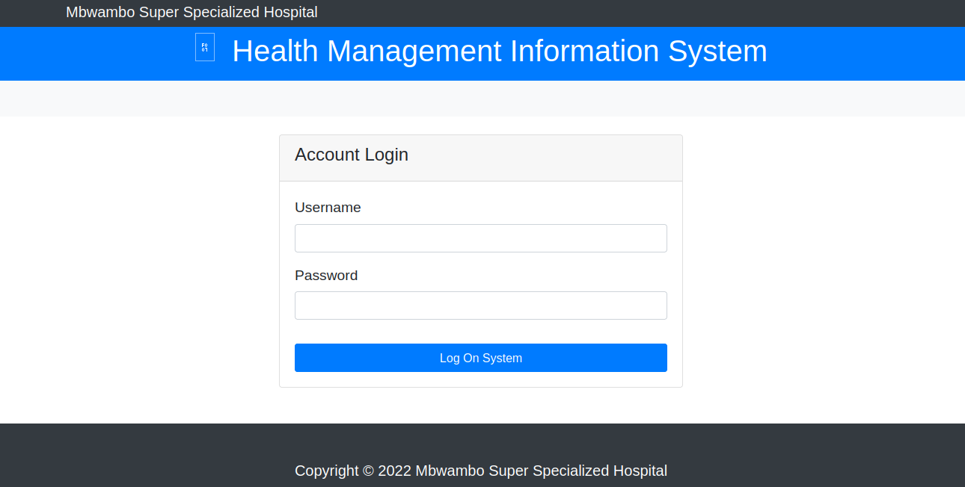

Fig: Congratulation, you have successful opened the system (The appearance of the system, might vary from time to time, however this is the default view of the system)

How to Logon to the system
You need username and password to logon to the system. The username and password, is the one provided to you by your system administrator. Every use of the system must have his or her own username and passwords. Note Email addresses registered with the system can be used instead of username, and also both username and passwords are case sensitive.
Once you have supply username and password, click the "Log On System" button.

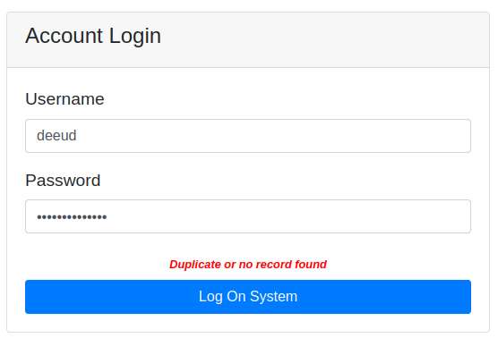
Fig: You have supplied either a wrong Username or wrong Password.

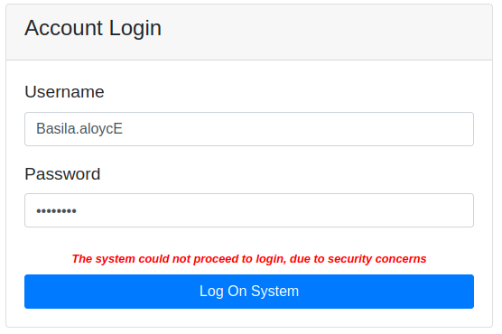
Fig: You have supplied correct Username and Password, however the username has failed case testing. In figure above "Basila.aloycE" while the saved one is "basila.aloyce".

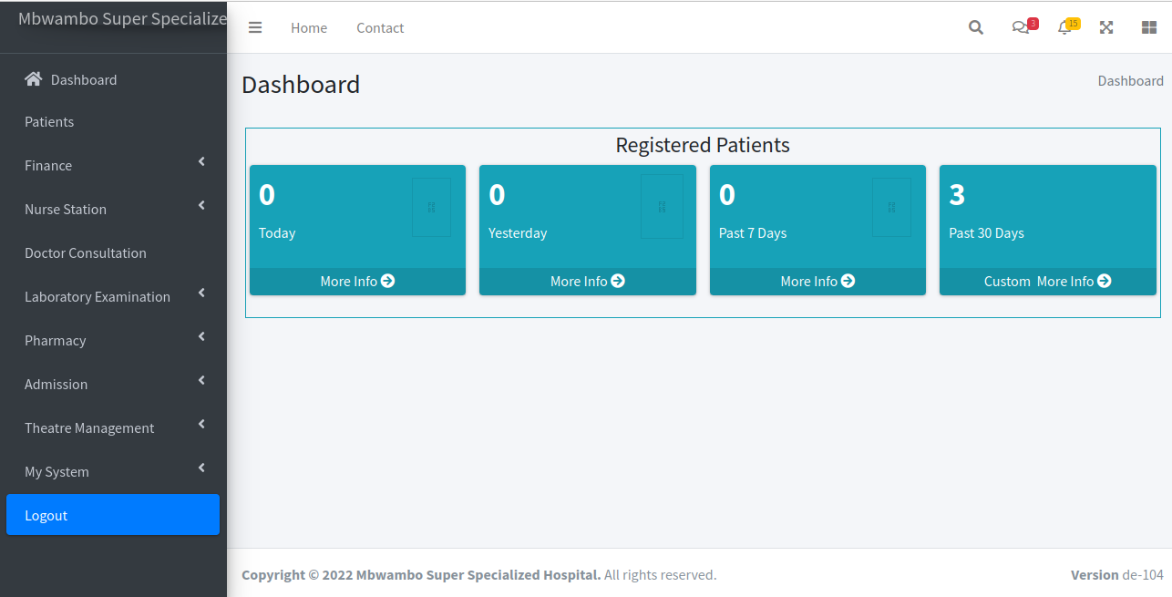
Fig: If you get a page resembling to this, you have successful Logged in the system. The appearance of page can be different from person to person due to Authorization grants (Access Levels) for each user. In case you need to logout, click "Logout" in the bottom of the LHS (Left Hand Side) menu.

General Look and Feel of the system
All subsystems or modules have almost the same look and feel, which comprises of a Search Box, Advanced Search (Search based on criteria), button to add a New Record. The User Interface (UI), contains also tabular search results (after searching), where on the further right consists of Edit, Delete and Details link against each record.

Let me ellaborate using the Patient Module,

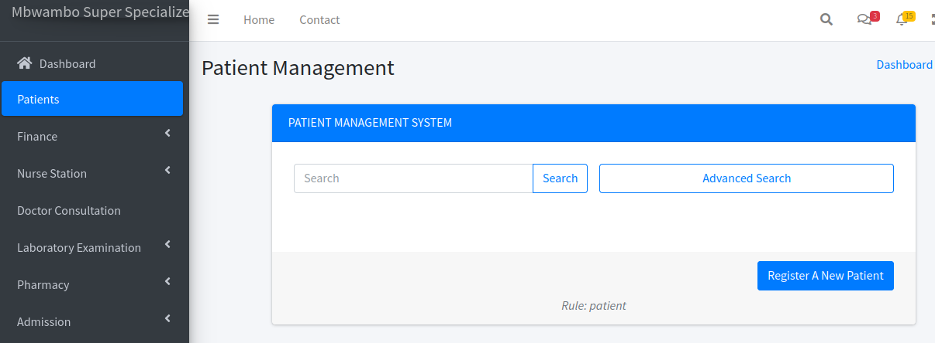
Fig: Search Box, Advanced Search and "Register A New Patient" or "Add New Record" for other modules.
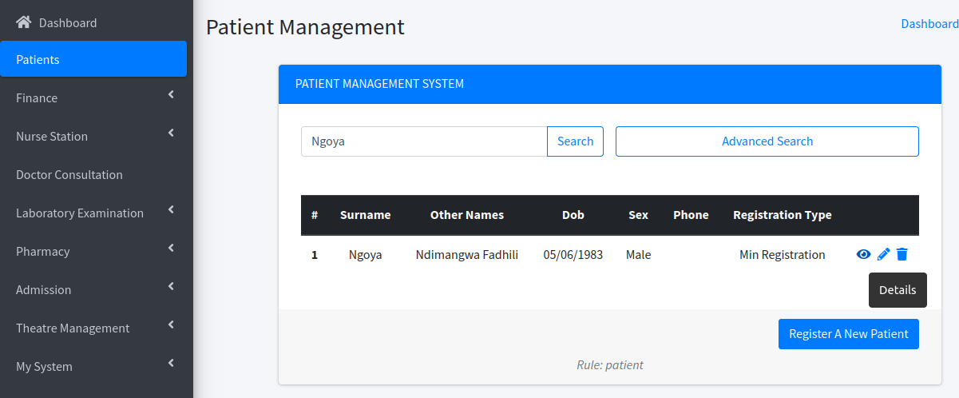
Fig: Searching the Patient Name, I just typed "Ngoya" in the Search box and clicked "Search" button and the records were returned. Once you search, the system will give you suggestion as you type. On the right of the returned record, there is three buttons Details, Edit and Delete (Note: For patient you can not delete).

Note: The system is built to assist the user while entering data, incase you have made an error, the system will give you the clue, what went wrong.

CHAPTER : PATIENT MANAGEMENT SYSTEM

The life of the Patient in the system begins at this point, all matters of registration are at this point. This module handles also patient who had previous served by the system for a different case.

Where to get Patient Module
On the Left Hand Side Menu, click Patients and the module will open as shown below.
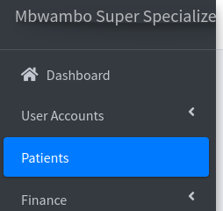

Fig: Menu for Patient (the bluish background with a caption "Patients")

How to register a New Patient
The system handles three types of Patients
- Transfer In
- Min Registration (The patient who uses small card or in common language, "kadi ndogo")
- Full Registration (The patient who uses large card or in common language, "kadi kubwa")
Note in all these three cases, the system will issue a registration number, the format of the Full Registration is the default one, which is being used manually at the hospital.

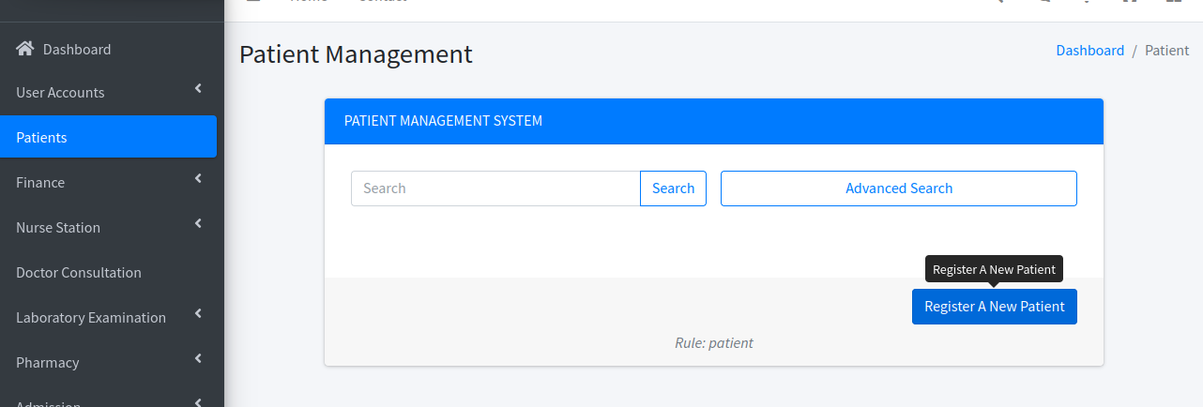
Fig : Patient Registration System, click "Register A New Patient" to register a new Patient.

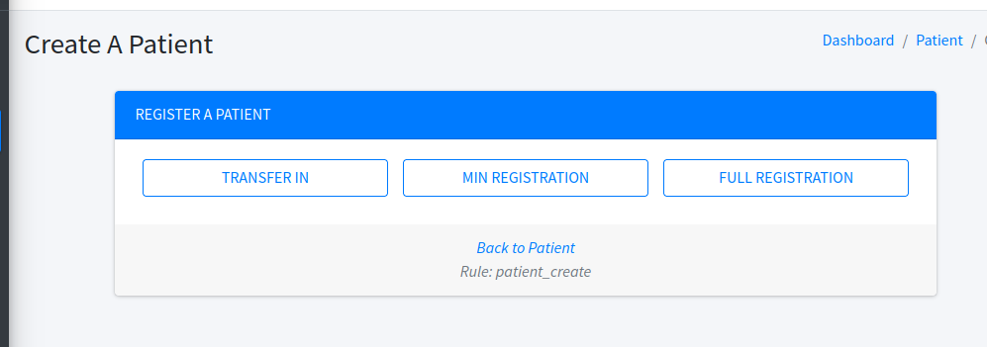
Fig : Once a "Register A New Patient" is clicked, page of registration types will open.
Registration of a New Patient, for any of the three types of patients are the same, what differ is the details of the boxes you fill, for the sake of this manual, we will use "Full Registration" as it contains everything present in the other registrations. Note at the end of each registration, the system will forward the notification to Finance module, specifying the type of service and the amount as defined in the Service sub-module of the Finance Module.

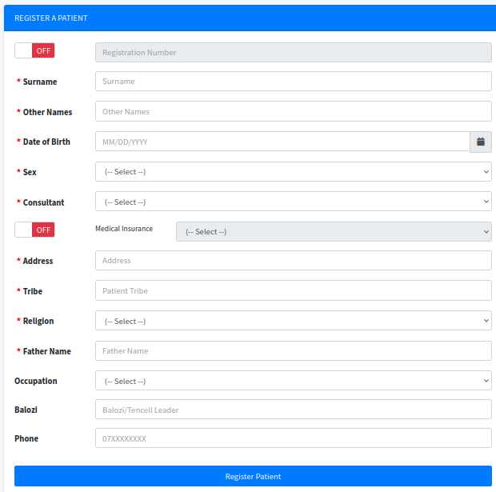
Fig: Full Registration form

The form resembles the actual manual form, however the important box is the first one, which is about "Registration Number", by default this box is OFF meaning the system will do automatically generate registration number, however if you slide the Left button which is written "OFF", the box will go ON, and will allow you to type Registration number (For safety leave it by default OFF, unless if you are registering the Patient who had already have the registration number, in the previous manual process).

Now you can proceed filling, the Patient details, once you complete click the "Register Patient" button, below the form, if everything has gone well you will get a screen below

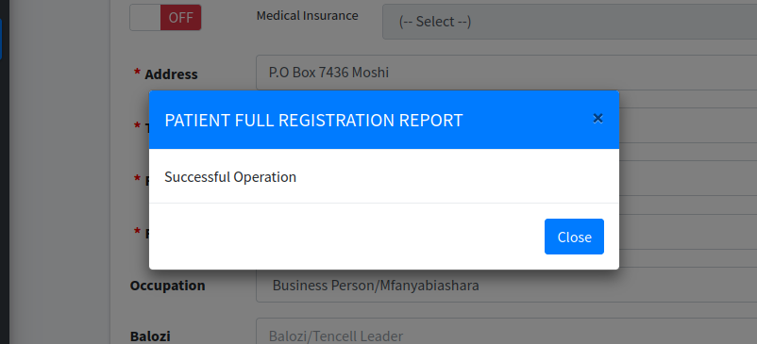
Fig: You have successful added a New Patient, click "Close" to proceed.

Since we have entered a new Patient, for my case I used "Ndimangwa02 Fadhili02" as Other Names, and "Ngoya02" as surname. Now it is time to move closely to see what the system has done.
Basically, adding a New Patient several things has happened at once
- A New Record has been added
- A New Registration Number (Unique) has been generated in case Registration Number box were OFF
- Finance Module has been updated with the information of the client.

Searching the Added Patient
In the patient module you can simply search by Surname, other given names, registration number. Let us use surname

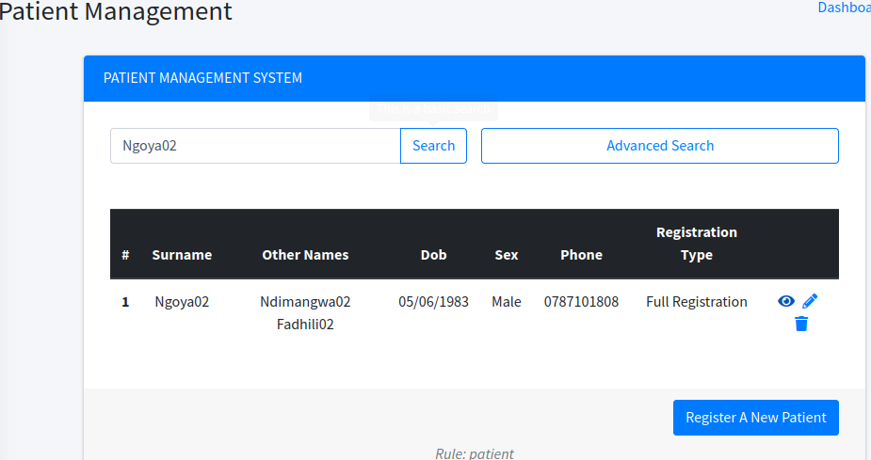
Fig: Searching the existing Patients

Now let us see the details of what we have entered, just click on the Right Hand Side (Against the name), the icon with eye-shaped


Fig: Details, an eye-like icon, click it

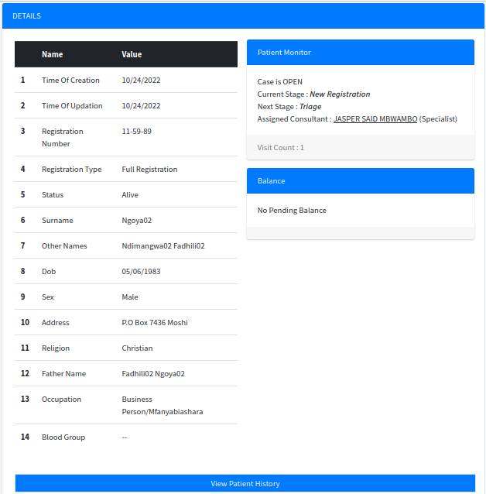
Fig: Details page of the Patient entered, the Balance section shows "No Pending Balance", because the Finance personnel has not risen any invoice against this patient, however the patient can not get any service unless a Finance personnel clears him.

Editing Patient Information
Sometimes a mistake may occur while registering a patient, and usually a Patient can move from being a "Small Card" to "Large Card", in this scenarios you do not have to re-enter the patient details, you just need to Search the Patient as usual, and click the edit icon (A pencil shape icon, just besides the Details Icon), and you will get an Edit/Update page

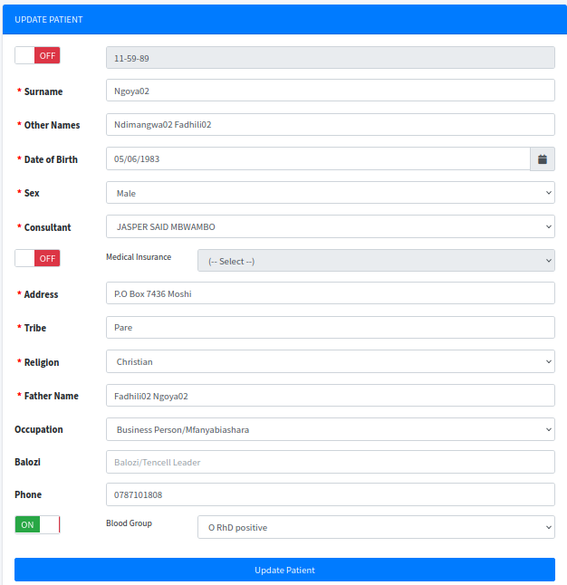
Fig: Update Patient Details
CHAPTER: FINANCE

Everything that the system can offer to the patient, is defined as Service and these services are grouped in categories "Service Category". Putting it in a simple language, a service is the very specific thing which the system can offer to a client, which defines the amount to be paid if any and if that service is countable. A Service is a backbone of the Finance system.
An Example, while doing a new Registration, the service corresponding with Full Registration "kadi kubwa" is called "OPENING FILE", while the one corresponding with Min Registration "kadi ndogo" is called "OPENING CARD", which means immediately after doing registration, the system will submit the correct amount to the Finance Module.

Where to get Finance Module
On the Left Hand Side Menu, click Finance and the module will open as shown below.
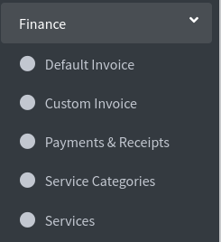

Fig: Finance Module with its sub-menus

What is found in Finance Module?
Finance module has submenus under it, which are exactly what the finance module is doing. Composition of Finance module is : -
- Default Invoice : - This feature is used for all invoices which follows normal flow, and will be initiated automatically by the system. A good example is registration of a new patient, it is known after registration, based on type of registration the patient must pay for opening a file or a card, in this case the system will initiate an invoice queue, where the finance personnel will approve the invoice (and issue discounts if any).
- Custom Invoice : - This feature is used if you want to raise invoice to the patient, which does not follow in the normal flow. A good example is when the patient has been admitted for operation, and the actual cost is not full known in advance, in this scenario a Patient will be issued multiple invoices depends on the number of days he/she will stay, the resources he/she will use.
- Payments & Receipts : - This feature is used for issuing receipts, once the invoice is generated (whether "Custom Invoice" or "Default Invoice"), the receipt queue will be initiated, and once the finance personnel receives payment, he/she will issue the receipt. Note : A single invoice can have multiple receipts, a patient can pay multiple times until the amount specified in the invoice is completed. The system will not grant the next step until the invoice is paid in full. In case the hospital needs to give an offer to a patient, then there is a need of raising a "0" amount invoice, and receive "0" amount for that invoice, alternatively you can apply a discount of the same amount as invoice amount. However, you will need to issue a receipt of "0" amount for that specific invoice. However for issues concerning Invoices and Receipts, the system does a large amount of work, and the work of finance personnel is quite simple.
- Service Categories : - Service category is one of the simplest feature of the system, it simply categorises services in different groups. The system is being made with the following categories : - Consultation, Contrast Studies, Endoscopic Surgery, Laboratory Examination, Nurse Station, Open Surgery, Pharmaceutical, Plain/Convention X-RAY, Registration and Ultrasound. The system is not limited to these categories only, the client can add more categories depends on how the business grows.
- Services : - Service defines the amount, countability of a service. The system is made with 232 different services, however services can be added on feature. Some of services are countable, example while issuing drugs, the quantity of drug is countable and this will reflect on the invoice. This means, each drug you add, the system will create a corresponding service for it (this happens automatically).

Now it is time to go in-depth on Finance Module

Default Invoice
In the normal flow of the system, the system will automatically initiate the invoice queue. An invoice queue is a prospective invoice (it is not yet to be called invoice, it just need the finance personnel to complete it to become an invoice).
To create a Default Invoice, the following are steps : -
- Open the Finance Module, click Finance Menu.
- Click the "Default Invoice", it will open default invoice page.
- Click on the "Create A New Invoice" button , on bottom of the page (bottom-right on large screen, or just bottom on small screens).
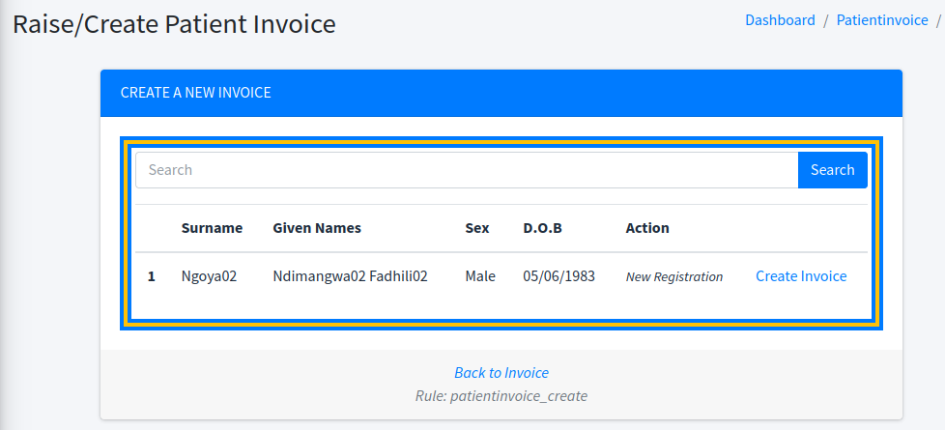
Fig: Queue of Prospective invoices
- In the list (if any), you will see the name of patients, with "Create Invoice" against each record. Note : In the Action column, you will see the summary of what the invoice is for. For the figure above, we have one item in list for patient "Ndimangwa02 Fadhili02" for "New Registration"
- Click "Create Invoice" agaist the row in the list which you want to create invoice for, and a Invoice creation window will open as follows
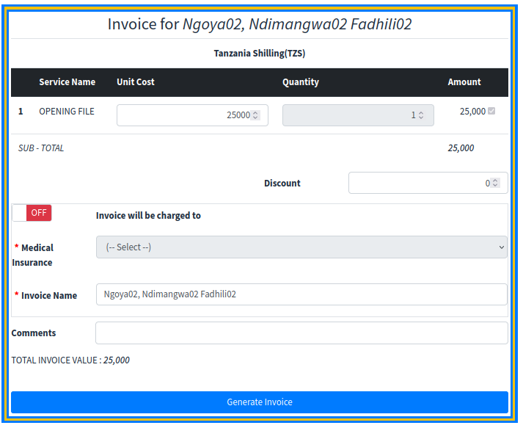
Fig: Invoice creation window, you can apply discount if you wish. Note the system will keep track of who prepared this invoice.
- Click "Generate Invoice" if the invoice details are okay with you,then you will get a report message as a feedback of your action. Immediately after the invoice has been generated, the system will initiate a Recipt Queue,so as to track receipts related to the generated invoice. You can click "Make Payment" if the patient is ready to pay at this moment,or he/she can pay later. You can click "Download Invoice" to get the invoice.
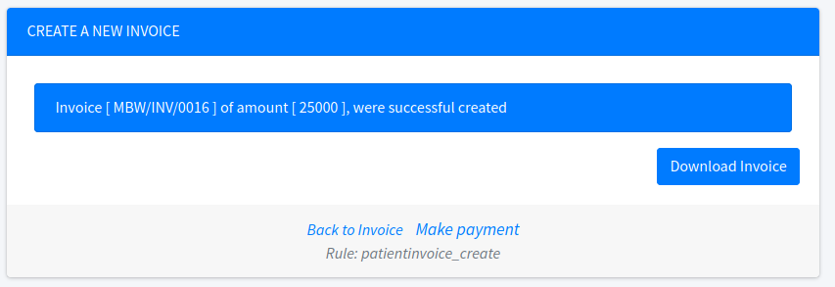
Fig : Invoice creation report, it gives option of "Make Payment" or "Download Invoice". At this point , if you go to the Details Page of this patient, you will see a balance of Tsh. 25,000 in the balance section.

- Click "Download Invoice", if you want to print, however printing invoices is not necessary, since, you can still search for the invoice and print it later.
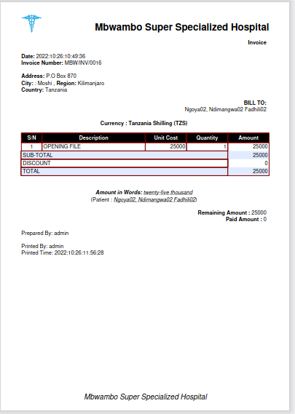

Fig : A PDF generated invoice

Up to this point, you have been able to generate an invoice. Note :- The procedures for invoice generation is the same, no matter what type of service you are dealing with, the system will autofill details automatically.

Custom Invoice
Custom Invoce is an invoice initiated at any time to an existing patient. It does not matter what stage the patient is, Custom invoice can initiated even if the patient has other unpaid invoices. The following are procedures or steps to initiate the "Custom Invoice"
- Open the Finance Module, click on "Finance" menu.
- Click "Custom Invoice", and a regular "Search Patient" page will open.
- Search for the desired client, for this time I will search "Fadhili".
- The usual search results, will display a list of results, now click the "Proceed" button against a record of interest as shown below
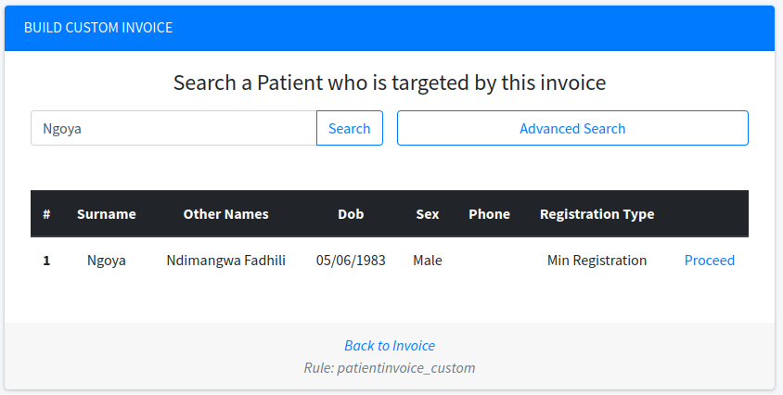
Fig: Search results of the Patient, whom I need to build a custom invoice, click "Proceed" button

- Now you need to Select categories of services, you can select multiple categories, this window helps to narrow down the intended services, as shown below (In my case let me choose OPEN SURGEY, REGISTRATION and ULTRASOUND), then click "Service Categories Selection" button.
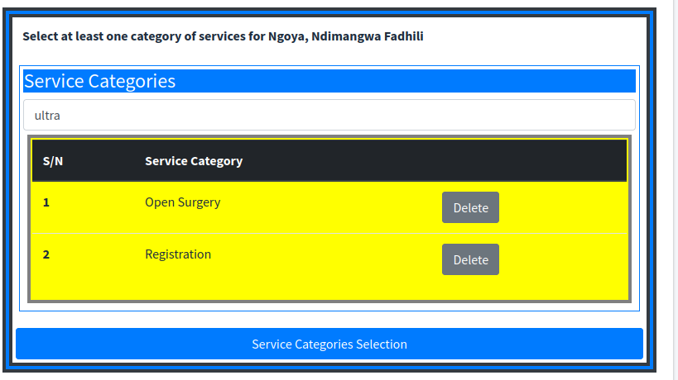
Fig: Service categories selection, I have choosen"Open Surgery", "Registration" and I am finishing now with "Ultrasound", you can navigate back using the link "Back to Patient Search"

- Now you need to select services; Note: Only those services falling on the categories selected in the previous steps will be searchable, the rest will not be applicable, in my case let me select four one in Open Surgery category (Cystectomy+urinary Diversion), one in ultra sound (USS WHOLE ABDOMEN), one in registration (OPENING FILE), but I am not limited to one only per category, let me add one more in ultra sound (USS BREAST), as shown below, then click "Service Selection" button.
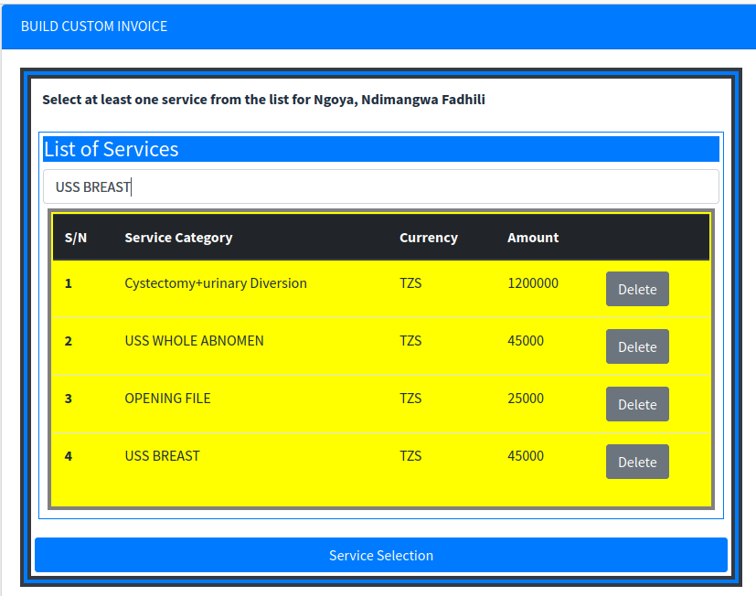
Fig: Service Selection

- Once you have clicked the "Service Selection" button, you have initiated the invoice. Now you can go to the "Default Invoice", and you can now proceed to create your invoice.

Note: What we have done in the "Custom Invoice" is to initiate the Invoice queue, then your custom invoice will be treated just like, a Default Invoice. We can prove this by going to the "Default Invoice", and the following initiation has done as shown in figure below

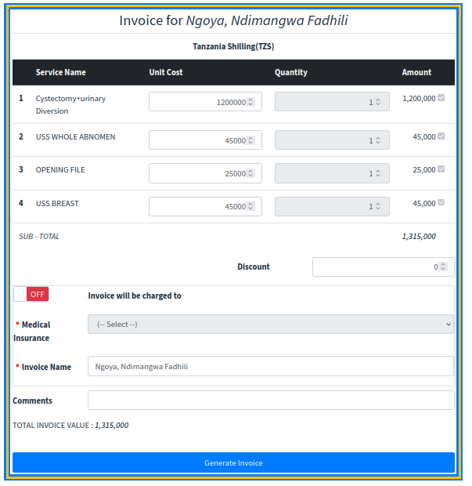
Fig: Our initiated "Custom Invoice", you can follow all steps of "Default Invoice" to raise this invoice.

Payments & Receipts
While in invoices we have "Default Invoice -- System Initiated" and "Custom Invoice -- Manual Initiated",in the "Payments & Receipts" module, we have only System Initiated Receipts. Every time, you create an Invoice (it does not matter which one), the system initiate a receipt queue for a prospective receipts. The system will make sure, each invoice will have a corresponding receipts,an invoice is marked as closed, only if the amount in the invoice, is equal to the total of the corresponding receipts.

To create a receipt, the steps are similar to the generation of a "Default Invoice".
- Open the Finance Module, click on "Finance" menu.
- Click on "Payments & Receipts" submenu.
- Click on the "Generate Receipt" on bottom of the page (bottom-right on the large screens, and bottom on the small screens).
- You will get a list (if any) same like in "Default Invoice", search the Patient Name and click on "Make Payment" agaist the record you need to make payment.
- A window will open as shown below, the system will fill the amount remained for this invoice, you can pay less, and next time pay for the remaining (procedure are the same)
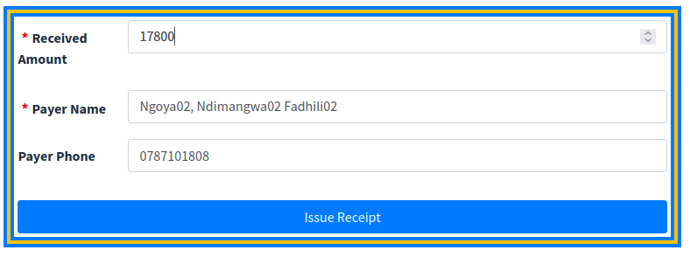
Fig: Filling Receipts details,I have decided to pay less

- If everything is OK, click "IssueReceipt" button, and your receipt will be ready.You can repeat the steps to receive the remained payments or issue another receipt.

Service Categories Sub Module
To access "Service Categories Sub Module" go to "Finance Menu",then click "Service Categories" sub menu and a Service Category page will open as shown below

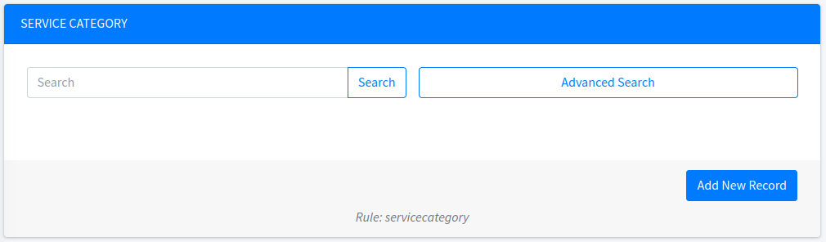
Fig: Service Category page, what is important in the service category is the name of the service category

The figure above, resembles much with the already discussed Patient Module. This system uses the consistency Look and Feel interface, so there is no much to discuss here, all the operation supported in Patient module are supported here too.

Service Module Sub Module
To access "Service Module", go to "Finance Menu", then click "Service sub menu", and a Service page will open as shown.

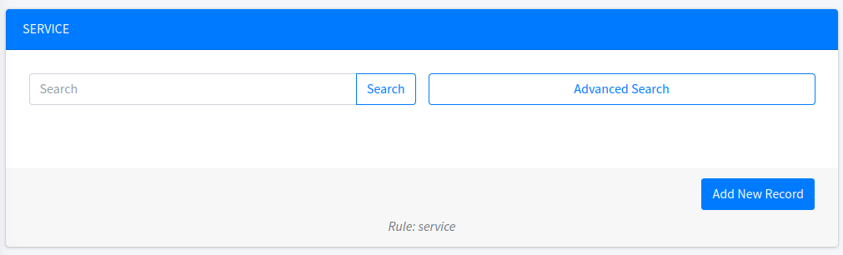
Fig : Service page, looks just like other modules.

As we pointed out service is the backbone of the finance module, it defines how charging should be done. To view the important fields in the Service Submodule, let us click the "Add New Record" button or we can search any service, and click the "Pencil icon" to view Edit/Update page.

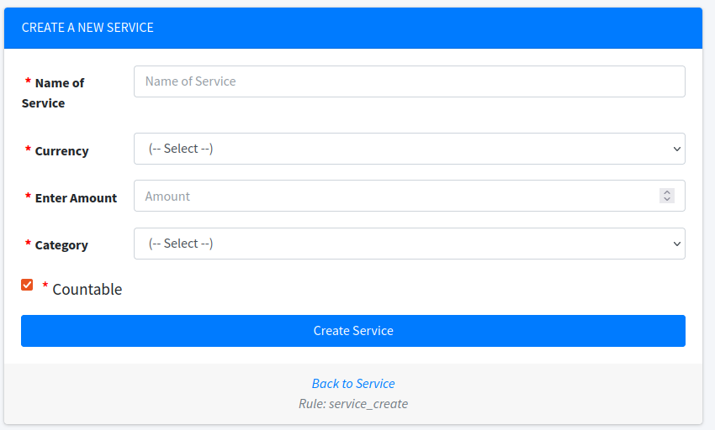
Fig : Service "Add New Page", the similar page will be seen, in "Update/Edit" page.

The service defines the name of the service, currency used for the service, amount for the service, category of the service and if the service is countable. In case the hospital decides to change the cost of the service, you just search the service and update the amount. Note: Services with different currencies, can not be put in one invoice.

The price of the Service has changed, what should I do?
It is simple, search the service and click update icon (Pencil like shape) then save the change. The new price will affect all future invoices. Let us try to change the price of Registration of a new Patient for "large file" from Tsh. 25,000 to Tsh. 27,000.

Here are the steps
- Open the Service Submodule, go to "Finance Menu", then "Service sub menu"
- Search the service, in our case it would OPENING FILE , as shown in the figure below
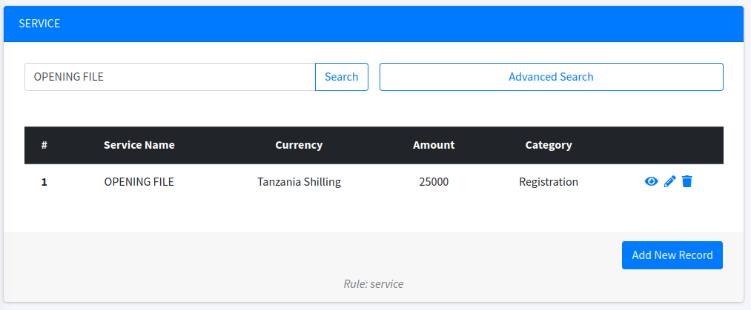
Fig: Searching a Service "OPENING FILE"

- Click on the "Pencil icon" on the right of the row, to open the edit window for the service.

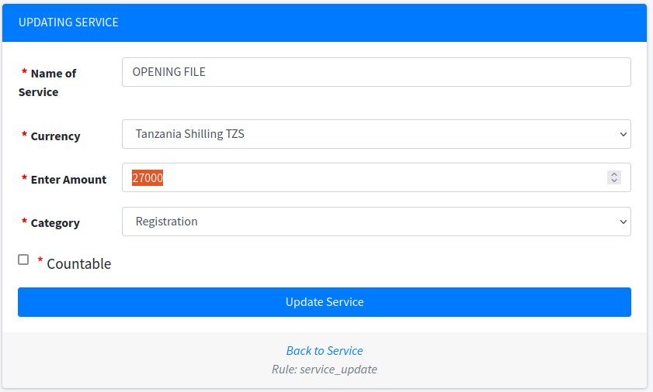
Fig: Edit "OPENING FILE" service, as you can see I have updated to Tsh. 27,000. If I click "Update Service" , then the new value will take effect, and all future invoices will reflect the new amount.
CHAPTER NURSE STATION
One of the key component in this system is the Nurse Station, the nurse station is responsible for all activities carried by nurses. Issues like triage, dressing etc is being done at this part.

Where to get Nurse Station?
On the menu click, Nurse Station, then submenu will open with Triage or Nurse Station (which you will find all other activities, with the exception of triage).
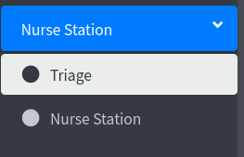

Fig: Nurse Station, comprises of "Triage" and "Nurse Station".

Triage
Triage is a submodule in the "Nurse Station", which is responsible for recording and tracking patient's vital signs.

Under "Nurse Station" menu, click "Triage" submenu, and the triage will open as follows

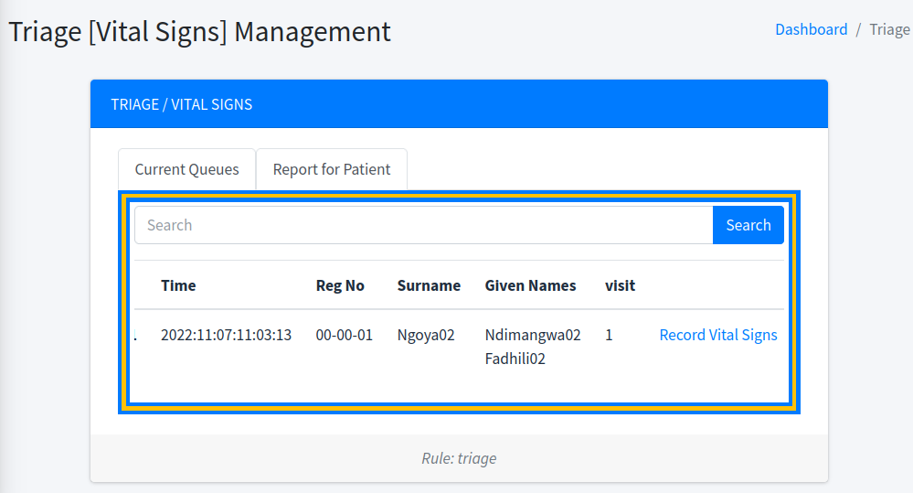
Fig: Home page for triage, showing the current queue for a patient waiting vitals signs recording

As you can see in the figure above, triage will open a default queue of patients who are waiting for their vital signs to be recorded.

Recording Vital Signs
There are two ways of recording vital signs for a patient : -
- Recording Vital Signs from a default queue : - This is the common way, because the system will make sure by default, the client needs to record vital signs prior seeing a medical consultant (or a medical doctor ), as you can see in the triage landing page, there is a queue of patient "Ndimangwa02 Fadhili02 Ngoya02", the system has detected, the client has opened a file, he has paid, and he needs to see the doctor, automatically the system has forced the client to triage.
- Recording Vital Signs on demand : - This feature allows the nurse to record vital signs of a client, at any time (it can be on daily basis, hour basis etc), the system will keep track of each reading, and can produce graphs as the readings increases, this feature will be discussed more under the "Report for Patient" tab.

Recording Vital Signs from a default queue
On the triage default landing page, if there is any patient listed, on the far right hand, click the button "Record Vital Signs", and a page will open as below, just fill as required (Most fields are optional)
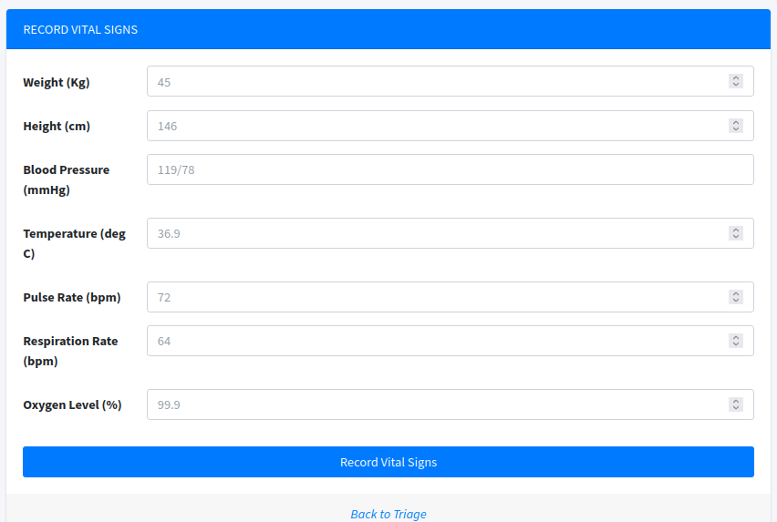
Fig : Vital Signs recording page, after filling just click "Record Vital Signs" button

Once you complete filling and saving the page, the system will forward the patient to the respective medical personnel.

If you noted, while opening the triage submodule, the page opened with two tabs at the top, the one with title "Current Queues" and the other with title "Report for Patient". Now we have gone through "Current Queues", it is time to navigate through "Report for Patient" tab.

Report for Patient tab
Click the "Report for Patient Tab" in the triage submodule, a page like patient module will open, you can search for your desired patient, and click search, the results will resemble mine below : -

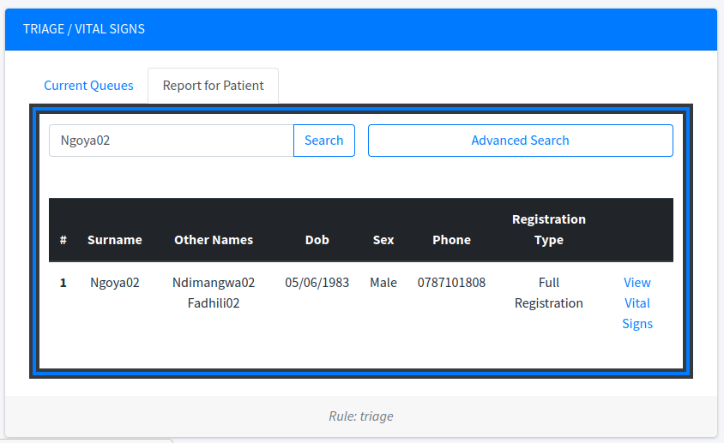
Fig : Report for Patient (This is a vital signs report)

Click on View Vital Signs on the far right against the record of the search patient.

Once you click "View Vital Signs" , a page as follows will open, which will allow you to view report (PDF) or view Vital Signs graphs, the page will also allow you to "Record Vital Signs -- this is what we referred to Record Vital Signs on Demand".

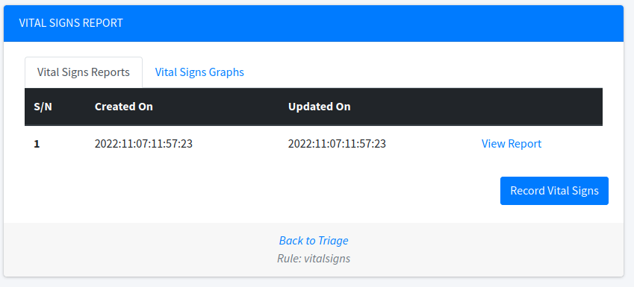
Fig : Vital Signs report, we currently have one report, you may record as many as vital signs for this patient.

You can click on "View Report" against each report to get a PDF report summary of the vital sign.

Let me record at least four vital signs and go to graph, as you can see in the figure below I have recorded, extra three vital signs, so I have a total of four reports
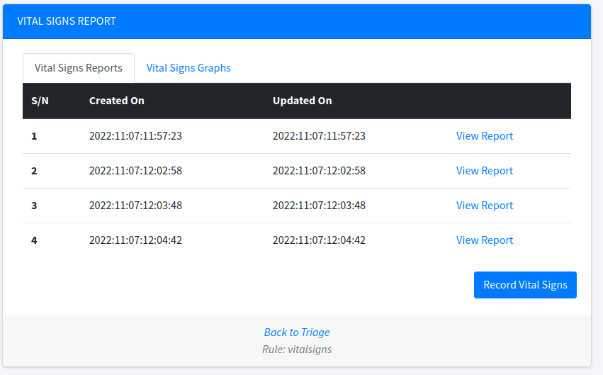
Fig: More vital signs record.

Now, click "Vital Signs Graph" tab, you will have the option to navigate each of the vital signs component.

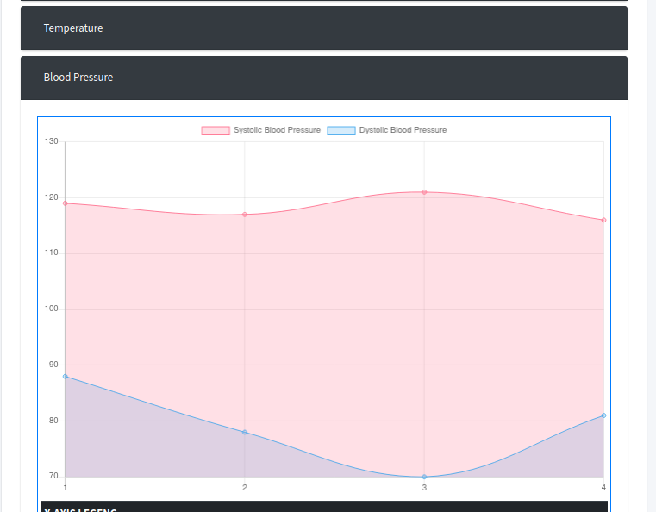
Fig: Graph, example here is the Blood Pressure graph

CHAPTER : DOCTOR CONSULTATION
One of the key module of the system is the Medical Doctor Consultation. This part is the central part of the system. The patient will reach the patient module, if he/she has been recorded vital signs (using the normal default triage queue), or the patient was already in the consultation queue, but has been scheduled for other services like laboratory, radiology, pharmacy, admission or operation. For a patient to cease to be in the consultation queue, is at the point the case is closed.

How do I get Doctor Consultation?
As usual on the Left Hand Side panel, click "Doctor Consultation" menu.
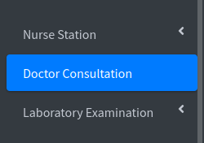

Fig: Doctor Consultation menu (highlighted)

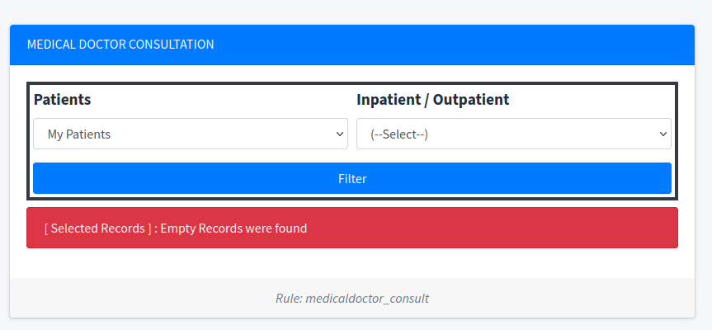
Fig: The default landing page of "Doctor Consultation". The page shows only my patients, which is empty, I will now click drop down to get all patients and click "Filter" button.

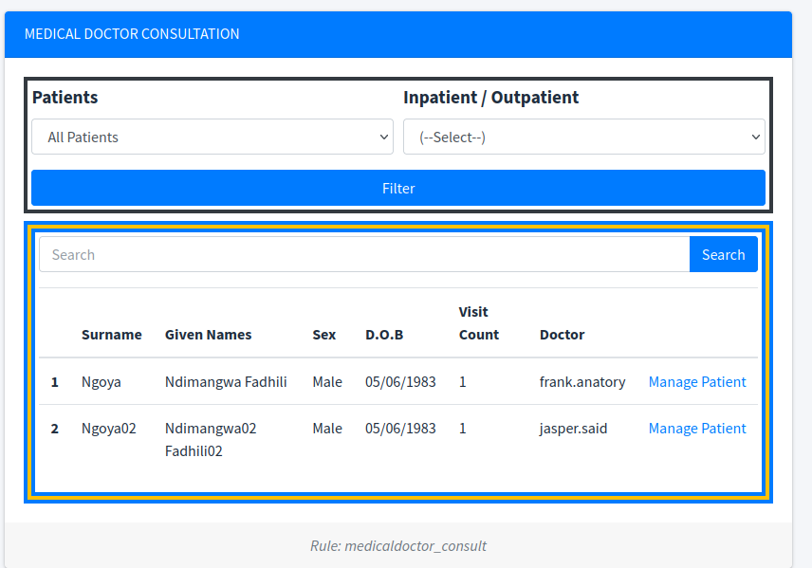
Fig: List of patients who needs medical consultation, or who are still under medical consultation (the list shows also respective assigned doctor, however another doctor can proceed to attend the patient).

As usual, the medical consultant , will search the patient (if the list has less number of patient, no need of searching, they are all visible), against the record of the desired patient, click "Manage Patient", the "Patient Management" form will open, this is where the medical consultant/medical doctor, can fill and request further investigations, and any thing which needs "Medical Doctor" consultation.

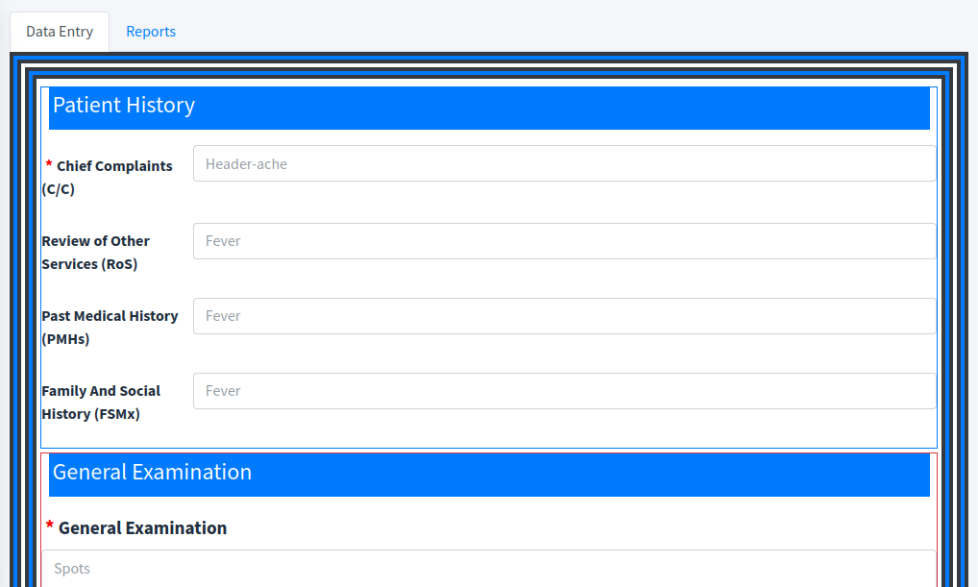
Fig: Part of "Medical Doctor Consultation" form.

In general, the "Medical Consultation", can assist a doctor to "Record Patient Information" as well as viewing reports of the Patient, if attended by other doctors.

A medical doctor, can do the following : -
- Record "Patient History"
- Record "General Examination"
- Record "Vital Signs"
- Record "Local Examination"
- Record "Systemic Examination"
- Record "Provision Diagnosis"
- Request "Examination for Laboratory & Radiology"
- Fill "Working Diagnosis"
- Assign "Drugs" for a patient
- Request "Admission & Operation" for a patient.
- Record general comments for the patient

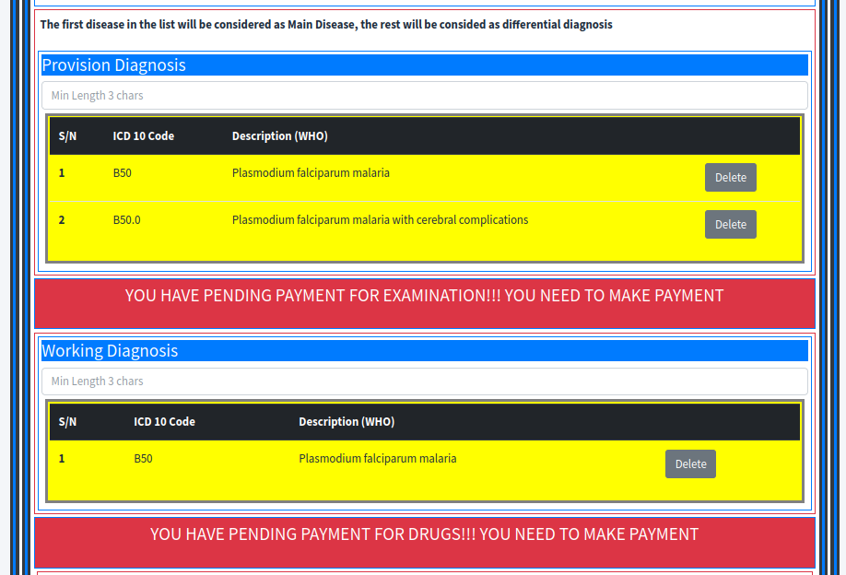
Fig: Part of the submitted patient form (If the service has payments to be done, the form will highlight as shown above, and it will not offer a place to refil)

The "Medical Form" for a patient, is the same as the one filled manually, a doctor who have filled and submitted the form, can revisit later to see the status of the patient. However if another medical personnel, open the same patient's form, he/she will be issued with a new form. Things start to behave a little different for the inpatient, for an inpatient the appearance of the form will be the same, and every medical personnel will get a new form (or open existing if the same medical personnel has attended the patient for the same case), for an inpatient, there is an extra thing, the system will offer you an option of opening a new form even if you have attended the patient, this makes possible to see an admitted patient's progress over time.

