When running the app…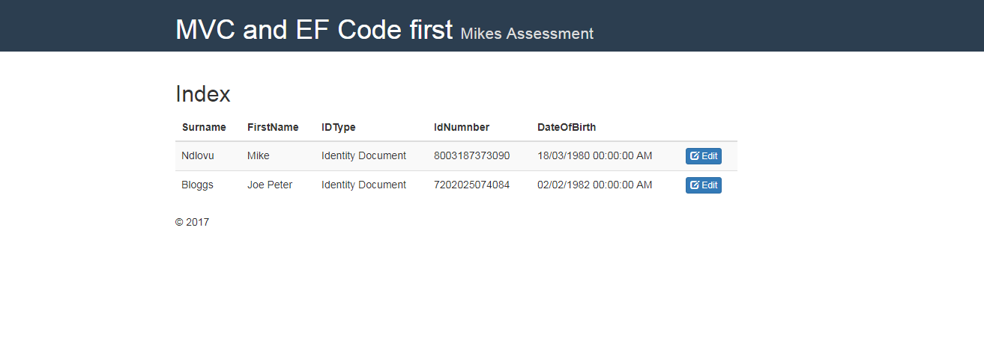

When you click the Edit button, it goes to the below screen

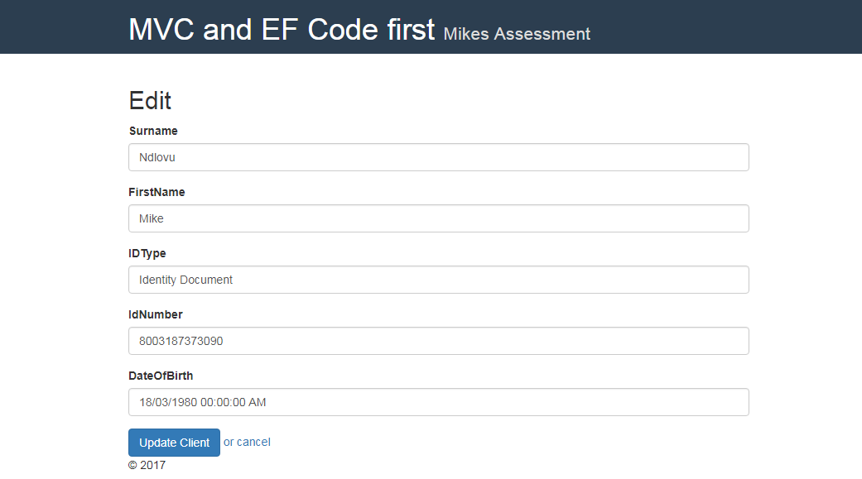

Then on the screen you can update or cancel then it will return to the index page

I have used the following technology

* MVC 4,
* EF 5 code first
* Bootstrap for my styling and css
* Sql Database stored on the local project on the App_Data folder
* Visual Studio 2012