NDONG HENRY NDANG

Buea, SW Region, Cameroon

[ndonghenryndang@gmail.com](mailto:ndonghenryndang@gmail.com)

Summary Guide To

**Data Analysis**

with IBM SPSS Statistics

By NDONG HENRY NDANG.

# Chapter 1

# Basics of Data Analysis

***

“Data are becoming the new raw material of business”

***

* **Data:** it simply refers to facts and statistics collected together for reference and or analysis….

Collecting data is very important and crucial step in the process of data analysis, this is because whatever results are obtained and whatever their interpretations may be will depend solely on the data collected.

Now after getting or collecting data, what do you do with ?...

Remember the essence of every data collected is to get useful *information* which intent enable us get *insights*, hence the process of *data analysis* comes in….

* **Data Analysis:** it is simply the process of talking that data collected and turning it into information that can be used to make strategic decisions.

***

“If you do not know how to ask the right questions, you discover nothing”

***

Take note, ***information*** is simply data that make sense and getting information from our data is not all we desire to achieve….

Data analysis goes beyong that, it actually aims at making sense of all the information we have to find patterns and trends and correlations. It’s a way to get insights that can help you make better decisions, identify opportunities and problems and track progress just to name a few.

***

“Torture the data, and it confess to anything”

***

And its not just for businesses, the Government, non-profit organizations and individuals can benefit from data analysis. *The key is to figure out what questions you want answered and then use the right tools to find the answers…*

***

“The goal is to turn data into information, and information into insight.”

***

* **Basic steps of data analysis:**

1. *Defining your question*, what are you trying to find out?
2. *Gather your data*, this can be anything from surveys, questionnaires, sales figures e.t.c
3. *Analyze your data*, what are the trends or what’s happening in different areas.
4. *Interpret your findings*, what do your results signify
5. *Take action*…

***

“You can have data without information, but you cannot have information without data”

***

* **How can data be used in decision making:** you can use data analysis in a lot of ways but one of the most important is to make informed decision. By understanding what your data is telling you, you can figure out what is working and what is not working and adjust your strategies accordingly….

For example you are running a market campaign, you can use data analysis to figure out how well its performing, where your leads are coming from and what kind of return on investment you are getting. This information will help you make decisions about whether to continue with the campaign, tweak it or scrap it altogether.

Data analysis is also a great tool for troubleshooting if your experiencing problems with your business, data analysis can help you identify the root cause and find solutions.

***

“Data is the new science. Big data holds the answers”

***

* **Nature of data:** data can be *Quantitative* or *Qualitative*.

*Quantitative data* is any data that can be counted or is data that are in form of values or counts and expressed as numbers for example age, weight or even height. *Qualitative* *data* is descriptive referring to things that can be observed but not measured. For example gender (male or female), yes or no…

1. **Quantitative data:** can be further divided into two;
2. **Discrete quantitative data:** takes on fixed numerical values and cannot be broken down further, it usually represent a whole (precise) number, for example the number of people in a hall or number of books on the table.
3. **Continuous quantitative data:** can contain in between values such as decimals, for example, height in cm or temperature in degree.
4. **Qualitative data:** which can be nominal or ordinal
5. **Nominal data:** is used to label or categorize certain variables without any order or hierarchy, for example, gender is a nominal variable because there is no order whether male is to come before female and vice versa
6. **Ordinal data:** is when the categories used to classify your qualitative data falls into a natural order, for example, level of education would be ordinal because to be in secondary school you must go through primary school or to be in class 4, you must have passed the lower classes which gives a certain hierarchy in naming the variable.

* **Pictorial Summary:**

***Steps of data analysis***

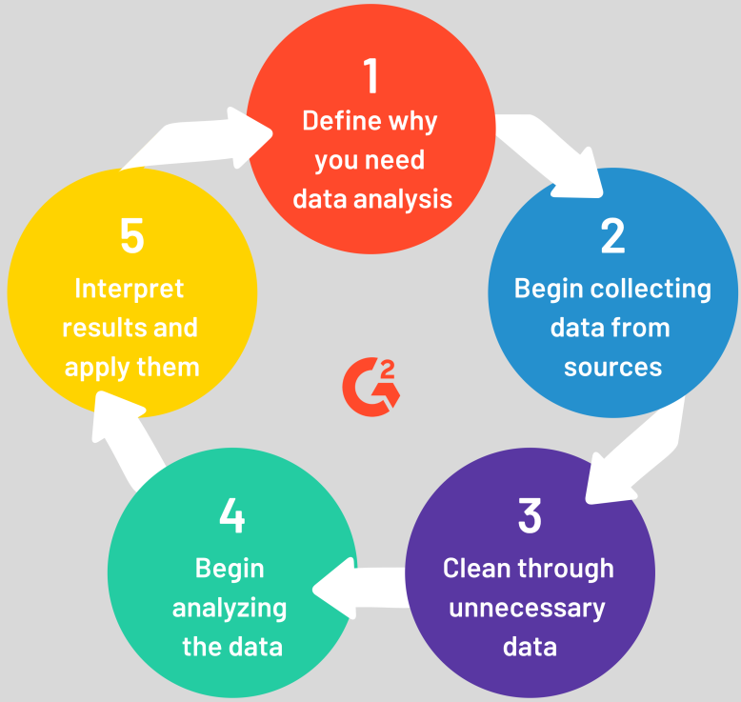

**Classification of data:**

