House Price Prediction with Multiple Linear Regression
Machine Learning | ETT Y4 BTech | Rwanda Polytechnic, Kigali College
Item | Details
Student name | Ndongozi Chris Arsene
Student REG | 26RP00610
GitHub repository | PASTE LINK HERE
Live app | PASTE STREAMLIT LINK HERE

1. Introduction and Objective
A real-estate agency in Rwanda wants a fast way to estimate the market price of a house from a few simple facts: floor area, bedrooms, bathrooms, age, distance to the city centre, parking spaces and neighbourhood. The objective of this project was to clean the agency's raw sales data, train a multiple linear regression model in scikit-learn, save it as house_price_model.sav, and publish it as a Streamlit web app so an agent can type in a house and see the predicted price in million RWF straight away.

2. Data Cleaning
The raw file had 125 rows. It contained blanks, repeated records and a few impossible values, so I inspected it with info(), describe(), boxplots and the IQR rule before modelling. After cleaning, 117 rows remained. Table 1 lists every decision.
Problem found | Where | Action taken | Reason
Missing value | House price (1 row) | Row dropped | A house with no price cannot be used for training
Missing values | Area, Bedrooms, Bathrooms, Age, Distance, Parking, Neighborhood (1 to 2 each) | Median (numbers) or most frequent (category) inside the pipeline | Keeps the rows; learning the fill value from training data only avoids leakage
Duplicate records | Houses 1011, 1026, 1041 repeated at the end of the file (5 extra rows) | Extra copies removed | Repeats would inflate performance
Impossible area | Area = 850 and 1200 m² | Set to blank, then imputed | Likely decimal typos; the rest of each row is fine
Impossible distance | Distance = 85 km | Set to blank, then imputed | Far outside the range of every other house
Impossible price | Price = 950 and 1200 | Rows dropped | Target is wrong and the true value is unknown
Text category | Neighborhood | One-hot encoding, one level dropped | Regression needs numbers; avoids the dummy-variable trap
Identifier | House_ID | Excluded from predictors | A label with no predictive meaning
Table 1: Cleaning decisions
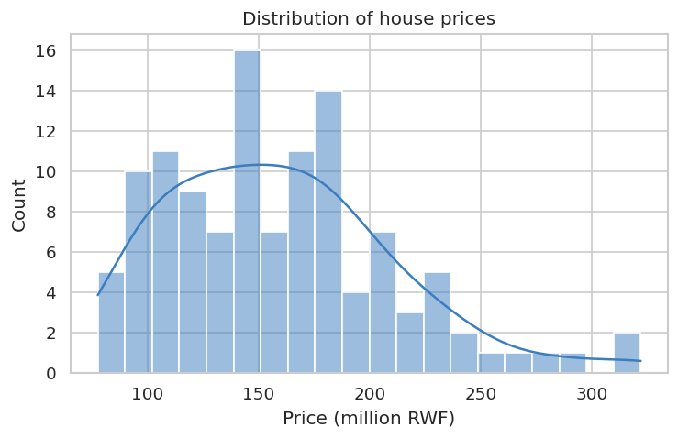
Figure 1: Most houses sell between roughly 100 and 200 million RWF, with a tail of expensive ones.
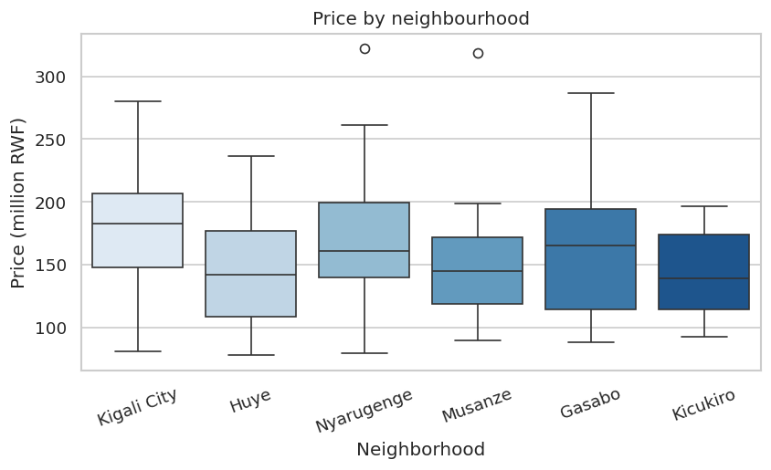
Figure 2: Kigali City has the highest typical price; Huye and Kicukiro sit lower.

3. Model Results
The predictors were split 80/20 into training (93 rows) and test (24 rows) sets with random_state=42. A scikit-learn Pipeline combined median/most-frequent imputation, one-hot encoding of Neighborhood (Gasabo as the dropped reference group) and LinearRegression, so the saved file predicts directly from raw inputs. The intercept is 35.23.
Variable | Coefficient
Area_m2 | 0.5229
Bedrooms | 2.5736
Bathrooms | 17.9817
House_Age_Years | -0.6234
Distance_to_City_km | -0.8867
Parking_Spaces | 7.4503
Neighborhood_Huye | -13.3318
Neighborhood_Kicukiro | -8.2010
Neighborhood_Kigali City | 22.6215
Neighborhood_Musanze | -9.4880
Neighborhood_Nyarugenge | 10.4429
Table 2: Regression coefficients (million RWF)
Set | R² | Adjusted R² | MAE | RMSE
Train | 0.8595 | 0.8404 | 14.83 | 18.47
Test | 0.8191 | 0.6533 | 18.92 | 23.26
Table 3: Evaluation metrics (MAE and RMSE in million RWF)
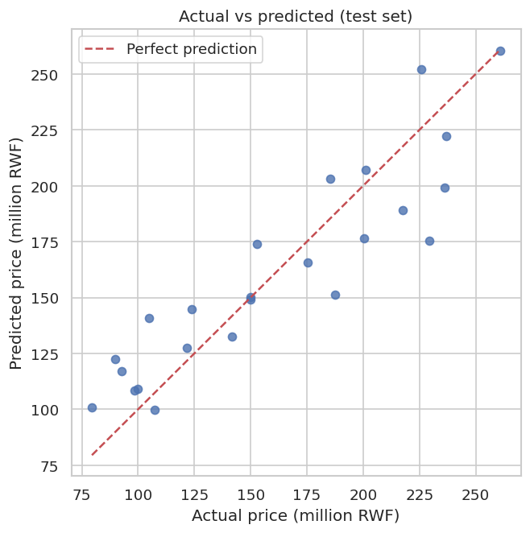
Figure 3: Actual vs predicted prices on the test set; points close to the dashed line are good predictions.
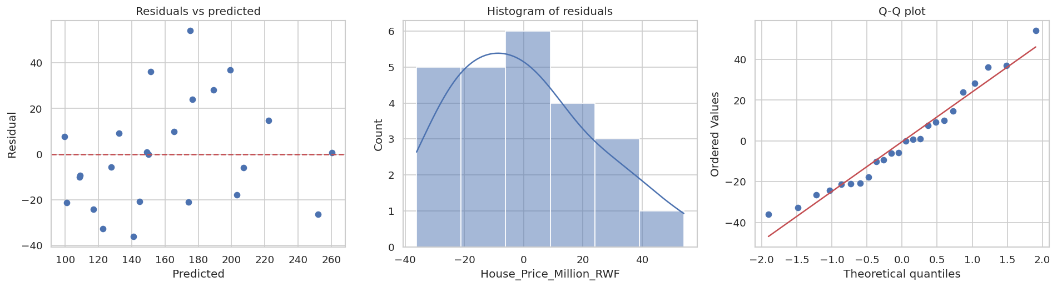
Figure 4: Residual diagnostics: no clear pattern, roughly normal, slight right skew.
Interpretation (holding everything else constant): each extra square metre adds about 0.52 million RWF; each extra year of age lowers the price by about 0.62 million RWF; and a house in Kigali City costs about 22.6 million RWF more than an identical house in Gasabo. The Bathrooms coefficient (about 18.0) is large partly because Bedrooms and Bathrooms are strongly related (correlation 0.93, VIF about 7.9), so the model shares their joint effect unevenly.
Assumptions: linearity, independence (Durbin-Watson about 2.04) and normal residuals (Shapiro-Wilk p about 0.44) are reasonably satisfied. Variance looks roughly constant, though 24 test points make that hard to judge. Multicollinearity is moderate, limited to the Bedrooms and Bathrooms pair. The test R² of 0.82 is close to the training R² of 0.86, so overfitting is mild.

4. Streamlit App
The app (app.py) loads the model once with @st.cache_resource, offers input widgets for all seven features, builds a one-row DataFrame with the training column names, and shows the predicted price in million RWF. It warns the user when area, age or distance fall outside the training range.
SCREENSHOT 1: the app running locally (streamlit run app.py) showing a prediction.
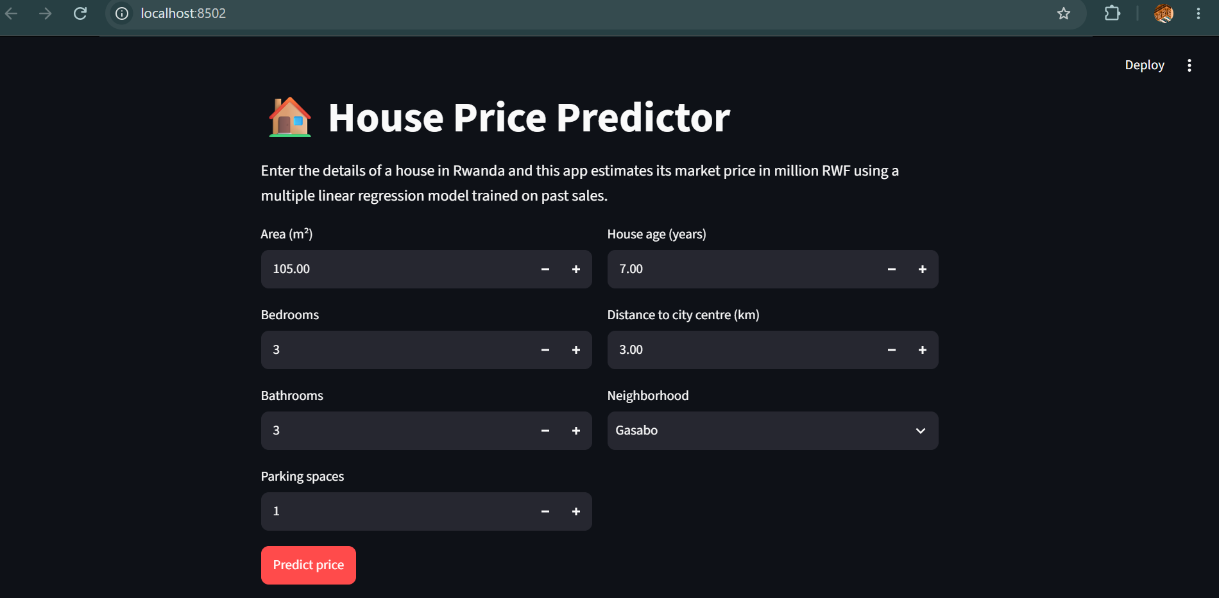

SCREENSHOT 2: the online app on Streamlit Community Cloud showing a prediction.
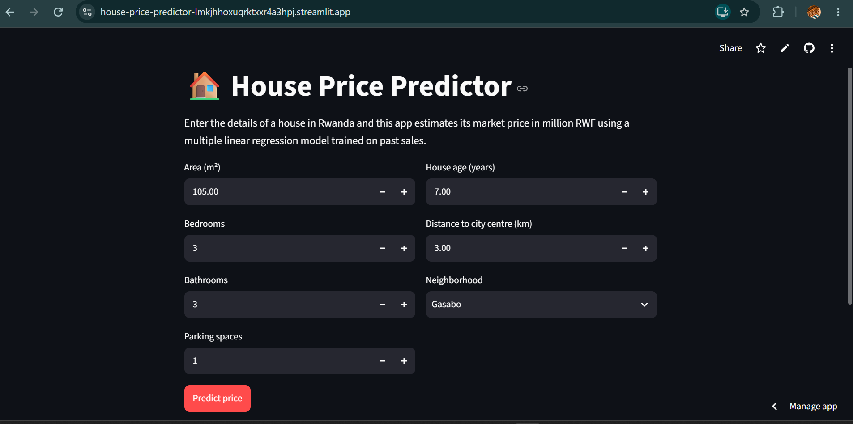

5. Conclusion, Limitations and Improvements
The model explains about 82% of the price variation on unseen houses, with a typical error of about 23 million RWF, which is good enough for a quick estimate tool but not for a valuation.
Limitations: (1) the dataset is small (117 rows, 24 in the test set), so results can shift with a different split and the Bedrooms and Bathrooms coefficients are unstable; (2) a straight-line model cannot capture interactions or diminishing returns, and it should not be trusted outside the training ranges, for example above 430 m² or for houses older than 50 years.
Ideas for improvement: collect more sales, combine or drop one of Bedrooms and Bathrooms, add interaction terms such as Area × Neighborhood, use cross-validation for steadier metrics, try Ridge regression or tree-based models, and add features such as plot size, finishing quality and year of sale.

