Nama : Drupadi Ginaris Shantanu

NIM : 0920240001

Kelas : RPL 2B

Konsep OOP yang digunakan :

1. Class dan Object
   1. Class
      1. Class Capybara pada file Capybara.cs

* 1. Object
     1. Object Masbro pada file Program.cs



* + 1. Object Mainan pada file Capybara.cs



1. Constractor

Constractor Capybara diinisiasi di file Capybara.cs

* 1. Constractor Capybara diinisiasikan pada file Capybara.cs

* 1. Constractor Peliharaan diinisiasikan pada file Peliharaan.cs

1. Encapsulation dan Data Hiding
   1. Properti kenyang di encapsulasi di file Capybara.cs

* 1. Properti senang di encapsulasi di file Capybara.cs

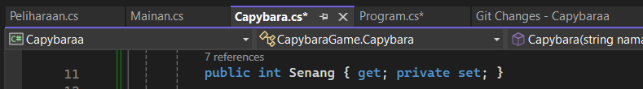

* 1. Properti peliharaan di encapsulasi di file Peliharaan.cs

1. Inheritance
   1. Pewarisan class peliharaan terjadi di file Capybara.sc

* 1. Pewarisan base class abstrak

1. Polymorphism
   1. Methode TampilkanAksiUnik Override, terletak pada file Peliharaan.cs

* 1. Methode BeriMakan Overload, yaitu terdapat 1 methode dengan 2 parameter yang berbeda, terletak di file Capybara.cs

* 1. Methode TampilkanAksiUnik Override, terletak pada Capybara.cs

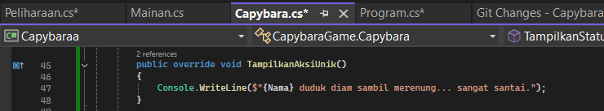

1. Composition
   1. Capybara memiliki objek “Mainan” di file Capybara.cs

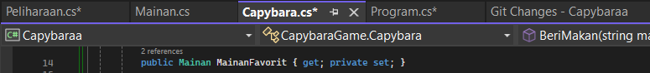

* 1. Class Mainan merupakan bagian dari kelas Capybara

