8050 Relay Control Circuit and Software Development
Flowchart
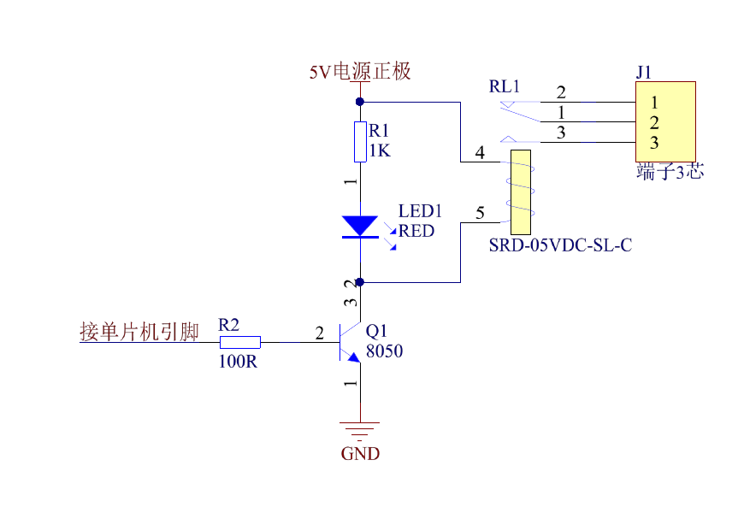
The relay module program is also very simple and only involves high and low logic levels. The transistor used here is the 8050, which turns on under a high-level signal. When the relay needs to be closed, the microcontroller only needs to output a high level to the transistor, which then drives the relay to close. When the microcontroller outputs a low level, the relay disconnects.
The flowchart is shown below:
