Prompt 1: is there any tool in figma that can generate wireframes? can you just generate it in figma if I connect you
Not fully, no. There’s a Figma connector you can add, but its tools are built for reading designs you already have and for making FigJam diagrams. It can’t draw editable app screens into a Figma design file from scratch, so it won’t take the wireframes off your hands. Connecting it also needs you to sign in to your Figma account and approve access, which only you can do. Once connected, I can read a Figma file you link (take screenshots, inspect layers and styles, check your screens against the use cases), but I still can’t create the screens inside Figma.
Two ways to get close:
- Import as editable layers (recommended). I export each screen as a standalone HTML file. You then pull them into Figma with a community plugin such as html.to.design, which turns a page into real frames, text and auto layout. Expect to tidy things up afterwards: fonts, a few spacing values, and renaming layers.
- Trace over images. Export the screens as PNG, drop them into Figma, lock them and redraw on top. It’s slower, but you get clean, hand-built components.
If you want option 1, I can make the HTML files whenever you’re ready.
Prompt 2: ok do the html. here is our use case file, make the wireframes for section 8
I’ve built the wireframes from the use case document. There are 17 screens, greyscale, 1440 wide (Figma Desktop, 1440 × 1024), one row per user. A screen that several users share has one number: no suffix is the main user’s version, b is the Administrator’s and c is the Technician’s. Button labels and status names are taken from the main flows and business rules in the document:
Screen | Use case | What it shows
S01 Forum (S01, S01b, S01c) | UC-01, UC-02, all actors | Approved reports as a feed with status, category, location and technician(s); search, sort and filters. Requester: Create Report and My reports. Administrator and Technician versions have their own header
S02 Create report | UC-01 | Title, Description, Photos and files on the left; Location (Campus › Block › Floor › Room), Tags and “What happens next” on the right; error messages; Submit report
S03 Report detail (S03, S03b) | UC-02, UC-04, UC-06, UC-08 | Status (Assigned → In progress → Closed), priority, technician(s), activity. Requester: Edit Report (author only). Administrator: Set priority, Reassign technician(s)
S04 Edit report | UC-02 | Same form as Create report, prefilled; “What happens next”: the report is hidden and its work order paused until the edit is approved ([Updated], back to Assigned) or rejected (original restored)
S05 Work order history (S05, S05b, S05c) | UC-08 | Closed work orders, resolved or not resolved, who closed them and when; tabs with counts, filters, search
S06 Review reports | UC-03, UC-04, UC-06 | Queue of pending reports; New version / Old version tabs for edited reports; Set priority *, Technician(s) *, Approve & send work order (greyed out until both are set), Reject with a reason
S07 Assign work order (pop-up) | UC-04 | Technician(s) dropdown with chips, notes for the technician(s), error messages, Assign
S08 Maintenance checklist (S08, S08b) | UC-05, UC-07 | Board with Assigned and In progress columns, sorted by priority, “Show [N] more”. Technician: own work orders. Administrator: all open work orders, filters for technician and priority
S09 Work order detail (S09, S09b) | UC-05, UC-07 | The report, the administrator’s notes, Status + Save changes, priority and technician(s), Close Work Order
S10 Close work order (pop-up) | UC-07 | Reason for closure, resolved Yes / No, attachments (required if Yes, max 10 MB each), error messages, Close Order
Report status: Assigned → In progress → Closed. A report waiting for approval is not shown on the forum, and closed reports move to History. The zips contain the screens as standalone HTML files, one folder per user, ready to drop into html.to.design. Set its viewport to 1440 so the frames match.
A few things in the use case document you should tell the author about:
- FR-08 leaves out technicians. It only mentions requesters and administrators, but UC-08 includes technicians and there is a Technician history screen.
- Section 7 has specifications only for UC-01 to UC-07. UC-08 has screens but no specification to check them against.
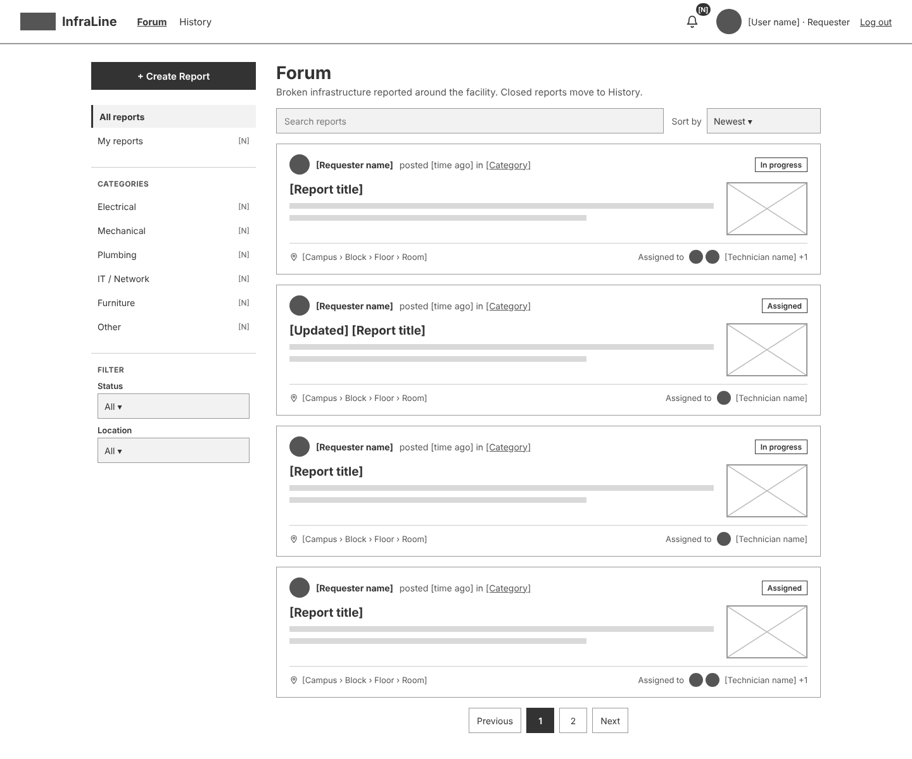
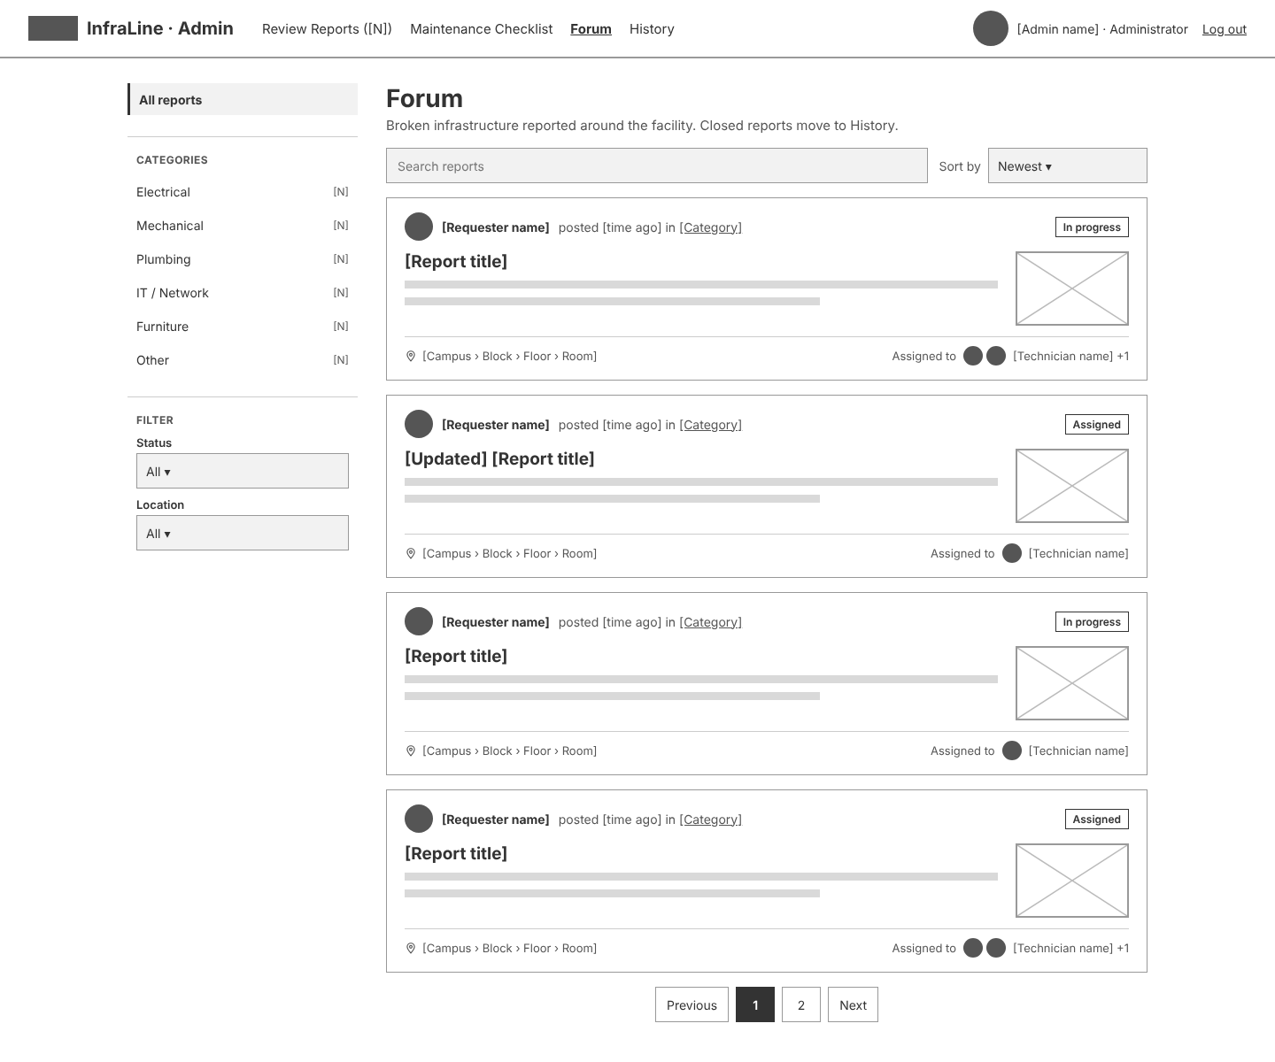
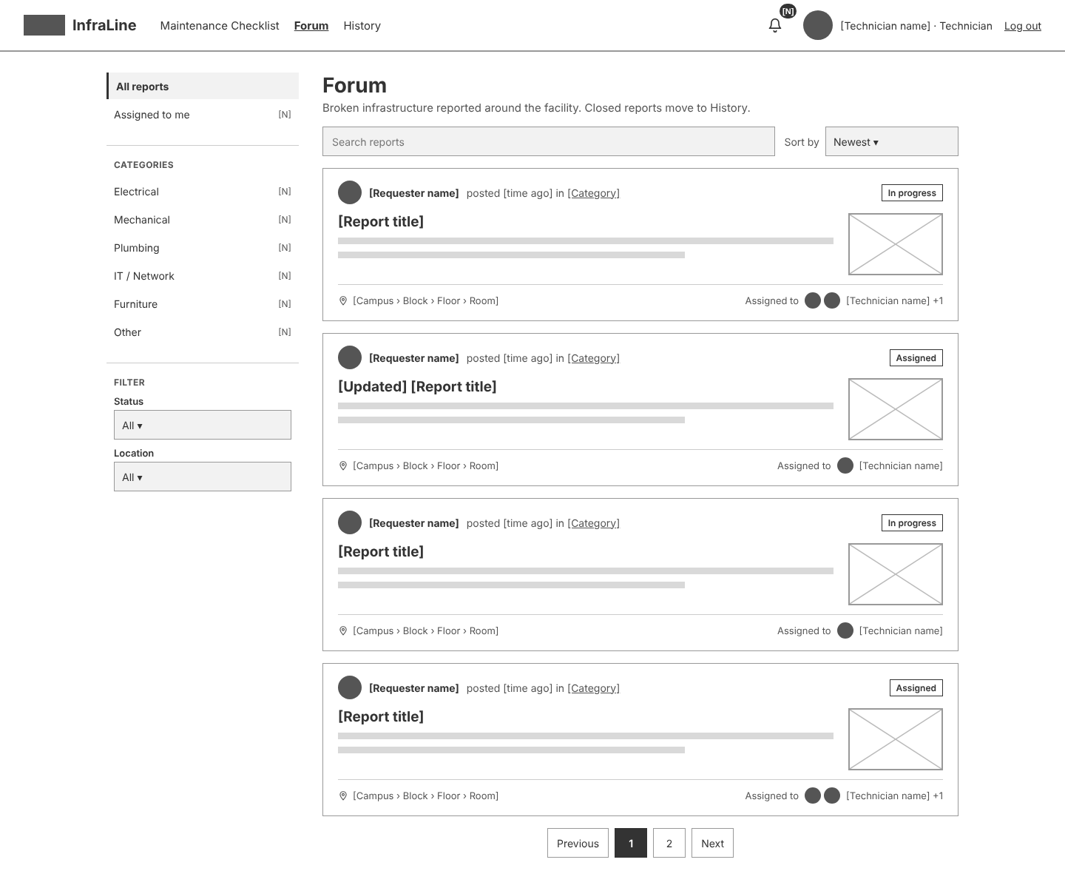
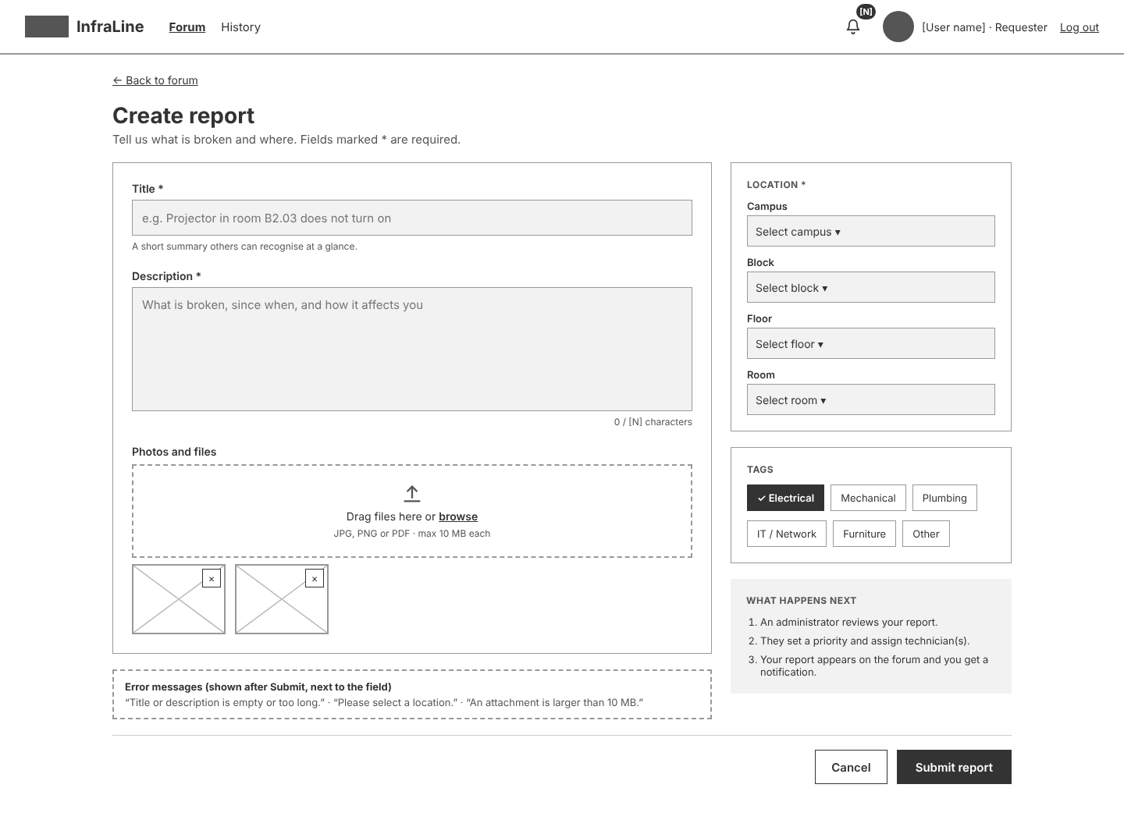
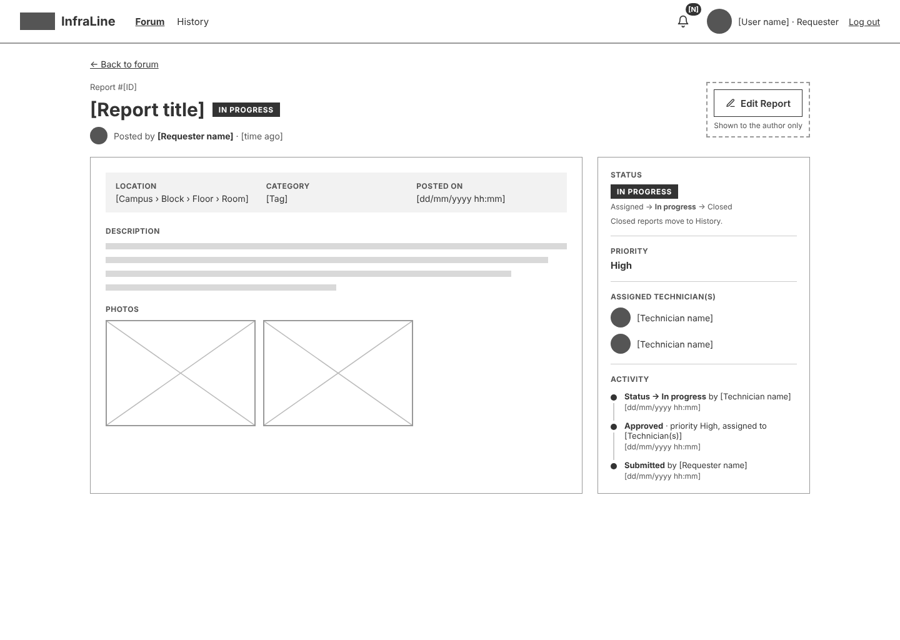
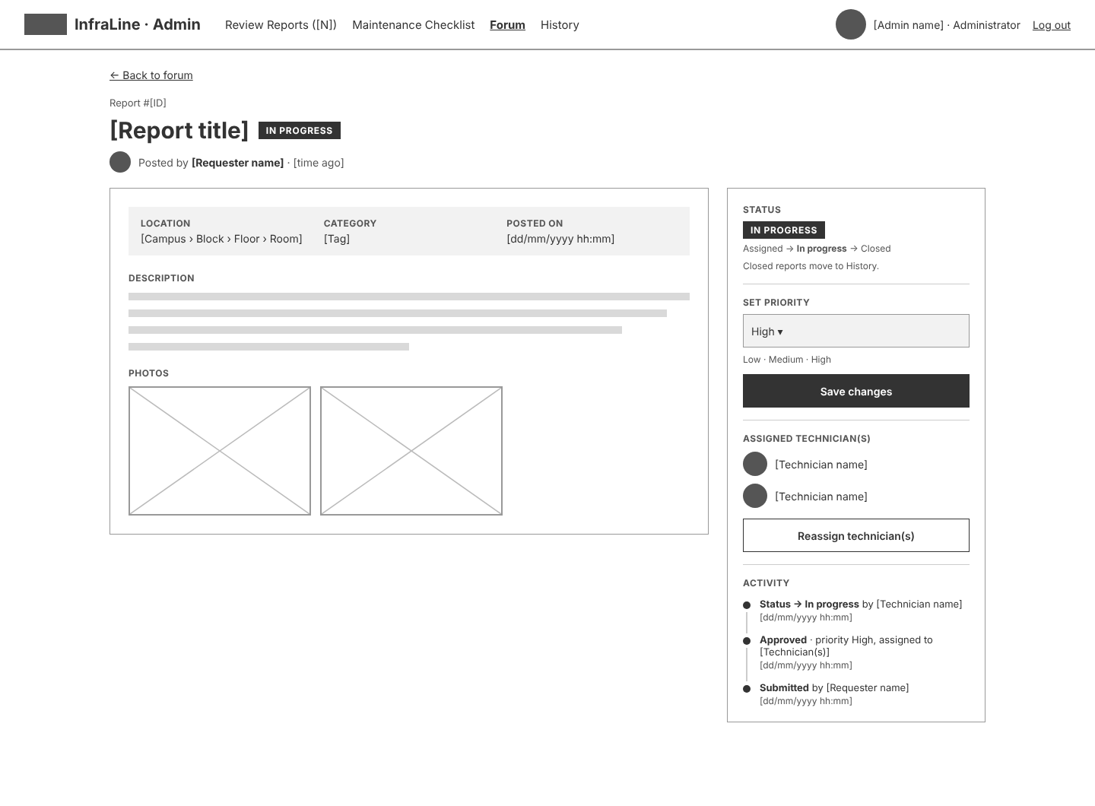
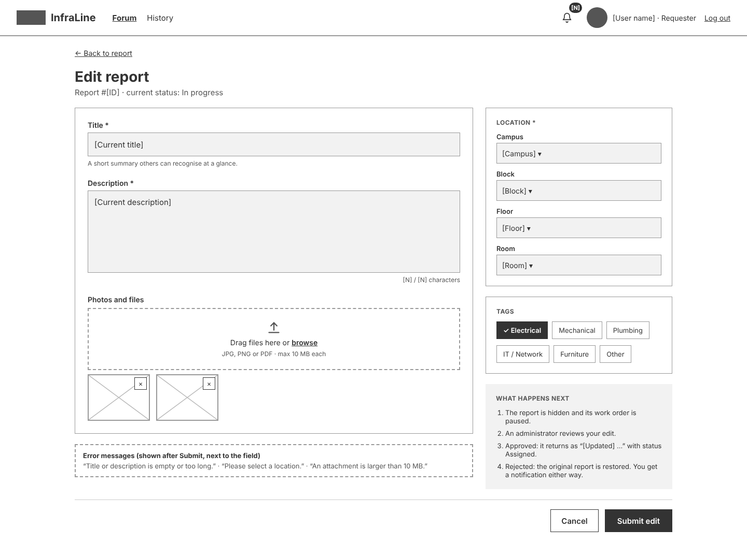
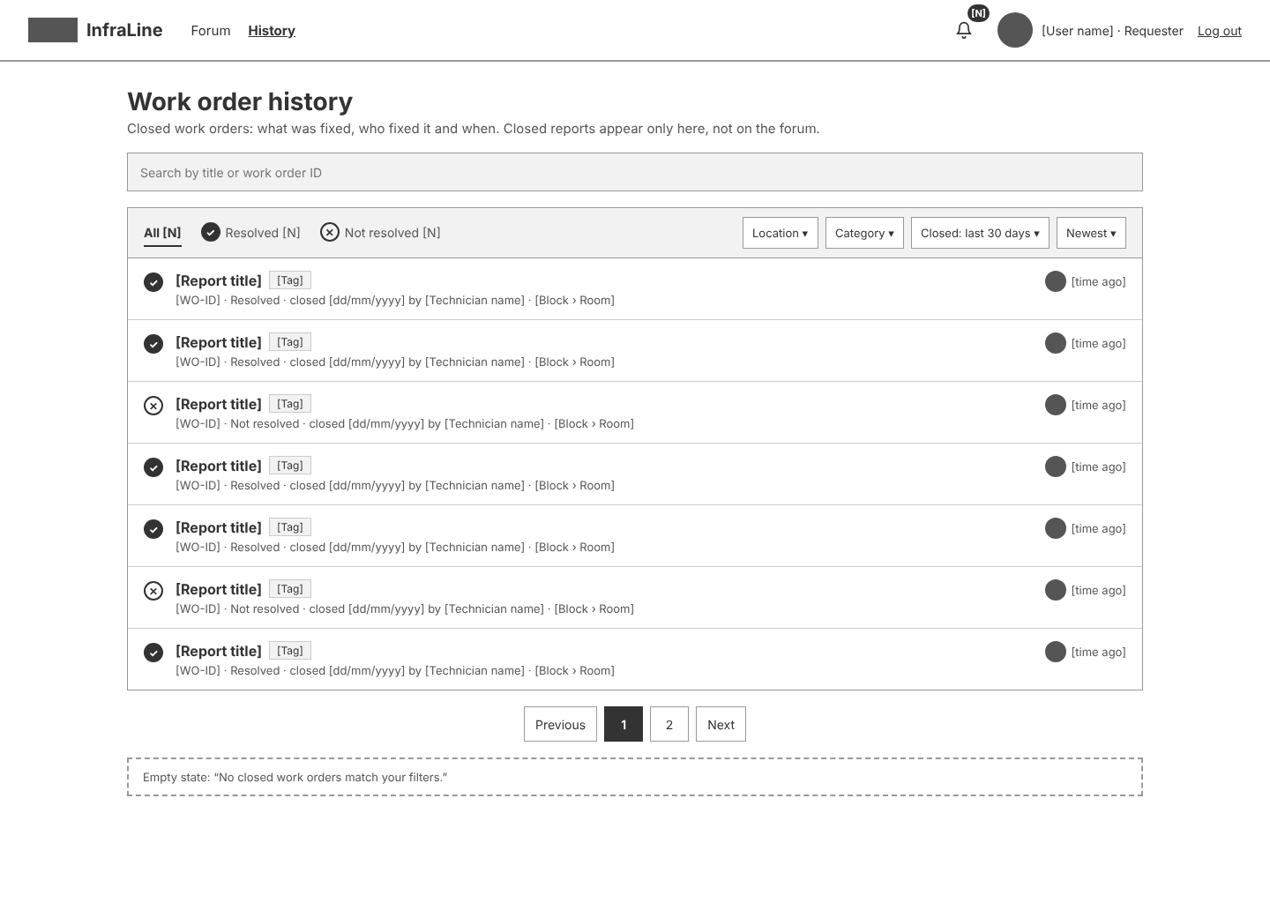
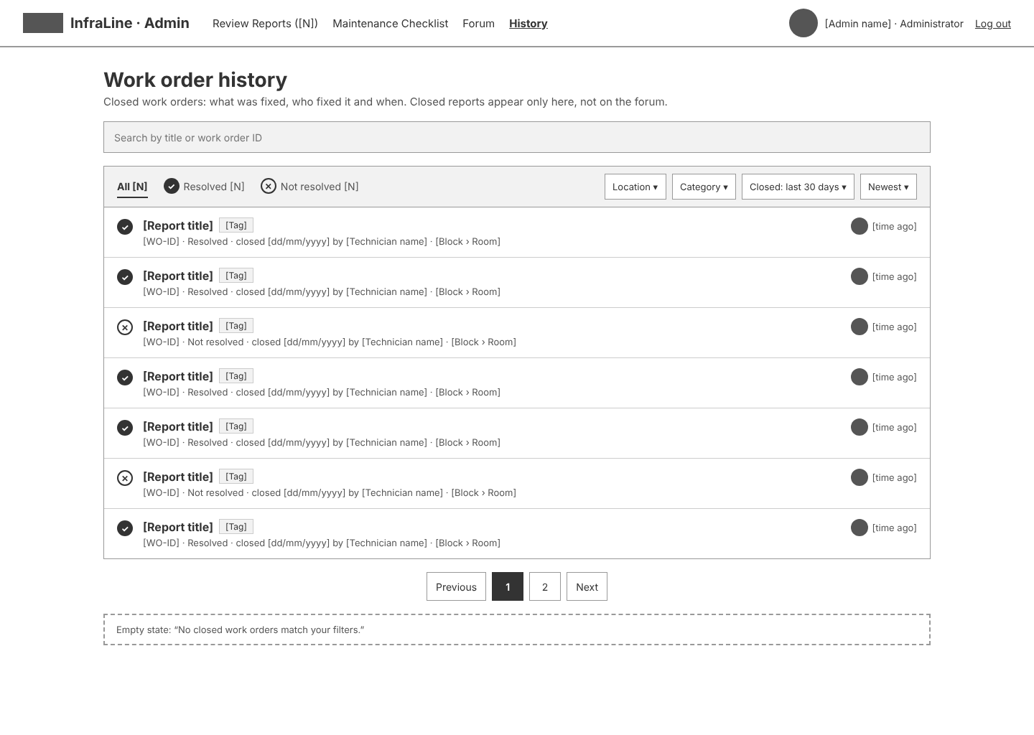
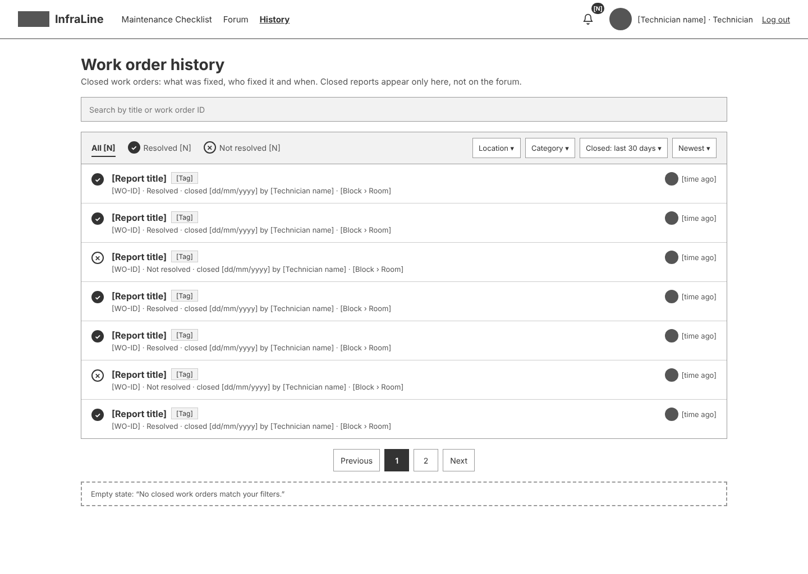
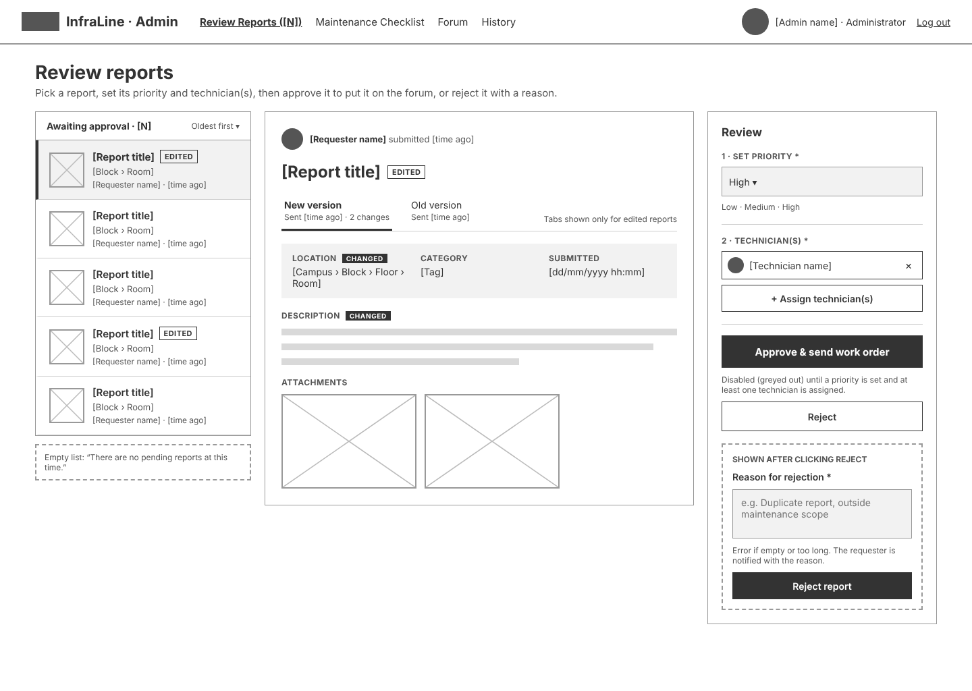
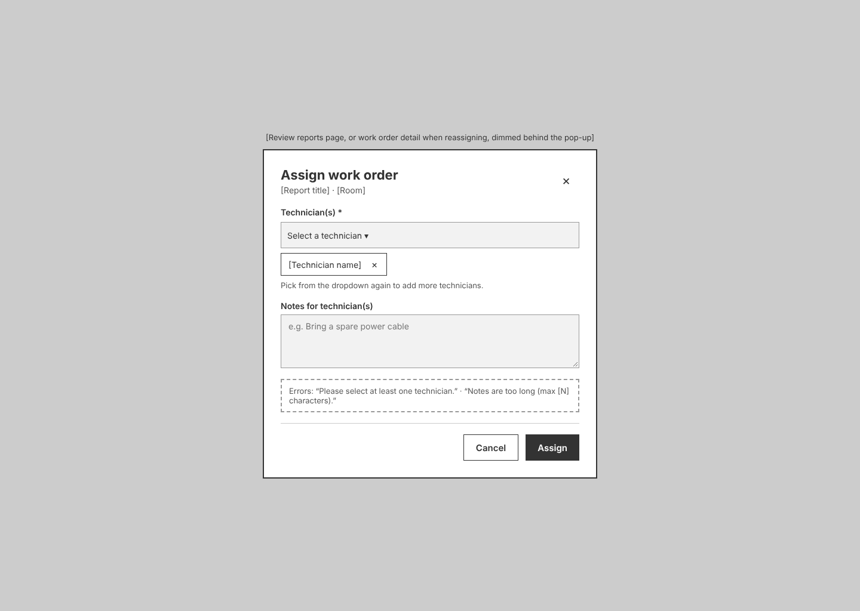
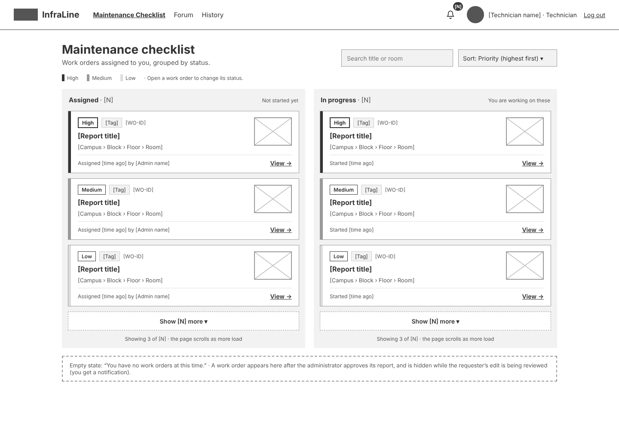
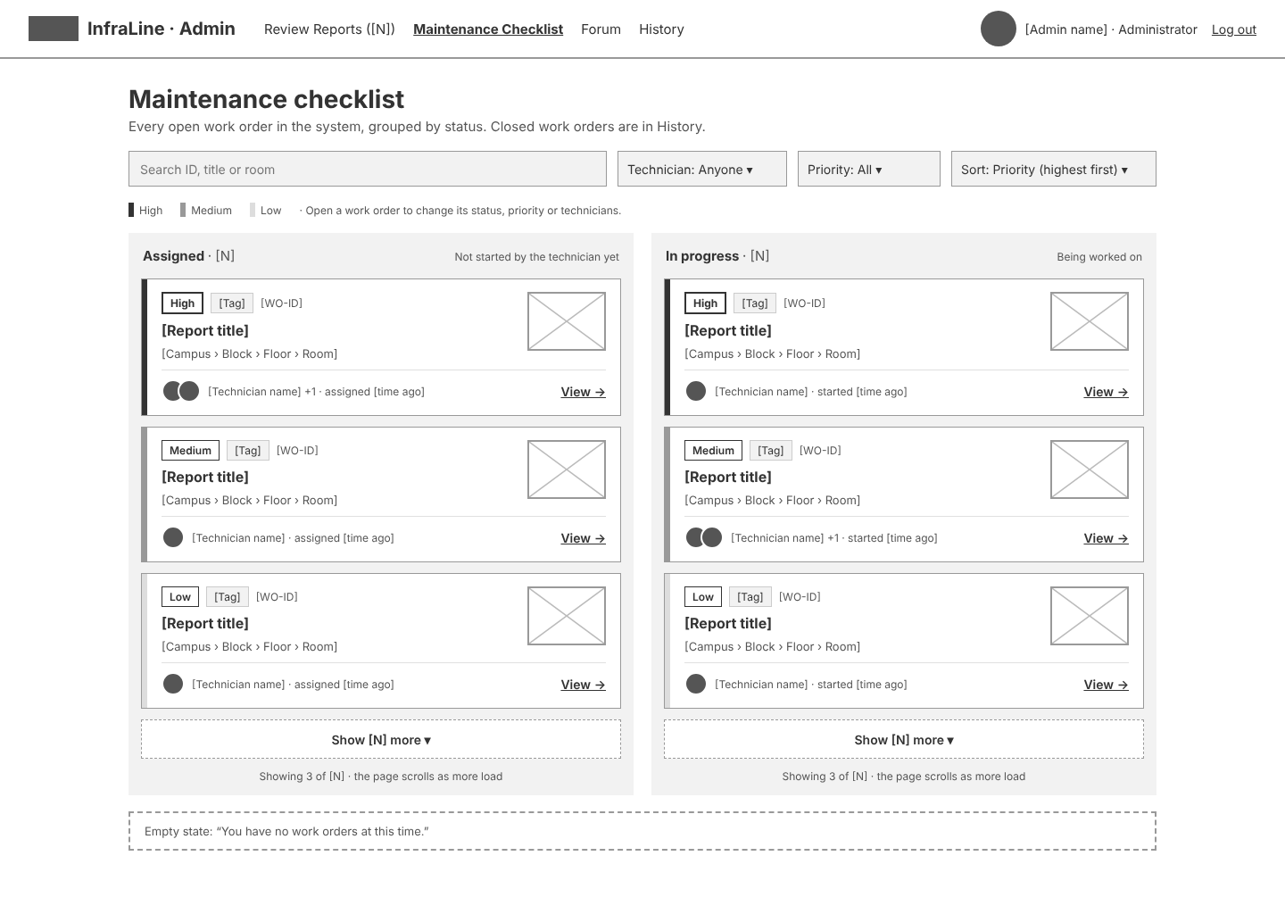
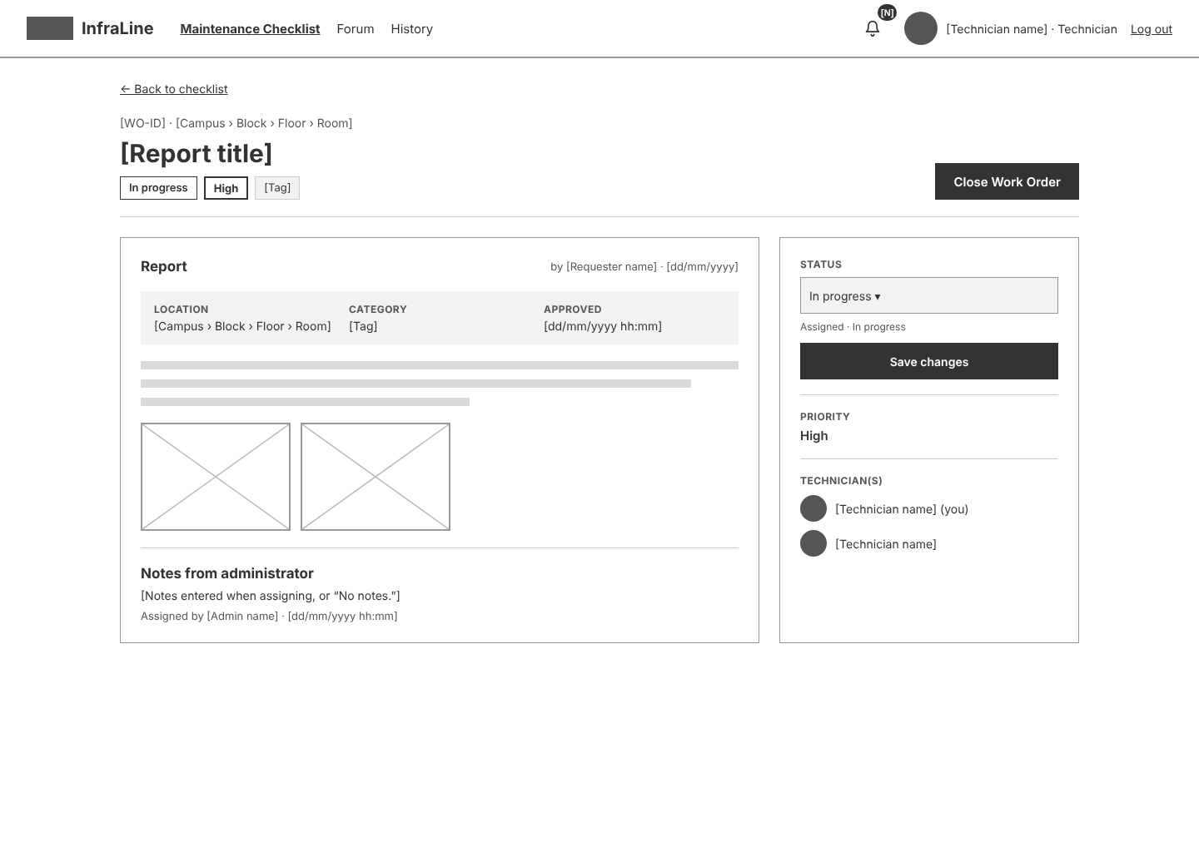
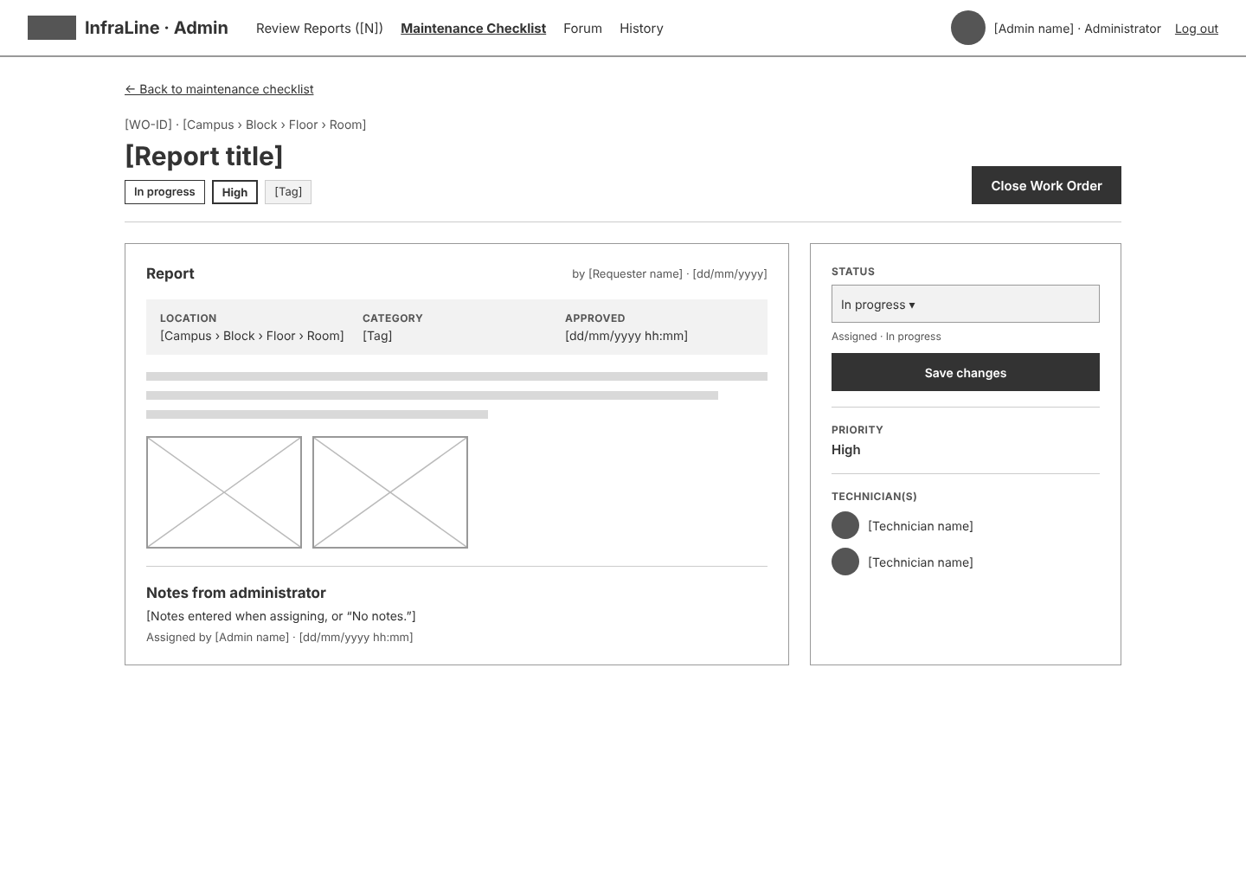
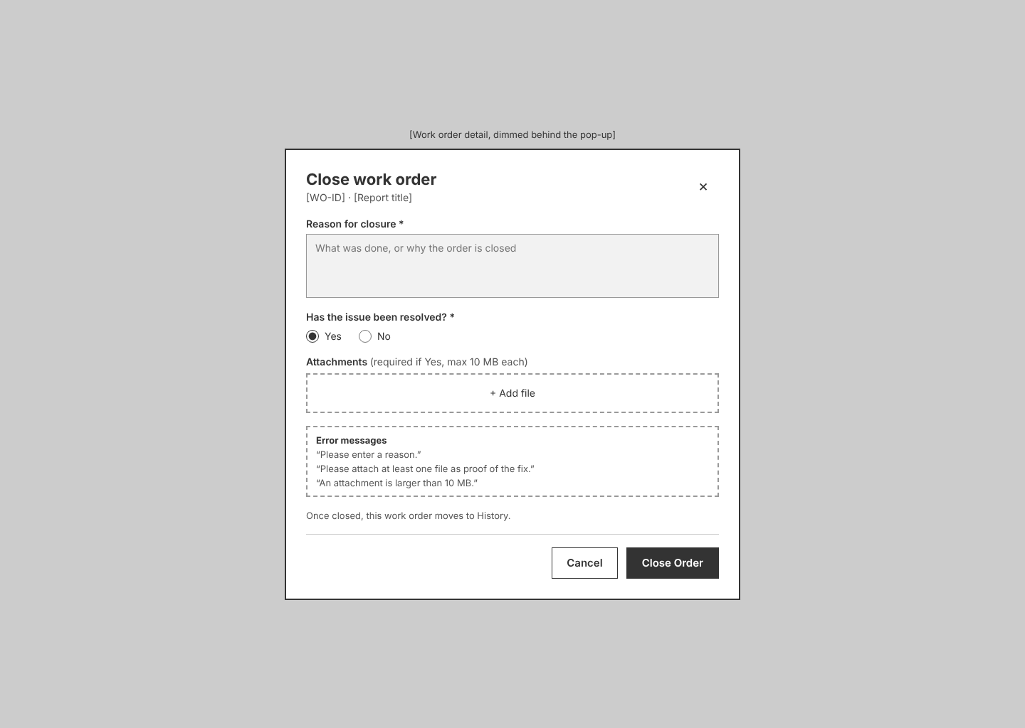
Prompt 3: wait why are some screens bigger than the others? can you keep them all at the standard 1440 × 1024
The taller frames were the screens with more content than one screen: the three Forum screens (1200), Edit report (1080), and Create report and Report detail – Administrator (1060). I fitted all of them into 1440 × 1024:
- Forum (all three versions): three posts plus the pagination instead of four.
- Create report and Edit report: a shorter description box and slightly tighter spacing. In Edit report, the “What happens next” list is written more briefly with the same meaning.
- Report detail – Administrator: the content already fit, so only the frame size changed.
All 17 frames are now exactly 1440 × 1024.
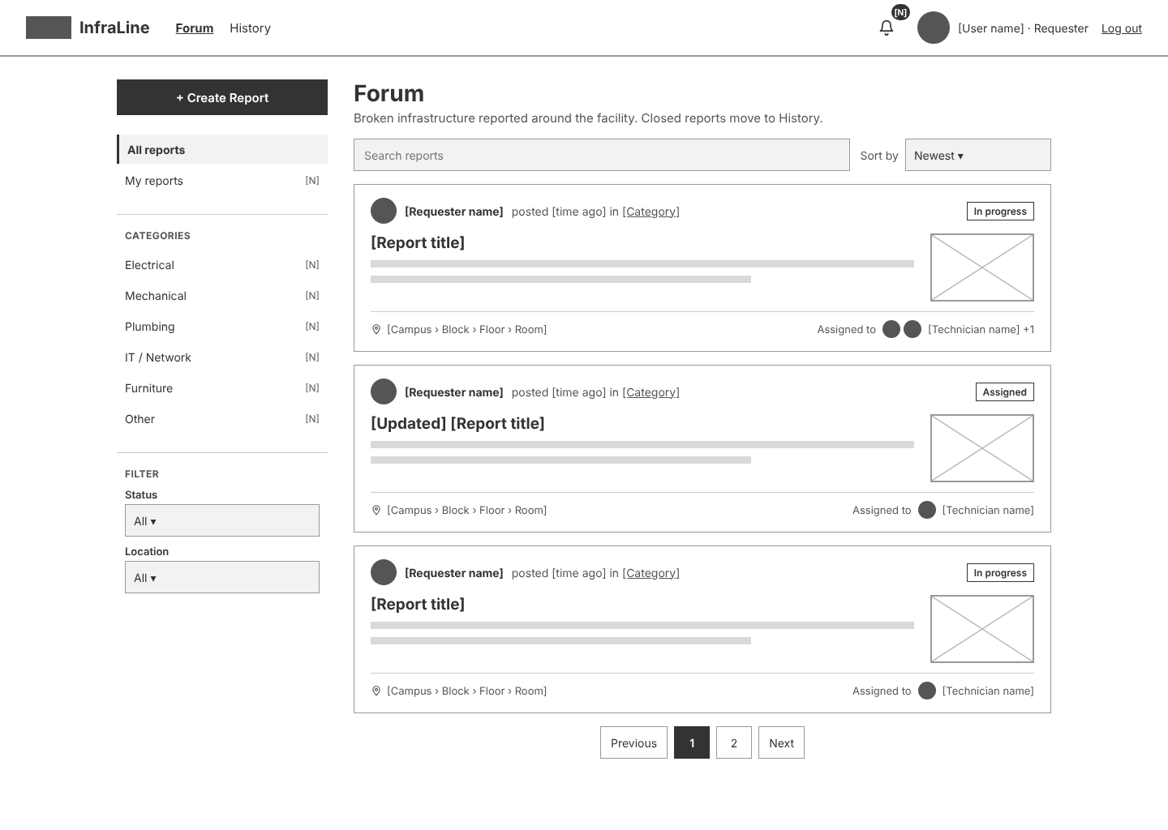
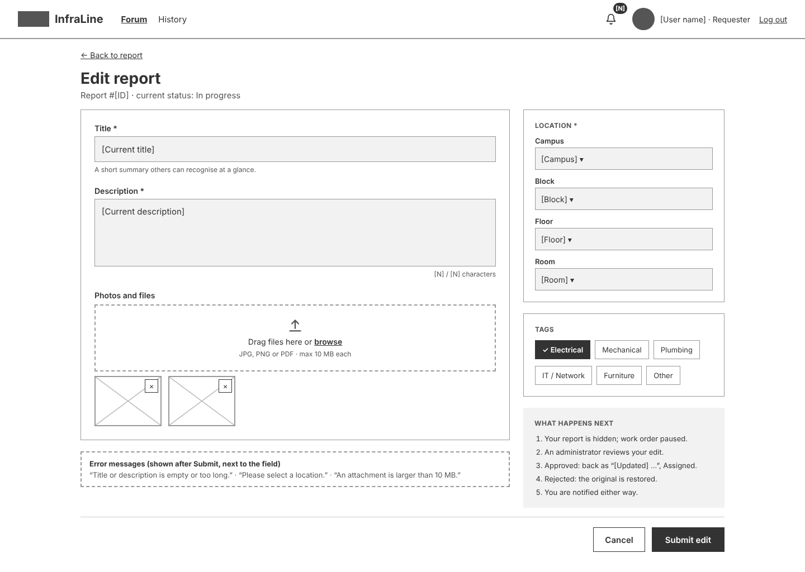
Prompt 4: I just realized we need one more Report Detail (Technician)
I added S03c Report detail – Technician. It uses the same layout as the requester’s Report detail, but read-only and with the technician’s header (Maintenance Checklist, Forum, History):
- No editing: no Edit Report button, and priority and technician(s) are only shown. The technician’s own name is marked “(you)”.
- Open work order →: shown only if the technician is assigned to the report, and goes to Work order detail – Technician.
- Links: posts on the technician’s Forum now open this screen instead of going straight to the work order.
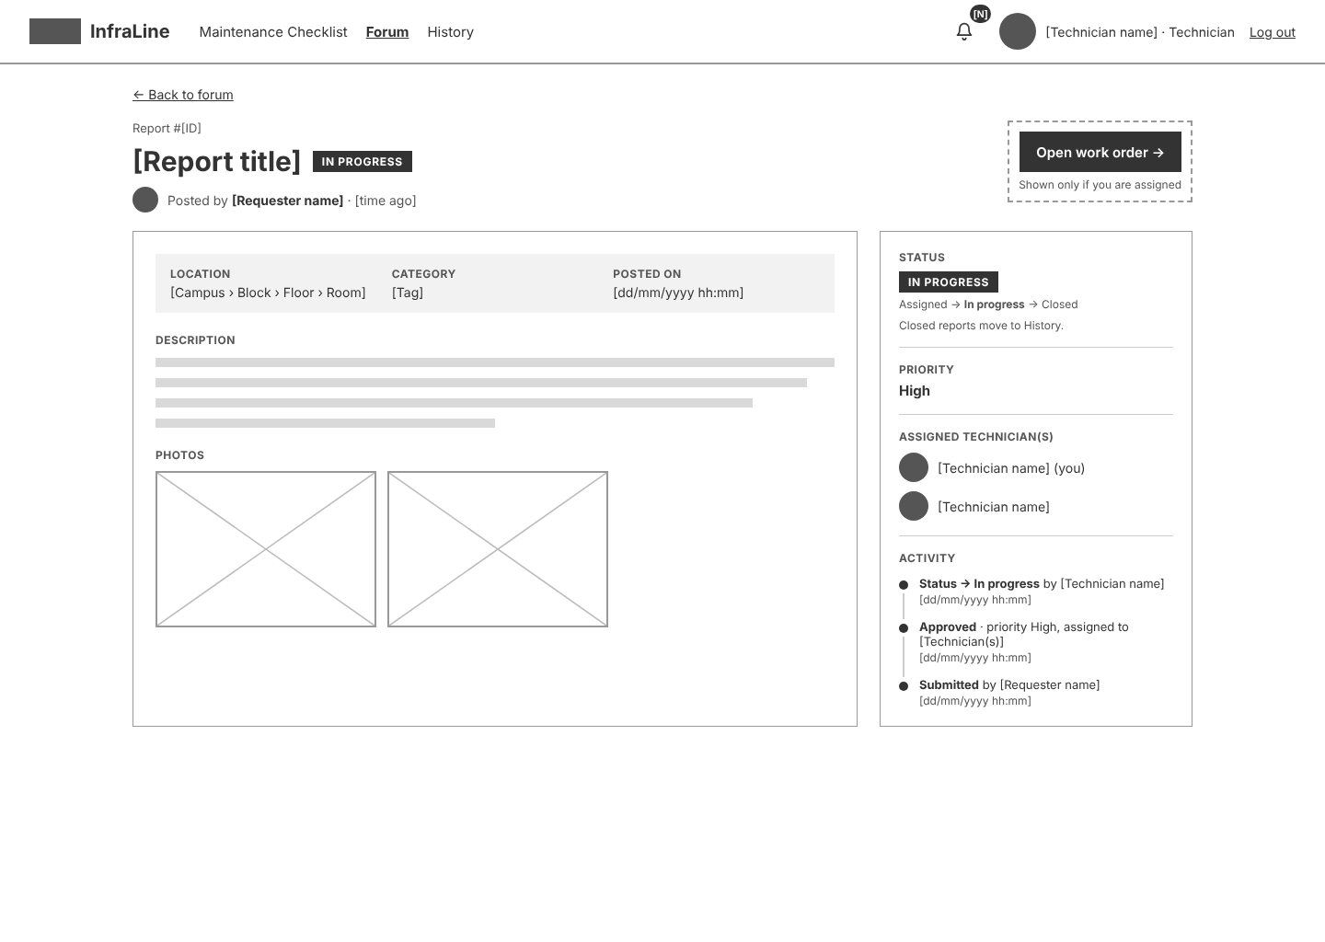
Prompt 5: can you also make the screens for UC-09, the private chat between the requester and the technician? add a way to open the chat from the screens they already use, and zip the new screens for me
I made the UC-09 screens for the private chat between the requester and the technician. There are 4 screens in the zip:
- S03 Report detail (Requester): a “Chat with technician” button under Assigned technician(s), shown to the author only.
- S09 Work order detail (Technician): a “Chat with requester” button next to the report’s author.
- S11 Messages (Requester) and S11c Messages (Technician): the conversation list on the left, the chat on the right with the report it is about pinned at the top, and a message box with an attach button and Send.
In Section 8, add UC-09 to the S03 and S09 rows and add a new row for S11 (UC-09) with a link for each perspective. In Section 9, FR-10 / UC-09 now maps to S03, S09 and S11.


