Prompt 1:
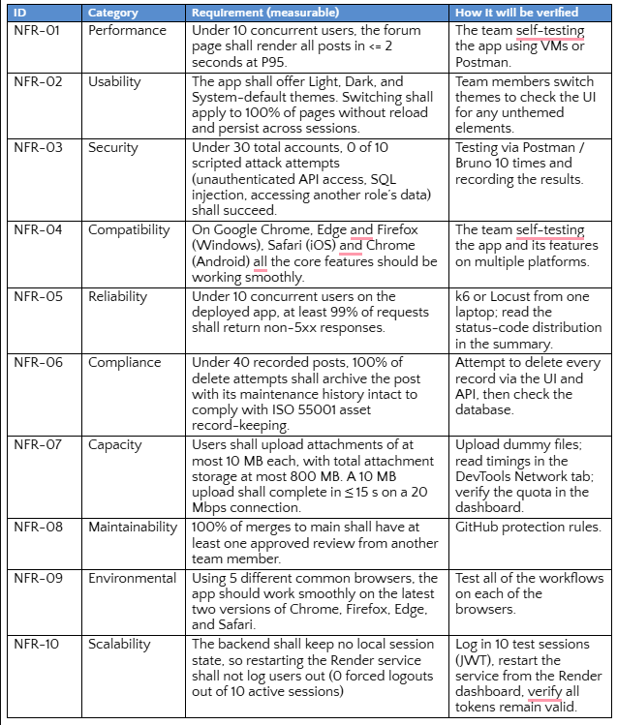
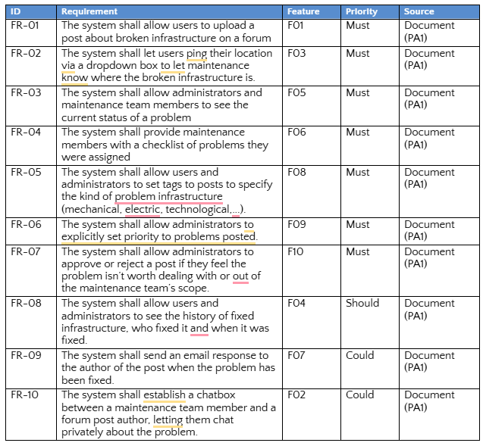
Attached are the functional and non-functional requirements. What should the domain requirements and business rules be for this software system?

Answer 1:
For InfraLine, I recommend adding Domain Requirements (DR) and Business Rules (BR) as two separate sections.
Although they are related, they serve different purposes:
- Domain requirements describe the infrastructure maintenance environment, its concepts, participants, and processes that the software must support.
- Business rules define the specific conditions, restrictions, and logic that govern how users and the system interact.
For InfraLine, domain requirements should focus on how infrastructure problems are reported, classified, assigned, maintained, and recorded. Business rules should specify exactly what each user role is allowed to do and how a report progresses through the system.
Here is a proposed specification that you can adapt for your project.
1. Domain Requirements
These describe the domain-specific knowledge and processes that InfraLine needs to represent.
Domain Requirements
ID | Domain Requirement
DR-01 | The system shall support the management of infrastructure problem reports concerning facilities, equipment, and other infrastructure components within an organization.
DR-02 | The system shall maintain a list of available facility locations so that infrastructure problems can be associated with their respective locations.
DR-03 | The system shall support classifying infrastructure problems into different categories, such as mechanical, electrical, technological, and other relevant categories.
DR-04 | The system shall distinguish between three main types of users: reporters (students/employees), maintenance personnel, and administrators, each with different responsibilities and access permissions.
DR-05 | The system shall support an infrastructure maintenance workflow in which reported problems can be submitted, reviewed, approved or rejected, assigned, addressed, and resolved.
DR-06 | The system shall support the assignment and tracking of maintenance tasks so that maintenance personnel can identify and manage the problems they are responsible for.
DR-07 | The system shall support prioritizing infrastructure problems based on their urgency and importance to help organizations allocate maintenance resources effectively.
DR-08 | The system shall maintain records of resolved infrastructure problems, including their original reports, maintenance personnel, resolution information, and relevant timestamps.
DR-09 | The system shall support communication between the person who reported a problem and the maintenance personnel responsible for addressing it.
DR-10 | The system shall support the preservation and archiving of infrastructure maintenance records for future reference and organizational asset management.

Why these are relevant:
DR-01 through DR-04 establish the basic infrastructure maintenance environment and the information InfraLine needs to represent.
DR-05 through DR-07 describe the actual maintenance process, which is the central purpose of the application.
DR-08 through DR-10 address accountability, communication, and long-term maintenance record management.
2. Business Rules
Business rules are more specific than domain requirements. They establish conditions that the system must enforce.
I recommend the following:
Business Rules
ID | Business Rule
BR-01 | Every infrastructure problem report must have a unique identifier, a reporting user, a description of the problem, a submission date and time, and an associated location.
BR-02 | Users must select a location from the locations available in the system when submitting a problem report.
BR-03 | A problem report may include one or more image attachments to help maintenance personnel identify the problem. Attachments must comply with the system's upload restrictions.
BR-04 | Every user must have an assigned role that determines which functions and information they are permitted to access.
BR-05 | Students and employees may submit problem reports and view the status of their reports, but cannot approve, reject, or set the priority of reports.
BR-06 | Only administrators are authorized to approve or reject submitted problem reports and set their maintenance priorities.
BR-07 | A rejected report cannot be assigned to maintenance personnel unless it is reviewed and approved again by an administrator.
BR-08 | An approved report must be assigned to a maintenance person or maintenance team before maintenance work can begin.
BR-09 | Maintenance personnel may update the status of reports assigned to them and record information about the work performed. They cannot modify administrative settings or independently change report priorities.
BR-10 | A problem report must have a resolved status before it is considered successfully completed. A resolution note should be recorded to describe the repair or action taken.
BR-11 | Every significant change to a problem report, including status updates, assignments, moderation decisions, and resolution information, must be recorded with the responsible user's identity and the date and time of the change.
BR-12 | Problem reports must not be permanently deleted. When a deletion is requested, the system must archive the report while preserving its associated maintenance history.
BR-13 | Private chat messages between a report's author and the assigned maintenance personnel must only be accessible to the authorized participants.
BR-14 | When a problem report is successfully resolved, the system shall send an email notification to its author if email notifications are enabled.
BR-15 | A maintenance person must only be able to manage tasks assigned to them or to a team they belong to, unless additional permissions are granted.
BR-16 | Administrators may modify report priorities, but the priority of a report must be maintained until an administrator explicitly changes it.
BR-17 | Reports must use valid categories and locations maintained by the system. Administrators are responsible for keeping these records up to date.

3. Recommended report status workflow
One particularly important part of InfraLine is the maintenance workflow. Your functional requirements mention report approval, rejection, assignment, status tracking, and resolution, but they do not yet define the exact status transitions.
I recommend establishing the following lifecycle:
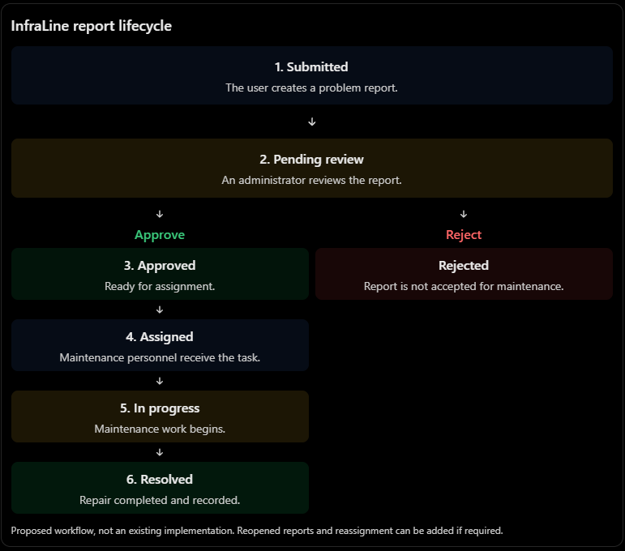
This workflow helps establish several important business rules:
- Only administrators can approve or reject reports.
- Only approved reports can proceed to assignment.
- Maintenance personnel can only begin work on assigned reports.
- A report cannot be considered completed until it has been resolved.
- Resolution information should be retained for future reference.
4. Important considerations for your existing requirements
There are a few details I would recommend clarifying before finalizing the specification.
Topic | Recommendation
Priority vs. tags | Keep them separate. A Critical tag describes the problem, whereas priority determines how urgently it should be addressed.
Report visibility | Decide whether all authenticated users can browse all reports or only their own reports.
Rejected reports | Consider requiring administrators to provide a rejection reason so the reporter understands the decision.
Deletion | Use archival or soft deletion rather than permanently deleting records. This is consistent with NFR-06.
Maintenance checklist | Clarify whether the checklist is simply a list of assigned reports or a list of individual repair steps.
Status transitions | Define which roles can perform each transition and whether resolved reports can be reopened.
Email and chatbot | Since these are marked Could, their associated business rules should apply only when those features are implemented.

One additional point concerns your NFR-06: it references ISO 55001. Retaining maintenance records is a sensible asset-management requirement, but the exact archival and retention policy should be established according to the applicable organizational requirements rather than assuming that the standard specifies indefinite retention.
5. How the three requirement types fit together
For your InfraLine documentation, the distinction can be summarized as follows:
Requirement type | Main question | InfraLine example
Functional (FR) | What must the system do? | Administrators can approve or reject reports.
Non-functional (NFR) | How well must it do it? | The application must respond within 2 seconds at P95.
Domain (DR) | What domain concepts and processes must the system understand? | Infrastructure reports have locations, categories, priorities, and maintenance histories.
Business (BR) | What conditions and rules must be enforced? | Only administrators can approve or reject reports.

My recommendation: Keep the domain requirements relatively high-level and use the business rules to specify enforceable conditions. Avoid repeating every functional requirement word-for-word. Together, these sections will make your specification more complete and provide a clearer foundation for designing the database, use cases, and activity diagrams.

Prompt 2:
Are there any legal-related business rules that we should be aware of?

Answer 2:
Yes. Since InfraLine is intended for use in Vietnam, there are several legal requirements worth considering, especially because the application handles information about students, employees, maintenance personnel, and potentially their photographs and private communications.
I would recommend adding a separate subsection called Legal and Regulatory Business Rules to your specification.
The most relevant legal areas are:
1. Personal data protection and privacy.
2. Cybersecurity and data storage.
3. Data retention and electronic records.
4. Protection of minors, particularly if InfraLine is deployed in schools.
5. Unauthorized disclosure and misuse of information.
1. Relevant Vietnamese laws and regulations
As of October 2026, these are the main legal references I would consider:
Law / Regulation | Relevance to InfraLine
Law on Personal Data Protection No. 91/2025/QH15 | Governs the collection, storage, processing, disclosure, and deletion of users' personal information. Effective January 1, 2026.
Decree 356/2025/ND-CP | Provides detailed implementation requirements for personal data protection, including cloud computing, data processing, and cross-border data transfers.
Law on Cybersecurity No. 116/2025/QH15 | Establishes cybersecurity responsibilities for organizations and enterprises operating in cyberspace. Effective July 1, 2026.
Decree 333/2026/ND-CP | Details cybersecurity requirements, including data storage in Vietnam and security-related data retention.
Law on Electronic Transactions No. 20/2023/QH15 | Establishes the legal validity and evidentiary value of electronic records and data messages. Effective July 1, 2024.

Sources: Chính phủ
The first two are particularly important because InfraLine collects and processes personal data as part of its normal operation.
2. Proposed legal business rules
The following are written in a format similar to your existing BR requirements. I recommend giving them separate identifiers, such as LBR-01, LBR-02, etc., to distinguish them from your existing business rules.
Legal and Regulatory Business Rules
ID | Business Rule
LBR-01 | The system shall inform users about the types of personal data collected, the purposes of processing, the parties responsible for processing, and their rights regarding their personal data before or when the data is collected, as required by applicable law.
LBR-02 | The system shall only collect and process personal data necessary for its infrastructure reporting and maintenance management purposes.
LBR-03 | Where consent is the applicable legal basis for processing personal data, the system shall obtain explicit, voluntary, informed, and purpose-specific consent from users. Silence or failure to respond shall not be considered consent.
LBR-04 | The system shall restrict access to users' personal information, uploaded attachments, and private communications to authorized individuals according to their roles and responsibilities.
LBR-05 | The system shall provide a mechanism for users to request access to, correction of, provision of, deletion of, or restriction of processing of their personal data, and to withdraw consent where applicable.
LBR-06 | The system shall retain personal data only for the period necessary to fulfill its intended purposes or other applicable legal retention requirements. Personal data shall be deleted or securely destroyed when its retention is no longer justified, unless an applicable legal exception or agreement requires otherwise.
LBR-07 | The system shall maintain appropriate security measures to prevent unauthorized access, modification, disclosure, loss, or destruction of personal data.
LBR-08 | The system shall record relevant security incidents and provide a mechanism for administrators or responsible personnel to identify and report personal data breaches in accordance with applicable legal requirements.
LBR-09 | The system shall not disclose users' personal information to unauthorized third parties without an applicable legal basis or the data subject's consent, as required by law.
LBR-10 | Where the system processes personal data belonging to children, it shall support the additional protection requirements applicable to children and their legal representatives.
LBR-11 | When using external cloud hosting or third-party services to process personal data, the system operator shall ensure that the relevant contracts, security measures, data-processing responsibilities, and cross-border transfer requirements comply with Vietnamese law.
LBR-12 | The system shall preserve the integrity, accessibility, and traceability of electronic maintenance records, including the identities of users performing actions and the timestamps of relevant activities.
LBR-13 | The system shall not allow users to use reports, attachments, or private communications to unlawfully disclose personal information or distribute content that violates applicable laws.
LBR-14 | The system operator shall maintain appropriate records and documentation of personal data processing activities and fulfill applicable personal data protection impact assessment and reporting obligations.

3. Why these rules matter for InfraLine
Some of these rules deserve particular attention because they directly affect your existing features.
A. User reports and uploaded images (FR-01)
A report may contain personal information beyond what the reporter explicitly enters. For example:
- A photograph may accidentally capture students or employees.
- A photograph may contain someone's computer screen, identification card, or personal documents.
- A report description might mention another employee or student.
Under Vietnam's Personal Data Protection Law, images and information that identify an individual can constitute personal data.
Therefore, InfraLine should restrict who can view attachments and discourage users from uploading unnecessary personal information.
B. Private chatbot (FR-10)
Your proposed chatbot allows maintenance personnel and reporters to communicate privately.
This means that the application must protect private conversations from unauthorized access. Administrators should not automatically have unrestricted access to every private conversation simply because they have administrative privileges.
Access should have a defined purpose and authorization policy.
The law also regulates disclosure and transfer of personal data.
C. Maintenance history and deletion (NFR-06)
This is particularly important because you already have a requirement stating:
Under 40 recorded posts, 100% of delete attempts shall archive the post with its maintenance history intact.
This is a good approach for preserving maintenance records, but there is a legal distinction worth making.
The organization should not retain identifiable personal data indefinitely just because maintenance records must be preserved.
A better approach would be to:
- Retain maintenance records according to the organization's documented retention policy.
- Delete or de-identify personal information when its purpose and applicable retention period have expired.
- Preserve information where a legal requirement or applicable agreement justifies its continued retention.
Vietnam's Personal Data Protection Law provides for deletion and destruction of personal data in specified circumstances. It also provides for deletion of employee personal data upon termination of employment, unless otherwise agreed or required by law.
I would therefore revise your existing BR-12 rather than enforce an unconditional prohibition on permanent deletion.
D. Student information and minors
Because InfraLine may be deployed in schools, some users could be children.
Vietnamese law provides additional protection for children's personal data. For example, publishing or disclosing information about the private life and personal secrets of children aged seven or older requires both the child's consent and that of their legal representative.
For InfraLine, I recommend keeping student reports accessible only to authorized personnel rather than making them publicly visible.
E. Cloud hosting and data storage
Your preliminary problem statement mentions that InfraLine may be deployed on a cloud server.
This introduces another legal consideration.
Under Decree 356/2025/ND-CP, cloud computing providers and organizations using cloud services have personal-data protection responsibilities. These include appropriate access controls, contractual responsibilities, and encryption of personal data both at rest and during transmission.
Additionally, Vietnam's 2025 Cybersecurity Law and Decree 333/2026/ND-CP contain data-storage requirements for covered domestic enterprises, including storage of specified user information in Vietnam. Whether a particular InfraLine deployment falls within these requirements depends on the organization operating the service and its legal classification.
You should therefore consider the hosting location before deciding on a cloud provider. An overseas cloud service may also involve cross-border personal-data transfer obligations, although specific exceptions exist.
F. Maintenance records as electronic records
InfraLine stores reports, approvals, repair notes, timestamps, and maintenance histories electronically.
The Law on Electronic Transactions recognizes the legal validity of electronic data messages. However, their evidentiary value depends on factors such as their integrity, reliability, and ability to identify their origin and relevant participants.
This supports your decision to maintain an audit history of who created, modified, approved, or resolved a report.
4. My recommendation: Which legal rules should you prioritize?
For your current project scope, I would prioritize these six:
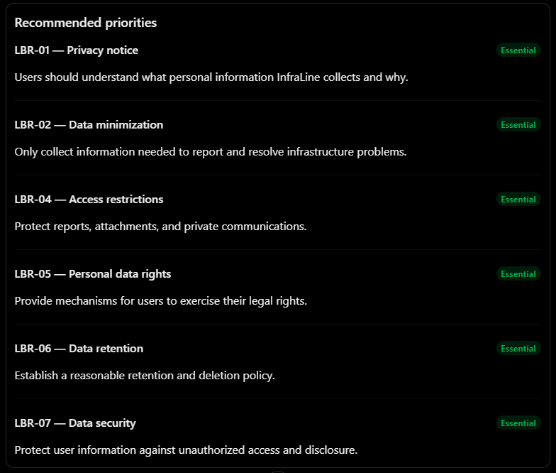
The other rules are important too, but some depend on deployment decisions. For example, cloud-related obligations depend on the hosting arrangement, while children's data protection requirements become particularly relevant when the application is deployed in schools.
One final distinction for your report: Not every legal obligation needs to become a software feature. Some are responsibilities of the organization operating InfraLine, such as appointing responsible personnel, preparing legally required impact assessment documents, and handling regulatory notifications. The software should provide the necessary support, but the organization remains responsible for fulfilling its legal obligations.
These recommendations are based on the Vietnamese legal framework, not a formal legal opinion. For an actual deployment, the organization should have its data-processing arrangements and hosting configuration reviewed by a qualified legal or compliance professional.

