Architecture

The overall functionality is quite complex but centres around the raspimjpeg process which accesses the camera data. The following diagram shows the major components. Blue lines indicate data flows. Red lines indicate control.

[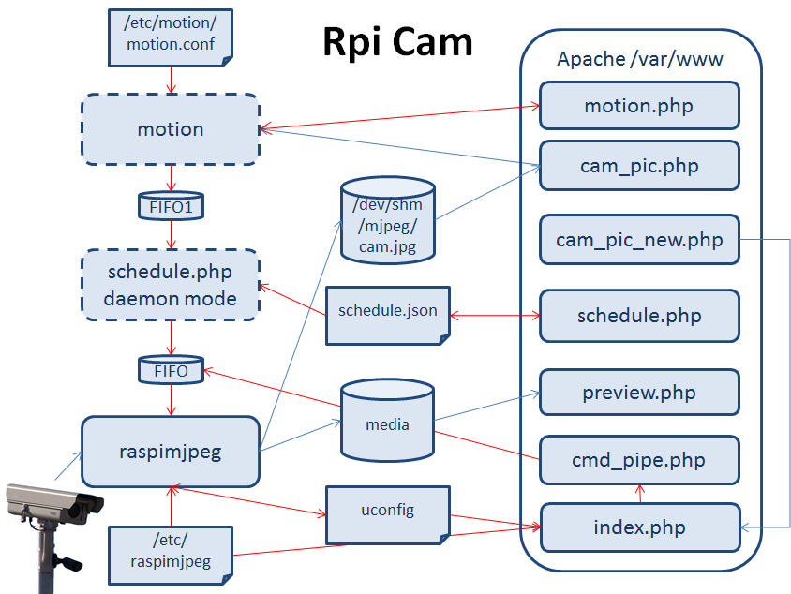](http://elinux.org/File:RPiCamArchitecture.png)