Zadanie 1:

a)

figure

x = linspace(0,1,100);

for k = [2:2:20,1:2:21]

y = x.^k;

plot(x,y);

pause(0.1);

end

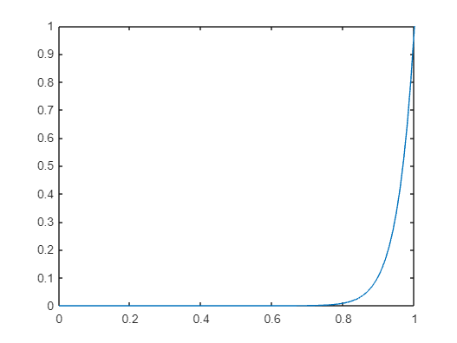

b)

x = linspace(0,2\*pi,100);

for k = linspace(0,1,100)

y = sin(x+k\*2\*pi);

plot(x,y);

pause(0.1);

end

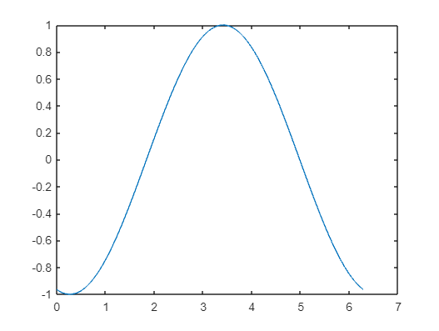

Zadanie 3

[X,Y] = meshgrid(-20:.5:20);

figure('Resize','off','units','normalized','outerposition',[0 0 1 1]);

for k = [1:-0.1:0.99,0,99:0.01:1]

Z = cos(k\*X)+cos(k\*Y);

surf(X,Y,Z);

pause(0.1);

end

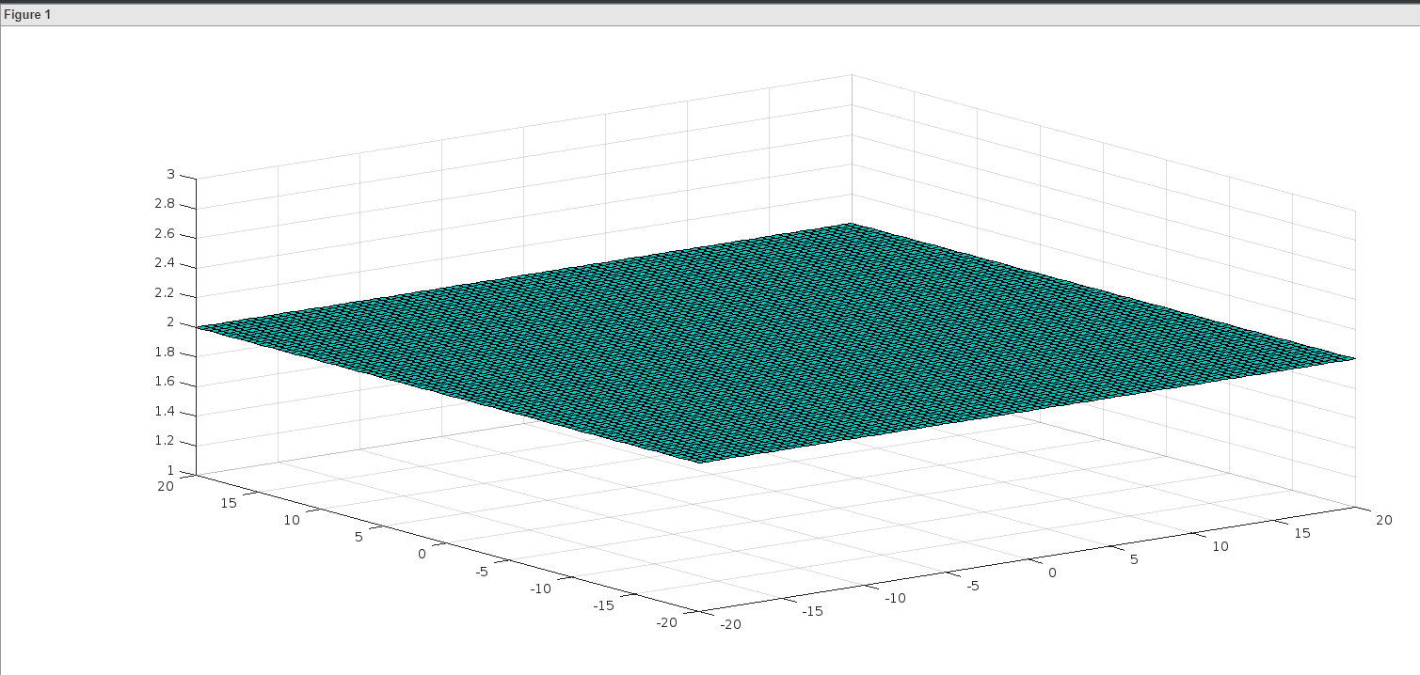

Zadanie 4:

>> a = 2;

>> b = 6;

>> figure

>> zakres = linspace(0, 2\*pi, 1000);

>> x = a \* cos(zakres);

>> y = b \* sin(zakres);

>> plot(x, y, 'LineWidth', 2);

>> hold on

>> point = plot(x(1), y(1), 'ro', 'MarkerSize', 10);

>> axis equal;

>> axis([-a a -b b]);

>> for i = 1:length(zakres)

set(point, 'XData', x(i), 'YData', y(i));

pause(0.05);

end

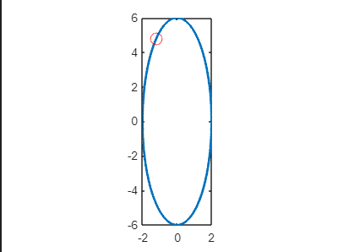

zadanie 5:

>> figure

>> t = linspace(0, 2\*pi, 1000);

x = cos(t) + cos(7\*t)/2 + sin(17\*t)/3;

>> y = sin(t) + sin(7\*t)/2 + cos(17\*t)/3;

>> plot(x, y, 'LineWidth', 2);

>> hold on

>> point = plot(x(1), y(1), 'ro', 'MarkerSize', 10);

>> axis equal;

>> for i = 1:length(t)

set(point, 'XData', x(i), 'YData', y(i));

pause(0.01);

end

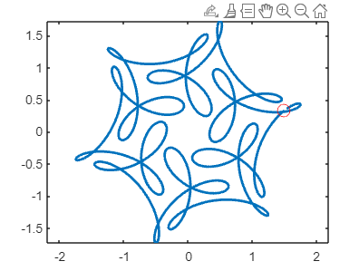

zadanie 6:

>> a = 4;

>> b = 9;

>> figure

>> t = linspace(0,20\*pi,1000);

>> x = a \* t - b \* sin(t);

>> y = a - b \* cos(t);

>> plot(x,y,'LineWidth',2);

>> hold on

>> point = plot(x(1), y(1), 'ro', 'MarkerSize', 10);

>> axis equal;

>> for i = 1:length(t)

set(point, 'XData', x(i), 'YData', y(i));

pause(0.01);

end

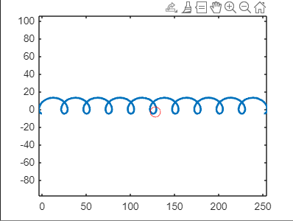

Zadanie 7:

>> a = 0.1;

>> figure

>> t = linspace(0,50,1000);

>> x = a\*t.\*cos(t);

>> y = a\*t.\*sin(t);

>> plot(x,y,'LineWidth',2);

>> hold on

>> point = plot(x(1), y(1), 'ro', 'MarkerSize', 10);

>> axis equal;

>> for i =1:length(t)

set(point, 'XData', x(i), 'YData', y(i));

pause(0.01);

end

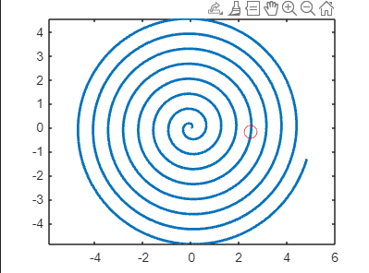

Zadanie 8:

>> A = 20;

B = 10;

a = 10;

b = 3;

c = 6;

d = 4;

>> figure

>> t = linspace(0,2\*pi,1000);

>> x = A\*cos(a\*t+b);

>> y = B\*cos(c\*t+d);

>> plot(x,y,'LineWidth',2);

>> hold on;

>> point = plot(x(1), y(1), 'ro', 'MarkerSize', 10);

>> axis equal;

>> for i = 1 : length(t)

set(point,'XData',x(i),'YData',y(i));

pause(0.01);

end

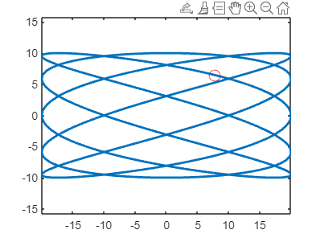

Zadanie 9:

t = linspace(0, 2\*pi, 1000);  
>>x = 5\*cos(t).^2;  
>>y = 5\*sin(t).\*cos(t);  
>>z = 5\*sin(t);  
>>figure;  
>>comet3(x, y, z);

