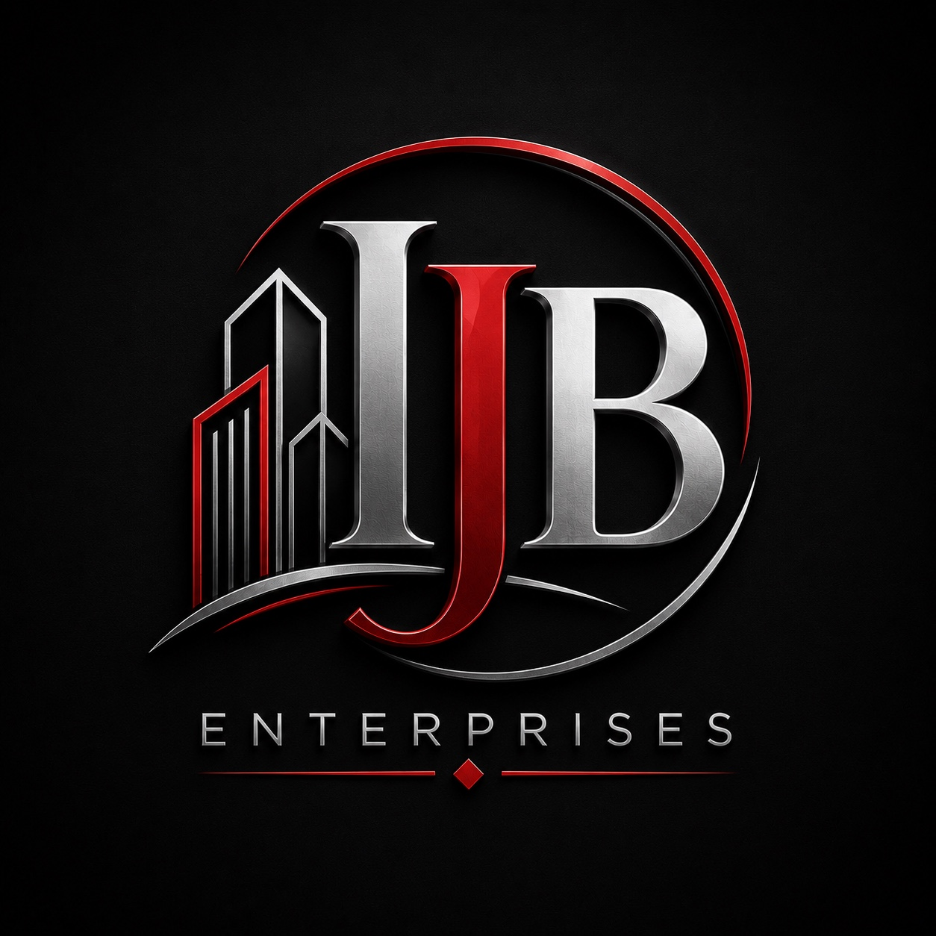
COMMERCIAL FINANCIAL STATEMENT PACKAGE
Prepared for Cornerstone Community Federal Credit Union
Attention: Michael Woods
Financing Request – 3887 Seneca Street
July 2026

Table of Contents
- 1. IJB Enterprises Inc. – Startup Statement of Income
- 2. IJB Enterprises Inc. – Startup Balance Sheet
- 3. 549 Indian Church LLC – Statement of Income
- 4. 549 Indian Church LLC – Balance Sheet
- 5. Durilla Development of WNY LLC – 561 Main Street Pro Forma Statement of Income
- 6. Supporting Documents

IJB Enterprises Inc.
Startup Statement of Income
Description | Amount
Revenue | $0.00
Organizational Expenses | $0.00
Net Income | $0.00
Entity formed for the acquisition of 3887 Seneca Street. No operations have commenced as of the reporting date.

IJB Enterprises Inc.
Startup Balance Sheet
Description | Amount
Cash | To be funded
Organizational Costs | Pending
Total Assets | To be funded
Liabilities | $0.00
Owner's Equity | To be funded

549 Indian Church LLC
Statement of Income
January 1, 2026 – April 30, 2026

Revenue
Description | Amount
Rental Income – 2829 Niagara Street | $2,333.98
Rental Income – 549 Indian Church Road – Unit 1 | $4,200.00
Rental Income – 549 Indian Church Road – Unit 2 | $2,800.00
Rental Income – 549 Indian Church Road – Unit 3 | $4,400.00
Total Revenue | $13,733.98

Operating Expenses
Description | Amount
Real Estate Taxes | $6,200.00
Property Insurance | $872.00
Total Operating Expenses | $7,072.00
Net Operating Income | $6,661.98

549 Indian Church LLC
Balance Sheet
Description | Amount
Cash | See Bank Statements
Investment Real Estate | See Personal Financial Statement
Liabilities | Per Mortgage Statements
Owner's Equity | Residual

Durilla Development of WNY LLC
561 Main Street
Pro Forma Statement of Income
Description | Amount
Projected Gross Income | $171,196
Projected Operating Expenses | $71,359
Projected Net Operating Income | $99,837
Estimated Value @ 8% Cap | $1,247,963
Estimated Value @ 7% Cap | $1,426,244

