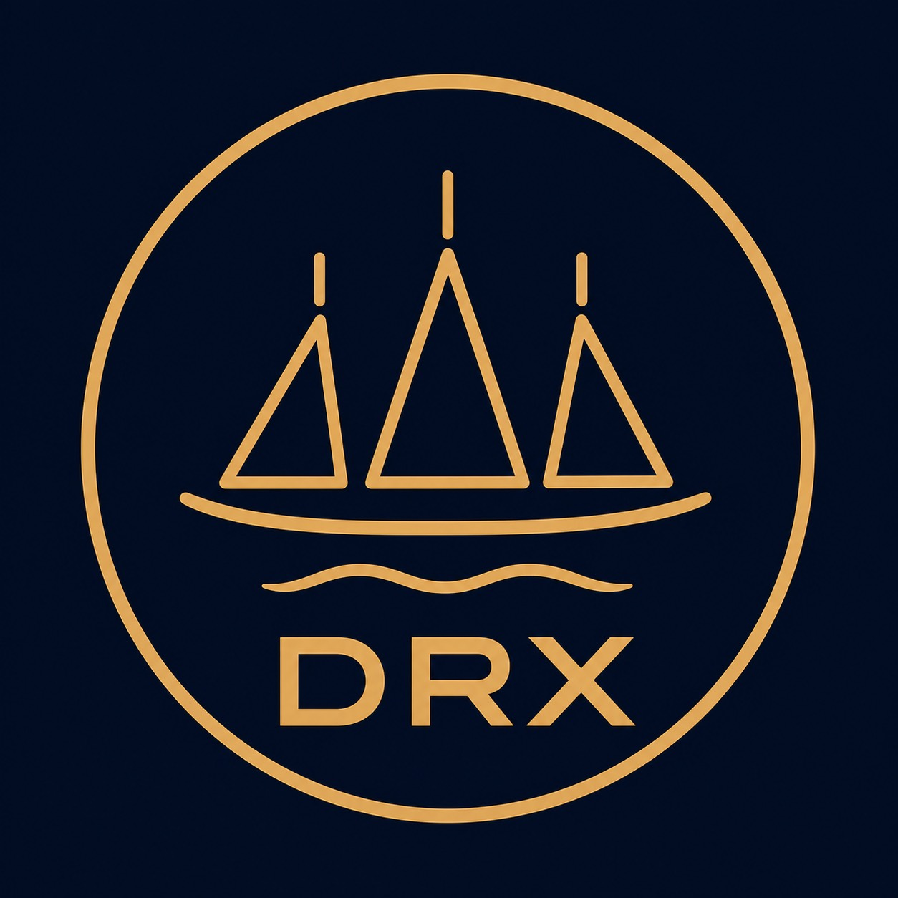
DRX PROGRAMME — INDEPENDENT DRACHMA
HELLENIC MONETARY TECHNOLOGY INITIATIVE

Executive Decision Memorandum
  - DRX PROGRAMME — INDEPENDENT DRACHMA · dig Δραχμή (ΔΡΑΧ)
Vendetta Labs · Gio (Kaspartizan)
1 September 2026
To: Hellenic Ministry of National Economy and Finance
From: Vendetta Labs / Gio (Kaspartizan)
Decision sought: Limited research authorisation
Status: Public research version of a private initiative; not commissioned or approved by the state
Not requested: Currency introduction, mainnet token, banknotes with face value, acceptance for tax payments or legal-tender status
Recommendation: Approval of a 12- to 18-month Phase 0 study up to a maximum of EUR 1.6 million. The subject matter comprises legal opinions, macro simulation, a valueless Kaspa Toccata testnet prototype, and CashLot and offline laboratory tests. Any continuation carrying value requires a new decision.

1. The decision in one sentence
The Ministry approves a strictly limited feasibility study to determine whether an independent unit of account, ΔΡΑΧ, as a Kaspa-native digital bearer currency as well as a fully digitally backed banknote and coin, would be technically, legally and macroeconomically defensible.

2. Concept
ΔΡΑΧ is neither a CBDC nor a EUR/USD stablecoin. The money supply is capped in advance. Digital value, offline value, banknotes and coins belong to a single aggregate supply:
S = D + P + O + E ≤ Mmax
Paper or metal may be issued only once the same nominal amount has been digitally locked in a CashLot. After return, authenticity verification and destruction, exactly that amount is released digitally. Banks receive no right to create money. Following a technically fixed genesis sunset, neither government nor central bank holds mint or freeze keys.

3. Why Kaspa Toccata
Kaspa Toccata has been active on mainnet since 30 June 2026 and enables UTXO-native covenants. This model suits conserving bearer transfers and self-validating state transitions. The maturity of Silverscript, wallets, indexers, offline hardware and CashLot sharding is not yet sufficiently evidenced. Precisely this uncertainty justifies a testnet research programme rather than a launch.

4. Legal position
Within the eurozone, ΔΡΑΧ cannot be introduced as national legal tender with a general obligation of acceptance. Article 128 TFEU and the euro introduction regulation form the binding starting position. Phase 0 therefore contains only research and valueless tests. A voluntary complementary pilot at a later stage requires a joint legal opinion on MiCA, Law 5193/2025, AML/Travel Rule, data protection and monetary law. Full legal tender is described only as a scenario under complete monetary sovereignty, not recommended.

5. Strategic benefit
- Greece acquires its own competence in covenant money, offline payment and digitally backed cash.
- Shipping, tourism, islands and the diaspora provide real, voluntary use cases for later research.
- The study examines an alternative to account-based CBDCs without imitating the digital euro.
- An open-source prototype improves the state's capacity for negotiation and assessment, even if ΔΡΑΧ is never introduced.

6. Risks not to be glossed over
Risk | Honest assessment
Eurozone law | Legal tender excluded in Phase 0; voluntary pilot legally open
Third-party settlement network | Kaspa provides neutrality, but not full state autarky
Deflation/credit | A fixed supply can lower prices, increase real debt burdens and make credit more expensive
No unlimited LOLR | Crisis liquidity must be pre-funded; rescue issuance is excluded
Cash fraud | The physical arm remains institutional; lock, bond, audit and destruction limit the risk
Offline double spend | Can only be bounded through pre-funding, limits and liability, not fully eliminated
Tooling maturity | Silverscript/indexer/wallet audits are a gate, not an afterthought
Political framing | The project must not be communicated as a covert Grexit or sanctions evasion

7. Phase 0 work packages
- EU/GR legal opinions and regulatory negative list;
- open macro simulations on deflation, credit, bank run and exchange rate;
- Toccata testnet prototype for Constitution, Bearer and CashLot;
- three independently reproducible supply indexers;
- offline secure-element laboratory test with two suppliers;
- cash issuance/redemption/destruction process without real value notes;
- two independent security reviews and a red-team exercise;
- public interim and final reports.

8. Budget and governance
Budget corridor: EUR 0.95 to 1.65 million; requested ceiling EUR 1.6 million.
Duration: at most 18 months.
Interim decision: month 9.
Automatic sunset: month 18.
Observers: BoG, HCMC, Data Protection Authority, Court of Audit, universities, banking, shipping, island and consumer representatives.

9. Hard stop criteria
- no defensible legal framework even for the limited pilot;
- Mmax/double-counting invariants not independently provable;
- Toccata/Silverscript toolchain without a sufficient audit baseline;
- offline or CashLot losses above the approved risk budget;
- migration away from Kaspa not demonstrable without double-validity risk;
- banking/crisis regime not viable under stress testing;
- genesis sunset technically circumventable;
- project communication becomes a de facto currency introduction without a decision.

10. Proposed resolution
The Ministry resolves:
- to establish the research programme "ΔΡΑΧ Phase 0" for a maximum of 18 months;
- a milestone-based funding ceiling of EUR 1.6 million;
- the express limitation to testnet, simulation and legal opinions;
- the publication of invariants, source code, audit results and known limitations;
- an interim decision after nine months;
- automatic termination absent a separate continuation resolution;
- the presentation of a final report with the options No-Go, Research-Only, limited voluntary pilot following legal clearance or separate sovereign scenario assessment.

11. Core sources
Kaspa Toccata Dev Guide; Article 128 TFEU; Regulation (EC) No 974/98; MiCA (EU) 2023/1114; Law 5193/2025/Bank of Greece; EU Regulations 2023/1113 and 2024/1624; ECB Digital Euro FAQ; UNCTAD Review of Maritime Transport 2025; Bank of Greece Tourism 2025. Full register in the whitepaper.

