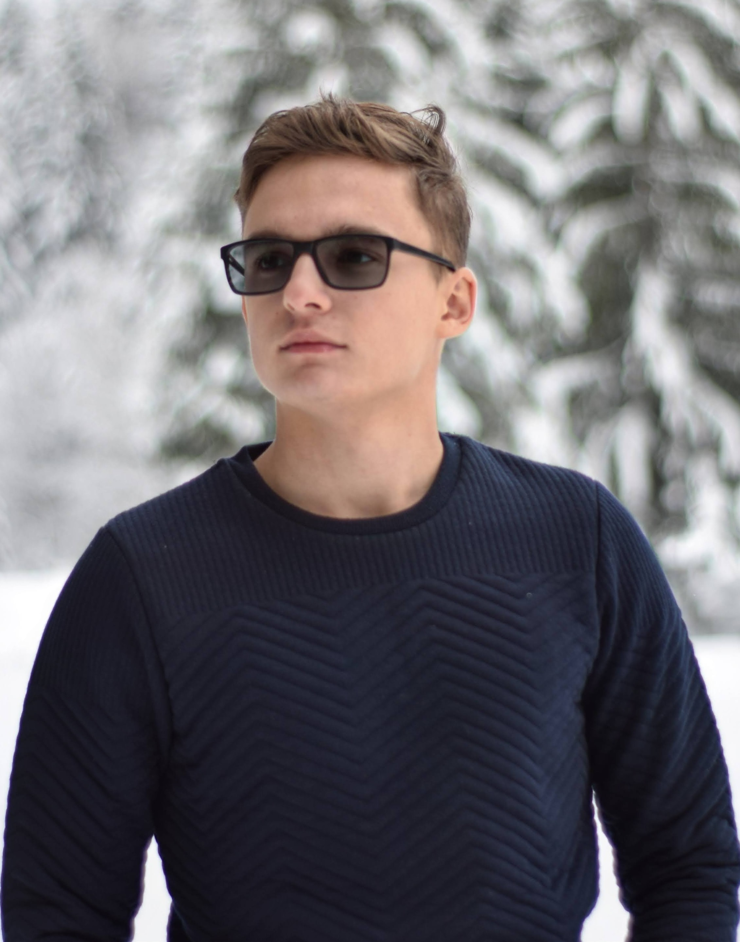

Stefan Neaga|0757909662 |neagastfean@gmail.com

# About me

I am a student in automotive engineering but I love to code, it's my passion. I live in Brasov, Romania and I am a comunicative and amitious person

# Work experience

**E-res** *04-07-2021-25-07-2021*I worked as a mechanic and I liked the envviroment but I didn't think it was for me

# Skills

* Python
* C++
* HTML/ CSS