

1)

|  |  |  |  |  |  |  |  |  |  |  |  |  |
| --- | --- | --- | --- | --- | --- | --- | --- | --- | --- | --- | --- | --- |
| Nb | X1 | x2 | x3 | x1-miu1 (1) | x2-miu2  (2) | x3-miu3  (3) | (1)^2 | (2)^2 | (3)^2 | (1)*(2) | (1)*(3) | (2)*(3) |
| 1 | 4 | 2 | 6 | 0 | -3 | -1 | 0 | 9 | 1 | 0 | 0 | 3 |
| 2 | 1 | 8 | 2 | -3 | 3 | -5 | 9 | 9 | 25 | -9 | 15 | -15 |
| 3 | 5 | 1 | 9 | 1 | -4 | 2 | 1 | 16 | 4 | -4 | 2 | -8 |
| 4 | 6 | 9 | 11 | 2 | 4 | 4 | 4 | 16 | 16 | 8 | 8 | 16 |
| Avg | 4 | 5 | 7 | 0 | 0 | 0 | 14/4 | 50/4 | 46/4 | -5/4 | 25/4 | -1 |

miu1 = (4 + 1 + 5 + 6)/4 = 16/4 = 4

miu2 = (2 + 8 + 1 + 9)/4 = 20/4 = 5

miu3 = (6 + 2 + 9 + 11)/4 = 28/4 = 7

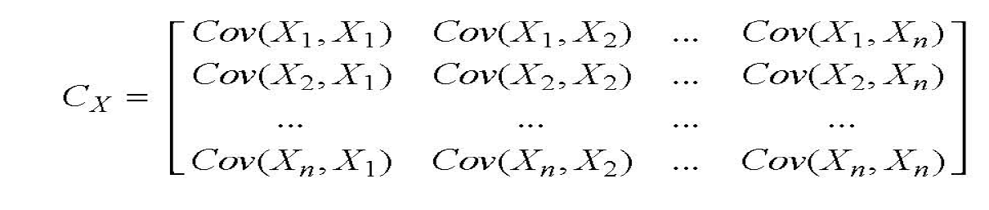



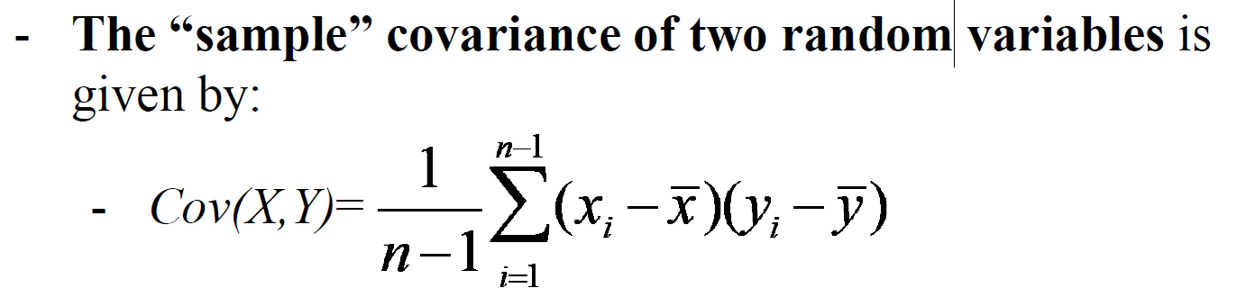

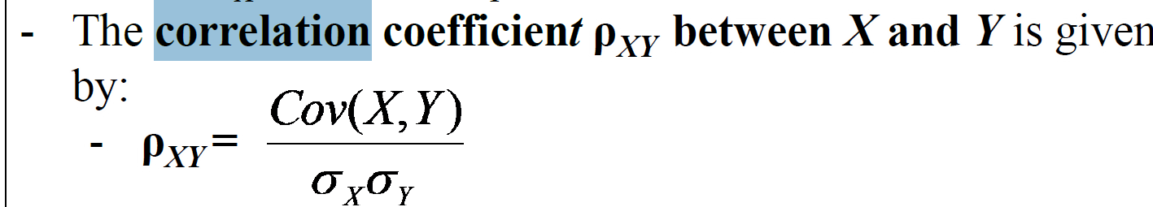

ro13 = 0.985

2)

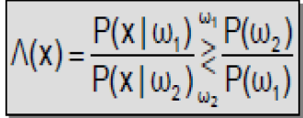

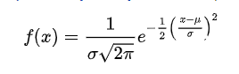

Solution:

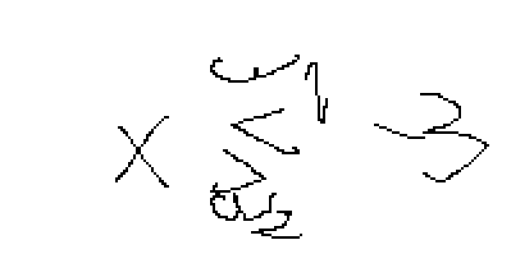

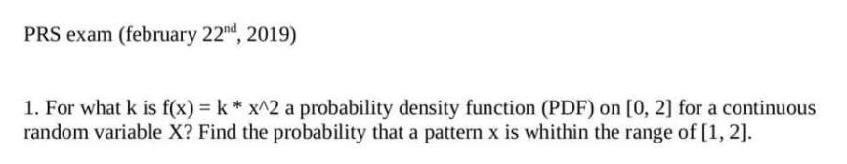



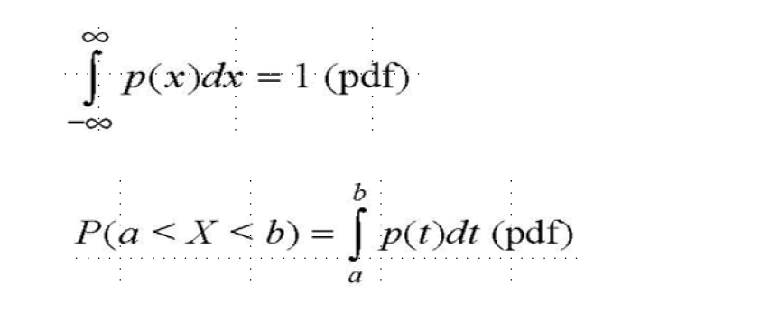

Step 1: Integral from 0 2 of (k * x^2) = 1 => k = 3/8

Step 2: probability that X is in [1,2] => integral from 1 2 of (3/8 * x^2) = 7/8



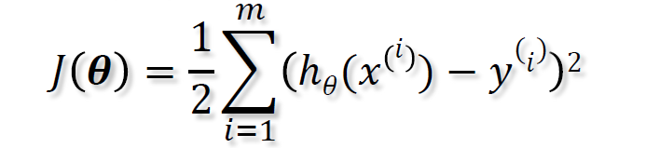

find a s.t. J is min

½ ( (60a – 160)^2 + (70a – 160)^2 + ...)

minimum = -b/2a

aX^2 + bX + c = 0



g(x) = - 3x1 + 5x2 + 1



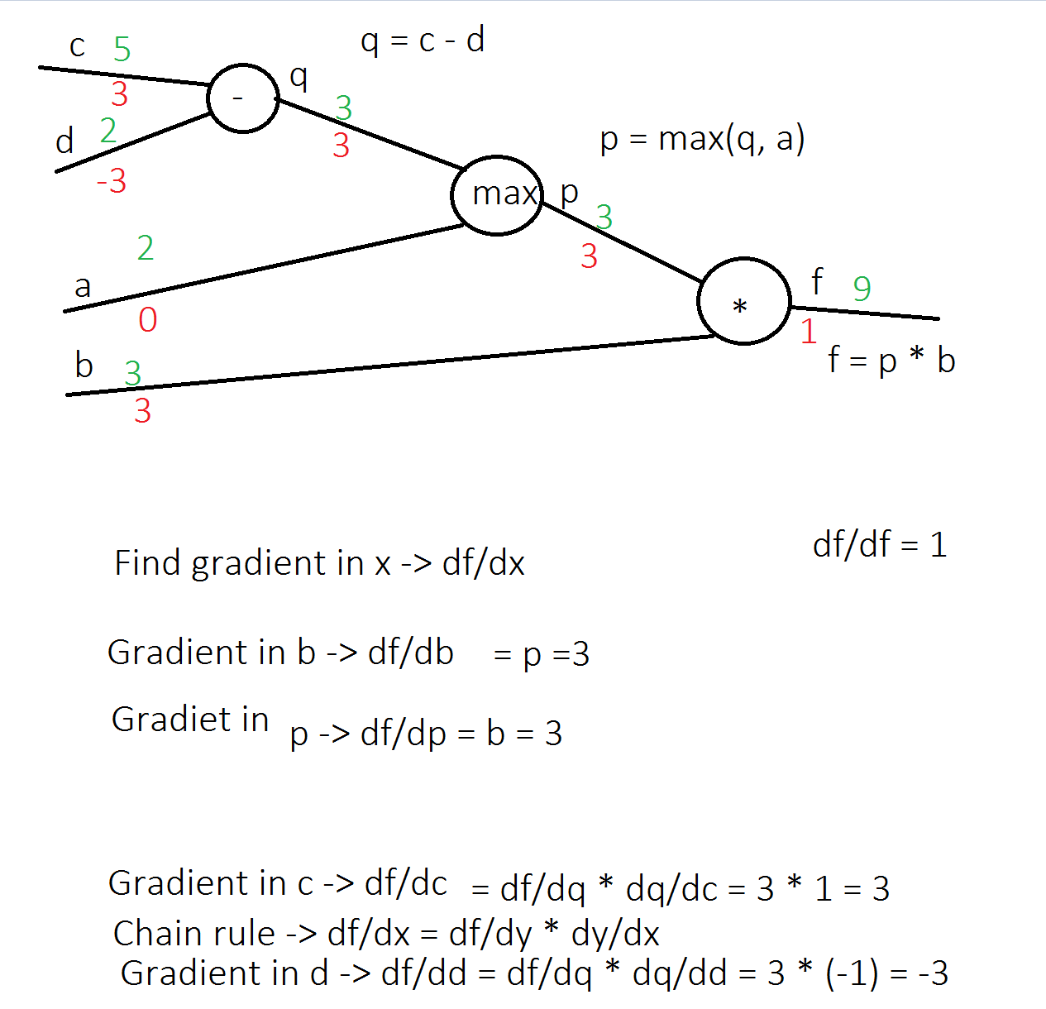

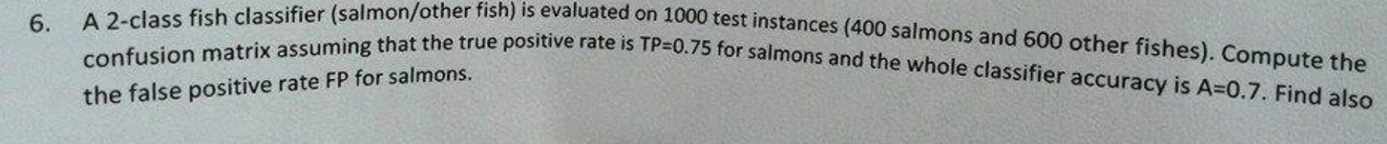

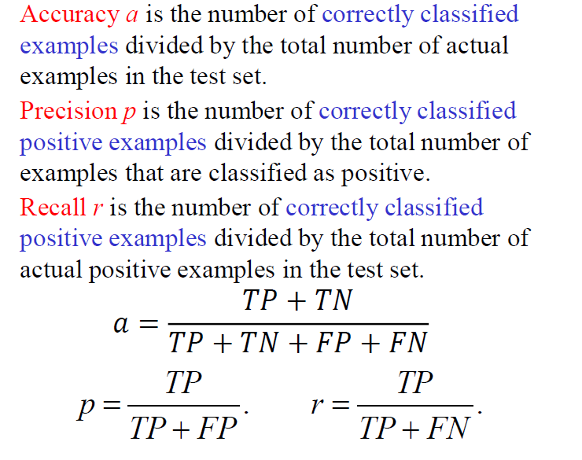

|  |  |  |  |
| --- | --- | --- | --- |
|  | Actual value | | |
| Predicted value |  | Salmon | Other Fish |
| Salmon | (TP) 300 | (FP) 200 |
| Other Fish | (FN) 100 | (TN) 400 |

rate of TP = 0.75

400 salmon * 0.75 = 300

a = (TP + TN )/ 1000 = (300 + TN)/1000

a = 0.7

TN = 400

falas positive rate = FP / (FP + TN) = 200/600 = 1/3 = 33.3%

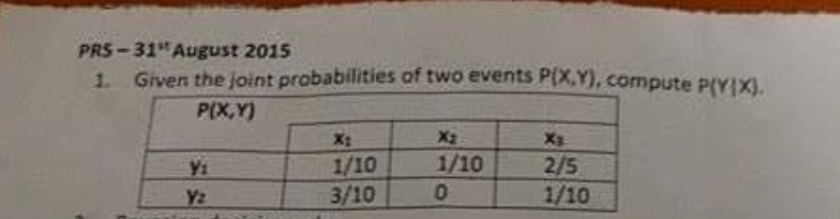

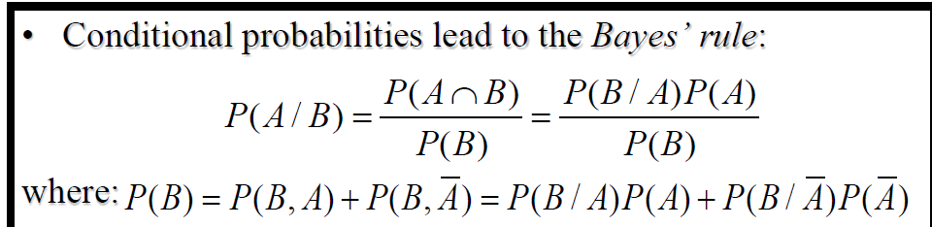

P(Y|X)

P(y1|x1) = 1/10 / 4/10 = ¼

P(x3|y2) = 1/10 / 4/10 = ¼

P(x1) = sum on column x1

P(y1) = sum on row y1

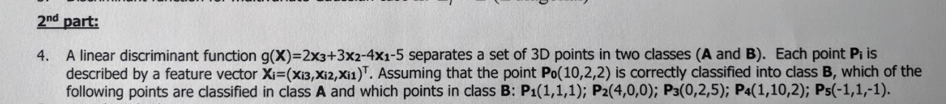

P0(10,2,2) -> class B

g(P0) = 2 * 10 + 3 * 2 – 4 * 2 - 5= 13 > 0 => g(x) > 0 -> Class B, g(x) < 0 -> Class A

