FORMULE

**BCWP** = **EV** (Budgeted Cost of Work Performed/Earned Value)

**BCWS** = **PV** (Budgeted Cost of Work Scheduled/Planned Value)

**ACWP** = **AC** (Actual Cost of Work Performed/Actual Value)

**BAC** (Budget at Complete)

**CV** (Cost Variance) = BCWP – ACWP (< 0 => over the budget)

**CPI** = BCWP/ACWP (Cost Performance Index) (< 1 => over the budget)

**SV** (Schedule Variance) = BCWP – BCWS (< 0 => behind schedule)

**SPI** (Schedule Performance Index) = BCWP/BCWS (< 1 => behind schedule)

**EAC** (Estimate at Completion)

1. 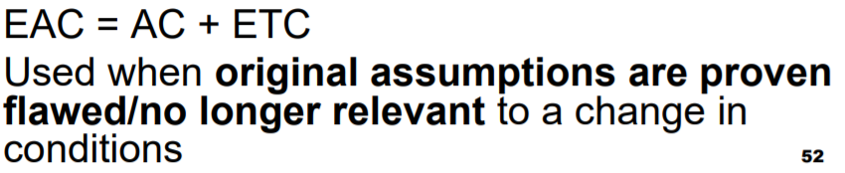
2. 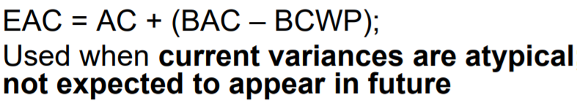
3. 