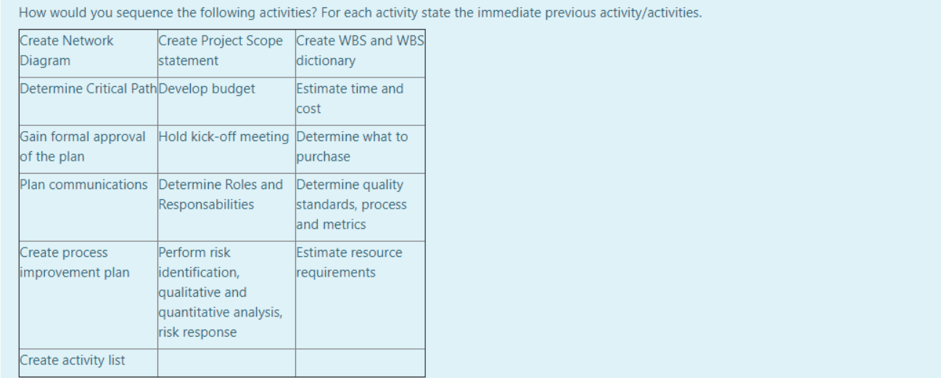

|  |  |
| --- | --- |
| **Activity** | **Previous activity** |
| Create Project Scope Statement | - |
| Determine Quality Standards, process and metrics | Create Project Scope Statement |
| Create WBS and WBS dictionary | Determine Quality Standards, process and metrics |
| Create activity List | Create WBS and WBS dictionary |
| Create Network Diagram | Create activity List |
| Determine Critical Path | Create Network Diagram |
| Estimate resource requirements | Determine Critical Path |
| Determine what to purchase | Estimate resource requirements |
| Estimate time and cost | Determine what to purchase |
| Develop budget | Estimate time and cost |
| Perform risk identification, .... | Develop budget |
| Determine roles and responsibilities | Perform risk identification, .... |
| Plan communications | Determine roles and responsibilities |
| Gain formal approval of the plan | Plan communications |
| Create Process improvement plan | Gain formal approval of the plan |
| Hold kick-off meeting | Gain formal approval of the plan |



Quality criteria may have not been determined correctly during the planning phase.

Another solution would be to use an agile approach in order to deliver incrementally to the stakeholders. This approach can deal with changing requirements. Modifications can be added more easily and risk assessment and management is built implicitly into agile approaches.

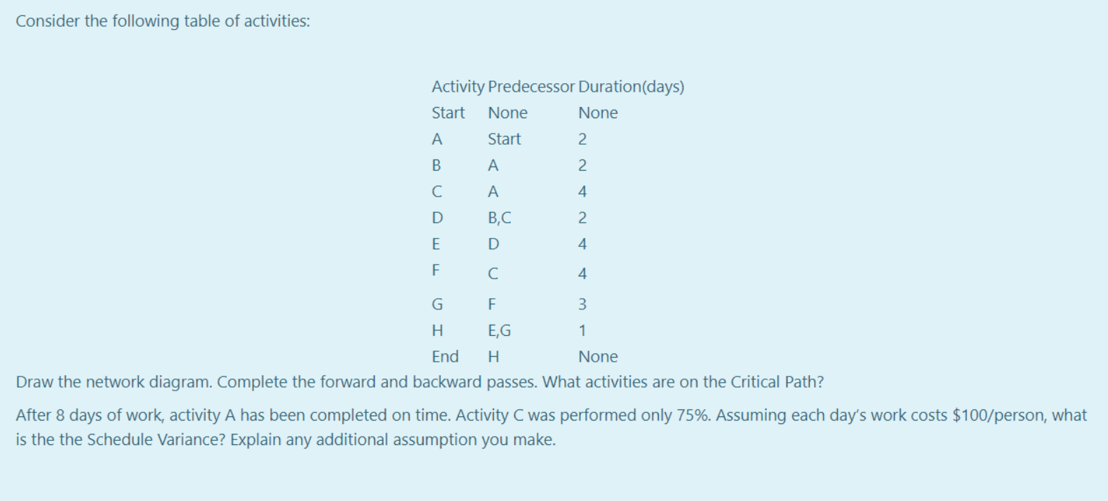

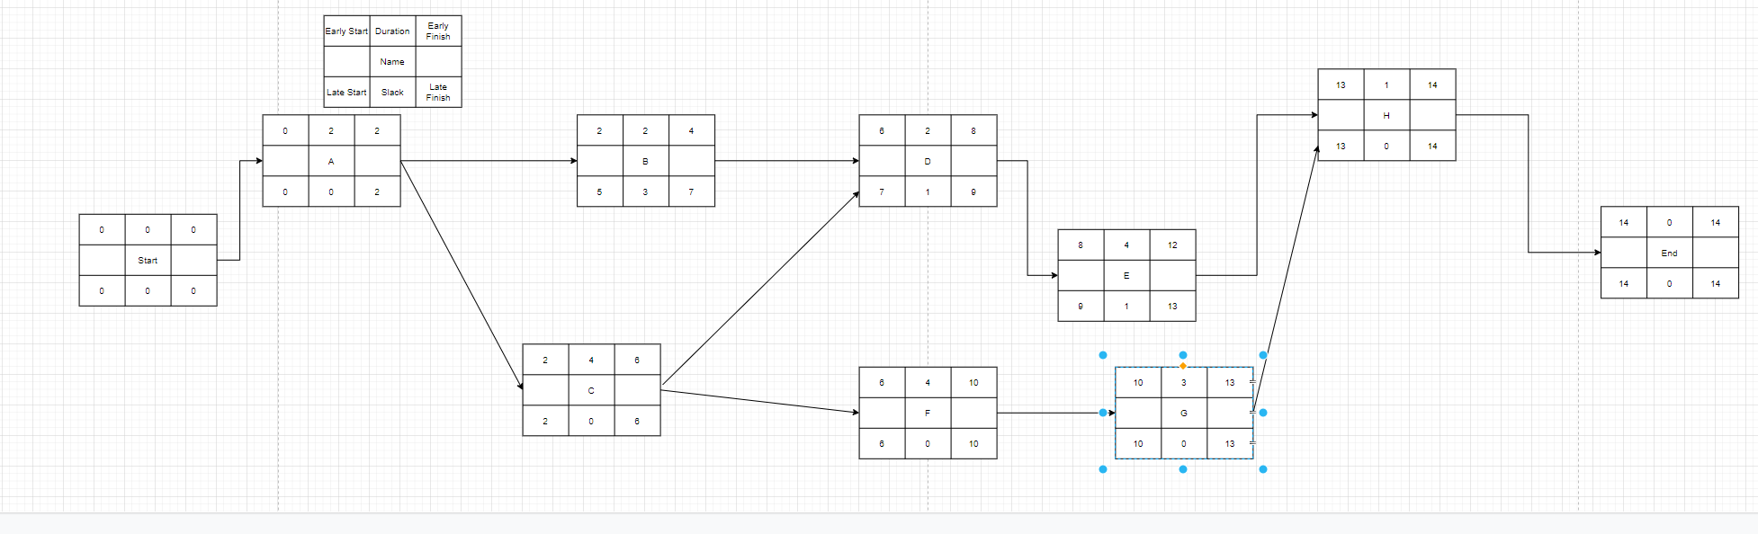

What we should have had  
A – 100% - 2 unit of work

B – 100% - 2 unit of work

C – 100%

D – at least 50%

F – 50%

Rest – 0%

Units of work - 11

We have

A – 100%

C – 75%

B – we can assume 100% (not specified)

F – 0% - Needs C

D – 0%, needs C

Units of work – 7

Assuming 1 person / unit of work => $100 / unit of work

BCWS = 11 units of work * $100 = $1 100

BCWP = 7 * $100 = $700

SV = BCWP – BCWS = $700 - $1 100 = -$400 < 0 => We are behind schedule



We assume that the current variances are indicative of future variances. Therefore EAC will be:

EAC = AC + (BAC – BCWP)/CPI

AC = ACWP = 60 000

BAC = 100 000

CPI = BCWP/ACWP

Week 6, 50% total (week 12) => We can assume we expected 50% of work to be done (assume linearity)

* BCWS = 50% * 100 000 = 50 000 (not used here)

BCWP = 40% * 100 000 = 40 000

CPI = 40 000/60 000 = 2/3

EAC = 60 000 + (100 000 – 40 000)/(2/3) = 150 000

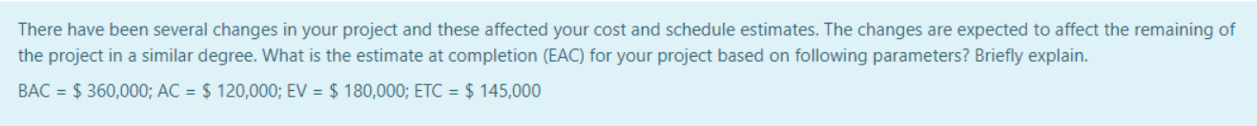

BCWP = EV = 180 000

ACWP = AC = 120 000

BAC = 360 000

EAC = AC + (BAC – BCWP)/CPI

CPI = BCWP/ACWP

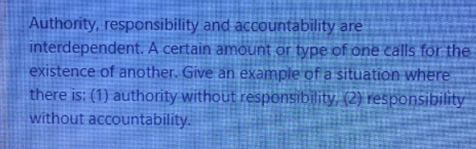

RACI

1. Șăf pune resposabilitatea de a face “o chestie” –Viktor 2k21 pe un alt om

Experts have authority in their field, but may not have responsibility if they are consultanst for example.

1. Project Team – from RACI. The team has responsibility to continue, but in case anything goes wrong, the Project Manager is accountable.

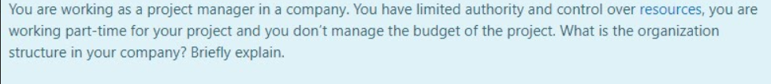

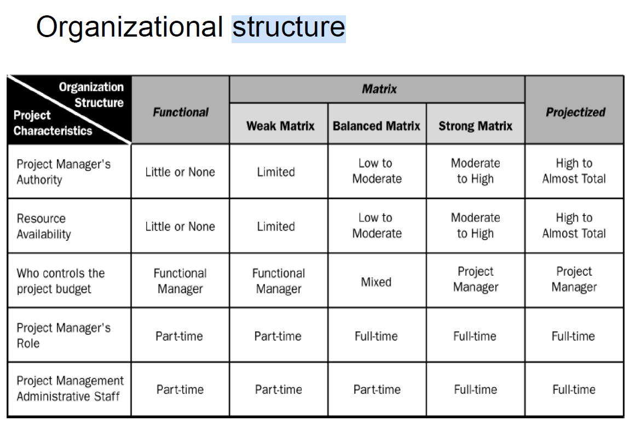



<https://en.wikipedia.org/wiki/Use_case_points>



CPI = BCWP/ACWP

BCWP = 75% * 2 units = 1.5

ACWP = 1

CPI = 1.5 > 1 => We are under budget

BCWS = 100% * 2 = 2

SPI = BCWP/BCWS = 1.5/2 = 0.75 < 1 => We are behind schedule.

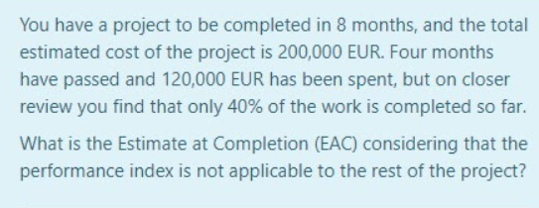

EAC = AC + (BAC – BCWP) (formula 2)

AC =ACWP = 120 000

BAC = 200 000

BCWP = 40% * 200 000 = 80 000

EAC = 120 000 + (200 000 – 80 000) = 240 000 => we estimate that at the end the project will cost 240 000 => 40 000 more than our original estimation of 200 000



EV = BCWP = 600

AC = ACWP = 650

PC = BCWS = 560

SV = BCWP – BCWS = 600 – 560 = 40 > 0 => We are ahead of schedule

CV = BCWP – ACWP = 600 – 650 = -50 < 0 => We are over budget

CPI = BCWP / ACWP = 600/650 < 1 => We are over budget



EV = BCWP = 70% * 100 000 = 70 000

BAC = 100 000

BCWS = 60% (day 6, assume linearity)* 100 000 = 60 000

ACWS = 65 000

SPI => ahead or behind schedule

EAC => Expected to complete on budget?



EV = BCWP = 70% * 4 000

BAC = 4 000

SPI => ahead or behind schedule

BCWS = 75% (assuming linearity, că altfel nu ai cum) * 4 000 = 3 000

EAC => Expected to complete on budget?

ACWP = 3 500

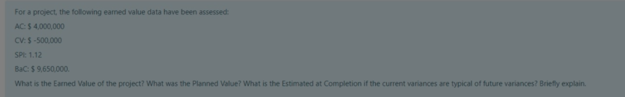

EV = BCWP

PV = BCWS

CV = BCWP – ACWP

BCWP = CV + ACWP = -500 000 + 4 000 000 = 3 500 000

SPI = BCWP / BCWS

BCWS = BCWP / SPI = 3 500 000 / 1.12 = 3 125 000

EAC – formula 3



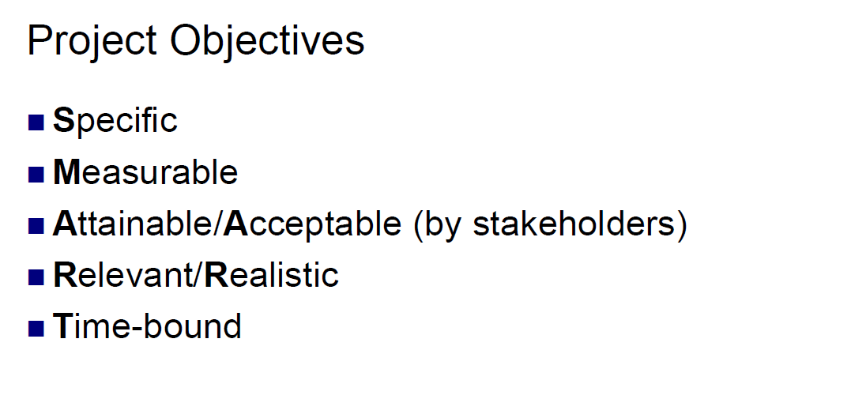

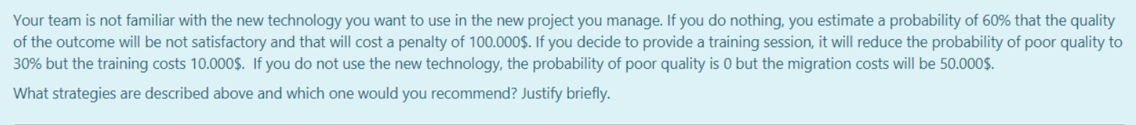

Risk – 4 strategies for dealing with risk

Accept – do nothing (but have a contingency plan)

Mitigate – reduce impact/probability of the risk

Transfer – transfer the risk to a third party

Avoid – ensure that the risk doesn’t happen

Case 1: Accept => Exposure: 60% * 100 000 = $60 000

**Case 2: Mitigate => Exposure: 10 000 + 30% * 100 000 = 40 000**

Case 3: Avoid => Exposure: 50 000

Choose mitigation as it has the lowest expected cost.



Mitigation => Train your team in integrating new components => reduce probability of risk

Contingency => Accept risk of incompatibility and have a backup plan (in case the risk happens) where you have a slower component that does the same thing, but it is easier to integrate it (no risk of incompatibility)

Transfer => Pay another company to integrate it for you



Projectized => see table