# Quiz 1

1. A project is : a finite timed effort aiming to create an unique result
2. Operational work : is repetitive
3. Projects are successful if they :

- are delivered on time,

- do not spend more than the agreed budget

- provide the required features at the agreed quality level

1. To be able to successfully manage a project, one needs adequate:

- requirements

- staff

- funding

-timing

1. To be a good Project Manager you need to have:
2. Interpersonal communication skills
3. Technical skills
4. General management(ie financial, sales, procurement) skills
5. Application domain knowledge

# Quiz 2

1. Companies with immature processes:

* May have processes that are completely different/unrelated
* May have no processes
* May have processes that are not enforced
* May have unpredictable outcomes

1. Which of the following is true:

* each project needs a specific process T
* a general process can be applied to just one project F
* a general process can be applied to several projects F
* several projects can use the same specific process F

1. Companies with mature processes:

* Have a general process template
* Enforce using processes
* Collect measurements
* Improve existing process models

1. Which of the following is true:

* We can have plan-driven and immature processes T
* Mature processes have predictable outcomes T
* We cannot have agile and mature processes F
* Only agile processes manage risks F
* Only agile processes manage change F

1. Agile and plan-driven methodologies are different because:

* You plan for a longer time span of the project in the plan-driven approach than in the agile one T
* Less formal communication is used in the agile approach T
* Iterations are used only in the agile approach F
* Risks and change are not managed in the plan-driven approach F
* It takes more time to plan in the plan-driven approach than in the agile approach F

# Quiz 3

1. Which of the following are components of a problem statement:

* F Resources needed
* T Ideal status
* F Objectives
* T Real status
* T Proposed solution

1. In a functional organization the project manager has:

* Part-time involvement in the project
* Little to none authority

1. In a projectized organization the project manager has:

* High control over the budget
* Full-time involvement in the project

1. which of the following statements is true:

* T The project scope statement contains the acceptance criteria
* F If an item id not included in the project scope, it will be not mentioned in the project scope statement
* F In an agile approach communication is not planned

1. Which of the following is true about risk management:

* Agile methodologies do include risk management
* It involves identifying uncertainties

# Quiz 4

1. Disciplined Agile Delivery(check all that applies)

* Provides a toolkit for tailoring agile processes
* May cover different project lifecycles

1. The explanatory lifecycle is not suitable for high-risk projects: False
2. Check all that applies regarding the Development Case:

* Contains the specific process instance applied to a project
* Includes references to templates defined at organizational level
* Is an artifact defined in the context of the Rational Unified Process
* May include references to guidelines defined by external organizations

1. The Lean Lifecycle flow is iterative: False
2. The Continuaous Delivery Agile Lifecycle is an extension of the Basic Agile lifecycle covering also Release and Operation: True
3. Process tailoring is about:

* Defining the organizational process template starting from a process framework

1. The continuous delivery lean lifecycle requires teams with mature DevOps practices: True

# Quiz 5

1. A WBS is a decomposition of work having structures of a : Tree
2. Not all the tasks in the WBS have to be executed in a project: False
3. All the tasks in the WBS need to be executed in the project but there might be additional optional tasks (not in the WBS) that can be executed: False
4. The WBS provides just a guideline of what could be executed: False
5. ?? Which of the following are components of a Project Scope statement?
6. Which of the following are examples of scope creep?:

* Adding new features without managing their effects on the project(ie schedule, cost)
* Adding new deliverables without managing their effects on the project (ie schedule, cost)

1. The backlog is different from the WBS because:

* Not all the backlog items are planned at the same level of detail

# Quiz 6

1. ??If the duration of the Critical Path of a project is 32 weeks then:

* The project can be done in 32 weeks or more

1. The three most important objectives when scheduling are:

* Least cost
* Best time
* Least risk

1. The simplified (linear) relation between effort, resources and duration is:

* Effort = Resources * Duration

1. We can have these types of dependencies between activities:

* Mandatory
* Discretionary/optional
* Resource driven
* External

1. Which of the following is true about the slack?

* Is the amount of time an activity can be delayed without affecting the depending activities

1. Is calculated as Late_Finish – Early_Finish

# Quiz 7

1. Risk management is performed:

-At specific milestones to re-evaluate the risk management plan

-Continuously during the liecycle of the project to identify and respond to events

1. Which are good examples of weight values of Juval Lowy’s criticality risk model:

-1,2,3,4

-13,21,34,55

1. Which of the following are frequent risk examples:

-Assumptions

-Near-critical activities

- Resource availability

-Weak contracts with suppliers

1. Risk mitigation plans are not applied in the agile practices: False
2. Risk identification should be performed during planning activities in agile practices
3. Adding an experienced developer to the team for a critical task is an example of mitigation.
4. Agile methodologies do not need risk management: False
5. Agile approaches support adaptation to change so no risk control is needed: False

# Quiz 8

1. In the Earned Value Analysis the following variables are defined:

-BCWP(Budgeted Cost of Work Performed)

-ACWP(Actual Cost of Work Performed)

-BaC(Budget of Completion)

-BCWS (Budget Cost of Work Schedules)

1. The Estimate at Completion depends in all the cases on the Budgeted at Completion: False
2. The Schedule variance indicator compares:

-The Budgeted Cost of work performed with the Budgeted cost of work scheduled

1. The Cost variance indicator compares:

-The Actual Cost of Work Performed with the Budgeted Cost of Work Performed

1. A project can be in the following states:

-Ahead of schedule and over the budget

-Behind schedule and under the budget

-Behind schedule and over the budget

-Ahead of schedule and under the budget

1. CPI never affects the Estimated at Completion: False
2. The Estimate at Completion does depend on the Actual Cost: True
3. SPI never affects the Estimate at Completion: True
4. Earned Value Analysis can be applied in agile methodologies: True

# Quiz 9

1. To be trusted a PM needs to:

-Be competent

-Have character(want the right thing)

-Be ethical

1. The following are stages of the team development model:

-Performing

-Norming

-Forming

1. The following is true about management and leadership:

-Management if about dealing with complexity while leadership deals with change

-Management is about monitoring results while leadership about initiating change

-Management is about solving technical problems while leadership about providing direction

-Management is about planning while leadership is about motivating

1. If the students of a grup disagree over the preferred exam date and the instructor decides the date is an example of: arbitration
2. A good manager:

-Initiates discussions with all the stakeholders(including the team)

-Is proactive

# Teorie:

BAC e bugetul alocat pt proiect

AC e costul pana la momentu actual,

PV e costul estimat folosind ziua curenta si ziua limita,

EV e costul luand in vedere procentul facut din proiect

Acceptance e cand iti asumi situația cum e si contingency e cand ai plan b

Slack time = earliest time an event can take plance – latest date it can occure without extending projects completion date

## Risk response strategies for threats:

* Avoidance
* Reduction (mitigate)
* Transfer
* Acceptance (=> consider contingency plan)

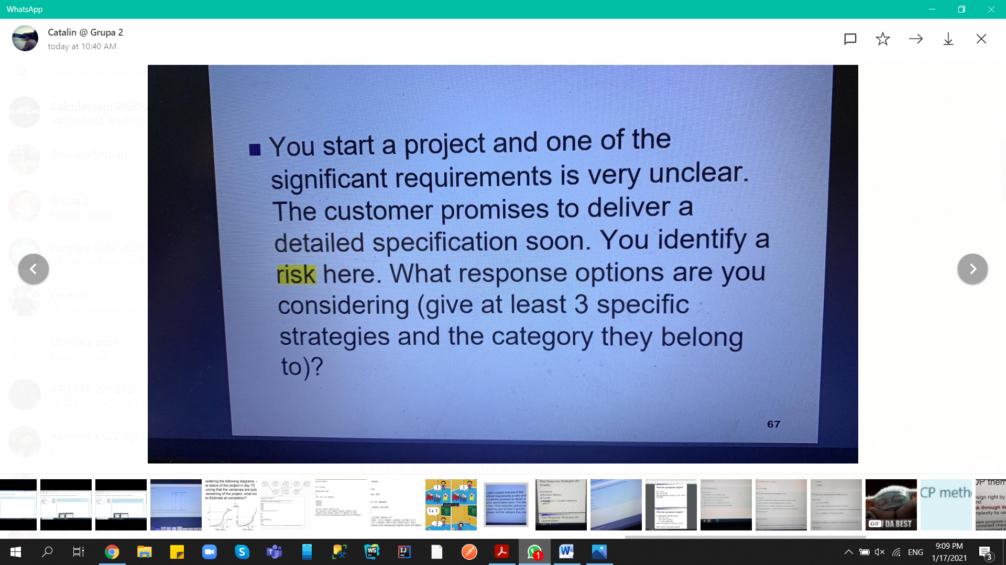

1. Avoidance : Amani cat mai mult posibil inceperea respectivului requirement
2. Mitigate: incerci sa faci respective cerinta dupa cat ai inteles ca vrea clientul si apoi cand vine cu cerinta clara modifici pe ce ai lucrat
3. Acceptance: accepti cerinta neclara si astepti dupa client sa o clarifice , in speranta ca asta se va intampla cat mai curand ( iar daca nu clarifica cerinta in timp util se ia in considerare un plan B)

## Risk response strategies for opportunities

Exploit (opposite to avoidance)

Enhance(opposite to reduce)

Share(opposite to transfer)

Acceptance

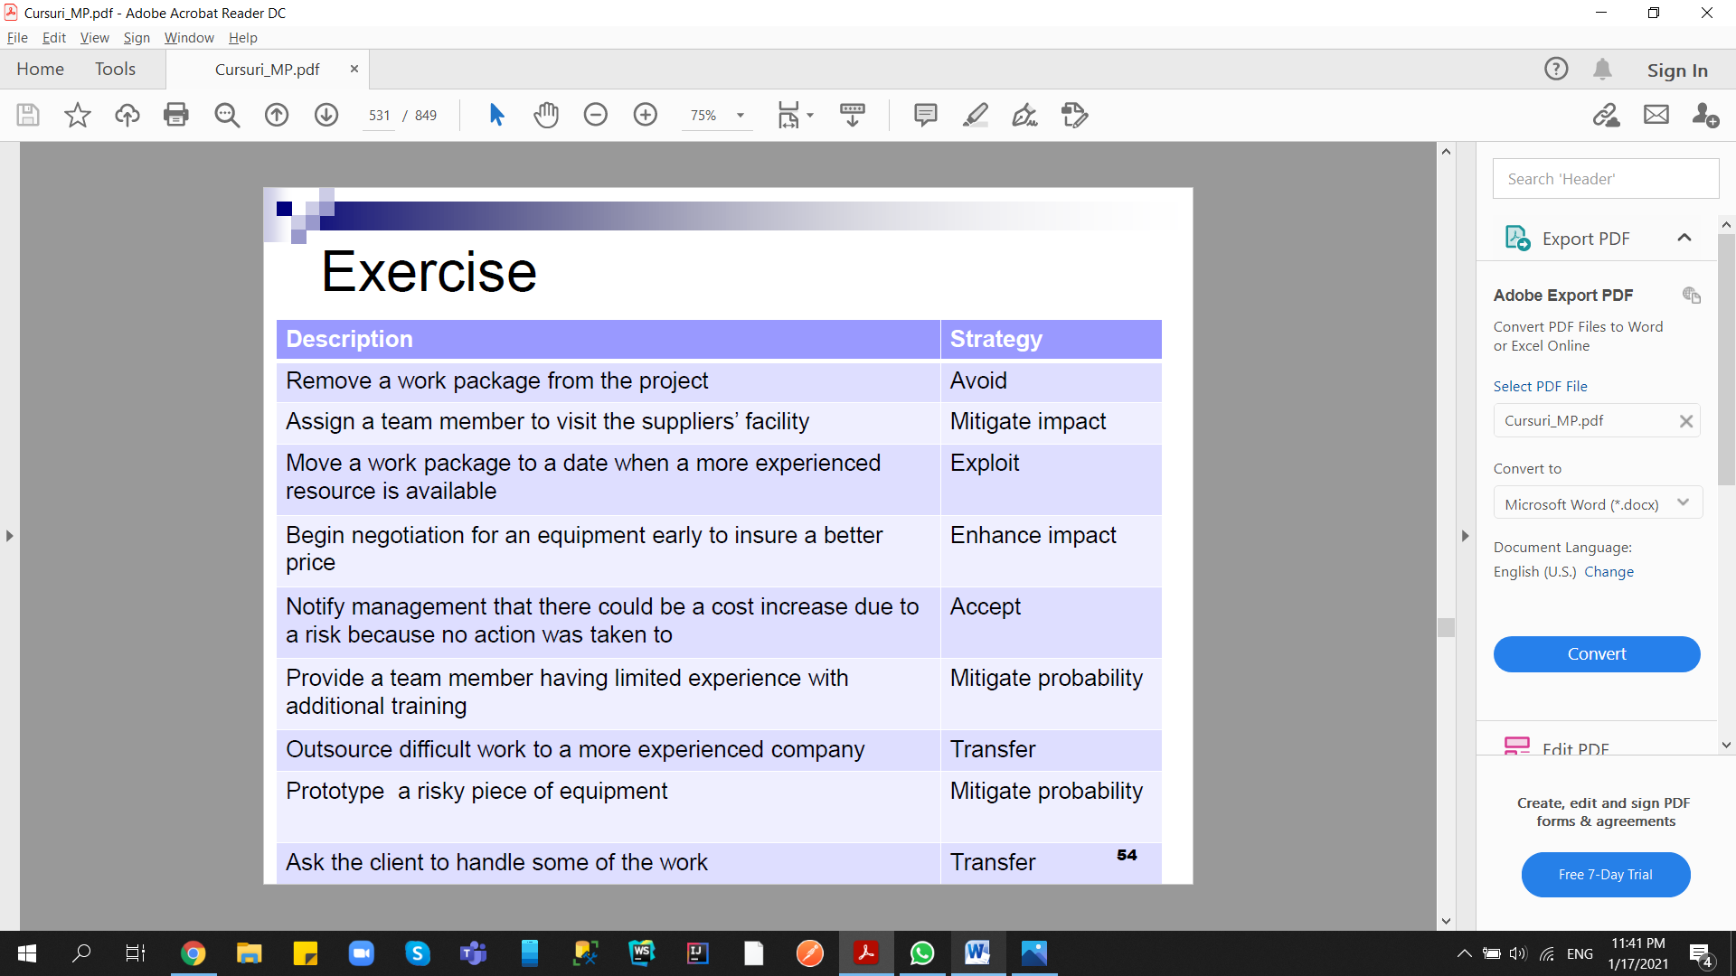

# Types of risks:

Resource risks

Business risks

Technical risks

Schedule risks

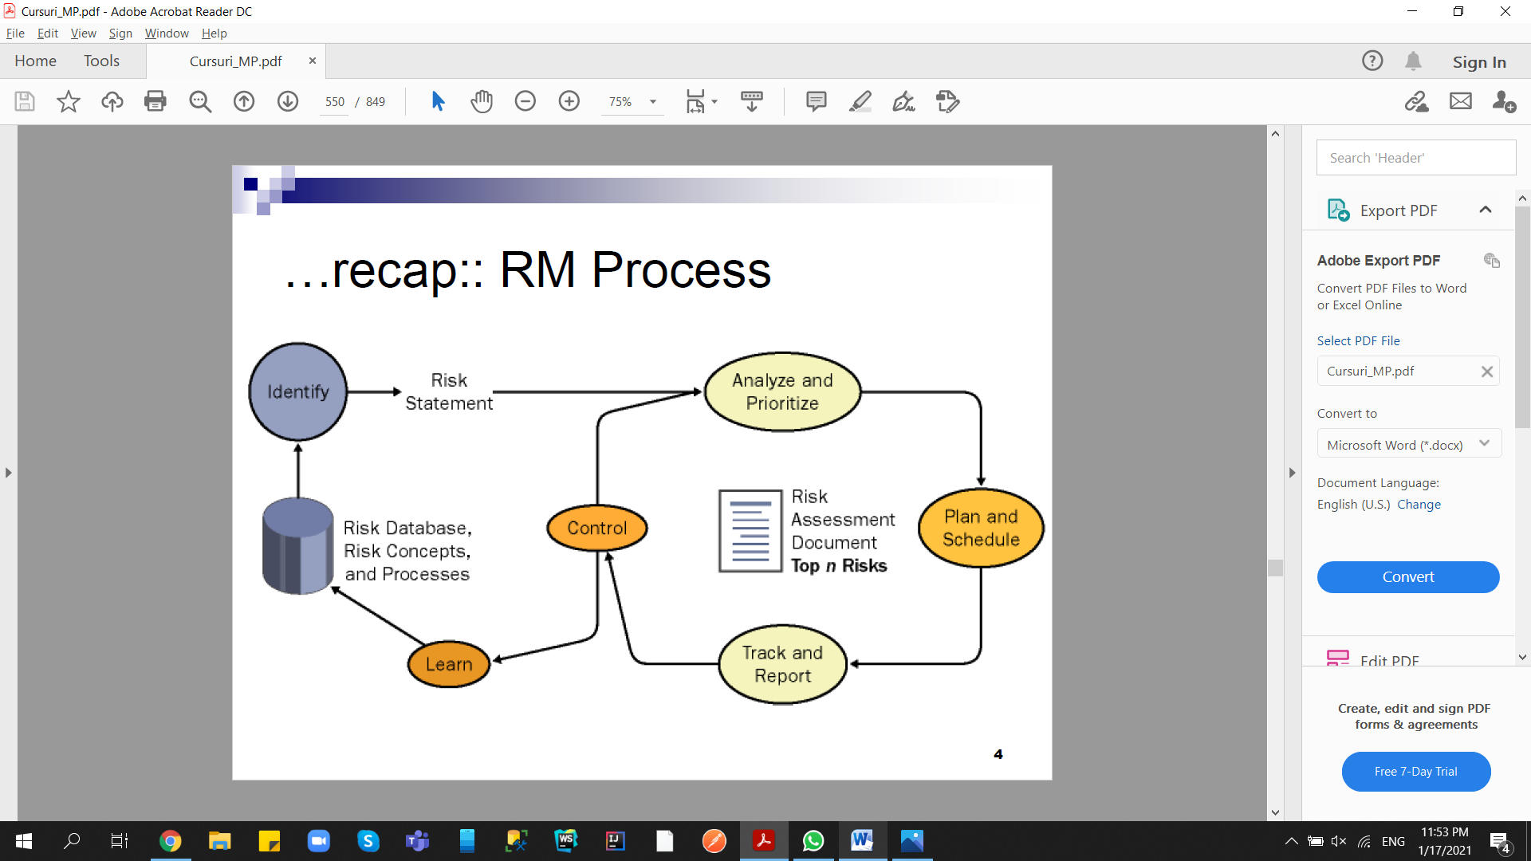

# Risk Metrics

Measurements:

* EP-Total Project Exposure
* Ei–Exposure for Risk i
* Ii–Impact for Risk i
* Pi–Probability for Risk i

Risk exposure metric (should -> 0)

Ep = sum Ei = sum Pi * Ii ( i de la 1 la n)

Risk exposure metric trend( should <0)

Ep = dEp / dt

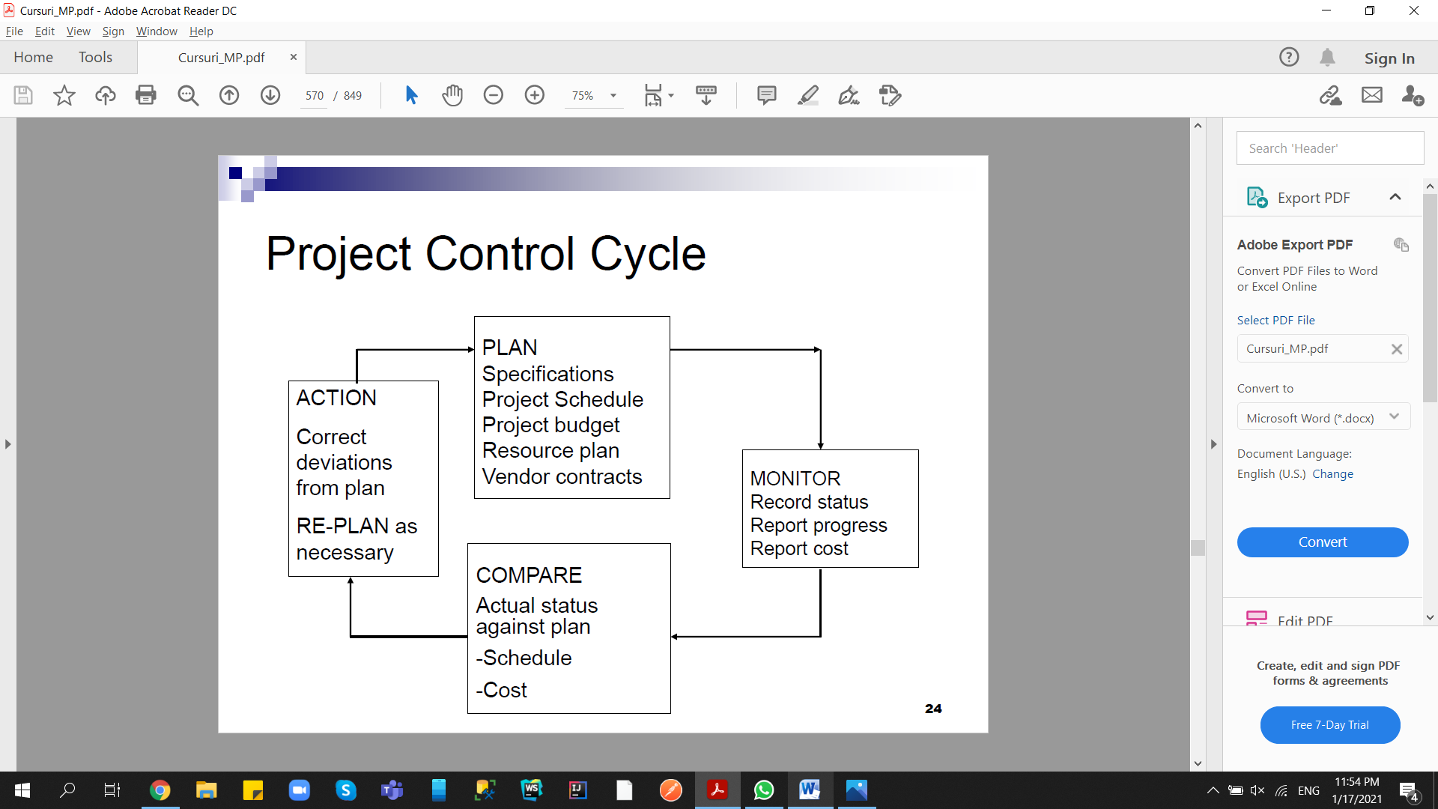

EVA = Earned Value Analasys

BCWS: budgeted cost of work scheduled; a.k.a. PV –Planned Value

ACWP: actual cost of work performed; a.k.a. AC –Actual Cost

BCWP: budgeted cost of work performed; a.k.a. EV –Earned Value

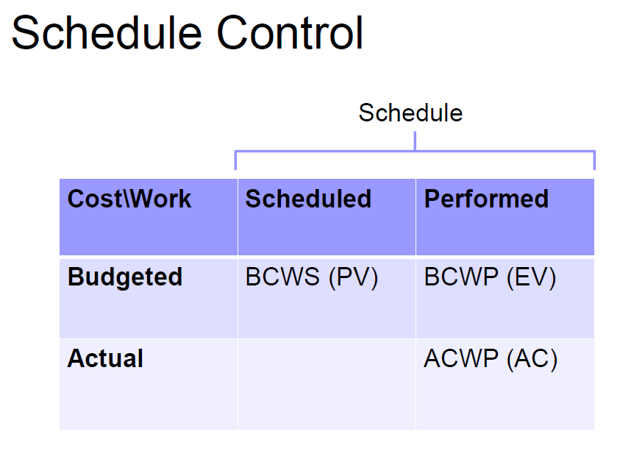

Schedule indicators

SV: Schedule Variance:

SV = BCWP –BCWS

< 0 => behind schedule

SPI: Schedule Performance Index

SPI = BCWP/BCWS

< 1 => behind schedule

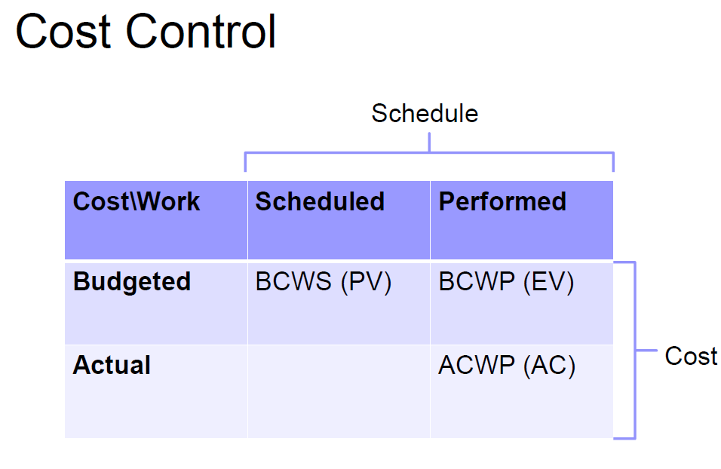

Cost indicators:

CV: Cost Variance

CV = BCWP –ACWP

< 0 => over the budget

CPI: Cost Performance Index

CPI = BCWP/ACWP

< 1 => over the budget

## EAC –Estimate At Completion

Forecast of most likely total project costs

3 options depending on the project characteristics

1. EAC = actuals to date + new estimate for remaining work

EAC = AC + ETC

Used when original assumptions are proven flawed/no longer relevant to a change in conditions

1. EAC = actuals to date + remaining budget

EAC = AC + (BAC –BCWP);

Used when current variances are atypical

1. EAC = actual to date + remaining budget modified by a performance factor (often CPI)

EAC = AC + (BAC –BCWP)/CPI

Used when current variances are typical of future variances

Once a project is 20% complete, the CPI does not vary from its current value by more than 10%.

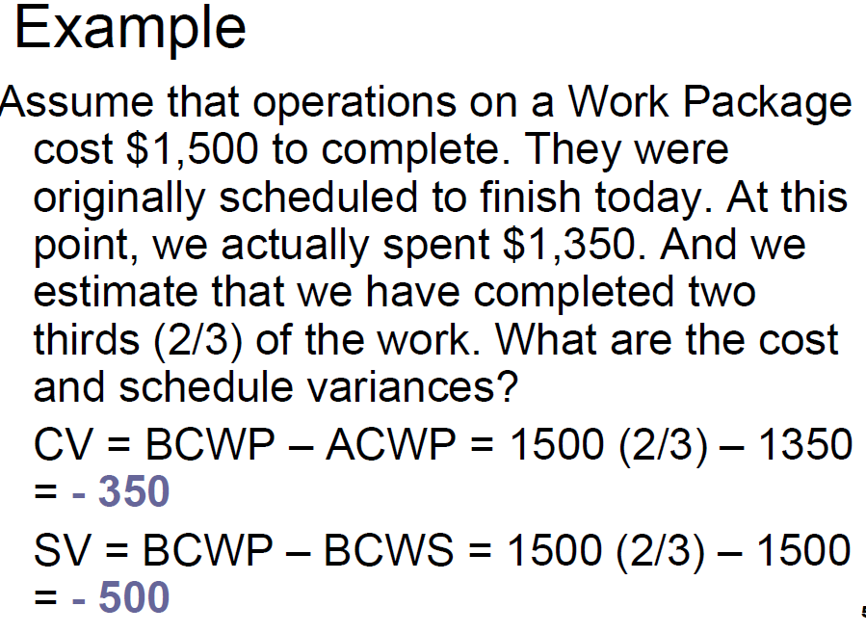

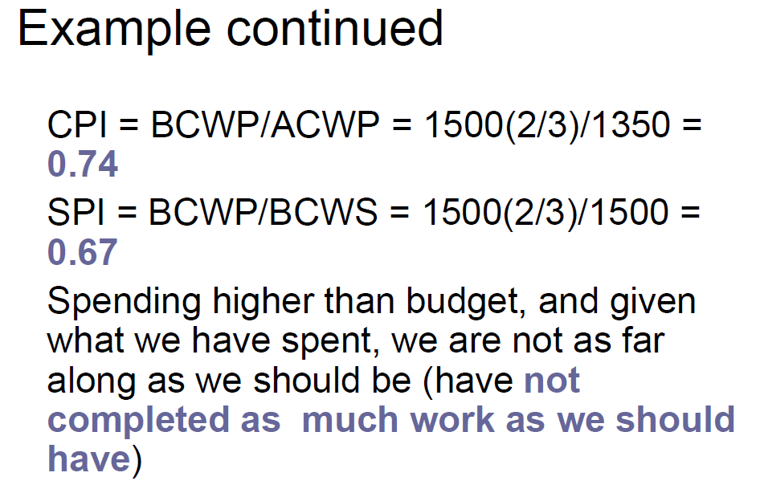

AC = actual cost = ACWP

PV = planed value = BCWS = BAC * EPC

EV = erned value = BCWP = BAC * APC

CPI = EV/AC

SPI = EV/PV

BAC = budget at complete(the planned mounth you expect to spend)

EPC = expected percent complete (current sprint(n)/total planned sprints)

APC = actual percent complete(story points completed/total planed story points)

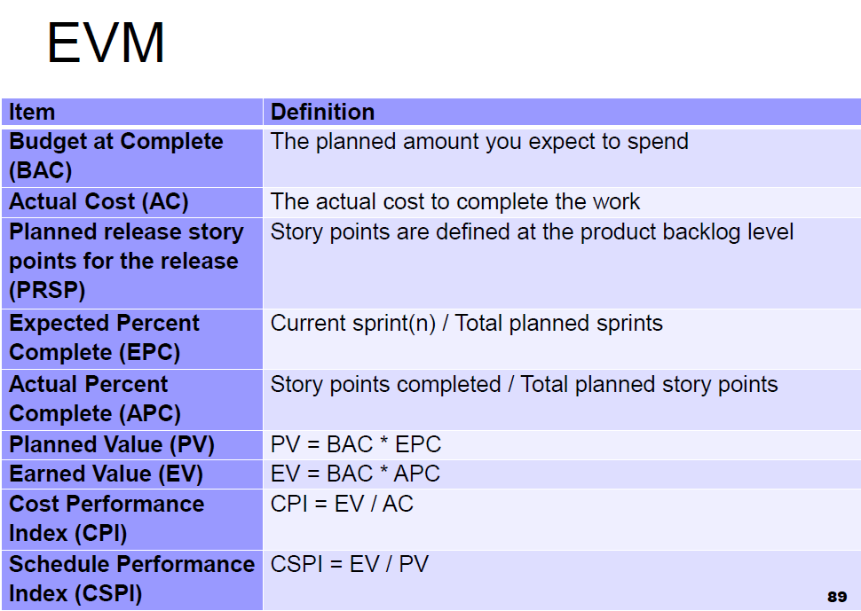

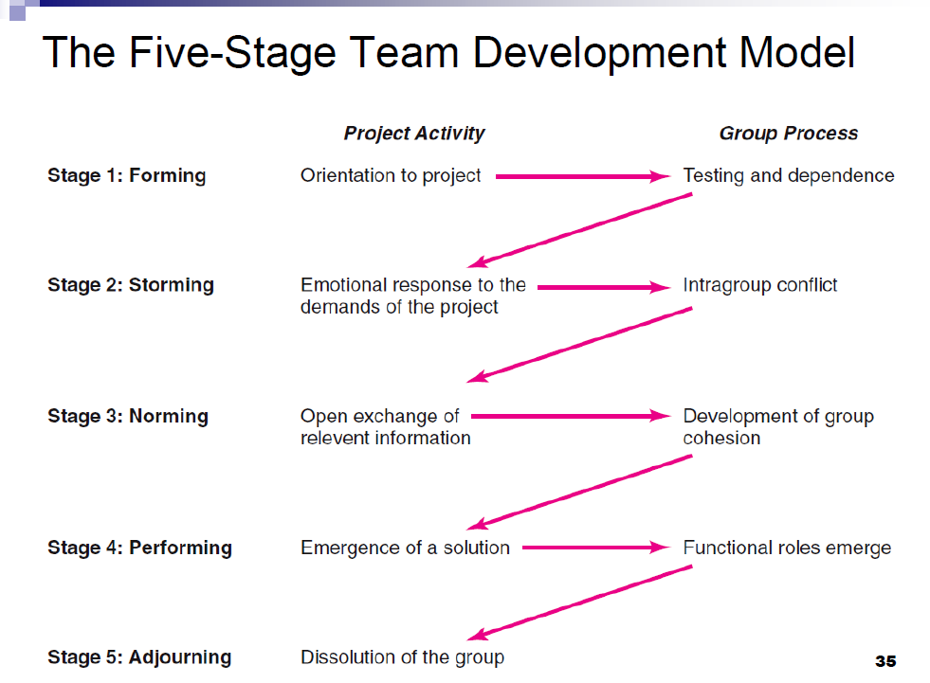

Shorten the critical path:

- scurteaza durata unui task din cp

- imparte taskul in mai multe taskuri mici ce pot fi lucrate in parallel de resurse diferite

- adauga resurse aditionale care sa lucreze la taskurile de pe cp

