

Fig.1

**CORRELATION MATRIX**

The dataset from the Vital Statistics Report 2018, Number of Live Births from 1903 to 2018 shows a strong correlation between year and population and year and number of live births. The correlation between the year and number of live births will be used.

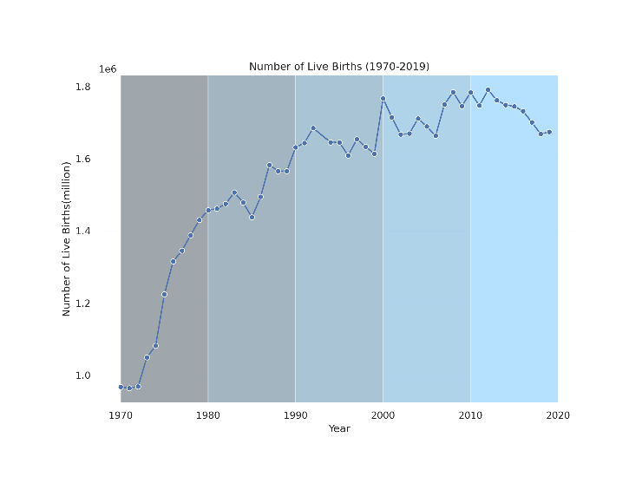

Fig.2

**TOTAL LIVE BIRTHS FROM 1970-2019**

As seen from the timeline of the total live births of the Philippines, there has been a 115.95% of increase in live births from 1970 to 2012 where the total live birth for the year 2012 has peaked at 1,790,367 live births. According to Rylee McDermott (n.d.), Among Asian countries, the Philippines has one of the highest population densities and fastest growth of population. But since we lack the government funded family planning methods, it holds us back from progressing to a future that we could obtain.

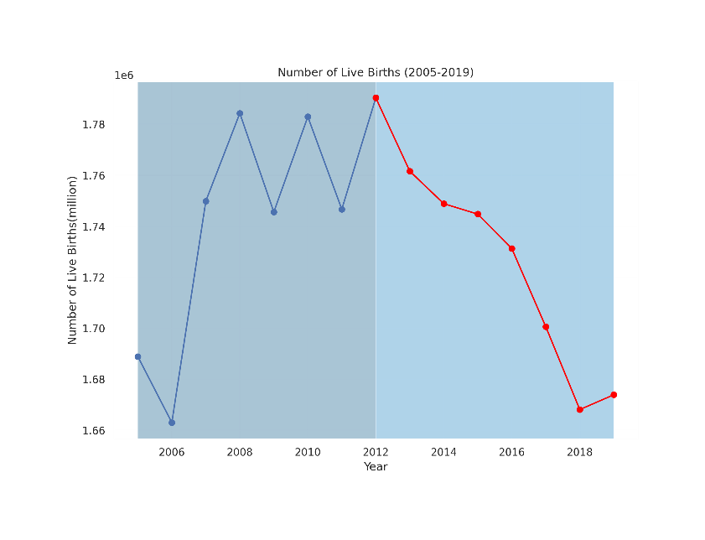

Fig.3

**TOTAL LIVE BIRTHS FROM 2005-2019**

But by 2012, the Responsible Parenthood and Reproductive Health Act of 2012, also known as the Reproductive Health Law or RH Law, and officially designated as Republic Act No. 10354, is a law in the Philippines, which guarantees universal access to methods on contraception, fertility control, sexual education, and maternal care which was enacted by the House of Representatives of the Philippines. This may be the help from the government that we may need since the lack of knowledge concerning reproductive health is associated with poverty, especially when it comes to overpopulation as stated by Zoë Nichols (2020). The graph now shows the considerable effect of the RH Law causing a -6.50% decrease in live births from 2012 to 2019.

Fig.4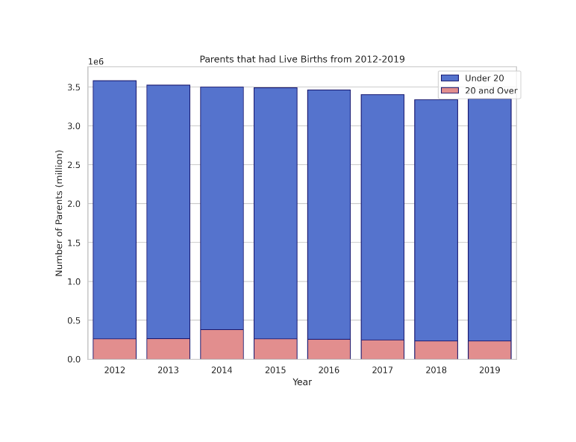.

**PARENTS THAT HAD LIVE BIRTHS FROM 2012-2019**

While the overall number of parents based on the previously shown live births is showing a clear sign of decline, the parents aged below 20 shows consistency in number per year. It can be speculated that universal access to contraceptives and fertility control has been effective for the adults, while the sexual education for the teenagers may not be as effective. The reason for this may stem from the fact that majority of Filipinos are Roman Catholics and the Catholic Church clearly opposes the idea of sex education and the use of contraceptives. As stated by Robles (2012), it is due to the Church’s pressure that has left the RH bill on a 14 year wait before it was passed as a law until the late former President Benigno S. Aquino III made reproductive health a priority issue. Even with the RH Act, an organization with the purpose of supporting Filipino children named Save the Children Philippines, still advocated for the Teenage Pregnancy bill and the requirement for schools to include in their curriculum a Comprehensive Sexuality Education (CSE) Zoë Nichols (2020). This would mean that the integrated sexual education from the RH Act was actually not as effective since an organization that focuses on helping Filipino children has advocated for a more comprehensive bill as a solution.

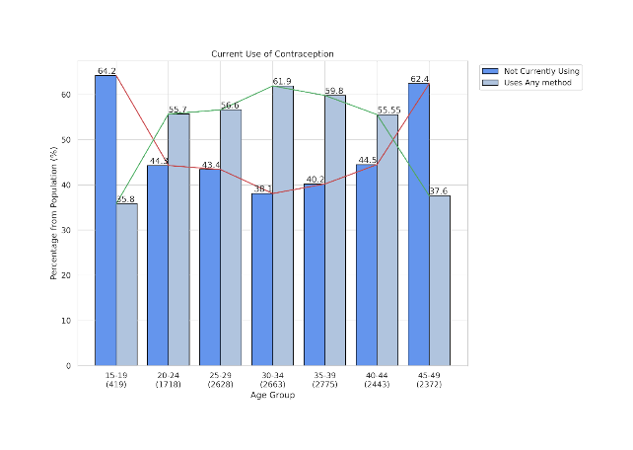 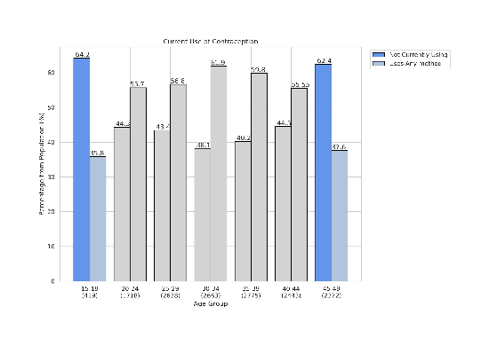

Fig.5.1 Fig.5.2

**CURRENT USE OF CONTRACEPTION**

Speaking of benefits of contraceptive use, we also analyzed data concerning the current use of contraception of married women and sexually active unmarried women aged 15 to 49 from the Philippines NDHS KIR. We’ve found out that among 7 age groups (15-19,20-24,25-29,30-34,35-39,40-44,45-49), the top two age groups that were not currently using any kind of contraception were ages groups 15 to 19 and 45 to 49 (64.2% and 62.4, respectively). They are also the only age groups whose population had a higher percentage of not using contraceptives. The graph shows that as an age group goes higher, the percentage of population who uses contraceptives also go higher up until a certain point. Which means as a person grows older, they become more aware of the situations they may get into if they have unprotected sex or that they have the age advantage of not getting embarrassed at idea of buying or getting free contraceptives.

Contradictory to the situation of the age group 15 to 19, they have less knowledge about sex and have the tendency to be ashamed of other people knowing about their sex lives. This is further supported by the results of the study of C.T. Galloway et al. (2016) entitled “Exploring African-American and Latino Teens’ Perception of Contraceptives and Access to Reproductive Health Care Services”, wherein they conducted focus groups for teenagers and gathered their insights concerning certain topics. Among the topics were the teen’s perceptions of accessing health services where they expressed their disbelief in doctor-patient confidentiality and the fear of everyone knowing their “business” and their parents being informed by the clinic due to being underage. They also stated that a more private health care clinic and a friendly welcoming staff would help them feel more relaxed and secure. Their beliefs about contraception were also gathered which were influenced by media and commercial messages. Among their insights were about shows that has sex scenes but they don’t see them getting condoms and doing it because of the “heat of the moment”. They also expressed their concerns about contraceptive commercials being scary due to the small print of possible side effects such as dizziness, drowsiness, and heart diseases. It was also identified that female participants were warry of the side effects of birth control pills such as gaining weight and other weird side effects. The results of the study of C.T. Galloway et al. (2016) somehow clarifies the reasons on most teenagers do not use contraceptives.

For age group 35 to 39 up to 45 to 49, the reason for the decline in use of contraceptives may be related to the fact that they are one of the few people who have had experienced difficulty in procreating and have decided to cease the use of contraception to increase their odds. It may also be concluded that some of these women, especially the sexually active ones, are actually incapable of bearing a child due to medical reasons so they don’t mind not using contraceptives. According to the study of Solanke (2017) about the “Factors influencing contraceptive use and non-use among women of advanced reproductive age in Nigeria”, the lower use of modern contraceptives for women with advanced reproductive age (35-39) was considered to be either due to sexual inactivity or completed fertility among women who are at the edge of their fertility period.

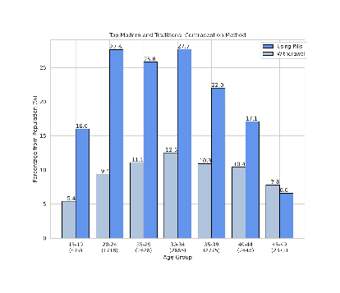

Fig. 6

**TOP MODERN AND TRADITIONAL CONTRACEPTION METHOD**

This chart shows the most common modern and traditional contraception method used by the population from the Philippines NDHS KIR 2017 data. The use of pills was the most common among age groups 20 up to 34 while slow declining from 35 to 49. Birth control pills are relatively cheap and can even be free if obtained from certain health clinics which is most likely the reason why a lot of the population use this method, even the teenagers. The traditional method of withdrawal had a lower rate of use due to its effectiveness relying on the male’s reaction time. Surprisingly, the 40 to 49 age groups had a higher rate of use for withdrawal compared to the 15 to 19 age group, possibly due to teenagers having little self-control making it hard to avoid pregnancies with this method.

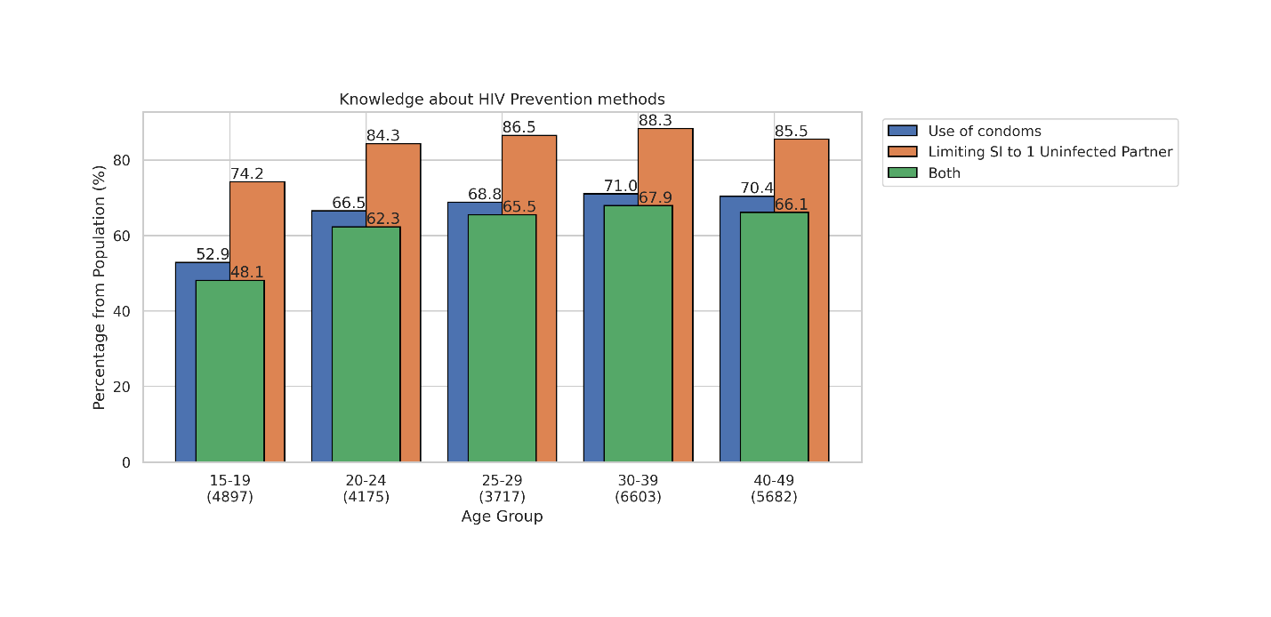

Fig. 7

**KNOWLEDGE ABOUT HIV PREVENTION METHODS**

With the previous visualizations, there is a topic for concern that was not mentioned as the main reasons for their use of contraception. The top most used modern and traditional contraception methods were capable of preventing pregnancies, but neither of them was eligible enough to prevent Sexually Transmitted Diseases (STD). The condom is the only contraceptive capable of preventing STD’s while also being hormone-free (which is the concern of some teenagers) and free at certain health clinics. Another data from the Philippines NDHS KIR 2017 shows the knowledge of women about HIV (Human Immunodeficiency Virus) prevention method whose ages range from 15 to 49. It showed that at least half of the population from every age group had at least knowledge about one HIV prevention method (Either method 1: by using condoms or method 2: limiting sexual intercourse to only one uninfected partner). With the method 2 being the most common knowledge among the population and only about 3 in 5 people having comprehensive knowledge (Knowing both methods) about the prevention methods. Of course the main reason for this is the lack of comprehensive sexual education and the guidance of parents who mostly opt to not talk to their children about it which is a terrible choice since teenagers are naturally curious. It was stated in a study of S. A. Marshall et al. (2020) that the limited knowledge of teenagers about the effectiveness of contraceptive methods and ways to access these contraceptives are a concern which needs the intervention of both parents and trusted adults.

**RECOMMENDATION #1 (CSE)**

Our first recommendation includes the integration of a more Comprehensive Sex Education as a subject required to be taken by students at if not all then almost every school. Since the initial integration was only for public schools most likely because they have more control over them. Our recommendation includes the integration of CSE at private schools as well since no teenager is safe from the consequences of early sexual intercourse. According to the Philippine National Demographic and Health Survey Key Indicators 2017, knowledge about HIV both prevention methods (use of condom and limiting sexual intercourse to one uninfected partner) were higher in urban areas compared to rural areas, 65% and 60% respectively. Even though those who reside in urban areas have a higher percentage, those who are in rural areas are not that far with only a 5% difference. Meaning, urban areas could possibly have more knowledgeable citizens if sex education is also implemented in private schools. With the CSE, we would most likely see an improvement in these numbers.

Topics to be included which are based from a non-profit organization called Planned Parenthood Federations of America Inc. are:

* Human development, including puberty, anatomy, sexual orientation, and gender identity
* Relationships, including self, family, friendships, romantic relationships, and health care providers
* Personal skills, including communication, boundary setting, negotiation, and decision-making
* Sexual behavior, including the full spectrum of ways people choose to be, or not be, sexual beings
* Sexual health, including sexually transmitted infections, birth control, pregnancy, and abortion
* Society and culture, including media literacy, shame and stigma, and how power, identity, and oppression impact sexual wellness and reproductive freedom

Of course the topics to be discussed are not final and will be needing the consultation of medical professionals.

According to the findings of Mark and Wu (2022) on their paper entitled “More comprehensive sex education reduced teen births: Quasi-experimental evidence”, they found that federal funding on comprehensive sex education reduced the overall rate of birth by teens by 3% at the county level. By advocating the Teenage Pregnancy bill as well, we could see a bigger reduction on teenage birth rates since the government funding targets on addressing the overpopulation, employment, and lack of education which are possible effects of teenage pregnancy.

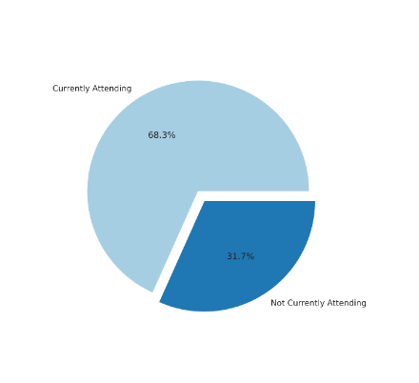

Fig. 8

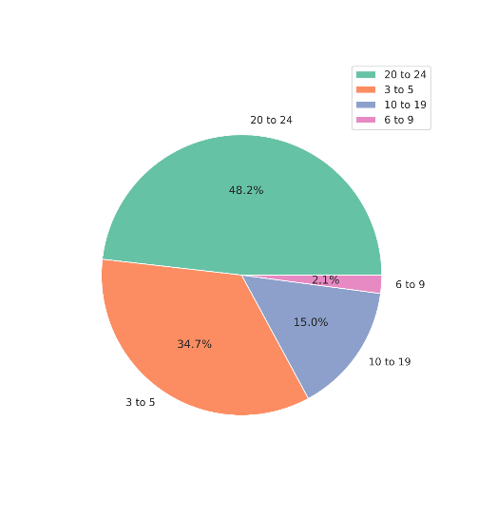

Fig. 9.1

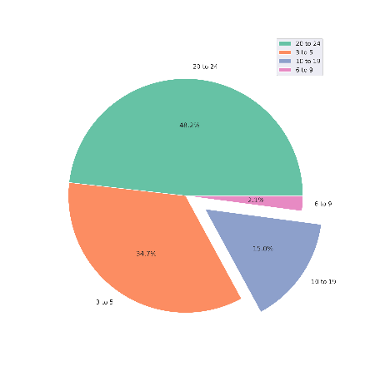

Fig. 9.2

**SCHOOLING STATUS**

A problem that cannot be solved by the previously stated recommendation about integration of CSE in schools is shown by the chart. According to the 2020 Annual Poverty Indicators Survey (APIS), at least 31.7% of the population they surveyed had answered that their school status was not currently attending. This may not be an issue since the ages of the surveyed population only range from 3 to 24 years old which could mean that they are either too young to go to school or already finished with it.

The second chart now shows the entirety of the 31.7% of respondents who answered that they were not currently attending school. Based on this chart, our assumptions previously were likely correct since almost half of the population (48.2%) not currently attending were aged 20 to 24 which could mean that they are already finished with their schooling. The second largest (34.7%) age group would be the 3 to 5 age group, again proving our assumptions earlier about the population being too young for school. While the adolescents or teenagers aged 10 to 19 only cover about 15% of the population which may not seem a lot, but if we get 15% of the population that were not currently attending at that time which is 14,803, we would get about 2220.45 which is still not a lot. But we would have to consider that the total population is in thousands, meaning 2220.45 is actually 2,220,450 which is a lot of teenagers at schooling age to not be in school. The lowest percentage group age is the 6 to 9 group age, which is also elementary school age. What could be their reasons for not attending school?

**RECOMMENDATION #2 (CSE Pamphlets)**

Our second recommendation includes the distribution of CSE pamphlets to every family in a barangay. This recommendation will also need further consultations from medical professionals for it to be comprehensive and easy to understand. But for now, it will include basic information about sex, sexuality, relationships, contraceptive methods that are available at health clinics and their locations per Municipality, different types of STD’s and so forth. How will we make sure that every family would introduce or teach their children about the pamphlets? Since the barangay officials will be distributing these pamphlets, they can announce that for citizens to be able to interact with interact with them (e.g. Get documents) they must first answer a short test regarding the CSE. This way even if the families would not thoroughly discuss the CSE pamphlets, they would still need to study about it before going to their respective barangay halls. Although teenagers are naturally curious, this would still help them since they would have to get documents at from their barangay halls as requirements.