**Recommended Special Precautions During Covid19 Pandemic**

**General**

Recommend temperature be taken for all upon arrival if feasible. Not higher than 99.5º

Prior to meeting: Sanitize stations, gavels, swords and other items that require contact during ceremony.

Strive to maintain at least six feet distancing at all times even though all have protective masks on.

**Opening and Closing a Royal Arch Chapter**

1. Face masks worn by all plus gloves for at least the High Priest, King, Scribe, Captain of the Host, Principal Sojourner, Royal Arch Captain and three Masters of the Veils.

2. All officers stations at least 6 feet apart. (EHP, EK & ES may relocate to floor in the East if necessary.)

3. Only officers with both mask and gloves assemble around the altar to participate in tactics during both opening and closing.

**Mark Master Degree**

Prior to meeting: Sanitize stations, gavels, swords, pieces of work, keystone, pattern, pennies, clear plastic cover for bible, presentation mark, quarter, working tools and all other items that require contact during ceremony.

1. Face masks worn by all plus gloves for at least the Right Worshipful Master, Candidate, Sr. Deacon, Assistant, Overseers, Secretary,

2. All officers stations at least 6 feet apart.

3. Sr. Deacon leads Assistant and Candidate with at least 6 feet separation between each.

4. Each stops six feet in front of Overseer then “work” is presented & received at full arm’s length of both participants.

5. Sr. Deacon verbally directs repositioning of Candidate at Sr. Overseer’s station and subsequently resumes leading him by six feet Through ceremony.

6. Procession filled with minimum number of brethren at six foot intervals.

7. Guard six feet West of pay window and Sr. Deacon six feet East from Candidate.

8. Sr. Deacon stops Guard with a verbal command.

9. Reprimanding Brother leads candidate out with six foot spacing.

10. Separate altars (e.g., pedestals) at least six feet apart with bible and sanitized covers can be used if more than one candidate.

11. Mark lesson must be performed on one Candidate at a time.

12. Right Worshipful Master, Assistant (from first section) and Candidate all have masks and gloves for grip.

13. Second procession filled with minimum number of brethren at six foot intervals as previously but not the same pennies unless they have been re-sanitized.

**Past Master Degree**

Prior to meeting: Sanitize stations, gavels, swords, WM Jewell, hat, clear plastic cover for bible, working tools and all other items that require contact during ceremony.

1. Face masks worn by all plus gloves for at least the Worshipful Master, Candidate, plus Sr. Deacon for Grip and also “seating.”

2. All officers stations at least 6 feet apart.

3. Sr. Deacon leads Candidate(s) with at least 6 feet separation.

4. Separate altars (e.g., pedestals) at least six feet apart with bible and sanitized covers can be used if more than one candidate.

5. Upon agreeing to “submit to these charges…,” each Candidate must receive “lesson” separately.

6. “Presentation items” will be shown but not handed to Candidate.

7. Senior Deacon moves to East but maintains distance while assisting/prompting Candidate.

8. Lesson, Lecture, Seat, etc. and complete the degree.

**Most Excellent Master Degree**

Prior to meeting: Sanitize stations, gavels, swords, keystone, clear plastic cover for bible, Ark, working tools and all other items that require contact during ceremony.

1. Face masks worn by all plus gloves for at least the Most Excellent Master, Candidate and Sr. Deacon.

2. All officers stations at least 6 feet apart.

3. Sr. Deacon leads Candidate(s) with at least 6 feet separation between each.

4. Separate altars (e.g., pedestals) at least six feet apart with bible and sanitized covers can be used if more

than one candidate.

5. Procession filled with minimum number of brethren at six foot spacing and intervals.

6. Only Most Excellent Master “Accepts and Receives” Candidate(s) and describes usual procedure to him (them.)

**Royal Arch Degree**

Prior to meeting: Sanitize stations, gavels, swords, Ark, Keystone, Working Tools, Squares, cords for conducting, clear plastic covers for bibles, and other items that require contact during ceremony.

Have three separate Bibles for Obligation, etc. to obtain maximum spacing in addition precautionary masks on Candidates.

1. Face masks worn by all plus gloves for at least the High Priest, King, Scribe, Captain of the Host, Principal Sojourner, Royal Arch Captain and six Companions for Arches and other assistance.

2. All officers stations at least 6 feet apart. (EHP, EK & ES may relocate to floor in the East if necessary.)

**Opening and Closing a Royal & Select Master Council**

Prior to meeting: Sanitize stations, gavels, swords and other items that require contact during ceremony.

1. Face masks worn by all.

2. All officers stations at least 6 feet apart.

3. Opening and Closing same as usual except keeping a distance of six feet between participants including for the special step 4 listed below.

4. When Captain of the Guards instructs Companions to assemble around the Altar during closing, only one Companion should proceed to West of Altar. (Word to be given at low breath and from a distance.

**Royal Master Degree**

Masks for all participants and all present. Gloves plus masks for Candidate, Thrice Illustrious Master and Conductor of the Council.

All participants should maintain 6 feet or more between each other. *See figures 1-3 for floor diagrams.*

Deposits, Beautiful Piece of Work and Bible cover sanitized. (e.g., Sanitized clear flexible plastic sheet for Bible cover.)

(If more than one candidate, pedestal Altars with separate Bibles and sanitized covers at least six feet apart may be used.)

Illustrious Principal Conductor of the Work at least six feet from table for deposits. Companions maintain at least six feet from each other and place deposits on table as they walk by it.

Conductor of the Council leads candidate(s) with at least six foot spacing.

**Select Master Degree**

Prior to meeting: Sanitize Stations, Swords, piece of chain, Ark plus Items for Deposit and Bible cover. (e.g., Sanitized clear flexible plastic sheet for Bible cover.) Repeat as necessary if more than one Candidate.

1. Face Masks worn by all participants and all present. Gloves plus masks for Candidate, Thrice Illustrious Master, Right Illustrious Deputy Master, Illustrious Principal Conductor, Captain of the Guards and Conductor of the Council.

2. All officer Stations at least six feet apart.

3. Separate altars (e.g., pedestals) at least six feet apart with bible and sanitized covers can be used if more than one candidate.

***Figure 1***

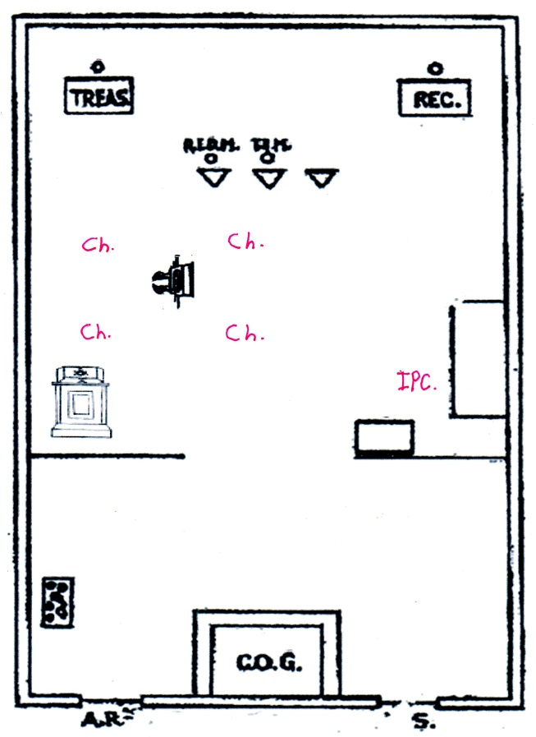

Cherubim >9’ from Ark and >6’ between them.

More cherubim if space allows.

Altar only moved if space is required.

Altar returned & Ark moved after deposits.

***Figure 2***

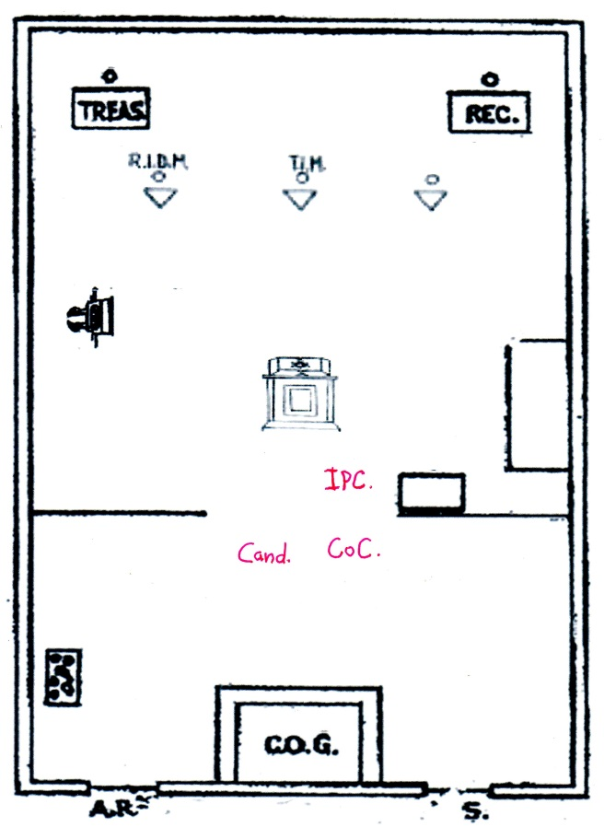

IPC, CoC & Candidate >6’ apart.

No contact IPC & CoC.

IPC can lead candidate by >6’ or do soliloquy in place.

If more than one candidate, >6’ spacing required.

***Figure 3***

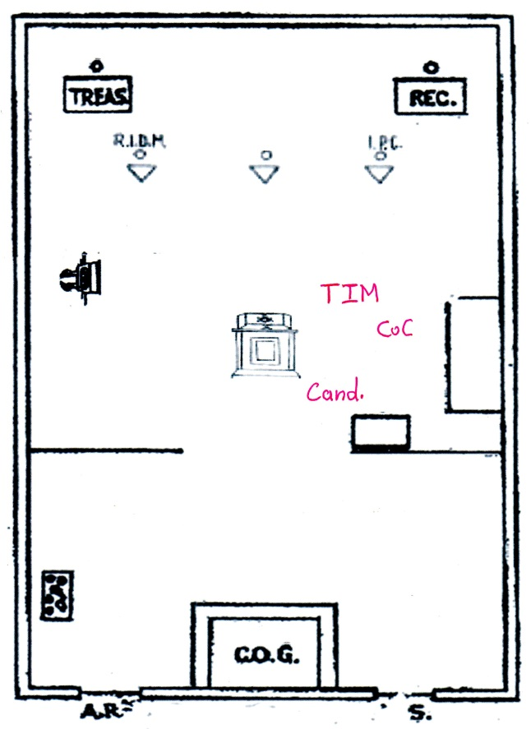

TIM & CoC with masks & gloves.