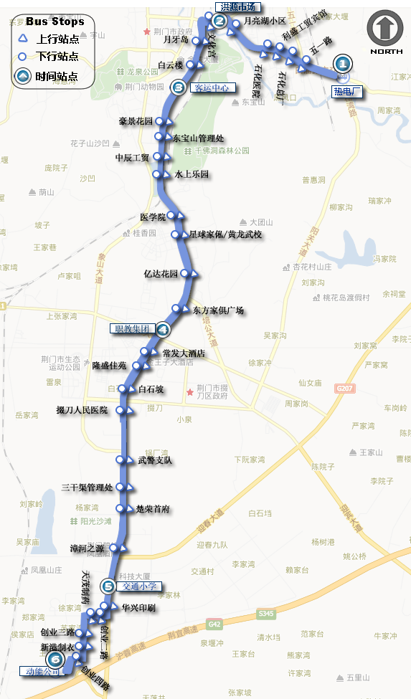



**8路**

18路Title1.png 18路Title2.png



**8路**

|  |  |  |  |  |  |  |  |  |  |  |  |
| --- | --- | --- | --- | --- | --- | --- | --- | --- | --- | --- | --- |
| 6:00 | 6:09 | 6:15 | 6:31 | 6:45 | 6:52 | 5:30 | 5:37 | 5:42 | 5:56 | 6:09 | 6:15 |
| 发车间隔5分钟 | | | | | | 发车间隔5分钟 | | | | | |
| 6:45 | 6:54 | 7:04 | 7:23 | 7:41 | 7:50 | 6:45 | 6:52 | 6:59 | 7:16 | 7:32 | 7:39 |
| 6:49 | 6:58 | 7:08 | 7:27 | 7:45 | 7:54 | 6:49 | 6:56 | 7:03 | 7:20 | 7:36 | 7:43 |
| 6:53 | 7:04 | 7:14 | 7:33 | 7:51 | 7:59 | 6:53 | 7:01 | 7:08 | 7:25 | 7:41 | 7:48 |
| 6:57 | 7:08 | 7:18 | 7:37 | 7:55 | 8:03 | 6:57 | 7:05 | 7:12 | 7:29 | 7:45 | 7:52 |
| 7:01 | 7:12 | 7:22 | 7:41 | 7:59 | 8:07 | 7:01 | 7:09 | 7:16 | 7:33 | 7:49 | 7:56 |
| 7:05 | 7:16 | 7:26 | 7:45 | 8:03 | 8:11 | 7:05 | 7:13 | 7:20 | 7:37 | 7:53 | 7:59 |
| 7:09 | 7:20 | 7:30 | 7:49 | 8:07 | 8:15 | 7:09 | 7:17 | 7:24 | 7:41 | 7:57 | 8:03 |
| 7:13 | 7:24 | 7:34 | 7:53 | 8:09 | 8:17 | 7:13 | 7:21 | 7:28 | 7:45 | 8:01 | 8:07 |
| 7:17 | 7:28 | 7:38 | 7:57 | 8:13 | 8:21 | 7:17 | 7:25 | 7:32 | 7:49 | 8:05 | 8:11 |
| 7:21 | 7:32 | 7:42 | 8:01 | 8:17 | 8:25 | 7:21 | 7:29 | 7:36 | 7:53 | 8:08 | 8:14 |
| 7:25 | 7:36 | 7:46 | 8:05 | 8:21 | 8:29 | 7:25 | 7:33 | 7:40 | 7:57 | 8:12 | 8:18 |
| 7:29 | 7:40 | 7:50 | 8:07 | 8:23 | 8:31 | 7:29 | 7:37 | 7:44 | 8:01 | 8:16 | 8:22 |
| 7:33 | 7:44 | 7:54 | 8:11 | 8:27 | 8:35 | 7:33 | 7:41 | 7:48 | 8:05 | 8:20 | 8:26 |
| 7:37 | 7:48 | 7:58 | 8:15 | 8:31 | 8:39 | 7:37 | 7:45 | 7:52 | 8:08 | 8:22 | 8:28 |
| 7:41 | 7:52 | 8:01 | 8:19 | 8:35 | 8:43 | 7:41 | 7:49 | 7:56 | 8:12 | 8:26 | 8:32 |
| 7:45 | 7:56 | 8:05 | 8:23 | 8:39 | 8:47 | 7:45 | 7:53 | 8:00 | 8:16 | 8:31 | 8:37 |
| 7:49 | 8:00 | 8:09 | 8:27 | 8:43 | 8:51 | 7:49 | 7:57 | 8:04 | 8:20 | 8:35 | 8:41 |
| 发车间隔5分钟 | | | | | | 发车间隔5分钟 | | | | | |
| 11:39 | 11:49 | 11:57 | 12:13 | 12:29 | 12:37 | 11:39 | 11:47 | 11:54 | 12:08 | 12:21 | 12:27 |
| 11:45 | 11:55 | 12:03 | 12:19 | 12:35 | 12:43 | 11:45 | 11:53 | 11:59 | 12:13 | 12:27 | 12:33 |
| 11:51 | 12:01 | 12:09 | 12:25 | 12:41 | 12:49 | 11:51 | 11:59 | 12:05 | 12:19 | 12:33 | 12:39 |
| 11:57 | 12:07 | 12:15 | 12:31 | 12:47 | 12:55 | 11:57 | 12:05 | 12:11 | 12:25 | 12:39 | 12:45 |
| 12:03 | 12:13 | 12:21 | 12:37 | 12:53 | 13:01 | 12:03 | 12:11 | 12:17 | 12:31 | 12:45 | 12:51 |
| 12:09 | 12:19 | 12:27 | 12:43 | 12:59 | 13:07 | 12:09 | 12:17 | 12:23 | 12:37 | 12:51 | 12:57 |
| 12:15 | 12:25 | 12:33 | 12:49 | 13:05 | 13:13 | 12:15 | 12:23 | 12:29 | 12:43 | 12:57 | 13:03 |
| 12:21 | 12:31 | 12:39 | 12:55 | 13:11 | 13:19 | 12:21 | 12:29 | 12:35 | 12:49 | 13:03 | 13:09 |
| 12:27 | 12:37 | 12:45 | 13:01 | 13:17 | 13:25 | 12:27 | 12:35 | 12:41 | 12:55 | 13:09 | 13:15 |
| 12:33 | 12:43 | 12:51 | 13:07 | 13:22 | 13:30 | 12:33 | 12:41 | 12:47 | 13:01 | 13:15 | 13:21 |
| 发车间隔6分钟 | | | | | | 发车间隔6分钟 | | | | | |
| 13:15 | 13:25 | 13:34 | 13:51 | 14:07 | 14:14 | 13:15 | 13:23 | 13:30 | 13:45 | 13:59 | 14:05 |
| 发车间隔5分钟 | | | | | | 发车间隔5分钟 | | | | | |
| 17:00 | 17:10 | 17:20 | 17:38 | 17:54 | 18:03 | 17:00 | 17:08 | 17:16 | 17:32 | 17:46 | 17:52 |
| 17:04 | 17:15 | 17:25 | 17:43 | 18:00 | 18:08 | 17:04 | 17:12 | 17:20 | 17:36 | 17:50 | 17:56 |
| 17:08 | 17:19 | 17:29 | 17:47 | 18:03 | 18:11 | 17:08 | 17:16 | 17:24 | 17:40 | 17:54 | 18:00 |
| 17:12 | 17:23 | 17:33 | 17:51 | 18:07 | 18:15 | 17:12 | 17:20 | 17:28 | 17:44 | 17:58 | 18:04 |
| 17:16 | 17:27 | 17:37 | 17:55 | 18:11 | 18:19 | 17:16 | 17:24 | 17:32 | 17:48 | 18:02 | 18:08 |
| 17:20 | 17:31 | 17:41 | 17:59 | 18:15 | 18:23 | 17:20 | 17:28 | 17:36 | 17:52 | 18:06 | 18:12 |
| 17:24 | 17:35 | 17:45 | 18:03 | 18:18 | 18:26 | 17:24 | 17:32 | 17:40 | 17:56 | 18:10 | 18:16 |
| 17:28 | 17:39 | 17:49 | 18:07 | 18:22 | 18:30 | 17:28 | 17:36 | 17:44 | 18:00 | 18:14 | 18:20 |
| 17:32 | 17:43 | 17:53 | 18:11 | 18:26 | 18:34 | 17:32 | 17:40 | 17:48 | 18:04 | 18:18 | 18:24 |
| 17:36 | 17:47 | 17:57 | 18:15 | 18:30 | 18:38 | 17:36 | 17:44 | 17:52 | 18:08 | 18:22 | 18:28 |
| 17:40 | 17:51 | 18:01 | 18:17 | 18:33 | 18:41 | 17:40 | 17:48 | 17:56 | 18:12 | 18:26 | 18:32 |
| 17:44 | 17:55 | 18:05 | 18:21 | 18:37 | 18:45 | 17:44 | 17:52 | 18:00 | 18:15 | 18:29 | 18:35 |
| 17:48 | 17:59 | 18:09 | 18:25 | 18:41 | 18:49 | 17:48 | 17:56 | 18:04 | 18:19 | 18:33 | 18:39 |
| 17:52 | 18:03 | 18:10 | 18:27 | 18:42 | 18:50 | 17:52 | 18:00 | 18:07 | 18:21 | 18:35 | 18:42 |
| 17:56 | 18:07 | 18:14 | 18:31 | 18:46 | 18:54 | 17:56 | 18:04 | 18:11 | 18:25 | 18:39 | 18:46 |
| 18:00 | 18:11 | 18:18 | 18:35 | 18:50 | 18:58 | 18:00 | 18:08 | 18:15 | 18:29 | 18:43 | 18:50 |
| 18:07 | 18:16 | 18:23 | 18:40 | 18:55 | 19:03 | 18:07 | 18:14 | 18:20 | 18:35 | 18:49 | 18:56 |
| 18:14 | 18:23 | 18:30 | 18:47 | 19:02 | 19:10 | 18:14 | 18:21 | 18:27 | 18:42 | 18:56 | 19:03 |
| 18:21 | 18:30 | 18:37 | 18:54 | 19:09 | 19:17 | 18:21 | 18:28 | 18:34 | 18:49 | 19:03 | 19:10 |
| 18:28 | 18:37 | 18:44 | 19:01 | 19:16 | 19:24 | 18:28 | 18:35 | 18:41 | 18:56 | 19:10 | 19:17 |
| 18:35 | 18:44 | 18:51 | 19:08 | 19:23 | 19:31 | 18:35 | 18:42 | 18:48 | 19:03 | 19:17 | 19:24 |
| 18:42 | 18:51 | 18:58 | 19:15 | 19:30 | 19:38 | 18:42 | 18:49 | 18:55 | 19:10 | 19:24 | 19:31 |
| 18:49 | 18:58 | 19:05 | 19:22 | 19:37 | 19:45 | 18:49 | 18:56 | 19:02 | 19:17 | 19:31 | 19:38 |
| 18:56 | 19:05 | 19:12 | 19:29 | 19:44 | 19:52 | 18:56 | 19:03 | 19:09 | 19:24 | 19:38 | 19:45 |
| 19:03 | 19:12 | 19:19 | 19:36 | 19:51 | 19:59 | 19:03 | 19:10 | 19:16 | 19:31 | 19:45 | 19:52 |
| 发车间隔7分钟 | | | | | | 发车间隔7分钟 | | | | | |
| 20:55 | 21:04 | 21:11 | 21:28 | 21:43 | 21:51 | 20:55 | 21:02 | 21:08 | 21:23 | 21:37 | 21:44 |