The Search for Outbursters – Physics B0049 Lab Computers

0 – Log in
Log in to one of the Mac Lab computers in B0049 or your personal device. The following instructions are made for the Mac Lab computers, but the changes to these instructions for other devices are very minor (for Windows) or almost nonexistent (for Mac and Linux). For Windows devices, for example, rather than using the terminal, you would use Windows Powershell. If my memory serves, the commands should be identical except the folder separator slashes are backslashes (\) instead of forward slashes (/)
If you are using your own device and would like help applying these instructions to your device, I’ll be happy to help you.
NOTE: It would be best if you worked at the same computer every time you come to work on this research as all files are stored locally. Moving from one computer to another may mean that you’d have to perform the first-time setup for each computer you use.
NOTE: In a few places, you will see text in font that looks like this. That font is for text shown in the terminal or commands that you will type into the terminal. The terminal is essentially a text-based method of interfacing with the computer. In some of those commands, you may see braces [containing some text]. Those braces represent blanks that will be filled by whatever is described by the text in the braces (for instance, a target number). You do not need to type the braces themselves. So, for example, if the instructions said something like cd Desktop/[name of folder], you would type into the terminal something like cd Desktop/MyFolder. I will describe what these commands do as they are encountered in this manual.

1 - First Time Setup
If you have already done this for the computer you’re working on, skip to section 2.

1.1 – Downloading your needed files and folders
- Log into CyBox using your ISU credentials
- There you should see two folders I have shared with you, “ResearchStarterFiles-S2025” (shared via link in an email I’ll have sent you) and “[YourName]Folder” (shared directly via CyBox). If you do not see one or both of these, please let me know as soon as possible.
  - Reminder, text in braces is placeholder text. Your second folder will not be “[YourName]Folder” but rather a folder with your name in the title
- Open “ResearchStarterFiles-S2025” Check to make sure the seven following files are in there:
  - example_input.txt
  - LICENSE
  - pvenv.cfg
  - README.md
  - requirements.txt
  - SampleC.vot
  - TESS-LS.py
  - TESSutils.py
  - MacLabManual-S2025.xlsx (This manual)
- Download the “ResearchStarterFiles-S2025” folder and place it anywhere you would like on your computer. As the rest of this manual works as if you placed it on the Desktop, I recommend you put it there
- Open “[YourName]Folder.” Check to ensure that there is an Excel Spreadsheet called “[YourName]TargetList” there. If this file does not exist, please let me know.
  - I recommend that you open but do not download “[YourName]Folder” because then you can just edit the target list in that folder and you won’t have to keep uploading new versions at the end of each session.
  - You can open the target list in Box by clicking on the file name, clicking on “Open” in the top menu bar, and then clicking on “Microsoft Excel Online”

2 – Searching for Outbursting White Dwarfs

2.1 – Preparing to Search for Outbursters
- Open the copy of “ResearchStarterFiles-S2025” that you downloaded
  - Again, the remainder of the manual assumes you put it on the Desktop, and future instructions will reflect that
- Open a terminal. You can find it in Launchpad → Other
  - The icon will look similar to this: 
  - You can know that your terminal is ready for use when you have the flashing cursor following the prompt line, which will say [computer tag]:~ [your ISU Net ID]$
  - See the figure for an example of what you should see in your terminal: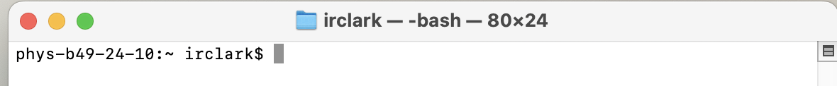
  - Info: “Computer tag” is basically just what the IT people named the computer
- In the terminal, navigate to “ResearchStarterFiles-S2025”.
  - To do this, type cd Desktop/[ResearchStarterFiles-S2025], and press enter. 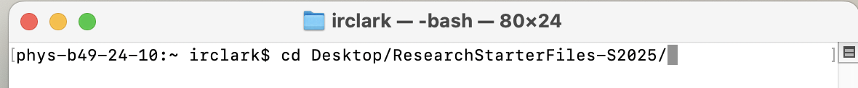
    - This command tells the terminal to change the folder or directory it’s working from (cd for change directory) and the destination folder (the part after cd).
  - There may be a prompt that comes up that asks if you want to allow the terminal to modify files on the desktop. Click “OK” If this prompt comes up.
- Your terminal display should now look like this: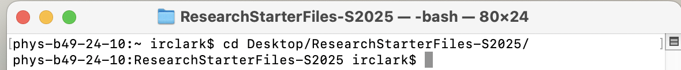

2.2 – Search for Outbursters
If you need a reminder of how the target lists work, please see Appendix A.
- Open your target list in CyBox in “[YourName]Folder”
  - See step 1.1.5b for how to do this in Box
- Check to see which targets next need to be worked on. The next one that doesn’t have any notes written on it would probably be your best next target.
- In your terminal, type python [TIC Number of your next target] and press enter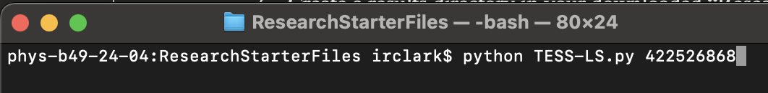
  - You may see an error that says, “No module named ‘[name of module]’, similar to this display:
    - This means that the script simply doesn’t have all the Python modules needed to run. The name of the missing module is in single quotes. Here, it is astroquery. To remedy the problem, type pip install [name of missing module] and press return. See the following image for an example:
    - Wait a moment and the prompt line should reappear (see the figure in Section 2.1, step 2c for a reminder of what the prompt line looks like). Once the prompt line reappears, repeat Section 2.2 (this section) step 3. If you receive this missing package error again, install the missing packages with the same procedure.
    - Another error that may appear: (FileNotFoundError: [Errno 2] No such file or directory: ‘COMPLETE’) This one comes due to a too-new version of one of the packages (astropy) being installed.
      - To remedy this error, type pip install astropy==5.2.2 and press enter to install a compatible version of the astropy package. After the prompt line reappears, repeat Section 2.2 (this section) step 4.
- Wait until the script completes.
  - You can tell that the script is completed when your prompt line reappears in your terminal window, instead of the last line being blank (see the figure in Section 2.1, step 2c for a reminder of what the prompt line looks like)
- Once it is finished, you will see folder in your ResearchStarterFiles-S2025 folder that is called “Results_[your target number]”. Open this folder.
  - Inside this folder, you will see several images that the script created:
    - TIC[target number]_expanded.png
      - This image is a greatly zoomed-in look at your lightcurve where each data point was recorded over 120 seconds
    - TIC[target number]_fast_expanded.png
      - This image is a greatly zoomed-in look at your lightcurve where each data point was recorded over 20 seconds
    - TIC[target number]_fast_full.png
      - This image is a moderately zoomed-in look at your lightcurve where each data point was recorded over 20 seconds
    - TIC[target number]_fast.png
      - This image shows a collection of graphs produced by the script as it analyzes the star’s data where each data point was recorded over 20 seconds. The most relevant graphs are described in step 2.2.6.
    - TIC[target number]_full.png
      - This image is a moderately zoomed-in look at your lightcurve where each data point was recorded over 120 seconds
    - TIC[target number].log
      - A file that logs some notes the script made concerning your target object. You do not need to worry about it
    - TIC[target number].png
      - This image shows a collection of graphs produced by the script as it analyzes the star’s data where each data point was recorded over 120 seconds.
- You’ll first want to open TIC[target number]_fast.png and TIC[target number].png. This is because this image has a collection of other pertinent graphs aside from the lightcurve. These are (with examples pictured):
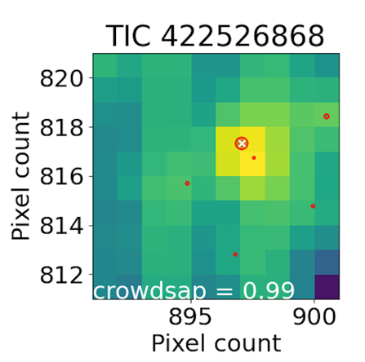
  - Top farthest left: a map that shows where the target star (red dot with white x through it) is in relation to other nearby stars (red dots).
    - If the target star shows interesting behavior and it is near other bright stars, it may be due to the influence of those nearby stars. If there is interesting behavior and there are nearby stars, that should be noted in your log sheet. Later followup work can help disentangle these two stars’ data to see if the behavior is associated with the target or with the other star.
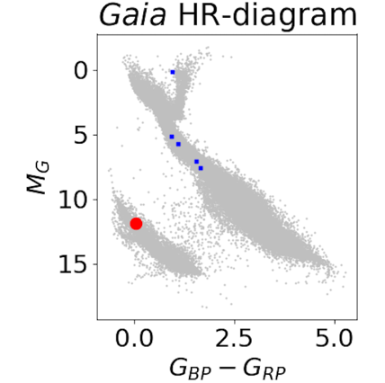
  - Top not-as-far left: your target star’s placement on the HR diagram (seen by a red dot)
    - The HR diagram is a way of graphically classifying stars. White dwarfs, like the stars we’re looking at, should be in the gray smudge on the bottom left of this graph (as pictured).
      - If the red dot is not in that area, the target is not likely to actually be a white dwarf and therefore cannot be an outbursting white dwarf. If you encounter this situation, please note that in your log sheet
  - Bottom left: the lightcurve, or graph of our star’s brightness over time. This is the graph you want to examine for the outburst behavior.
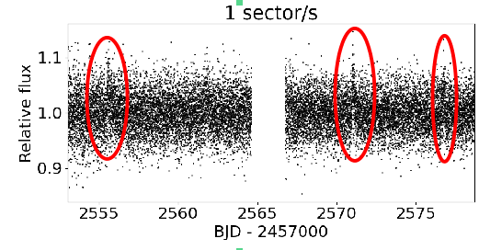
    - What constitutes outburster behavior will be a few somewhat regularly-spaced spikes in the lightcurve (although sometimes there will only be one spike) with notches below them. For example, see the following image. The outbursts are circled in red. If you look at the whole scatter plot, you see that the whole of the data spikes up during an outburst.

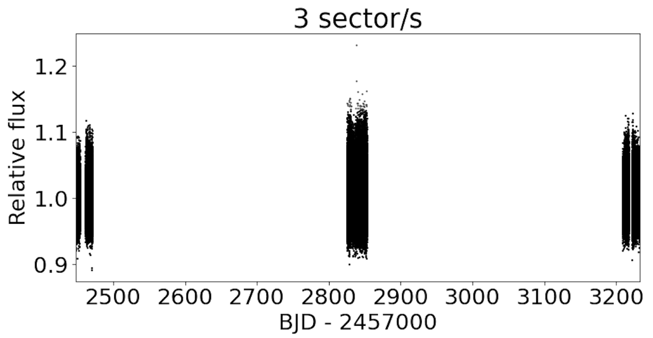
- If the data points are too closely packed to tell what’s going on (as in the following figure), take a look at the other graphs that the script generated.
  - If the data is STILL too closely packed, make a note of it in your log sheet and we can take a closer look with followup work
- Enter the outburst behavior of the object in your target list (even if there is no outburst or other unusual behavior).
  - See Appendix A if you need a reminder on the intended use of the target list
- Upload the now full results folder to your “[YourName]Folder” on CyBox.
- Repeat all previous steps in Section 2.2 for as many objects as you want to do today.

Appendix A: Description of the Target Lists
Your target list also doubles as your log sheet.

Your target list has the TIC numbers, or the TESS Input Catalog numbers of your stars. These TIC numbers are how TESS identifies its targets.
You will have three columns in your target list.
Column 1: The TIC numbers of your targets
Column 2: The status of your target. There will be 5 options here:
Done – No outburster: For if you have investigated the star and it does not show outbursting or other unusual behavior. In other words, the graph will basically just look like a fuzzy bar. See the figure for an example: 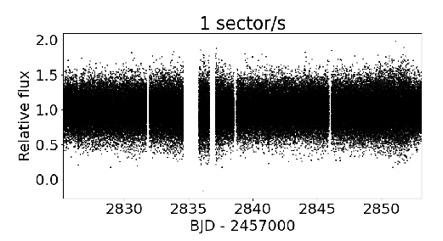

Done – Outburster: If you have investigated the star and it shows outbursting behavior. See the figure for an example: 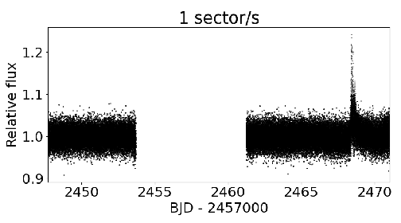

Done – No Available Light Curves: For when there are no lightcurves available for your object.
Done – Other: If you have investigated the star and it does not show outbursting behavior, but it does show some other interesting behavior.
Done – Can’t tell: This is when the data is so packed together that it’s hard to tell what’s going on, outburst or otherwise. See the figure for an example:
Note: If you have a “Can’t tell” graph, it would be a good idea to look at the “expanded” and “full” graphs that the script produces. The star’s behavior might be better seen on those ones. I can’t really include an image here because those graphs go beyond the width of the page. 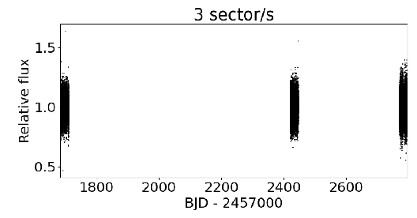

Column 3: Notes you have about your target. If it is an outburst, list at what time it occurs on the lightcurve (the x-coordinate), and how bright they are, as recorded by how high the outburst is on the graph. If it is not an outburster but has some other interesting behavior, you would also describe that behavior here, in detail.

