Automation Suite Introduction

#### Conditions:

Visual studio 2019

Chrome 90.0.4430.93

#### Steps:

1. Download the whole project and double click as followed:

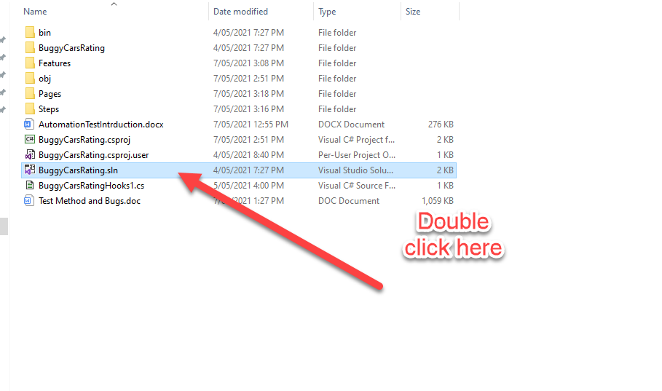

2.Using Visual Studio 2019 version to open the project “BuggyCarsRating”

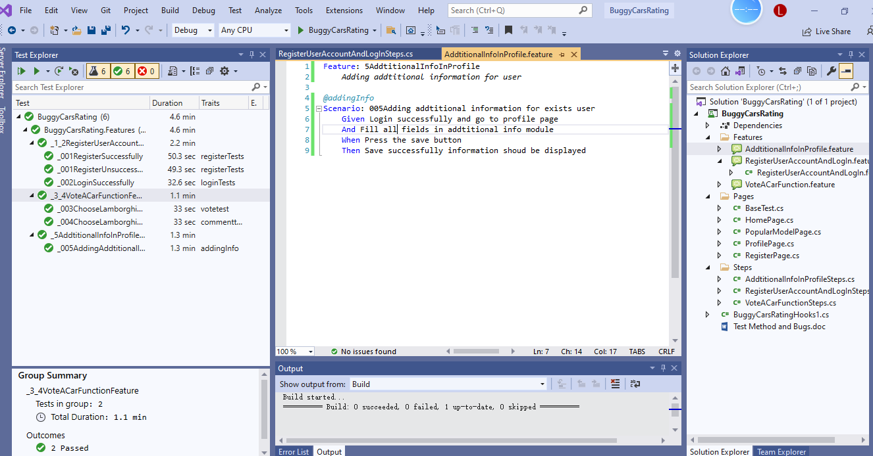

3.Click on the arrow button in the very left hand side, it will run all scripts in this automation suite.

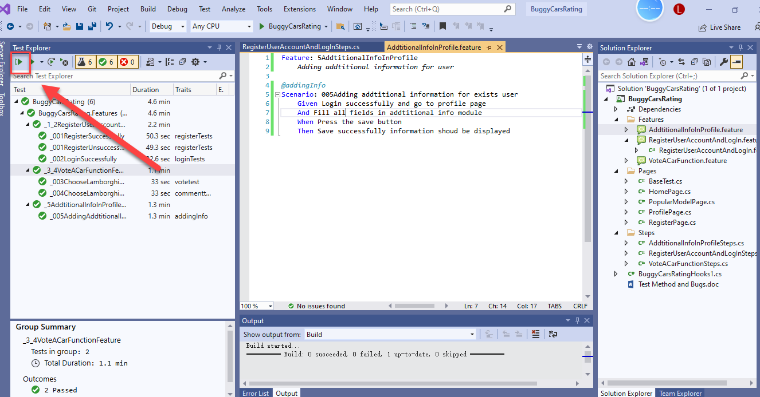

4.After all scripts done, then you could see the results at the left side:

