Automation Suite Introduction

#### Conditions:

1. Visual studio 2019

2. Chrome 90.0.4430.93

3.Before running the whole suite, please make sure that specFlow are added properly:

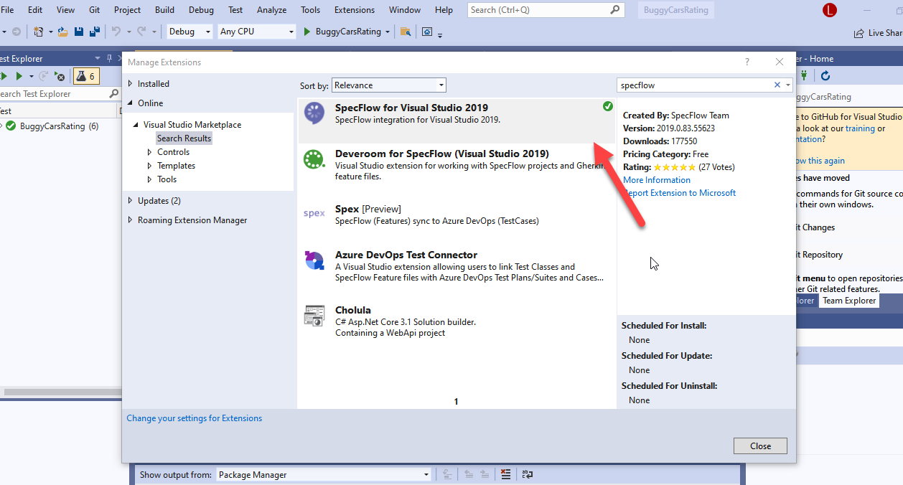

The method: Extensions -> Manage Extensions -> search specFlow at the right top search box -> download -> following the guidance

4.Before running the whole scripts, please confirm the dependencies are added properly:

DotNetSeleniumExtras.PageObjects

DotNetSeleniumExtras.PageObjects.Core

NUnit

NUnit.Console

NUnit.ConsoleRunner

NUnit.Runners.Net4

NUnit3TestAdapter

NUnitTestAdapter

Selenium.Firefox.WebDriver

Selenium.Support

Selenium.WebDriver

Selenium.WebDriver.ChromeDriver

SpecFlow

SpecFlow.NUnit

SpecRun.Runner

The added method: Tools -> Nuget Package Manager -> Manage Nuget Package for solution

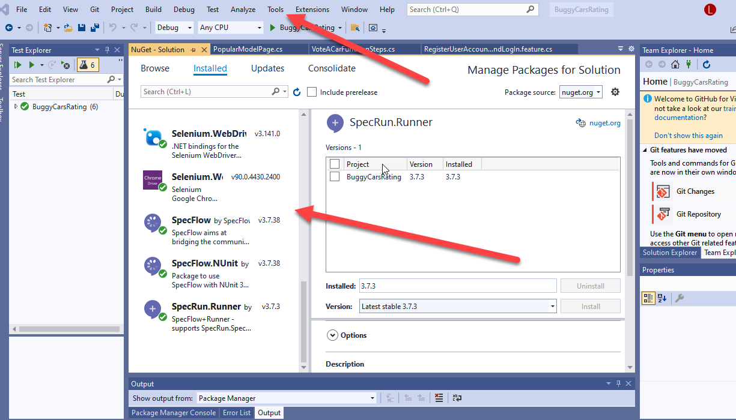

#### Steps:

1. Download the whole project and double click as followed:

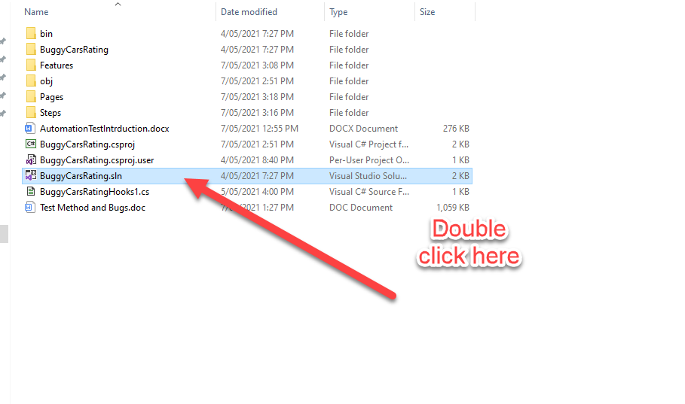

2.Using Visual Studio 2019 version to open the project “BuggyCarsRating”

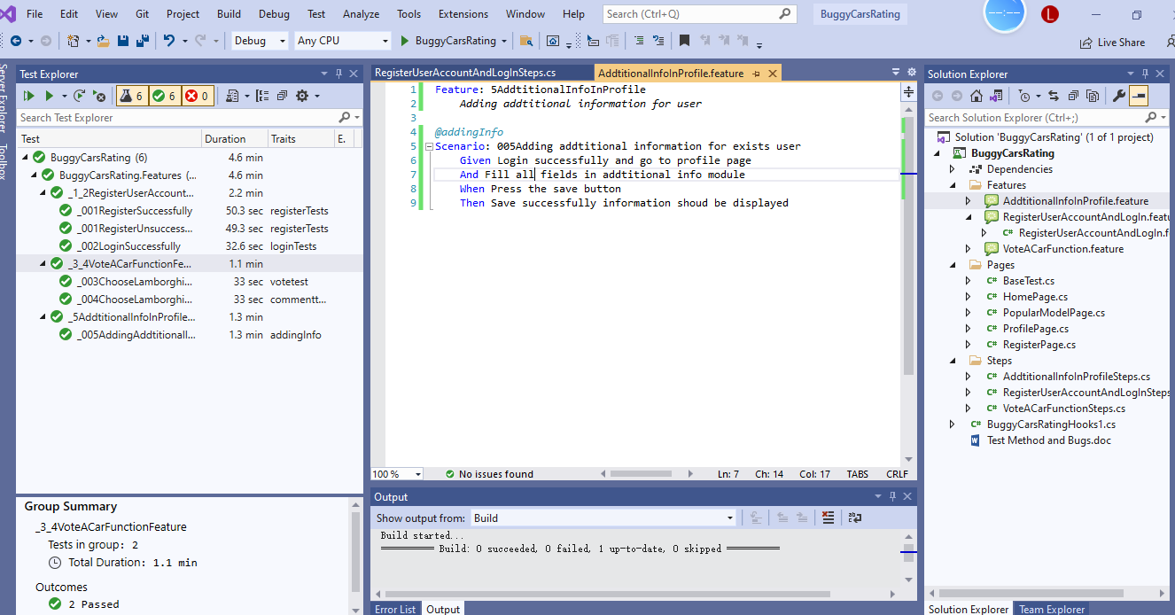

3.Click on the arrow button in the very left hand side, it will run all scripts in this automation suite.

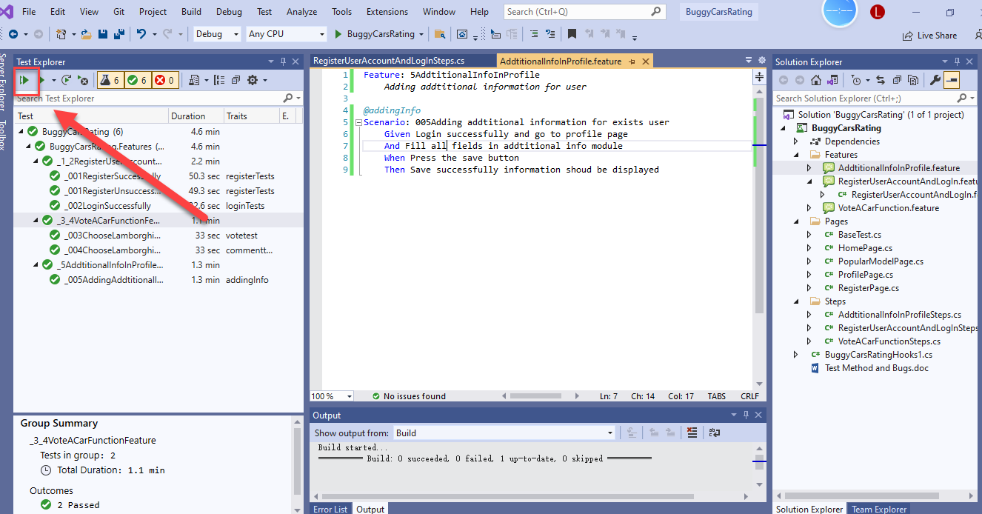

4.After all scripts done, then you could see the results at the left side:

