Hi Planit Talent Acquisition,

Hope you are doing well today. This is my solution for the challenge I got yesterday, and hopefully you are satisfied with that. I choose C# with specflow because I notice that C# is the key technology in job description, even I haven't use it for a long time. Before you start, just give you a little instruction so that you can check it easily.

1. The Visual Studio

Before you check it , you need to download visual studio (I recommend 2019 community because I use it to develop)

2. Run the scripts

Using Test -> Test Explorer and press "run" button then you can run the whole suite
Also you can run every single test case by right clicking your mouse on the particular case then Press run

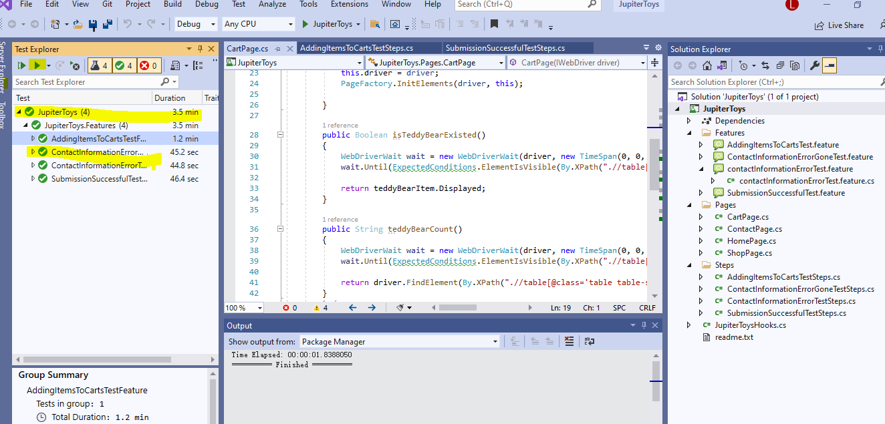

Then you could get the results , sometime it failed by timing issue, I have add some waiting functions in my project, sometimes you may need to run it one more time then , it will get the report.

