Code for this part can be found in the folder under Part1.m

Acceleration was found to be 3.3x1017.



Figure : Electron Trajectory



Figure : Average Current Plot

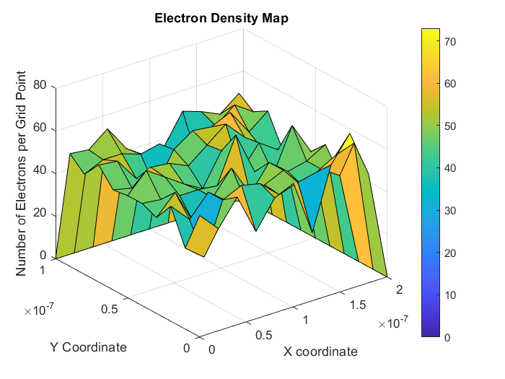

Figure : Electron Density Map

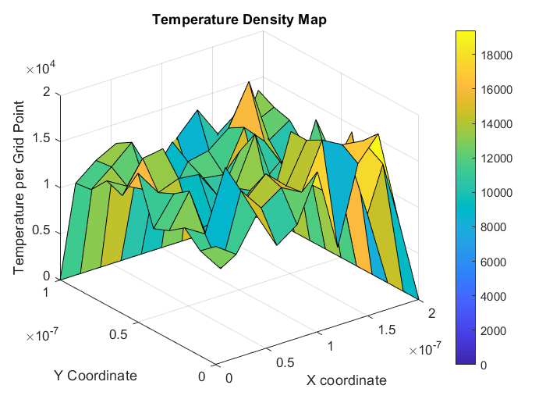

Figure : Temperature Density Map