Code for this part can be found in the folder as part2.m

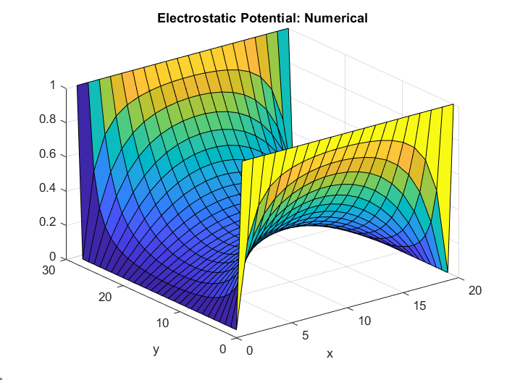

Figure : Surface Plot



Figure : Potential with Quiver

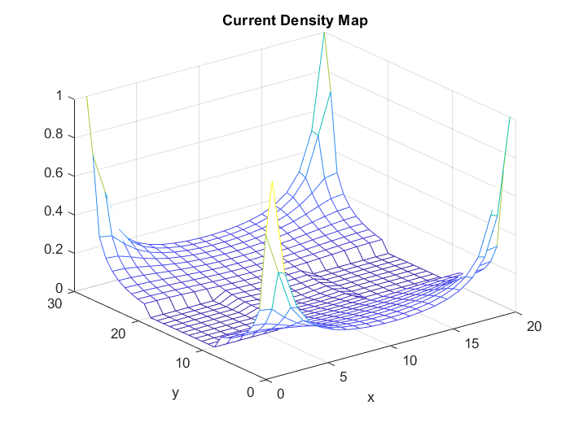

Figure : Current Density plot