All code for this part can be seen in the zip folder under part 3.

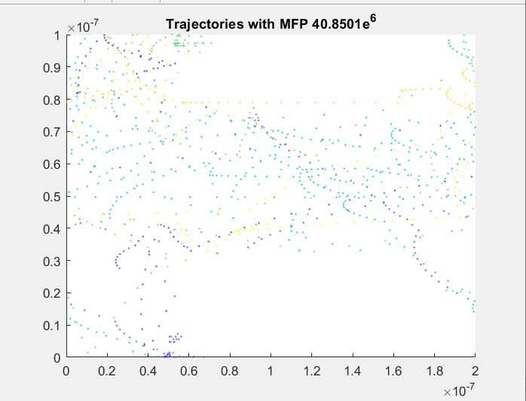

Figure : Electron Trajectory using 0.8V field

For this plot we are using a 0.8V field. The accelerated curling is much more drastic than what we saw in a 0.1V field.



Figure : Electron Trajectory using 0.1V field

The plot above is using a 0.1V field. The electron path is much more stable with less drastic curling.

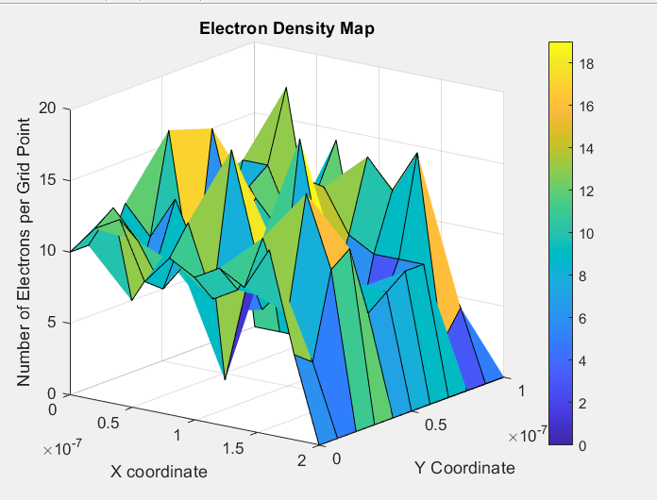

Figure : Electron Density Plot

From the density plot, it is noticeable that the electrons are settling on the left side of the density plot. With very little electrons on the y axis.

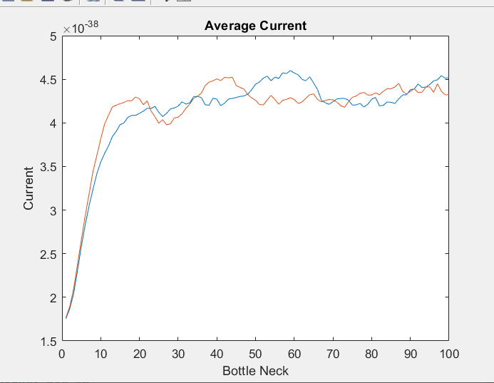

Figure : Current vs Bottleneck Area Plot

From the current vs bottle neck plot we can see that as the bottle neck is increased our current seems to reach an asymptotic value.