**Analyzing and Visualizing Waterdogs**

**Introduction**

Waterdogs is a Twitter account that rates people's dogs with a humorous comment about the dog.

These ratings almost always have a denominator of 10. The numerators, though? Almost always greater than 10. 11/10, 12/10, 13/10, etc.

**Why?**

Because "[**they're good dogs Brent**](http://knowyourmeme.com/memes/theyre-good-dogs-brent)." Waterdogs has over 4 million followers and has received international media coverage.

Waterdogs [**downloaded their Twitter archive**](https://support.twitter.com/articles/20170160)

This file has the basic tweet data (tweet ID, timestamp, text, etc.) for all 5000+ of their tweets as they stood on August 1, 2017.

Data link

[https://twitter.com/dog_rates](https://twitter.com/dog_rates/status/889531135344209921)

**Most common dog type Waterdogs**

has over 6000+ tweets. I was able to analyzed around 1900+ tweets. The most rated dog was golden retriever with more than 110 ratings.

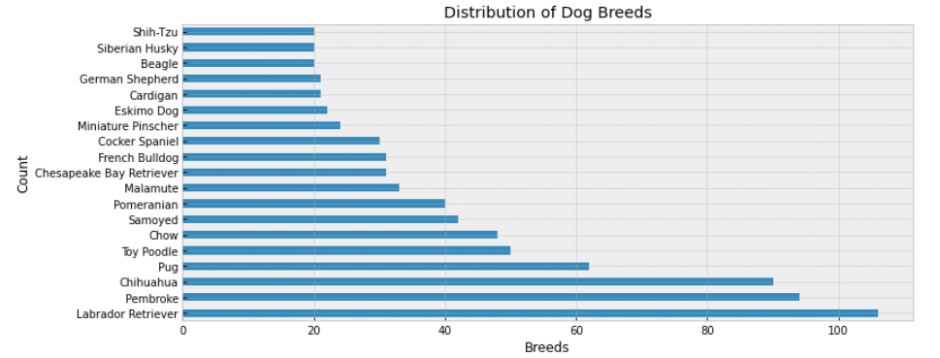

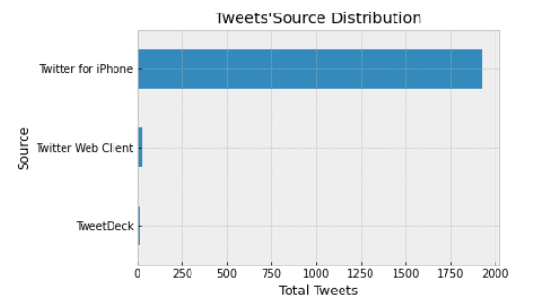**From the figure we get the most tweets from iPhone which represent 99%**

**Most popular day and month to post a dog photo**

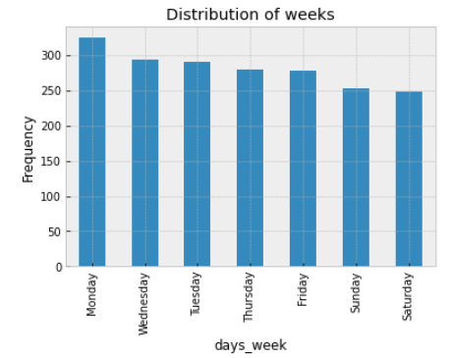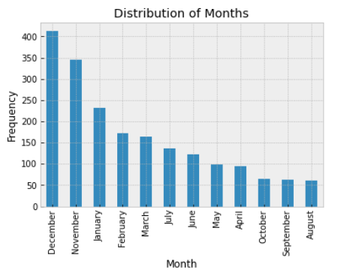

From the figure we get

* Most day is Monday with almost 340 tweets
* 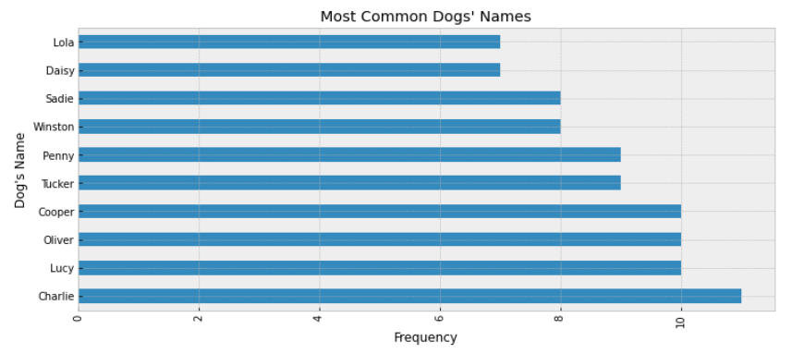Most month is December with almost 400 tweets

**The most common Dog**

**name is Charlie**

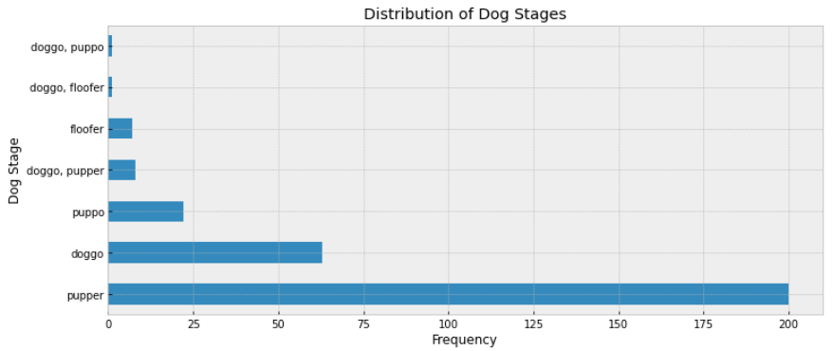**The most common Dog stage is Pupper, his frequency around 200 tweets**

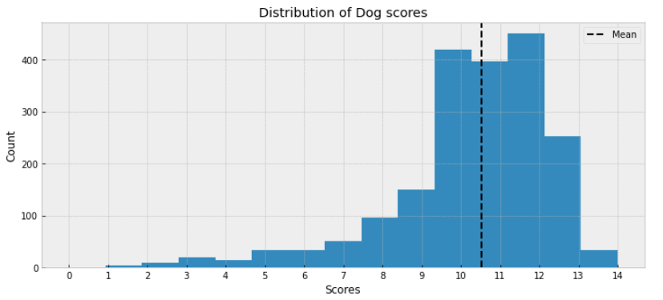**The mean distribution of dogs is around**

* The maximum frequent score is 14.
* The minimum frequent score is 1.
* The mean frequent is around 10.5.
* The most frequent is 12.

**The most common breed is golden retriever which followed by**

* 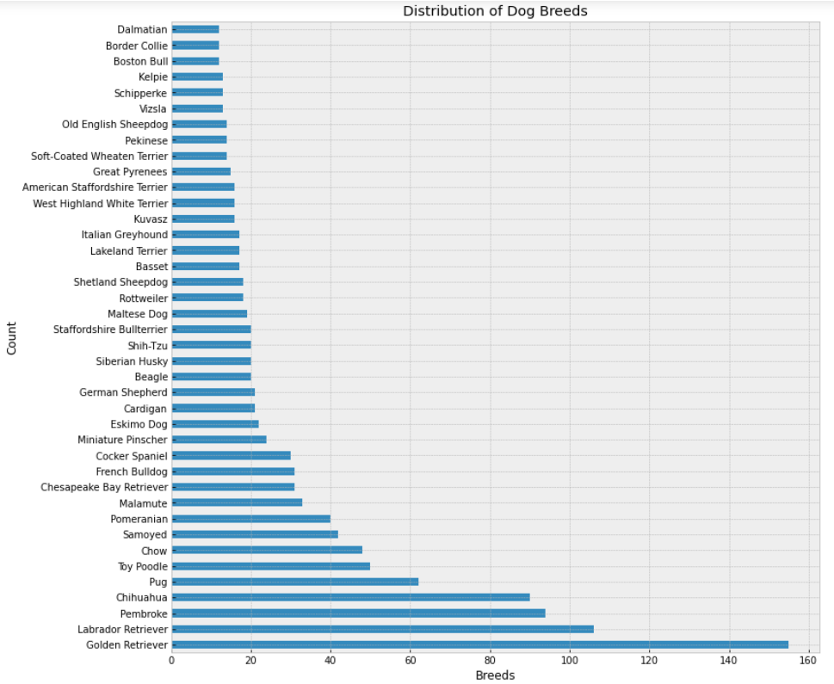Labrador Retriever.
* Pembroke
* Chihuahua.
* Pug.

4/10/2020

[nana.mostafa29@gmail.com](mailto:nana.mostafa29@gmail.com)