**22W_CST8116_451 Intro to Computer Programming**

Assignment #5 Java Programming: Loops and Arrays

**Carol Ann Wilson**

Student ID: 040672794

Instructor: Piyush Jangam

Date: March 3, 2022

# Assignment #1 Java Programming Loops and Arrays

## Write a Java program to sort a numeric array and a string array.

Code:

Run results:

## Write a Java program to calculate the average value of array elements.

Code:

Run results:

## Write a Java program to test if an array contains a specific value.

Code

Run results:

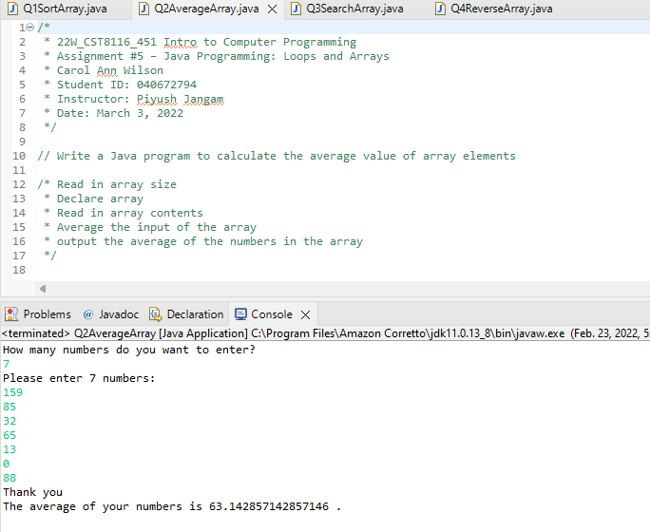

## Write a Java program to reverse an array of integer values.\

### Option 1: Sorting an array in descending order

### Option 2: Reversing the actual order of an array

## References

### Software

Eclipse Foundation. (n.d.). Eclipse IDE for Java Developers, Version (2021-12(4.22.0). *Eclipse.org*. Retrieved January 20, 2022, from <https://www.eclipse.org/> .

Amazon. (n.d.). Amazon Corretto Java Development Kit, Version (11.0.13.8.1). *Amazon Corretto*. Amazon. Retrieved January 20, 2022, from <https://aws.amazon.com/corretto/>

### Websites

Jones, A. (n.d.). *Java programming*. Test Automation University. Retrieved February 23, 2022, from <https://testautomationu.applitools.com/java-programming-course/>

Help, S. T. (2022, February 3). *Reverse an array in Java - 3 methods with examples*. Software Testing Help. Retrieved February 25, 2022, from <https://www.softwaretestinghelp.com/reverse-an-array-in-java/>