**Nathan Ketterlinus**

**TSEM ~~Body Image through History~~ Blood, Lust, and the American Dream  
Citations Exercise   
2 points toward your final grade  
Due Fri Feb 10**

The content of **Citations Assignments** will be assessed according to whether the student has gathered and used academic resources effectively and according to the standards and rules of academic integrity in formulating and presenting a substantive interpretation, argument, and/or analysis of a problem or issue.

Review Lisa Woznicki’s panopto and powerpoint about MLA citations by clicking open “Library Sessions” on our blackboard coursesite.

Then, open “Online Module: Library Session 2 – MLA Citation

Then, open each of the links in turn for useful resources.

**Practice citation #1: Journal article from a database with a permalink**

Here is part of your citation page from the *SocIndex with Full Text* database for a journal article accessed electronically through this database:

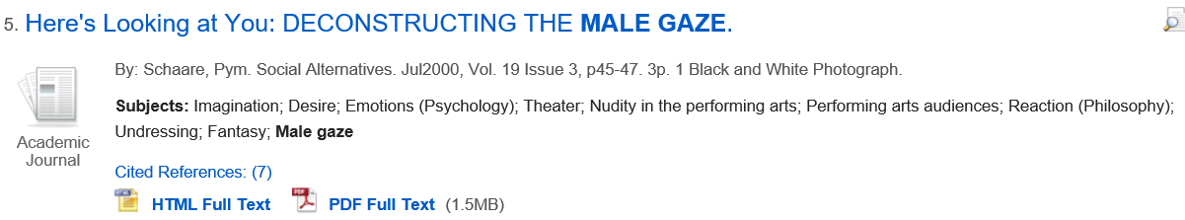

Here is the **permalink** to the citation page in the database – open this to see all parts of the citation page:

<http://proxy-tu.researchport.umd.edu/login?ins=tu&url=http://search.ebscohost.com/login.aspx?direct=true&db=sih&AN=3561274&site=ehost-live>

**1a. Create a Bibliography entry for this article by following the steps below**.

1. First, look at the example for a *Journal Article Electronically Retrieved from a Database* entry on your **MLA Citations Quick Guide: TSEM Shute** document.
2. Follow the pattern for that example and use information found through the permalink to create your own citation.
3. Remember, your instructor likes a permalink as the location for the article. It will be the last piece of the citation.

**Create your citation here**:

Schaare, Pym. “Here’s Looking at You: DECONSTRUCTING THE MALE GAZE.” *Social Alternatives*, vol. 19, no. 3, July 2000, pp. 45–47. *SocIndex*, <http://proxy-tu.researchport.umd.edu/login?ins=tu&url=http://search.ebscohost.com/login.aspx?direct=true&db=sih&AN=3561274&site=ehost-live>.

**1b. Create an in-text citation for this article by following the steps below. (Cite page 48.)**

1. First, look at the guidelines and examples for In-Text Citations at the beginning of your **MLA Citations Quick Guide: TSEM Shute** document.
2. Follow the pattern for the in-text citation of a journal article to create your own in-text citation at the end of the sentence below. (Every in-text citation should have a page number or time marker, unless it is from a newspaper article retrieved from an online database, or a webpage.)

Both vampires and zombies are undying cannibals (Schaare 48).

**Practice citation #2: Journal article from JSTOR database with a stable URL**

Here is part of the citation page from the *JSTOR* database for a journal article accessed electronically through *JSTOR*:

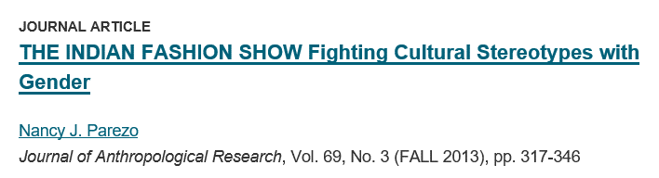

Here is a link to that citation page in the database – this is a stable URL:

<https://www.jstor.org/stable/24393652> - note, if you are off campus, you will not be able to see the entire article with this URL without logging in to the database and searching for the article again. To complete the exercise, just exit out of the log in screen; you will see the landing page for the article which is enough to complete the exercise.

**2a. Create a Bibliography entry for this article**. Follow the directions above given for Exercise #1 to complete your entry. In this case, rather than a permalink, the database uses a stable URL. Use this in place of the permalink in your Works Cited citation.

**Create your citation here:**

Parezo, Nancy J. “THE INDIAN FASHION SHOW Fighting Cultural Stereotypes with Gender.” *Journal of Anthropological Research*, vol. 69, no. 3, Fall 2013, pp. 317–46. *JSTOR*, <http://www.jstor.org/stable/24393652>.

**2b. Create an in-text citation for this article at the end of the sentence below. (Cite page 340.)**

The author concludes that hard-shell tacos are the only authentic taco (Parezo 340).

**Practice Citation #3: Dance Video**

Here is the catalog record for a DVD film owned in the library’s collection:

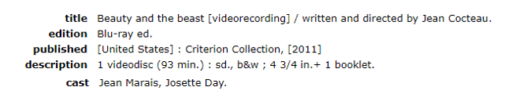

**3a. Create a Bibliography entry for this article by following the steps below**.

1. First, look at the example for a **Film** entry on your **MLA Citations Quick Guide: TSEM Shute** document.
2. Follow the pattern for that example and use information found through the catalogue record to create your own citation.
3. There is no permalink to use here. Remember that the videos for this class are from dvd recordings; even though you access them through a private database, they are only publicly available by dvd.

**Create your citation here**:

Cocteau, Jean, director. *Beauty and the beast [videorecording] / written and directed by Jean Cocteau. Criterion* Collection, 2011.

**2b. Create an in-text citation for this film at the end of the sentence below. (Cite time marker 00:21-1:05.)**

Ripley shakes her head sadly at the foolishness of her male colleagues (Cocteau 0:21-1:05)

**Remember that your Bibliography goes at the end of the paper, after your text. Alphabetize bibliographic entries.**

Cocteau, Jean, director. *Beauty and the beast [videorecording] / written and directed by Jean Cocteau. Criterion* Collection, 2011.

Parezo, Nancy J. “THE INDIAN FASHION SHOW Fighting Cultural Stereotypes with Gender.” *Journal of Anthropological Research*, vol. 69, no. 3, Fall 2013, pp. 317–46. *JSTOR*, <http://www.jstor.org/stable/24393652>.

Schaare, Pym. “Here’s Looking at You: DECONSTRUCTING THE MALE GAZE.” *Social Alternatives*, vol. 19, no. 3, July 2000, pp. 45–47. *SocIndex*, <http://proxy-tu.researchport.umd.edu/login?ins=tu&url=http://search.ebscohost.com/login.aspx?direct=true&db=sih&AN=3561274&site=ehost-live>.