Building Java Programs
Chapter 10, 12 Lab Handout

Chapter 10, ArrayList
1. Write a method markLength4 that takes an ArrayList of Strings as a parameter and that places a String of four asterisks ("****") in front of every String of length 4. For example, suppose that an ArrayList called "list" contains the following values:
(this, is, lots, of, fun, for, every, Java, programmer)
And you make the following call:
markLength4(list);
Then list should store the following values after the call:
(****, this, is, ****, lots, of, fun, for, every, ****, Java, programmer)
Notice that you leave the original Strings in the list (this, lots, Java) but include the four-asterisk String in front of each to mark it. You may assume that the ArrayList contains only String values, but it might be empty.
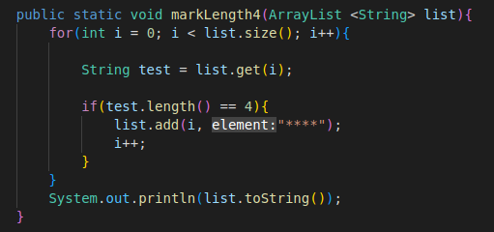
2. Write a method manyStrings that takes an ArrayList of Strings and an integer n as parameters and that replaces every String in the original list with n of that String. For example, suppose that an ArrayList called "list" contains the following values:
("squid", "octopus")
And you make the following call:
manyStrings(list, 2);
Then list should store the following values after the call:
("squid", "squid", "octopus", "octopus")
As another example, suppose that list contains the following:
("a", "a", "b", "c")
and you make the following call:
manyStrings(list, 3);
Then list should store the following values after the call:
("a", "a", "a", "a", "a", "a", "b", "b", "b", "c", "c", "c")
You may assume that the ArrayList you are passed contains only Strings and that the integer n is greater than 0.

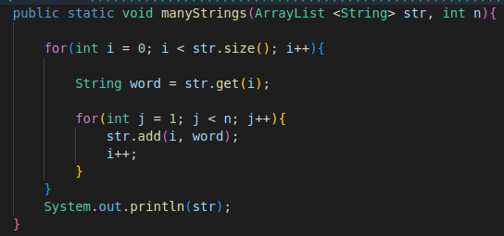

Chapter 12, Recursion
3. Write a RECURSIVE method called “sequence” that takes a single int parameter (n) and returns the int value of the nth element of the sequence S = 2, 4, 6, 12, 22, 40, 74, 136, 250, 460, …
Where S is defined by the recursive formula:
For n >= 0
S(0) = 2; // Base case 1
S(1) = 4; // Base case 2
S(2) = 6; // Base case 3
S(N) = 2 * ( S(N-1)/2 + S(N-2)/2 + S(N-3)/2)
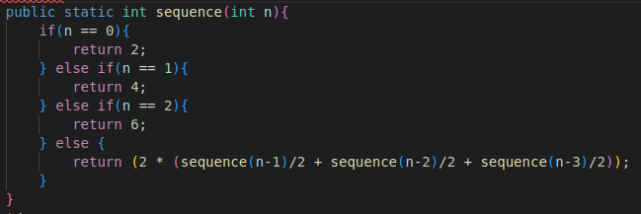

4. Given the sequence, S2 = 1, 2, 4, 5, 7, 8, 10, 11, 13, 14, …
Write a RECURSIVE method called “sequence2” that takes a single int parameter (n) and returns the int value of the nth element of the sequence S2. You will need to determine any base cases and a recursive case that describes the listed sequence.

Use the following code to test your answers to questions 3 and 4
the output should print the two sequences given (S & S2):
public class TestSequences {

public static void main(String[] args) {
for(int i = 0; i < 10; i++) {
System.out.print(sequence(i) + " "); // 2, 4, 6, 12, 22, 40, 74, 136, 250, 460
}
System.out.println();

for(int i = 0; i < 10; i++) {
System.out.print(sequence2(i) + " "); // 1, 2, 4, 5, 7, 8, 10, 11, 13, 14
}
}

// *** Your method for sequence here ***

// *** Your method for sequences2 here ***

} // end of TestSequences class

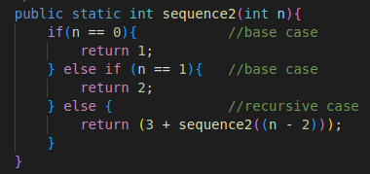

5. For the TimeSpan class described below, add a compareTo method that takes another TimeSpan object as a parameter & returns:
-1 if this TimeSpan is SMALLER than to the TimeSpan object passed in as a parameter
0 if both TimeSpans are the same
1 if this TimeSpan is GREATER than the TimeSpan object passed in as a parameter
Add code, as needed, to allow the Collections class to sort the ArrayList of TimeSpan objects
import java.util.*;
public class TimeSpan implements {
private int hours;
private int minutes;

public TimeSpan(int hours1, int minutes1) {
hours = 0;
minutes = 0;
add(hours1, minutes1);
}

public void add(int hours1, int minutes1) {
hours += hours1;
minutes += minutes1;
while (minutes > 60) {
minutes -= 60; // convert 60 min --> 1 hour
hours++;
}
}

public void add(TimeSpan time) {
add(time.hours, time.minutes);
}

public double getTotalHours() {
return hours + minutes / 60.0;
}

public String toString() {
return hours + "h-" + minutes + "m";
}

// *** Your method code here ***

public static void main(String[] args) {
TimeSpan t1 = new TimeSpan(4, 13);
TimeSpan t2 = new TimeSpan(5, 8);
TimeSpan t3 = new TimeSpan(3, 51);
TimeSpan t4 = new TimeSpan(6, 76);
TimeSpan t5 = new TimeSpan(1, 1);
ArrayList<TimeSpan> list = new ArrayList<TimeSpan>();
list.add(t1);
list.add(t2);
list.add(t3);
list.add(t4);
list.add(t5);
System.out.println(list);
Collections.sort(list);
System.out.println(list);
}
}
Expected Output: > run TimeSpan
[4h-13m, 5h-8m, 3h-51m, 7h-16m, 1h-1m]
[1h-1m, 3h-51m, 4h-13m, 5h-8m, 7h-16m]

I’m not quite sure if this is what you’re looking for, this seems to be a problem directed to last week’s lab and I’m not sure how recursion would tie into this but here you go!

