Specification File of In-Flight Entertainment System

Document generated automatically by M2Doc from Capella model of the system

# Tables of Content

**Aucune entrée de table des matières n'a été trouvée.**

# Description of the system Missions

## Mission : Provide Entertainement Solutions

Description:

*No description*

Involved actors:

* **Aircraft**
* **Passenger**

Exploited capabilities:

### Capability : Provide Moving-Map Services

Description:

[Wikipedia]<br />  
A moving-map system is a real-time flight information video channel broadcast through to cabin project/video screens and  
personal televisions (PTVs). In addition to displaying a map that illustrates the position and direction of the plane, the  
system gives the altitude, airspeed, outside air temperature, distance to the destination, distance from the origination  
point, and local time. The moving-map system information is derived in real time from the aircraft's flight computer  
systems.

Capability inclusion relations:

|  |  |  |
| --- | --- | --- |
| **Including capabilities** | **Current capability** | **Included capabilities** |
| *No including capability* | Provide Moving-Map Services | *No included capability* |

Capability extension relations:

|  |  |  |
| --- | --- | --- |
| **Extended capabilities** | **Current capability** | **Extending capabilities** |
| *No extended capability* | Provide Moving-Map Services | *No extending capability* |

Capability generalization relations:

|  |  |  |
| --- | --- | --- |
| **Super capabilities** | **Current capability** | **Sub capabilities** |
| *No super capability* | Provide Moving-Map Services | *No sub capability* |

Involved functions:

*No involved function*

Involved functional chains:

*No involved functional chain*

Involved actors:

* **Aircraft**
* **Passenger**

Available in modes and states:

*No state or mode availability defined*

Involved scenarios:

*No involved scenario*

### Capability : Provide Audio Entertainment Services

Description:

<p>  
 [Wikipedia]<br />  
 Audio entertainment covers music, as well as news, information, and comedy. Most music channels are pre-recorded and  
 feature their own DJs to provide chatter, song introductions, and interviews with artists. In addition, there is  
 sometimes a channel devoted to the plane's radio communications, allowing passengers to listen in on the pilot's  
 in-flight conversations with other planes and ground stations.  
</p>

Capability inclusion relations:

|  |  |  |
| --- | --- | --- |
| **Including capabilities** | **Current capability** | **Included capabilities** |
| *No including capability* | Provide Audio Entertainment Services | *No included capability* |

Capability extension relations:

|  |  |  |
| --- | --- | --- |
| **Extended capabilities** | **Current capability** | **Extending capabilities** |
| *No extended capability* | Provide Audio Entertainment Services | *No extending capability* |

Capability generalization relations:

|  |  |  |
| --- | --- | --- |
| **Super capabilities** | **Current capability** | **Sub capabilities** |
| *No super capability* | Provide Audio Entertainment Services | *No sub capability* |

Involved functions:

*No involved function*

Involved functional chains:

*No involved functional chain*

Involved actors:

* **Passenger**

Available in modes and states:

*No state or mode availability defined*

Involved scenarios:

*No involved scenario*

### Capability : Provide Video Entertainment Services

Description:

<p>  
 [Wikipedia]<br />  
 Video entertainment is provided via a large video screen at the front of a cabin section, as well as via smaller  
 monitors situated every few rows above the aisles. Sound is supplied via the same headphones as those distributed for  
 audio entertainment.<br />  
 Personal televisions (PTVs) for every passenger provide passengers with channels broadcasting new and classic films, as  
 well as comedies, news, sports programming, documentaries, children's shows, and drama series. Some airlines also  
 present news and current affairs programming, which are often pre-recorded and delivered in the early morning before  
 flights commence.<br />  
 PTVs are operated via an In flight Management System which stores pre-recorded channels on a central server and streams  
 them to PTV equipped seats during flight. VOD (Video On Demand) systems store individual programs separately, allowing  
 a passenger to have a specific program streamed to them privately, and be able to control the playback.  
</p>

Capability inclusion relations:

|  |  |  |
| --- | --- | --- |
| **Including capabilities** | **Current capability** | **Included capabilities** |
| *No including capability* | Provide Video Entertainment Services | *No included capability* |

Capability extension relations:

|  |  |  |
| --- | --- | --- |
| **Extended capabilities** | **Current capability** | **Extending capabilities** |
| *No extended capability* | Provide Video Entertainment Services | *No extending capability* |

Capability generalization relations:

|  |  |  |
| --- | --- | --- |
| **Super capabilities** | **Current capability** | **Sub capabilities** |
| *No super capability* | Provide Video Entertainment Services | *No sub capability* |

Involved functions:

* **Select Passenger Service**
* **Manage Passenger Service Interruptions**
* **Watch Video on Private Screen**
* **Broadcast Audio Video Streams**
* **Manage Passenger Services Lifecycle**
* **Store Digital Media**
* **Command VOD Service**
* **Watch Video on Cabin Screen**
* **Set Passenger Service Authorization**
* **Handle VOD Movie Controls**

Involved functional chains:

* **VOD Movie Interruption [NOT DONE]**
* **VOD Service Activation [NOT DONE]**
* **Stop VOD Movie[NOT DONE]**
* **Resume VOD Movie**
* **Start Playing VOD Movie**

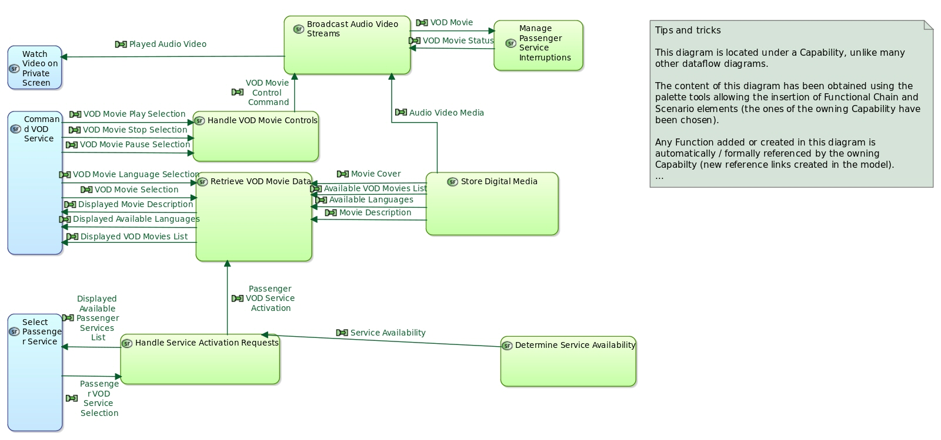

Involved actors:

* **Passenger**

Available in modes and states:

*No state or mode availability defined*

Involved scenarios:

* **[ES] Start VOD Service**
* **[ES] Start Playing VOD Movie**

### Capability : Provide Video Gaming Services

Description:

[Wikipedia]<br />  
Video games are another emerging facet of in-flight entertainment. Some game systems are networked to allow interactive  
playing by multiple passengers. Later generations of IFE games began to shift focus from pure entertainment to learning.  
The best examples of this changing trend are the popular trivia game series and the Berlitz Word Traveler that allows  
passengers to learn a new language in their own language. Appearing as a mixture of lessons and mini games, passengers can  
learn the basics of a new language while being entertained

Capability inclusion relations:

|  |  |  |
| --- | --- | --- |
| **Including capabilities** | **Current capability** | **Included capabilities** |
| *No including capability* | Provide Video Gaming Services | *No included capability* |

Capability extension relations:

|  |  |  |
| --- | --- | --- |
| **Extended capabilities** | **Current capability** | **Extending capabilities** |
| *No extended capability* | Provide Video Gaming Services | *No extending capability* |

Capability generalization relations:

|  |  |  |
| --- | --- | --- |
| **Super capabilities** | **Current capability** | **Sub capabilities** |
| *No super capability* | Provide Video Gaming Services | *No sub capability* |

Involved functions:

*No involved function*

Involved functional chains:

*No involved functional chain*

Involved actors:

* **Passenger**

Available in modes and states:

*No state or mode availability defined*

Involved scenarios:

*No involved scenario*

## Mission : Provide Cabin Management Solutions

Description:

*No description*

Involved actors:

* **Cabin Crew**
* **Passenger**
* **Aircraft**

Exploited capabilities:

### Capability : Provide Audio and Video Intercommunication Means

Description:

Capability inclusion relations:

|  |  |  |
| --- | --- | --- |
| **Including capabilities** | **Current capability** | **Included capabilities** |
| *No including capability* | Provide Audio and Video Intercommunication Means | *No included capability* |

Capability extension relations:

|  |  |  |
| --- | --- | --- |
| **Extended capabilities** | **Current capability** | **Extending capabilities** |
| *No extended capability* | Provide Audio and Video Intercommunication Means | *No extending capability* |

Capability generalization relations:

|  |  |  |
| --- | --- | --- |
| **Super capabilities** | **Current capability** | **Sub capabilities** |
| *No super capability* | Provide Audio and Video Intercommunication Means | *No sub capability* |

Involved functions:

* **Set Passenger Service Authorization**
* **Handle VOD Movie Controls**
* **Manage Passenger Service Interruptions**
* **Watch Video on Private Screen**
* **Store Digital Media**
* **Broadcast Audio Video Streams**
* **Command VOD Service**
* **Play Airline-Imposed Videos**
* **Manage Imposed Video Selections**
* **Listen to Audio Announcement**
* **Play Sound in Cabin**
* **Send Audio Announcement**

Involved functional chains:

* **Pause Running Imposed Video [NOT DONE]**
* **Stop Playing Imposed Video [NOT DONE]**
* **Watch Imposed Video on Cabin Screen**
* **Broadcast Audio Announcement**
* **Watch Imposed Video on Private Screen**

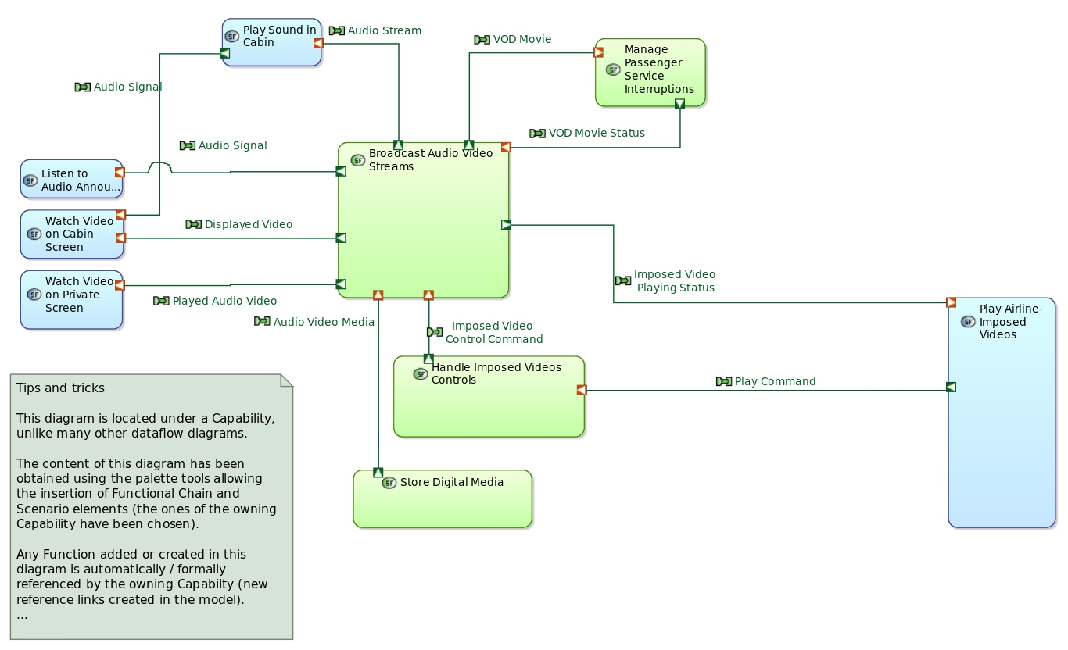

Involved actors:

* **Cabin Crew**
* **Passenger**
* **Aircraft**

Available in modes and states:

*No state or mode availability defined*

Involved scenarios:

* **[FS] Perform Audio Announcement**
* **[ES] Perform Audio Announcement**

## Mission : Provide Test and Maintenance Means

Description:

*No description*

Involved actors:

* **Ground Operator**
* **Cabin Crew**
* **Aircraft**

Exploited capabilities:

### Capability : Provide Testing Interface

Description:

*No description*

Capability inclusion relations:

|  |  |  |
| --- | --- | --- |
| **Including capabilities** | **Current capability** | **Included capabilities** |
| *No including capability* | Provide Testing Interface | *No included capability* |

Capability extension relations:

|  |  |  |
| --- | --- | --- |
| **Extended capabilities** | **Current capability** | **Extending capabilities** |
| *No extended capability* | Provide Testing Interface | *No extending capability* |

Capability generalization relations:

|  |  |  |
| --- | --- | --- |
| **Super capabilities** | **Current capability** | **Sub capabilities** |
| *No super capability* | Provide Testing Interface | *No sub capability* |

Involved functions:

*No involved function*

Involved functional chains:

*No involved functional chain*

Involved actors:

* **Aircraft**
* **Ground Operator**

Available in modes and states:

*No state or mode availability defined*

Involved scenarios:

*No involved scenario*

### Capability : Provide Configuration Means

Description:

*No description*

Capability inclusion relations:

|  |  |  |
| --- | --- | --- |
| **Including capabilities** | **Current capability** | **Included capabilities** |
| *No including capability* | Provide Configuration Means | *No included capability* |

Capability extension relations:

|  |  |  |
| --- | --- | --- |
| **Extended capabilities** | **Current capability** | **Extending capabilities** |
| *No extended capability* | Provide Configuration Means | *No extending capability* |

Capability generalization relations:

|  |  |  |
| --- | --- | --- |
| **Super capabilities** | **Current capability** | **Sub capabilities** |
| *No super capability* | Provide Configuration Means | *No sub capability* |

Involved functions:

*No involved function*

Involved functional chains:

*No involved functional chain*

Involved actors:

* **Ground Operator**
* **Cabin Crew**

Available in modes and states:

*No state or mode availability defined*

Involved scenarios:

*No involved scenario*

## Mission : Provide Connectivity Solutions

Description:

[Wikipedia]<br />  
In recent years, IFE has been expanded to include in-flight connectivity—services such as Internet browsing, text  
messaging, cell phone usage (where permitted), and emailing. In fact, some in the airline industry have begun referring to  
the entire in-flight-entertainment category as "IFEC" (In-Flight Entertainment and Connectivity or In-Flight Entertainment  
and Communication).

Involved actors:

* **Passenger**
* **Aircraft**

Exploited capabilities:

### Capability : Provide Satellite and Internal Telephony Services

Description:

[Wikipedia]<br />  
Some airlines provide satellite telephones integrated into their system. These are either found at strategic locations in  
the aircraft or integrated into the passenger remote control used for the individual in-flight entertainment. Passengers  
can use their credit card to make phone calls anywhere on the ground. These systems are usually not capable of receiving  
incoming calls. There are also some aircraft that allow faxes to be sent and the rate is usually the same as the call rate,  
but at a per page rate. Some systems also allow the transmission of SMS. More modern systems allow passengers to call  
fellow passengers located in another seat by simply keying in the recipient's seat number.

Capability inclusion relations:

|  |  |  |
| --- | --- | --- |
| **Including capabilities** | **Current capability** | **Included capabilities** |
| *No including capability* | Provide Satellite and Internal Telephony Services | *No included capability* |

Capability extension relations:

|  |  |  |
| --- | --- | --- |
| **Extended capabilities** | **Current capability** | **Extending capabilities** |
| *No extended capability* | Provide Satellite and Internal Telephony Services | *No extending capability* |

Capability generalization relations:

|  |  |  |
| --- | --- | --- |
| **Super capabilities** | **Current capability** | **Sub capabilities** |
| *No super capability* | Provide Satellite and Internal Telephony Services | *No sub capability* |

Involved functions:

*No involved function*

Involved functional chains:

*No involved functional chain*

Involved actors:

* **Passenger**
* **Aircraft**

Available in modes and states:

*No state or mode availability defined*

Involved scenarios:

*No involved scenario*

### Capability : Provide Wi-Fi Connectivity Service

Description:

<p>  
 [Wikipedia]<br />  
 In-flight internet service is provided either through a satellite network or an air-to-ground network. Data  
 communication via satellite&nbsp; system allows passengers to connect to live internet from the individual IFE units or  
 their laptops via the in-flight Wi-Fi access  
</p>

Capability inclusion relations:

|  |  |  |
| --- | --- | --- |
| **Including capabilities** | **Current capability** | **Included capabilities** |
| *No including capability* | Provide Wi-Fi Connectivity Service | *No included capability* |

Capability extension relations:

|  |  |  |
| --- | --- | --- |
| **Extended capabilities** | **Current capability** | **Extending capabilities** |
| *No extended capability* | Provide Wi-Fi Connectivity Service | *No extending capability* |

Capability generalization relations:

|  |  |  |
| --- | --- | --- |
| **Super capabilities** | **Current capability** | **Sub capabilities** |
| *No super capability* | Provide Wi-Fi Connectivity Service | *No sub capability* |

Involved functions:

*No involved function*

Involved functional chains:

*No involved functional chain*

Involved actors:

* **Passenger**

Available in modes and states:

*No state or mode availability defined*

Involved scenarios:

*No involved scenario*

### Capability : Provide Personal Device Connectivity

Description:

*No description*

Capability inclusion relations:

|  |  |  |
| --- | --- | --- |
| **Including capabilities** | **Current capability** | **Included capabilities** |
| *No including capability* | Provide Personal Device Connectivity | *No included capability* |

Capability extension relations:

|  |  |  |
| --- | --- | --- |
| **Extended capabilities** | **Current capability** | **Extending capabilities** |
| *No extended capability* | Provide Personal Device Connectivity | *No extending capability* |

Capability generalization relations:

|  |  |  |
| --- | --- | --- |
| **Super capabilities** | **Current capability** | **Sub capabilities** |
| *No super capability* | Provide Personal Device Connectivity | *No sub capability* |

Involved functions:

*No involved function*

Involved functional chains:

*No involved functional chain*

Involved actors:

* **Passenger**

Available in modes and states:

*No state or mode availability defined*

Involved scenarios:

*No involved scenario*

## Mission : Provide Administration Means and Runtime Management

Description:

*No description*

Involved actors:

* **Ground Operator**
* **Ground Operator**

Exploited capabilities:

### Capability : Update Entertainment Offer

Description:

*No description*

Capability inclusion relations:

|  |  |  |
| --- | --- | --- |
| **Including capabilities** | **Current capability** | **Included capabilities** |
| *No including capability* | Update Entertainment Offer | *No included capability* |

Capability extension relations:

|  |  |  |
| --- | --- | --- |
| **Extended capabilities** | **Current capability** | **Extending capabilities** |
| *No extended capability* | Update Entertainment Offer | *No extending capability* |

Capability generalization relations:

|  |  |  |
| --- | --- | --- |
| **Super capabilities** | **Current capability** | **Sub capabilities** |
| *No super capability* | Update Entertainment Offer | *No sub capability* |

Involved functions:

*No involved function*

Involved functional chains:

*No involved functional chain*

Involved actors:

* **Ground Operator**

Available in modes and states:

*No state or mode availability defined*

Involved scenarios:

*No involved scenario*

### Capability : Provide Access Management Control

Description:

*No description*

Capability inclusion relations:

|  |  |  |
| --- | --- | --- |
| **Including capabilities** | **Current capability** | **Included capabilities** |
| *No including capability* | Provide Access Management Control | * **dangling reference for bookmark 5acd248a-3961-4e71-85a4-5bc3b775215fIntegrate Aircraft Constraints** |

Capability extension relations:

|  |  |  |
| --- | --- | --- |
| **Extended capabilities** | **Current capability** | **Extending capabilities** |
| *No extended capability* | Provide Access Management Control | *No extending capability* |

Capability generalization relations:

|  |  |  |
| --- | --- | --- |
| **Super capabilities** | **Current capability** | **Sub capabilities** |
| *No super capability* | Provide Access Management Control | *No sub capability* |

Involved functions:

* **Determine Operating Profiles**
* **Handle Service Activation Requests**
* **Determine Service Availability**
* **Select Passenger Service**
* **Retrieve VOD Movie Data**

Involved functional chains:

*No involved functional chain*

Involved actors:

* **Ground Operator**

Available in modes and states:

*No state or mode availability defined*

Involved scenarios:

* **[FS] Determine Passenger Service Availability**

# Description of the system Capabilities

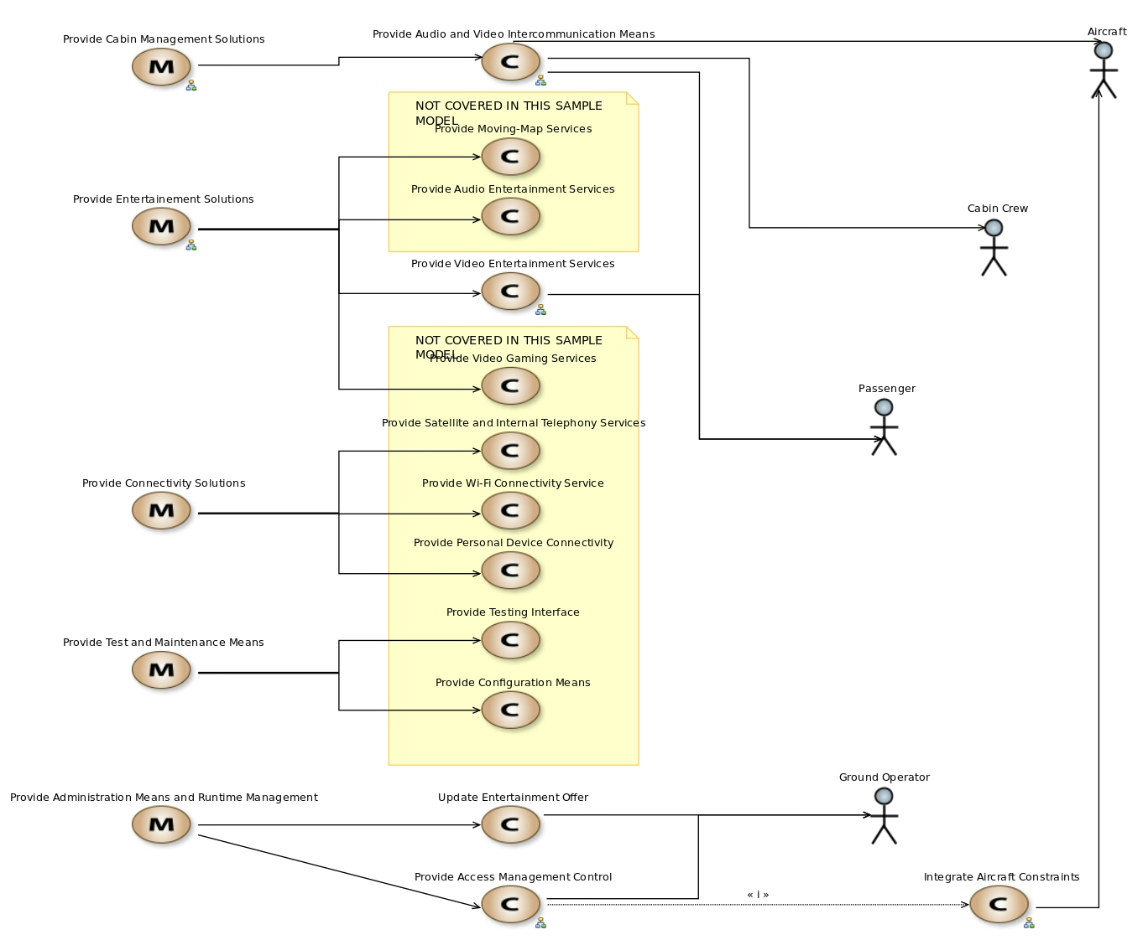

# Description of the System and its Environment

## Architecture Blank Diagrams

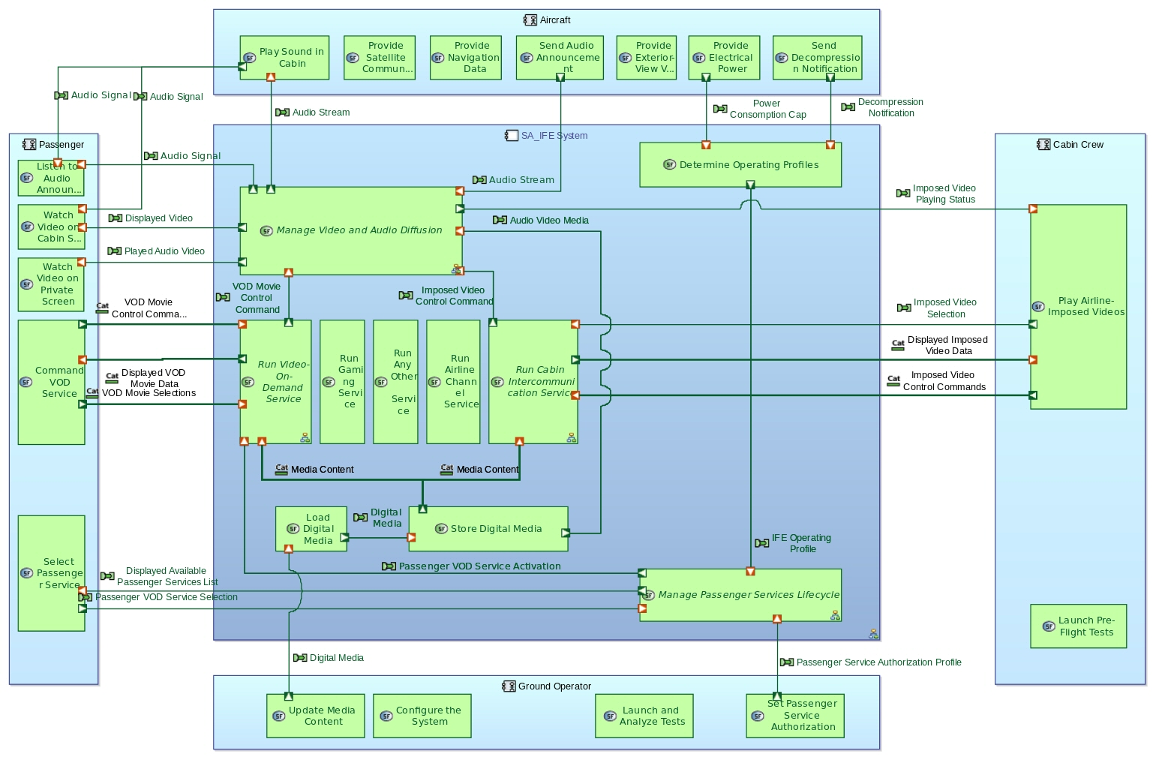

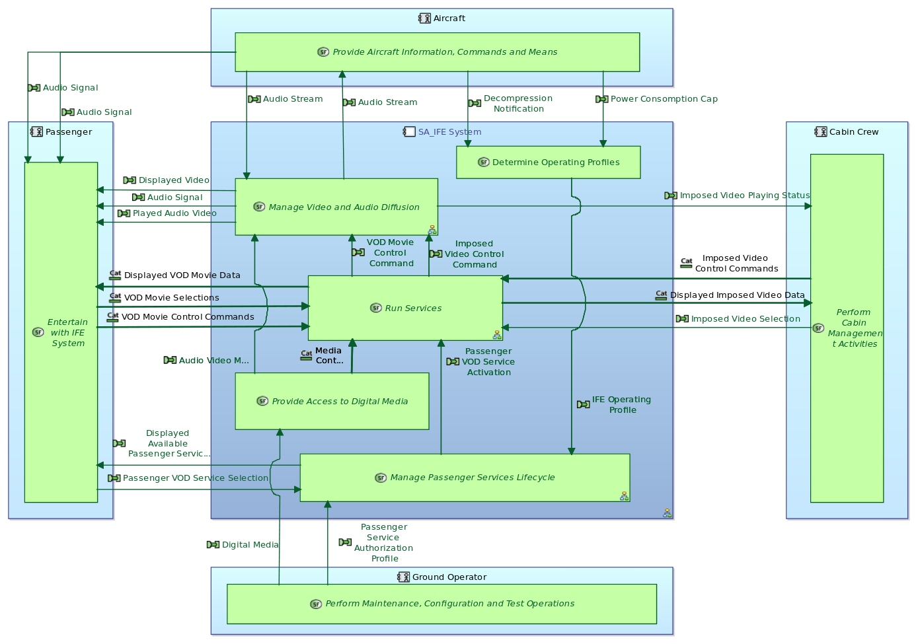

## System: SA_IFE System

Modes & State Machines:

* IFE Operating Modes

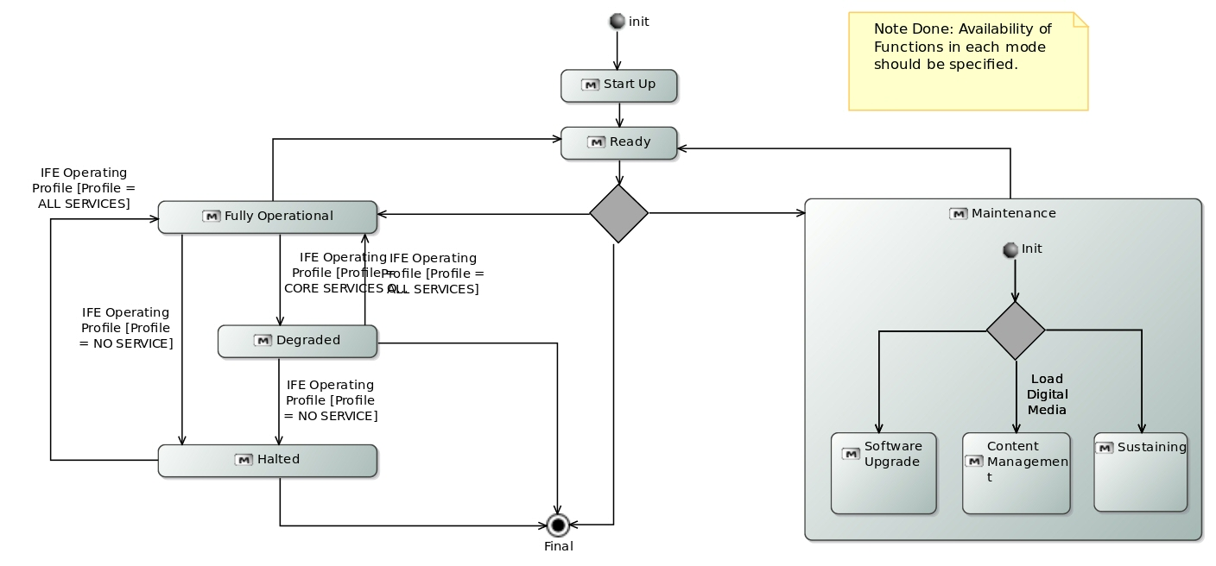

* PTV Movie Player Modes

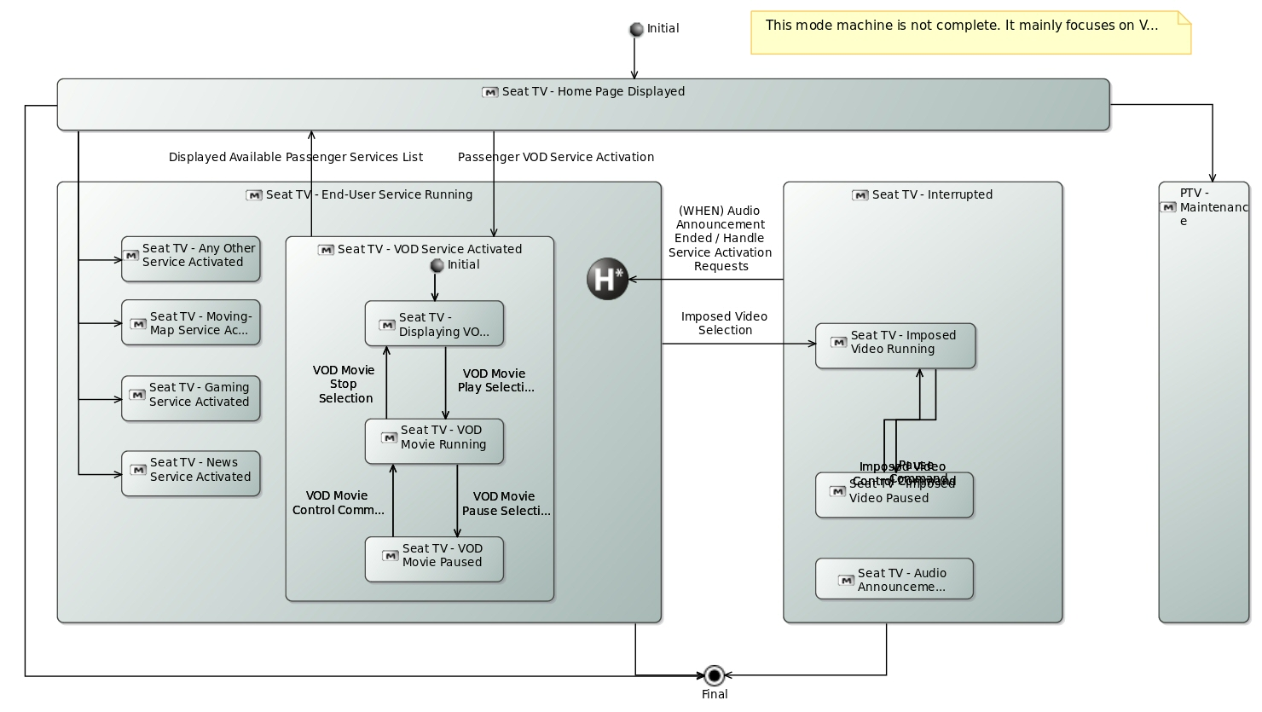

Allocated functions:

* **Manage Passenger Service Interruptions**
* **Handle VOD Movie Controls**
* **Store Digital Media**
* **Handle Service Activation Requests**
* **Determine Service Availability**
* **Broadcast Audio Video Streams**
* **Load Digital Media**
* **Retrieve VOD Movie Data**
* **Manage Imposed Video Selections**
* **Handle Imposed Videos Controls**
* **Determine Operating Profiles**
* **Run Gaming Service**
* **Run Any Other Service**
* **Run Airline Channel Service**

## Actor: Passenger

Modes & State Machines:

*No modes & states machine*

Allocated functions:

* **Select Passenger Service**
* **Watch Video on Private Screen**
* **Watch Video on Cabin Screen**
* **Command VOD Service**
* **Listen to Audio Announcement**

## Actor: Cabin Crew

Modes & State Machines:

*No modes & states machine*

Allocated functions:

* **Play Airline-Imposed Videos**
* **Launch Pre-Flight Tests**

## Actor: Aircraft

Modes & State Machines:

*No modes & states machine*

Allocated functions:

* **Play Sound in Cabin**
* **Provide Satellite Communication Means**
* **Provide Navigation Data**
* **Send Audio Announcement**
* **Provide Exterior-View Videos**
* **Provide Electrical Power**
* **Send Decompression Notification**

## Actor: Ground Operator

Modes & State Machines:

*No modes & states machine*

Allocated functions:

* **Configure the System**
* **Update Media Content**
* **Launch and Analyze Tests**
* **Set Passenger Service Authorization**

# Description of the Functions

The Functions are sorted in the following packages:

|  |  |  |
| --- | --- | --- |
| **Parent element** | **Function package** | **Contained functions** |
| System Functions | Root System Function | **Perform Cabin Management Activities**  **Entertain with IFE System**  **Provide Aircraft Information, Commands and Means**  **Perform Maintenance, Configuration and Test Operations**  **IFE System** |

## Function: Perform Cabin Management Activities

Description:

*No description*

Parent / Children functions:

|  |  |  |
| --- | --- | --- |
| **Parent function** | **Current function** | **Children functions** |
| **Root System Function** | Perform Cabin Management Activities | * **Play Airline-Imposed Videos** * **Launch Pre-Flight Tests** |

List of inputs:

*No input*

List of outputs:

*No output*

Participation to functional chains:

* **Broadcast Audio Announcement**

Allocated to:

*Function not allocated*

## Function: Play Airline-Imposed Videos

Description:

This function consists in triggering the play of pre-recorded airline videos. In particular, these imposed videos inclure pre-flight safety instructions (detailed explanation given before takeoff to airline passengers about the safety features of a commercial aircraft). Such imposed videos can also be commercial ads.

Parent / Children functions:

|  |  |  |
| --- | --- | --- |
| **Parent function** | **Current function** | **Children functions** |
| **Perform Cabin Management Activities** | Play Airline-Imposed Videos | *No children function* |

List of inputs:

| **Incoming functional exchange** | **Exchanged items** |
| --- | --- |

|  |  |
| --- | --- |
| Displayed Imposed Videos List | *No exchanged item* |

|  |  |
| --- | --- |
| Imposed Video Playing Status | *No exchanged item* |

List of outputs:

| **Outgoing functional exchange** | **Exchanged items** |
| --- | --- |

|  |  |
| --- | --- |
| Imposed Video Selection | *No exchanged item* |

|  |  |
| --- | --- |
| Pause Command | *No exchanged item* |

|  |  |
| --- | --- |
| Stop Command | *No exchanged item* |

|  |  |
| --- | --- |
| Play Command | *No exchanged item* |

Participation to functional chains:

* **Watch Imposed Video on Cabin Screen**
* **Watch Imposed Video on Private Screen**

Allocated to:

* **Cabin Crew**

## Function: Launch Pre-Flight Tests

Description:

This function consists in triggering a series of system auto-tests before each flight.

Parent / Children functions:

|  |  |  |
| --- | --- | --- |
| **Parent function** | **Current function** | **Children functions** |
| **Perform Cabin Management Activities** | Launch Pre-Flight Tests | *No children function* |

List of inputs:

*No input*

List of outputs:

*No output*

Participation to functional chains:

*None*

Allocated to:

* **Cabin Crew**

## Function: Entertain with IFE System

Description:

*No description*

Parent / Children functions:

|  |  |  |
| --- | --- | --- |
| **Parent function** | **Current function** | **Children functions** |
| **Root System Function** | Entertain with IFE System | * **Watch Video on Private Screen** * **Watch Video on Cabin Screen** * **Select Passenger Service** * **Command VOD Service** * **Listen to Audio Announcement** |

List of inputs:

*No input*

List of outputs:

*No output*

Participation to functional chains:

*None*

Allocated to:

*Function not allocated*

## Function: Watch Video on Private Screen

Description:

This function represents the fact that the&nbsp;passenger can watch a movie/video on&nbsp;a private screen (i.e. the  
in-seat TV).&nbsp;

Parent / Children functions:

|  |  |  |
| --- | --- | --- |
| **Parent function** | **Current function** | **Children functions** |
| **Entertain with IFE System** | Watch Video on Private Screen | *No children function* |

List of inputs:

| **Incoming functional exchange** | **Exchanged items** |
| --- | --- |

|  |  |
| --- | --- |
| Played Audio Video | *No exchanged item* |

List of outputs:

*No output*

Participation to functional chains:

* **Watch Imposed Video on Private Screen**
* **Start Playing VOD Movie**
* **Resume VOD Movie**

Allocated to:

* **Passenger**

## Function: Watch Video on Cabin Screen

Description:

This function represents the fact that the&nbsp;passenger can watch a video on&nbsp;a cabin&nbsp;screen (typically located  
in the ceiling).&nbsp;

Parent / Children functions:

|  |  |  |
| --- | --- | --- |
| **Parent function** | **Current function** | **Children functions** |
| **Entertain with IFE System** | Watch Video on Cabin Screen | *No children function* |

List of inputs:

| **Incoming functional exchange** | **Exchanged items** |
| --- | --- |

|  |  |
| --- | --- |
| Audio Signal | *No exchanged item* |

|  |  |
| --- | --- |
| Displayed Video | *No exchanged item* |

List of outputs:

*No output*

Participation to functional chains:

* **Watch Imposed Video on Cabin Screen**

Allocated to:

* **Passenger**

## Function: Select Passenger Service

Description:

This function covers the selection by the passenger of&nbsp;a given IFE&nbsp;service (gaming, moving-map, VOD, etc.).

Parent / Children functions:

|  |  |  |
| --- | --- | --- |
| **Parent function** | **Current function** | **Children functions** |
| **Entertain with IFE System** | Select Passenger Service | *No children function* |

List of inputs:

| **Incoming functional exchange** | **Exchanged items** |
| --- | --- |

|  |  |
| --- | --- |
| Displayed Available Passenger Services List | *No exchanged item* |

List of outputs:

| **Outgoing functional exchange** | **Exchanged items** |
| --- | --- |

|  |  |
| --- | --- |
| Passenger VOD Service Selection | *No exchanged item* |

Participation to functional chains:

*None*

Allocated to:

* **Passenger**

## Function: Command VOD Service

Description:

This function is dedicated to the interactions in the context of the VOD service: Selection of movies and control on these  
movies (play, pause, stop, etc.).

Parent / Children functions:

|  |  |  |
| --- | --- | --- |
| **Parent function** | **Current function** | **Children functions** |
| **Entertain with IFE System** | Command VOD Service | *No children function* |

List of inputs:

| **Incoming functional exchange** | **Exchanged items** |
| --- | --- |

|  |  |
| --- | --- |
| Displayed Available Languages | *No exchanged item* |

|  |  |
| --- | --- |
| Displayed VOD Movies List | *No exchanged item* |

|  |  |
| --- | --- |
| Displayed Movie Description | *No exchanged item* |

List of outputs:

| **Outgoing functional exchange** | **Exchanged items** |
| --- | --- |

|  |  |
| --- | --- |
| VOD Movie Play Selection | *No exchanged item* |

|  |  |
| --- | --- |
| VOD Movie Language Selection | *No exchanged item* |

|  |  |
| --- | --- |
| VOD Movie Pause Selection | *No exchanged item* |

|  |  |
| --- | --- |
| VOD Movie Stop Selection | *No exchanged item* |

|  |  |
| --- | --- |
| VOD Movie Selection | *No exchanged item* |

Participation to functional chains:

* **Start Playing VOD Movie**
* **Resume VOD Movie**

Allocated to:

* **Passenger**

## Function: Listen to Audio Announcement

Description:

<p>  
 Audio announcements are information about the flight provided by the cabin crew or the captain (boarding, pre-flight  
 announcements, captain's announcements, safety briefing, turbulence, take-off/ascent, descent/final, landing, etc.).  
 The passenger can listen to these annoucements aither through the aircraft speakers either through the individual Seat  
 TVs.  
</p>

Parent / Children functions:

|  |  |  |
| --- | --- | --- |
| **Parent function** | **Current function** | **Children functions** |
| **Entertain with IFE System** | Listen to Audio Announcement | *No children function* |

List of inputs:

| **Incoming functional exchange** | **Exchanged items** |
| --- | --- |

|  |  |
| --- | --- |
| Audio Signal | *No exchanged item* |

|  |  |
| --- | --- |
| Audio Signal | *No exchanged item* |

List of outputs:

*No output*

Participation to functional chains:

* **Broadcast Audio Announcement**

Allocated to:

* **Passenger**

## Function: Provide Aircraft Information, Commands and Means

Description:

*No description*

Parent / Children functions:

|  |  |  |
| --- | --- | --- |
| **Parent function** | **Current function** | **Children functions** |
| **Root System Function** | Provide Aircraft Information, Commands and Means | * **Provide Satellite Communication Means** * **Provide Navigation Data** * **Provide Electrical Power** * **Provide Exterior-View Videos** * **Send Audio Announcement** * **Play Sound in Cabin** * **Send Decompression Notification** |

List of inputs:

*No input*

List of outputs:

*No output*

Participation to functional chains:

* **Broadcast Audio Announcement**

Allocated to:

*Function not allocated*

## Function: Provide Satellite Communication Means

Description:

This function consists in providing satellite network, typically for telephony or in-cabin wifi systems.

Parent / Children functions:

|  |  |  |
| --- | --- | --- |
| **Parent function** | **Current function** | **Children functions** |
| **Provide Aircraft Information, Commands and Means** | Provide Satellite Communication Means | *No children function* |

List of inputs:

*No input*

List of outputs:

*No output*

Participation to functional chains:

*None*

Allocated to:

* **Aircraft**

## Function: Provide Navigation Data

Description:

Navigation is the determination of position and direction on or above the surface of the Earth. Avionics can use  
satellite-based systems (such as GPS and WAAS), ground-based systems (such as VOR or LORAN), or any combination thereof.  
The IFE system requires this data to run the moving-map service.

Parent / Children functions:

|  |  |  |
| --- | --- | --- |
| **Parent function** | **Current function** | **Children functions** |
| **Provide Aircraft Information, Commands and Means** | Provide Navigation Data | *No children function* |

List of inputs:

*No input*

List of outputs:

*No output*

Participation to functional chains:

*None*

Allocated to:

* **Aircraft**

## Function: Provide Electrical Power

Description:

This function is responsible for providing power consumption profiles. According to different flying conditions and phases,  
the power made available to the IFE system may differ.

Parent / Children functions:

|  |  |  |
| --- | --- | --- |
| **Parent function** | **Current function** | **Children functions** |
| **Provide Aircraft Information, Commands and Means** | Provide Electrical Power | *No children function* |

List of inputs:

*No input*

List of outputs:

| **Outgoing functional exchange** | **Exchanged items** |
| --- | --- |

|  |  |
| --- | --- |
| Power Consomption Cap | *No exchanged item* |

Participation to functional chains:

*None*

Allocated to:

* **Aircraft**

## Function: Provide Exterior-View Videos

Description:

This functions relays the videos captured&nbsp;external cameras, typically located on the&nbsp;tail or&nbsp;the nose of the  
plane. &nbsp;

Parent / Children functions:

|  |  |  |
| --- | --- | --- |
| **Parent function** | **Current function** | **Children functions** |
| **Provide Aircraft Information, Commands and Means** | Provide Exterior-View Videos | *No children function* |

List of inputs:

*No input*

List of outputs:

*No output*

Participation to functional chains:

*None*

Allocated to:

* **Aircraft**

## Function: Send Audio Announcement

Description:

Audio announcement include: boarding, pre-flight announcements, captain's announcements, safety briefing, turbulence,  
take-off/ascent, descent/final, landing, etc.

Parent / Children functions:

|  |  |  |
| --- | --- | --- |
| **Parent function** | **Current function** | **Children functions** |
| **Provide Aircraft Information, Commands and Means** | Send Audio Announcement | *No children function* |

List of inputs:

*No input*

List of outputs:

| **Outgoing functional exchange** | **Exchanged items** |
| --- | --- |

|  |  |
| --- | --- |
| Audio Stream | *No exchanged item* |

Participation to functional chains:

* **Broadcast Audio Announcement**

Allocated to:

* **Aircraft**

## Function: Play Sound in Cabin

Description:

This function receives digital audio streams and play them on the aricraft speakers.

Parent / Children functions:

|  |  |  |
| --- | --- | --- |
| **Parent function** | **Current function** | **Children functions** |
| **Provide Aircraft Information, Commands and Means** | Play Sound in Cabin | *No children function* |

List of inputs:

| **Incoming functional exchange** | **Exchanged items** |
| --- | --- |

|  |  |
| --- | --- |
| Audio Stream | *No exchanged item* |

List of outputs:

| **Outgoing functional exchange** | **Exchanged items** |
| --- | --- |

|  |  |
| --- | --- |
| Audio Signal | *No exchanged item* |

|  |  |
| --- | --- |
| Audio Signal | *No exchanged item* |

Participation to functional chains:

* **Watch Imposed Video on Cabin Screen**

Allocated to:

* **Aircraft**

## Function: Send Decompression Notification

Description:

If ever a decompression occurs, a notification is sent to the IFE system (which will automatically swtich to "Halted" mode.

Parent / Children functions:

|  |  |  |
| --- | --- | --- |
| **Parent function** | **Current function** | **Children functions** |
| **Provide Aircraft Information, Commands and Means** | Send Decompression Notification | *No children function* |

List of inputs:

*No input*

List of outputs:

| **Outgoing functional exchange** | **Exchanged items** |
| --- | --- |

|  |  |
| --- | --- |
| Decompression Notification | *No exchanged item* |

Participation to functional chains:

*None*

Allocated to:

* **Aircraft**

## Function: Perform Maintenance, Configuration and Test Operations

Description:

*No description*

Parent / Children functions:

|  |  |  |
| --- | --- | --- |
| **Parent function** | **Current function** | **Children functions** |
| **Root System Function** | Perform Maintenance, Configuration and Test Operations | * **Update Media Content** * **Configure the System** * **Launch and Analyze Tests** * **Set Passenger Service Authorization** |

List of inputs:

*No input*

List of outputs:

*No output*

Participation to functional chains:

*None*

Allocated to:

*Function not allocated*

## Function: Update Media Content

Description:

This function consists in updating the IFE media server with new content. Using a specific device, the ground operator can  
for example updload new movies/music and remove others.

Parent / Children functions:

|  |  |  |
| --- | --- | --- |
| **Parent function** | **Current function** | **Children functions** |
| **Perform Maintenance, Configuration and Test Operations** | Update Media Content | *No children function* |

List of inputs:

*No input*

List of outputs:

| **Outgoing functional exchange** | **Exchanged items** |
| --- | --- |

|  |  |
| --- | --- |
| Digital Media | *No exchanged item* |

Participation to functional chains:

*None*

Allocated to:

* **Ground Operator**

## Function: Configure the System

Description:

[Not coevered in this version of the model]

Parent / Children functions:

|  |  |  |
| --- | --- | --- |
| **Parent function** | **Current function** | **Children functions** |
| **Perform Maintenance, Configuration and Test Operations** | Configure the System | *No children function* |

List of inputs:

*No input*

List of outputs:

*No output*

Participation to functional chains:

*None*

Allocated to:

* **Ground Operator**

## Function: Launch and Analyze Tests

Description:

[Not covered in the version of the model] This function consists in triggering system tests, typically during maintenance  
phases.

Parent / Children functions:

|  |  |  |
| --- | --- | --- |
| **Parent function** | **Current function** | **Children functions** |
| **Perform Maintenance, Configuration and Test Operations** | Launch and Analyze Tests | *No children function* |

List of inputs:

*No input*

List of outputs:

*No output*

Participation to functional chains:

*None*

Allocated to:

* **Ground Operator**

## Function: Set Passenger Service Authorization

Description:

The airline company may have specific business strategies: According to the class they are travelling in, passengers may  
benefit from different IFE services.&nbsp;This function consists in uploading a profile that describes the authorization  
schemes.

Parent / Children functions:

|  |  |  |
| --- | --- | --- |
| **Parent function** | **Current function** | **Children functions** |
| **Perform Maintenance, Configuration and Test Operations** | Set Passenger Service Authorization | *No children function* |

List of inputs:

*No input*

List of outputs:

| **Outgoing functional exchange** | **Exchanged items** |
| --- | --- |

|  |  |
| --- | --- |
| Passenger Service Authorization Profile | *No exchanged item* |

Participation to functional chains:

*None*

Allocated to:

* **Ground Operator**

## Function: IFE System

Description:

*No description*

Parent / Children functions:

|  |  |  |
| --- | --- | --- |
| **Parent function** | **Current function** | **Children functions** |
| **Root System Function** | IFE System | * **Provide Access to Digital Media** * **Manage Passenger Services Lifecycle** * **Run Services** * **Manage Video and Audio Diffusion** * **Determine Operating Profiles** |

List of inputs:

*No input*

List of outputs:

*No output*

Participation to functional chains:

*None*

Allocated to:

*Function not allocated*

## Function: Provide Access to Digital Media

Description:

*No description*

Parent / Children functions:

|  |  |  |
| --- | --- | --- |
| **Parent function** | **Current function** | **Children functions** |
| **IFE System** | Provide Access to Digital Media | * **Store Digital Media** * **Load Digital Media** |

List of inputs:

*No input*

List of outputs:

*No output*

Participation to functional chains:

*None*

Allocated to:

*Function not allocated*

## Function: Store Digital Media

Description:

This function is responsible for&nbsp;the storage of audio and video&nbsp;files that will be streamed&nbsp;and of movie  
information such as metadata (pictures,description).

Parent / Children functions:

|  |  |  |
| --- | --- | --- |
| **Parent function** | **Current function** | **Children functions** |
| **Provide Access to Digital Media** | Store Digital Media | *No children function* |

List of inputs:

| **Incoming functional exchange** | **Exchanged items** |
| --- | --- |

|  |  |
| --- | --- |
| Digital Media | *No exchanged item* |

List of outputs:

| **Outgoing functional exchange** | **Exchanged items** |
| --- | --- |

|  |  |
| --- | --- |
| Audio Video Media | *No exchanged item* |

|  |  |
| --- | --- |
| Available Airline Video List | *No exchanged item* |

|  |  |
| --- | --- |
| Available VOD Movies List | *No exchanged item* |

|  |  |
| --- | --- |
| Available Languages | *No exchanged item* |

|  |  |
| --- | --- |
| Movie Description | *No exchanged item* |

|  |  |
| --- | --- |
| Movie Cover | *No exchanged item* |

Participation to functional chains:

* **Watch Imposed Video on Cabin Screen**
* **Watch Imposed Video on Private Screen**
* **Start Playing VOD Movie**
* **Resume VOD Movie**

Allocated to:

* **SA_IFE System**

## Function: Load Digital Media

Description:

This function is responsible for receiving the media content uploaded by the ground operator and for moving it onto the IFE  
media storage unit.

Parent / Children functions:

|  |  |  |
| --- | --- | --- |
| **Parent function** | **Current function** | **Children functions** |
| **Provide Access to Digital Media** | Load Digital Media | *No children function* |

List of inputs:

| **Incoming functional exchange** | **Exchanged items** |
| --- | --- |

|  |  |
| --- | --- |
| Digital Media | *No exchanged item* |

List of outputs:

| **Outgoing functional exchange** | **Exchanged items** |
| --- | --- |

|  |  |
| --- | --- |
| Digital Media | *No exchanged item* |

Participation to functional chains:

*None*

Allocated to:

* **SA_IFE System**

## Function: Manage Passenger Services Lifecycle

Description:

This function is responsible for controling the launch of services such as VOD, gaming, moving-map, etc. It determines the  
availability of the services given the airline company authorization scheme and the constraints received from the  
aircraft.&nbsp;This function&nbsp;provides means to select among a predefined list of services.

Parent / Children functions:

|  |  |  |
| --- | --- | --- |
| **Parent function** | **Current function** | **Children functions** |
| **IFE System** | Manage Passenger Services Lifecycle | * **Determine Service Availability** * **Handle Service Activation Requests** |

List of inputs:

*No input*

List of outputs:

*No output*

Participation to functional chains:

*None*

Allocated to:

*Function not allocated*

## Function: Determine Service Availability

Description:

This function is responsible for computing the availability of passenger services based on the authorization scheme  
(airline business strategy) and the aircraft contraints.

Parent / Children functions:

|  |  |  |
| --- | --- | --- |
| **Parent function** | **Current function** | **Children functions** |
| **Manage Passenger Services Lifecycle** | Determine Service Availability | *No children function* |

List of inputs:

| **Incoming functional exchange** | **Exchanged items** |
| --- | --- |

|  |  |
| --- | --- |
| Passenger Service Authorization Profile | *No exchanged item* |

|  |  |
| --- | --- |
| IFE Operating Profile | *No exchanged item* |

List of outputs:

| **Outgoing functional exchange** | **Exchanged items** |
| --- | --- |

|  |  |
| --- | --- |
| Service Availability | *No exchanged item* |

Participation to functional chains:

*None*

Allocated to:

* **SA_IFE System**

## Function: Handle Service Activation Requests

Description:

This function displays the available services and trigger service activations when applicable.

Parent / Children functions:

|  |  |  |
| --- | --- | --- |
| **Parent function** | **Current function** | **Children functions** |
| **Manage Passenger Services Lifecycle** | Handle Service Activation Requests | *No children function* |

List of inputs:

| **Incoming functional exchange** | **Exchanged items** |
| --- | --- |

|  |  |
| --- | --- |
| Passenger VOD Service Selection | *No exchanged item* |

|  |  |
| --- | --- |
| Service Availability | *No exchanged item* |

List of outputs:

| **Outgoing functional exchange** | **Exchanged items** |
| --- | --- |

|  |  |
| --- | --- |
| Displayed Available Passenger Services List | *No exchanged item* |

|  |  |
| --- | --- |
| Passenger VOD Service Activation | *No exchanged item* |

Participation to functional chains:

*None*

Allocated to:

* **SA_IFE System**

## Function: Run Services

Description:

This function regroups all IFE services running functions.

Parent / Children functions:

|  |  |  |
| --- | --- | --- |
| **Parent function** | **Current function** | **Children functions** |
| **IFE System** | Run Services | * **Run Video-On-Demand Service** * **Run Cabin Intercommunication Service** * **Run Gaming Service** * **Run Any Other Service** * **Run Airline Channel Service** |

List of inputs:

*No input*

List of outputs:

*No output*

Participation to functional chains:

*None*

Allocated to:

*Function not allocated*

## Function: Run Video-On-Demand Service

Description:

VOD Service is a passenger service. This function gathers all functions in charge of managing the VOD-related interactions  
of the passenger (selection of movies, play/pause/stop controls, display of movie data, etc.).

Parent / Children functions:

|  |  |  |
| --- | --- | --- |
| **Parent function** | **Current function** | **Children functions** |
| **Run Services** | Run Video-On-Demand Service | * **Handle VOD Movie Controls** * **Retrieve VOD Movie Data** |

List of inputs:

*No input*

List of outputs:

*No output*

Participation to functional chains:

*None*

Allocated to:

*Function not allocated*

## Function: Handle VOD Movie Controls

Description:

This function forwards the&nbsp;VOD Movie&nbsp;play/pause/stop commands.

Parent / Children functions:

|  |  |  |
| --- | --- | --- |
| **Parent function** | **Current function** | **Children functions** |
| **Run Video-On-Demand Service** | Handle VOD Movie Controls | *No children function* |

List of inputs:

| **Incoming functional exchange** | **Exchanged items** |
| --- | --- |

|  |  |
| --- | --- |
| VOD Movie Play Selection | *No exchanged item* |

|  |  |
| --- | --- |
| VOD Movie Stop Selection | *No exchanged item* |

|  |  |
| --- | --- |
| VOD Movie Pause Selection | *No exchanged item* |

List of outputs:

| **Outgoing functional exchange** | **Exchanged items** |
| --- | --- |

|  |  |
| --- | --- |
| VOD Movie Control Command | *No exchanged item* |

Participation to functional chains:

* **Start Playing VOD Movie**
* **Resume VOD Movie**

Allocated to:

* **SA_IFE System**

## Function: Retrieve VOD Movie Data

Description:

This function consists both in displaying&nbsp;lists of available VOD movies and capturing the&nbsp;passenger  
VOD&nbsp;selections.

Parent / Children functions:

|  |  |  |
| --- | --- | --- |
| **Parent function** | **Current function** | **Children functions** |
| **Run Video-On-Demand Service** | Retrieve VOD Movie Data | *No children function* |

List of inputs:

| **Incoming functional exchange** | **Exchanged items** |
| --- | --- |

|  |  |
| --- | --- |
| Movie Description | *No exchanged item* |

|  |  |
| --- | --- |
| Available Languages | *No exchanged item* |

|  |  |
| --- | --- |
| Available VOD Movies List | *No exchanged item* |

|  |  |
| --- | --- |
| Movie Cover | *No exchanged item* |

|  |  |
| --- | --- |
| VOD Movie Selection | *No exchanged item* |

|  |  |
| --- | --- |
| VOD Movie Language Selection | *No exchanged item* |

|  |  |
| --- | --- |
| Passenger VOD Service Activation | *No exchanged item* |

List of outputs:

| **Outgoing functional exchange** | **Exchanged items** |
| --- | --- |

|  |  |
| --- | --- |
| Displayed Available Languages | *No exchanged item* |

|  |  |
| --- | --- |
| Displayed Movie Description | *No exchanged item* |

|  |  |
| --- | --- |
| Displayed VOD Movies List | *No exchanged item* |

Participation to functional chains:

*None*

Allocated to:

* **SA_IFE System**

## Function: Run Cabin Intercommunication Service

Description:

Cabin intercommunication is a&nbsp;cabin crew&nbsp;service. This function gathers all functions in charge of managing the  
cabin crew interactions related to imposed&nbsp;videos&nbsp;(selection of videos, play/pause/stop controls, display  
of&nbsp;video data, etc.).

Parent / Children functions:

|  |  |  |
| --- | --- | --- |
| **Parent function** | **Current function** | **Children functions** |
| **Run Services** | Run Cabin Intercommunication Service | * **Handle Imposed Videos Controls** * **Manage Imposed Video Selections** |

List of inputs:

*No input*

List of outputs:

*No output*

Participation to functional chains:

*None*

Allocated to:

*Function not allocated*

## Function: Handle Imposed Videos Controls

Description:

This function forwards the imposed videos play/pause/stop commands.

Parent / Children functions:

|  |  |  |
| --- | --- | --- |
| **Parent function** | **Current function** | **Children functions** |
| **Run Cabin Intercommunication Service** | Handle Imposed Videos Controls | *No children function* |

List of inputs:

| **Incoming functional exchange** | **Exchanged items** |
| --- | --- |

|  |  |
| --- | --- |
| Stop Command | *No exchanged item* |

|  |  |
| --- | --- |
| Play Command | *No exchanged item* |

|  |  |
| --- | --- |
| Pause Command | *No exchanged item* |

List of outputs:

| **Outgoing functional exchange** | **Exchanged items** |
| --- | --- |

|  |  |
| --- | --- |
| Imposed Video Control Command | *No exchanged item* |

Participation to functional chains:

* **Watch Imposed Video on Cabin Screen**
* **Watch Imposed Video on Private Screen**

Allocated to:

* **SA_IFE System**

## Function: Manage Imposed Video Selections

Description:

This function consists both in displaying&nbsp;lists of available imposed&nbsp;videos and capturing the cabin crew  
selections.

Parent / Children functions:

|  |  |  |
| --- | --- | --- |
| **Parent function** | **Current function** | **Children functions** |
| **Run Cabin Intercommunication Service** | Manage Imposed Video Selections | *No children function* |

List of inputs:

| **Incoming functional exchange** | **Exchanged items** |
| --- | --- |

|  |  |
| --- | --- |
| Imposed Video Selection | *No exchanged item* |

|  |  |
| --- | --- |
| Available Airline Video List | *No exchanged item* |

List of outputs:

| **Outgoing functional exchange** | **Exchanged items** |
| --- | --- |

|  |  |
| --- | --- |
| Displayed Imposed Videos List | *No exchanged item* |

Participation to functional chains:

*None*

Allocated to:

* **SA_IFE System**

## Function: Run Gaming Service

Description:

Gaming&nbsp;Service is a passenger service. [Not yet covered in this model].

Parent / Children functions:

|  |  |  |
| --- | --- | --- |
| **Parent function** | **Current function** | **Children functions** |
| **Run Services** | Run Gaming Service | *No children function* |

List of inputs:

*No input*

List of outputs:

*No output*

Participation to functional chains:

*None*

Allocated to:

* **SA_IFE System**

## Function: Run Any Other Service

Description:

[Not yet covered in this model].

Parent / Children functions:

|  |  |  |
| --- | --- | --- |
| **Parent function** | **Current function** | **Children functions** |
| **Run Services** | Run Any Other Service | *No children function* |

List of inputs:

*No input*

List of outputs:

*No output*

Participation to functional chains:

*None*

Allocated to:

* **SA_IFE System**

## Function: Run Airline Channel Service

Description:

Airline Channel is a&nbsp;cabin crew&nbsp;service. [Not yet covered in this model].

Parent / Children functions:

|  |  |  |
| --- | --- | --- |
| **Parent function** | **Current function** | **Children functions** |
| **Run Services** | Run Airline Channel Service | *No children function* |

List of inputs:

*No input*

List of outputs:

*No output*

Participation to functional chains:

*None*

Allocated to:

* **SA_IFE System**

## Function: Manage Video and Audio Diffusion

Description:

This function is responsible for broadcasting audio and video streams, should they be VOD movies, imposed videos, on-demand  
or imposed music. This function also covers the transmission of audio announcements (coming from the aircraft) and the IFE  
passenger service interruptions triggered by these announcements.

Parent / Children functions:

|  |  |  |
| --- | --- | --- |
| **Parent function** | **Current function** | **Children functions** |
| **IFE System** | Manage Video and Audio Diffusion | * **Broadcast Audio Video Streams** * **Manage Passenger Service Interruptions** |

List of inputs:

*No input*

List of outputs:

*No output*

Participation to functional chains:

*None*

Allocated to:

*Function not allocated*

## Function: Broadcast Audio Video Streams

Description:

<p>  
 This function is responsible for broadcasting existing audio&nbsp;and video media as well as transmitting audio  
 announcements coming from the aircraft. Transmitting audio and video streams means:  
</p>  
<p>  
 -&nbsp;sending them to each passenger (on Seat TVs)  
</p>  
<p>  
 - sending them to the cabin screens  
</p>  
<p>  
 -&nbsp;providing the cabin crew with a status of their running imposed videos. &nbsp;  
</p>

Parent / Children functions:

|  |  |  |
| --- | --- | --- |
| **Parent function** | **Current function** | **Children functions** |
| **Manage Video and Audio Diffusion** | Broadcast Audio Video Streams | *No children function* |

List of inputs:

| **Incoming functional exchange** | **Exchanged items** |
| --- | --- |

|  |  |
| --- | --- |
| Audio Video Media | *No exchanged item* |

|  |  |
| --- | --- |
| VOD Movie Control Command | *No exchanged item* |

|  |  |
| --- | --- |
| Imposed Video Control Command | *No exchanged item* |

|  |  |
| --- | --- |
| VOD Movie Status | *No exchanged item* |

|  |  |
| --- | --- |
| Audio Stream | *No exchanged item* |

List of outputs:

| **Outgoing functional exchange** | **Exchanged items** |
| --- | --- |

|  |  |
| --- | --- |
| Played Audio Video | *No exchanged item* |

|  |  |
| --- | --- |
| Displayed Video | *No exchanged item* |

|  |  |
| --- | --- |
| Audio Stream | *No exchanged item* |

|  |  |
| --- | --- |
| Imposed Video Playing Status | *No exchanged item* |

|  |  |
| --- | --- |
| Audio Signal | *No exchanged item* |

|  |  |
| --- | --- |
| VOD Movie | *No exchanged item* |

Participation to functional chains:

* **Watch Imposed Video on Cabin Screen**
* **Watch Imposed Video on Private Screen**
* **Broadcast Audio Announcement**
* **Start Playing VOD Movie**
* **Resume VOD Movie**

Allocated to:

* **SA_IFE System**

## Function: Manage Passenger Service Interruptions

Description:

This function is responsible for triggering passenger service interruptions as soon as an imposed video is played or an  
audio announcement is performed. When a VOD movie is running, this means for example that the movie as to be automatically  
paused and the current position stored.

Parent / Children functions:

|  |  |  |
| --- | --- | --- |
| **Parent function** | **Current function** | **Children functions** |
| **Manage Video and Audio Diffusion** | Manage Passenger Service Interruptions | *No children function* |

List of inputs:

| **Incoming functional exchange** | **Exchanged items** |
| --- | --- |

|  |  |
| --- | --- |
| VOD Movie | *No exchanged item* |

List of outputs:

| **Outgoing functional exchange** | **Exchanged items** |
| --- | --- |

|  |  |
| --- | --- |
| VOD Movie Status | *No exchanged item* |

Participation to functional chains:

* **Watch Imposed Video on Private Screen**
* **Broadcast Audio Announcement**
* **Start Playing VOD Movie**
* **Resume VOD Movie**

Allocated to:

* **SA_IFE System**

## Function: Determine Operating Profiles

Description:

Based on the notifications it receives from the aircraft, this function computes the mode in which the IFE system has to  
operate. For example, if the aircraft sends a power reduction request, the IFE may switch to a downgraded mode.

Parent / Children functions:

|  |  |  |
| --- | --- | --- |
| **Parent function** | **Current function** | **Children functions** |
| **IFE System** | Determine Operating Profiles | *No children function* |

List of inputs:

| **Incoming functional exchange** | **Exchanged items** |
| --- | --- |

|  |  |
| --- | --- |
| Decompression Notification | *No exchanged item* |

|  |  |
| --- | --- |
| Power Consomption Cap | *No exchanged item* |

List of outputs:

| **Outgoing functional exchange** | **Exchanged items** |
| --- | --- |

|  |  |
| --- | --- |
| IFE Operating Profile | *No exchanged item* |

Participation to functional chains:

*None*

Allocated to:

* **SA_IFE System**

# Description of the Functional Chains

## Functional Chain : Watch Imposed Video on Cabin Screen

This functional chain is illustrated by the following diagram:

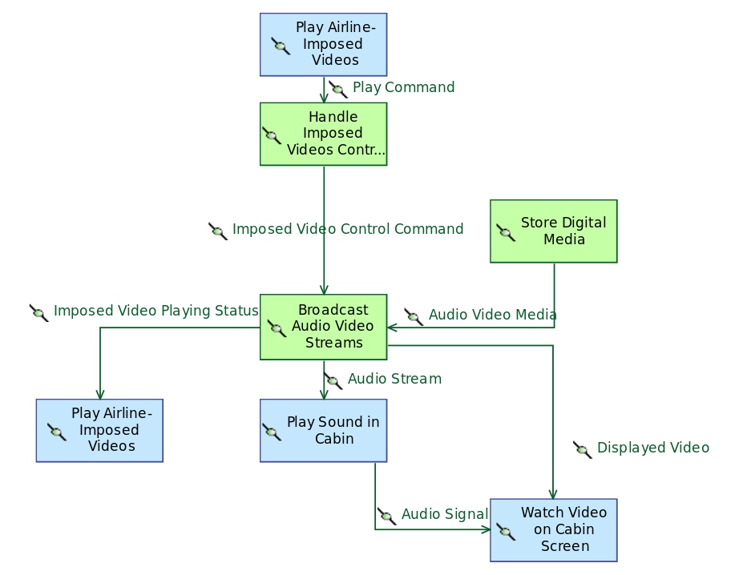

Description:

*No description*

Involved elements:

This functional chain involves the following elements:

| **Functional exchange** | **Source function** | **Target function** |
| --- | --- | --- |

|  |  |  |
| --- | --- | --- |
| Displayed Video | **Broadcast Audio Video Streams** | **Watch Video on Cabin Screen** |

|  |  |  |
| --- | --- | --- |
| Audio Stream | **Broadcast Audio Video Streams** | **Play Sound in Cabin** |

|  |  |  |
| --- | --- | --- |
| Audio Signal | **Play Sound in Cabin** | **Watch Video on Cabin Screen** |

|  |  |  |
| --- | --- | --- |
| Audio Video Media | **Store Digital Media** | **Broadcast Audio Video Streams** |

|  |  |  |
| --- | --- | --- |
| Play Command | **Play Airline-Imposed Videos** | **Handle Imposed Videos Controls** |

|  |  |  |
| --- | --- | --- |
| Imposed Video Playing Status | **Broadcast Audio Video Streams** | **Play Airline-Imposed Videos** |

|  |  |  |
| --- | --- | --- |
| Imposed Video Control Command | **Handle Imposed Videos Controls** | **Broadcast Audio Video Streams** |

Involving capabilities:

* **Provide Audio and Video Intercommunication Means**

## Functional Chain : Watch Imposed Video on Private Screen

This functional chain is illustrated by the following diagram:

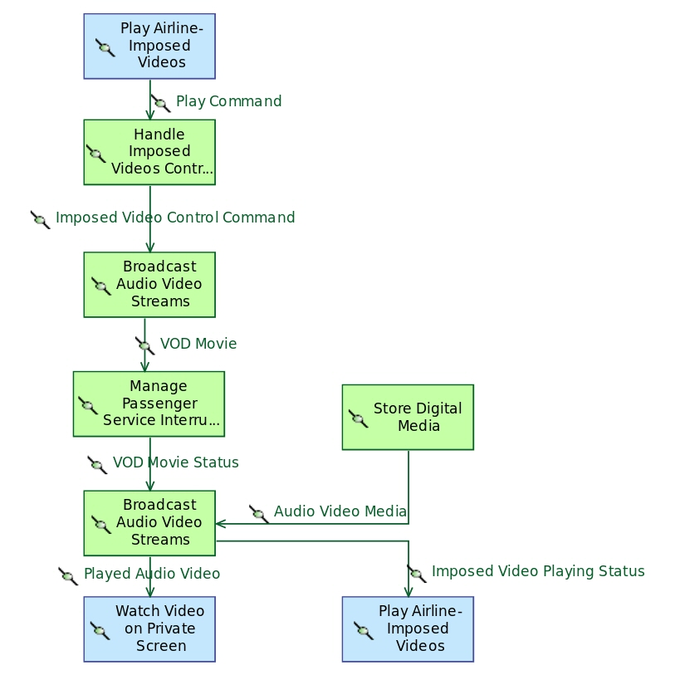

Description:

*No description*

Involved elements:

This functional chain involves the following elements:

| **Functional exchange** | **Source function** | **Target function** |
| --- | --- | --- |

|  |  |  |
| --- | --- | --- |
| Audio Video Media | **Store Digital Media** | **Broadcast Audio Video Streams** |

|  |  |  |
| --- | --- | --- |
| Play Command | **Play Airline-Imposed Videos** | **Handle Imposed Videos Controls** |

|  |  |  |
| --- | --- | --- |
| Imposed Video Playing Status | **Broadcast Audio Video Streams** | **Play Airline-Imposed Videos** |

|  |  |  |
| --- | --- | --- |
| VOD Movie Status | **Manage Passenger Service Interruptions** | **Broadcast Audio Video Streams** |

|  |  |  |
| --- | --- | --- |
| Played Audio Video | **Broadcast Audio Video Streams** | **Watch Video on Private Screen** |

|  |  |  |
| --- | --- | --- |
| Imposed Video Control Command | **Handle Imposed Videos Controls** | **Broadcast Audio Video Streams** |

|  |  |  |
| --- | --- | --- |
| VOD Movie | **Broadcast Audio Video Streams** | **Manage Passenger Service Interruptions** |

Involving capabilities:

* **Provide Audio and Video Intercommunication Means**

## Functional Chain : Stop Playing Imposed Video [NOT DONE]

Description:

*No description*

Involved elements:

*No involved elements*

Involving capabilities:

* **Provide Audio and Video Intercommunication Means**

## Functional Chain : Pause Running Imposed Video [NOT DONE]

Description:

*No description*

Involved elements:

*No involved elements*

Involving capabilities:

* **Provide Audio and Video Intercommunication Means**

## Functional Chain : Broadcast Audio Announcement

This functional chain is illustrated by the following diagram:

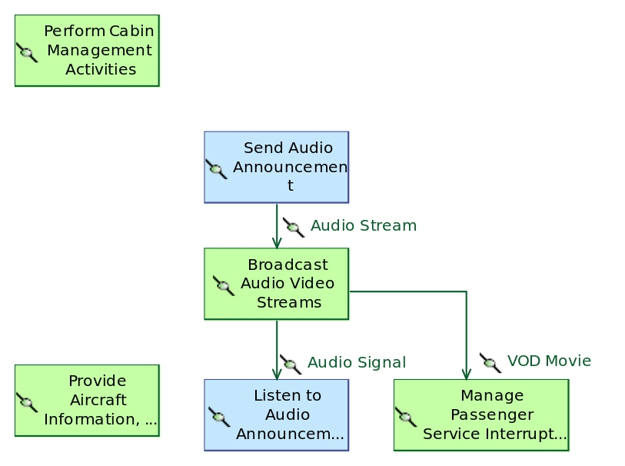

Description:

*No description*

Involved elements:

This functional chain involves the following elements:

| **Functional exchange** | **Source function** | **Target function** |
| --- | --- | --- |

|  |  |  |
| --- | --- | --- |
| Audio Stream | **Send Audio Announcement** | **Broadcast Audio Video Streams** |

|  |  |  |
| --- | --- | --- |
| VOD Movie | **Broadcast Audio Video Streams** | **Manage Passenger Service Interruptions** |

|  |  |  |
| --- | --- | --- |
| Audio Signal | **Broadcast Audio Video Streams** | **Listen to Audio Announcement** |

Involving capabilities:

* **Provide Audio and Video Intercommunication Means**

## Functional Chain : Start Playing VOD Movie

This functional chain is illustrated by the following diagram:

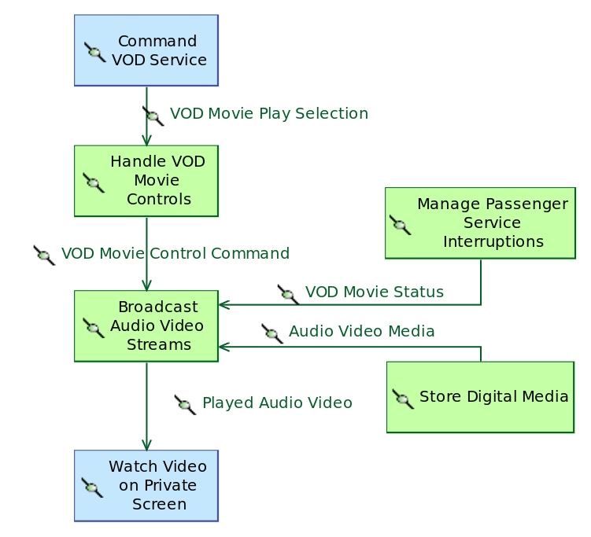

Description:

*No description*

Involved elements:

This functional chain involves the following elements:

| **Functional exchange** | **Source function** | **Target function** |
| --- | --- | --- |

|  |  |  |
| --- | --- | --- |
| VOD Movie Play Selection | **Command VOD Service** | **Handle VOD Movie Controls** |

|  |  |  |
| --- | --- | --- |
| Played Audio Video | **Broadcast Audio Video Streams** | **Watch Video on Private Screen** |

|  |  |  |
| --- | --- | --- |
| Audio Video Media | **Store Digital Media** | **Broadcast Audio Video Streams** |

|  |  |  |
| --- | --- | --- |
| VOD Movie Control Command | **Handle VOD Movie Controls** | **Broadcast Audio Video Streams** |

|  |  |  |
| --- | --- | --- |
| VOD Movie Status | **Manage Passenger Service Interruptions** | **Broadcast Audio Video Streams** |

Involving capabilities:

* **Provide Video Entertainment Services**

## Functional Chain : Resume VOD Movie

This functional chain is illustrated by the following diagram:

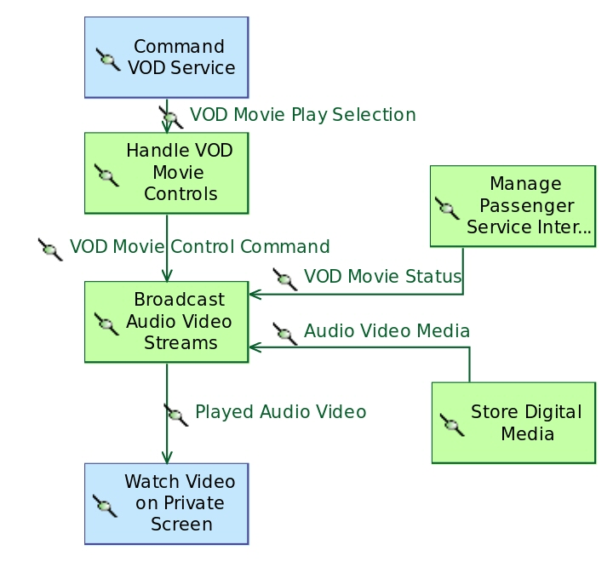

Description:

*No description*

Involved elements:

This functional chain involves the following elements:

| **Functional exchange** | **Source function** | **Target function** |
| --- | --- | --- |

|  |  |  |
| --- | --- | --- |
| VOD Movie Play Selection | **Command VOD Service** | **Handle VOD Movie Controls** |

|  |  |  |
| --- | --- | --- |
| Played Audio Video | **Broadcast Audio Video Streams** | **Watch Video on Private Screen** |

|  |  |  |
| --- | --- | --- |
| Audio Video Media | **Store Digital Media** | **Broadcast Audio Video Streams** |

|  |  |  |
| --- | --- | --- |
| VOD Movie Status | **Manage Passenger Service Interruptions** | **Broadcast Audio Video Streams** |

|  |  |  |
| --- | --- | --- |
| VOD Movie Control Command | **Handle VOD Movie Controls** | **Broadcast Audio Video Streams** |

Involving capabilities:

* **Provide Video Entertainment Services**

## Functional Chain : VOD Service Activation [NOT DONE]

Description:

*No description*

Involved elements:

*No involved elements*

Involving capabilities:

* **Provide Video Entertainment Services**

## Functional Chain : VOD Movie Interruption [NOT DONE]

Description:

*No description*

Involved elements:

*No involved elements*

Involving capabilities:

* **Provide Video Entertainment Services**

## Functional Chain : Stop VOD Movie[NOT DONE]

Description:

*No description*

Involved elements:

*No involved elements*

Involving capabilities:

* **Provide Video Entertainment Services**

# Description of Scenarios

## Scenario: [FS] Perform Audio Announcement

Description:

*No description*

Allocated capability:

* **Provide Audio and Video Intercommunication Means**

Representation:

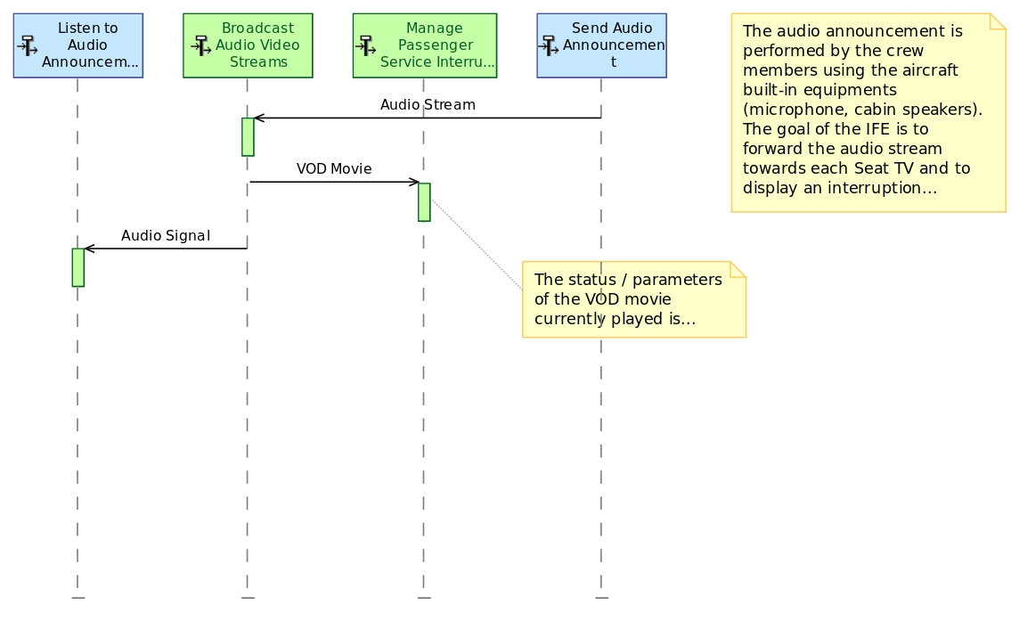

Owned messages:

* Audio Stream
* VOD Movie
* Audio Signal

## Scenario: [ES] Perform Audio Announcement

Description:

*No description*

Allocated capability:

* **Provide Audio and Video Intercommunication Means**

Representation:

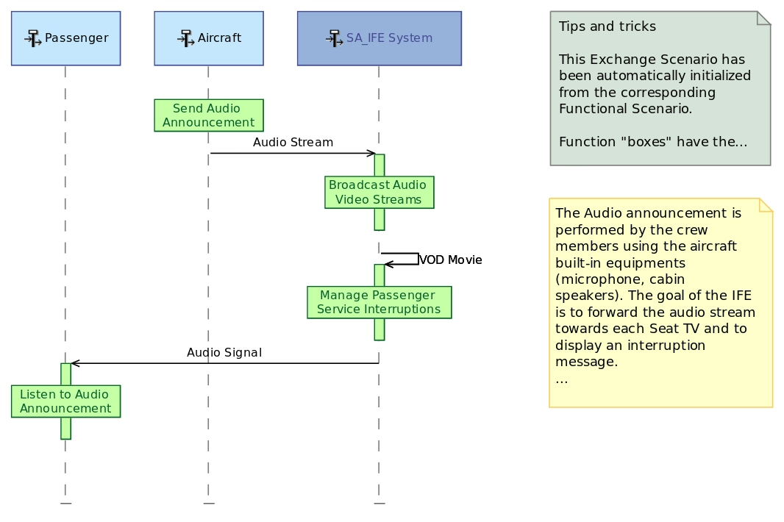

Owned messages:

* Audio Stream
* VOD Movie
* Audio Signal

## Scenario: [ES] Start VOD Service

Description:

*No description*

Allocated capability:

* **Provide Video Entertainment Services**

Representation:

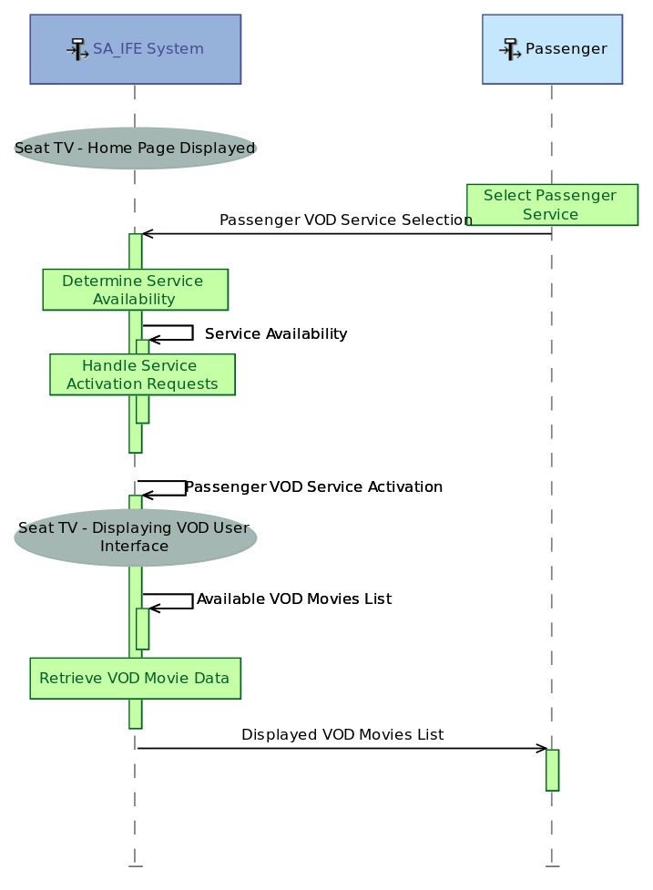

Owned messages:

* Passenger VOD Service Selection
* Service Availability
* Passenger VOD Service Activation
* Available VOD Movies List
* Displayed VOD Movies List

## Scenario: [ES] Start Playing VOD Movie

Description:

*No description*

Allocated capability:

* **Provide Video Entertainment Services**

Representation:

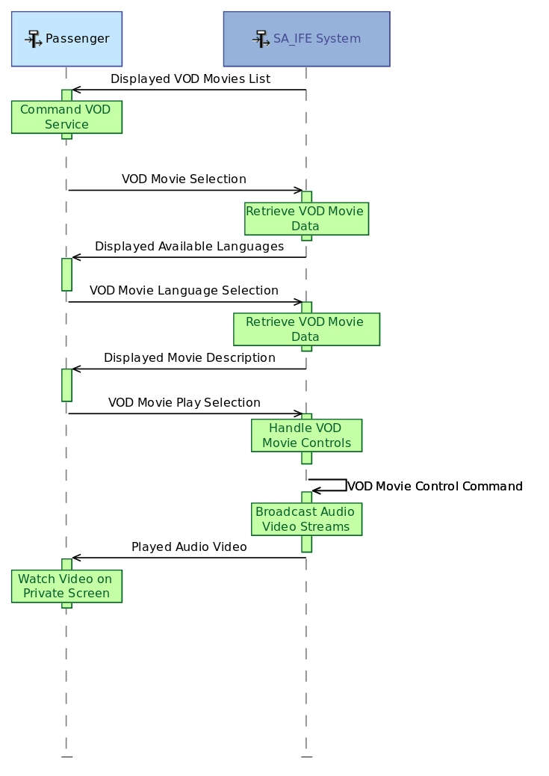

Owned messages:

* Displayed VOD Movies List
* VOD Movie Selection
* Displayed Available Languages
* VOD Movie Language Selection
* Displayed Movie Description
* VOD Movie Play Selection
* VOD Movie Control Command
* Played Audio Video

## Scenario: [FS] Determine Passenger Service Availability

Description:

*No description*

Allocated capability:

* **Provide Access Management Control**

Representation:

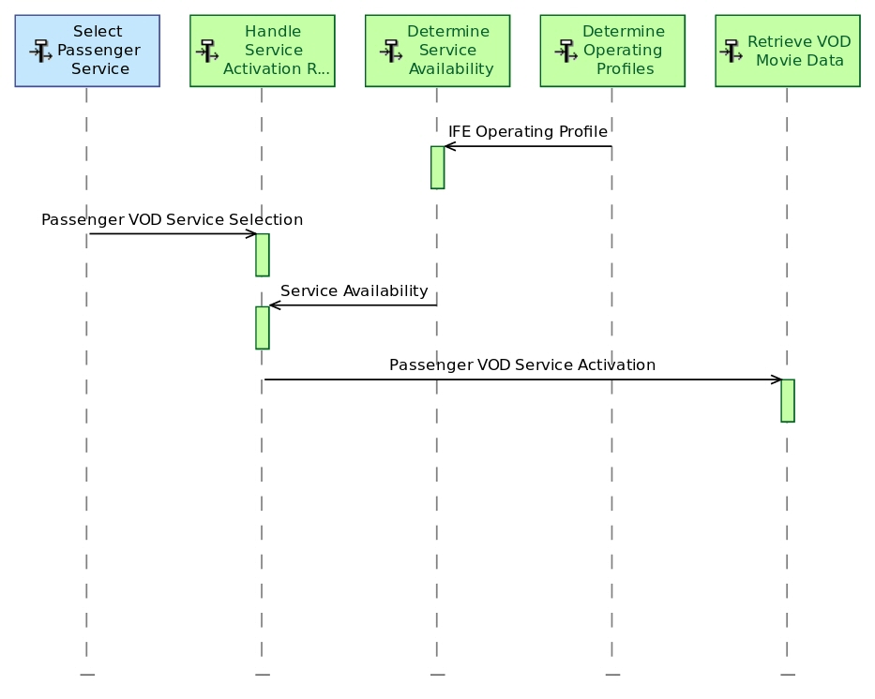

Owned messages:

* IFE Operating Profile
* Passenger VOD Service Selection
* Service Availability
* Passenger VOD Service Activation

## Scenario: [FS] Handle Cabin Decompression Event

Description:

*No description*

Allocated capability:

* **dangling reference for bookmark 5acd248a-3961-4e71-85a4-5bc3b775215fIntegrate Aircraft Constraints**

Representation:

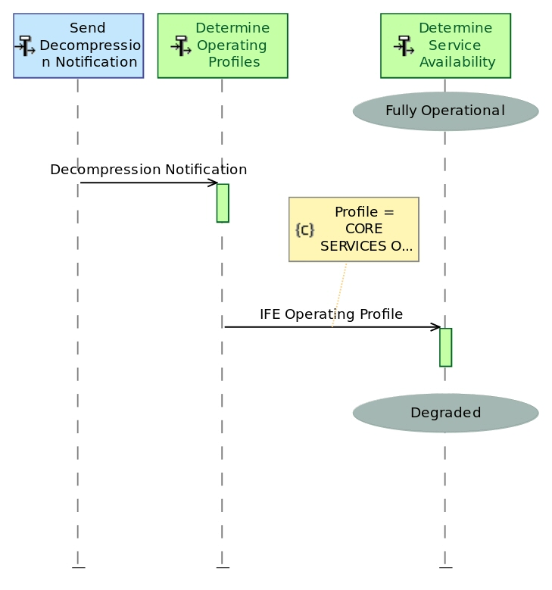

Owned messages:

* Decompression Notification
* IFE Operating Profile

# Data definition

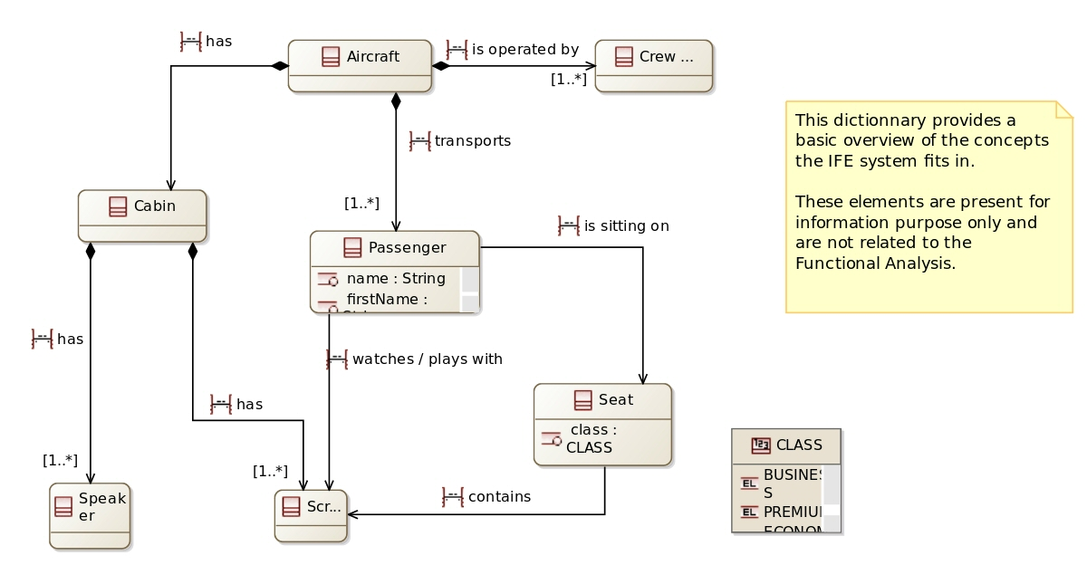

## Data

## Common

Data types definition:

* String
* Boolean

## BusinessEntity

Classes definition:

Seat

|  |  |
| --- | --- |
| **Contained property** | **Property type** |

|  |  |
| --- | --- |
| class | [CLASS] |

|  |  |
| --- | --- |
|  | [Screen] |

Passenger

|  |  |
| --- | --- |
| **Contained property** | **Property type** |

|  |  |
| --- | --- |
| seat | [Seat] |

|  |  |
| --- | --- |
| name | [String] |

|  |  |
| --- | --- |
| firstName | [String] |

|  |  |
| --- | --- |
|  | [Seat] |

|  |  |
| --- | --- |
|  | [Screen] |

Cabin

|  |  |
| --- | --- |
| **Contained property** | **Property type** |

|  |  |
| --- | --- |
| crew | [Crew Member] |

|  |  |
| --- | --- |
| passenger | [Passenger] |

|  |  |
| --- | --- |
|  | [Speaker] |

|  |  |
| --- | --- |
|  | [Screen] |

Aircraft

|  |  |
| --- | --- |
| **Contained property** | **Property type** |

|  |  |
| --- | --- |
| cabin | [Cabin] |

|  |  |
| --- | --- |
|  | [Cabin] |

|  |  |
| --- | --- |
|  | [Passenger] |

|  |  |
| --- | --- |
|  | [Crew Member] |

Crew Member

*No contained property*

Speaker

*No contained property*

Screen

*No contained property*

Data types definition:

* CLASS