Architecture File of In-Flight Entertainment System

Document generated automatically by M2Doc from Capella model of the system

# Table of Contents

# Descriptions of Logical Components

## Logical Component : IFE System

*No description*

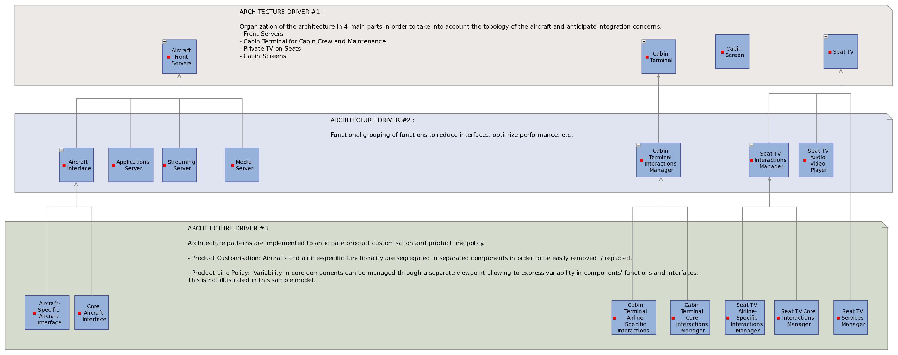

### Realizing system components:

* IFE System

### Realizing physical components:

* IFE System
* BEHAVIOURAL PCs

## Logical Component : Aircraft Front Servers

*No description*

### Realizing physical components:

* Aircraft Front Servers

## Logical Component : Aircraft Interface

*No description*

### Realizing physical components:

* Aircraft Interface SW

### Component Exchanges

|  |  |
| --- | --- |
| **Name** | Audio-Video Streams |
| **Direction** | INOUT |
| **Destination Component** | Aircraft |

*No description*

|  |  |
| --- | --- |
| **Name** | Aircraft Messages |
| **Direction** | IN |
| **Destination Component** | Aircraft |

*No description*

## Logical Component : Aircraft-Specific Aircraft Interface

*No description*

### Realizing physical components:

* Aircraft-Specific Aircraft Interface

### Allocated Functions

|  |  |
| --- | --- |
| **Function name** | **Description** |

|  |  |
| --- | --- |
| Capture Aircraft Notifications and Parameters | This function is concentrating the reception of the messages / notifications sent by the aircraft. The implementation of this function is likely to be specific to each aircraft model: The format of the incoming messages is defined by the aircraft manufacturer. |

|  |  |
| --- | --- |
| Forward Audio Stream to Aircraft Cabin Speakers | This function receives the audio track of imposed videos and forward them to the aircraft. The video part is played on the Cabin Screen through another dedicated function. |

|  |  |
| --- | --- |
| Acquire Audio Stream from Aircraft | Audio announcements are performed through the aricraft built-in sound system (microphone, speakers, etc.). The IFE system is responsible for dispatching these announcements to each Seat TV. This function receives the audio streams from the aircraft and forwards it to the IFE applicative server. The implementation of this function is likely to be specific to each aircraft. |

## Logical Component : Core Aircraft Interface

*No description*

### Realizing physical components:

* Core Aircraft Interface

### Allocated Functions

|  |  |
| --- | --- |
| **Function name** | **Description** |

|  |  |
| --- | --- |
| Determine Operating Profiles | Based on the notifications it receives from the function interfacing with the aircraft, this function computes the mode in which the IFE system has to operate. For example, if the aircraft sends a power reduction request, the IFE may switch to a downgraded mode. |

## Logical Component : Media Server

*No description*

### Realizing physical components:

* Media Server

### Allocated Functions

|  |  |
| --- | --- |
| **Function name** | **Description** |

|  |  |
| --- | --- |
| Load Digital Media | This function is responsible for receiving the media content uploaded by the ground operator and for moving it onto the IFE media storage unit. |

|  |  |
| --- | --- |
| Store Digital Media | This function is responsible for the storage of audio and video files that will be streamed and of movie information such as metadata (pictures,description). |

### Component Exchanges

|  |  |
| --- | --- |
| **Name** | Media Data |
| **Direction** | OUT |
| **Destination Component** | Seat TV Interactions Manager |

*No description*

|  |  |
| --- | --- |
| **Name** | Media Data |
| **Direction** | INOUT |
| **Destination Component** | Cabin Terminal Interactions Manager |

*No description*

## Logical Component : Streaming Server

*No description*

### Realizing physical components:

* Streaming Server

### Allocated Functions

|  |  |
| --- | --- |
| **Function name** | **Description** |

|  |  |
| --- | --- |
| Broadcast Audio Video Stream | This function consists in transmitting audio and video streams to one or several Seat TVs and or to the cabin screens. The implementation of this function is likely to be based on streaming solutions. |

|  |  |
| --- | --- |
| Prepare Broadcasts | Thiis function is responsible for preparing broadcast material: Retrieving the digital content to be broadcasted from the storage unit and transmitting information about the target(s) of the broadcast. |

### Component Exchanges

|  |  |
| --- | --- |
| **Name** | Streaming Protocol |
| **Direction** | OUT |
| **Destination Component** | Cabin Screen |

*No description*

|  |  |
| --- | --- |
| **Name** | Streaming Protocol |
| **Direction** | OUT |
| **Destination Component** | Seat TV Audio Video Player |

*No description*

|  |  |
| --- | --- |
| **Name** | Command and Status |
| **Direction** | INOUT |
| **Destination Component** | Cabin Terminal Interactions Manager |

*No description*

|  |  |
| --- | --- |
| **Name** | Commands |
| **Direction** | IN |
| **Destination Component** | Seat TV Interactions Manager |

*No description*

## Logical Component : Applications Server

*No description*

### Realizing physical components:

* Applications Server

### Allocated Functions

|  |  |
| --- | --- |
| **Function name** | **Description** |

|  |  |
| --- | --- |
| Determine Passenger Service Availability | This function is responsible for computing the availability of passenger services based on the authorization scheme (airline business strategy) and the aircraft contraints. |

|  |  |
| --- | --- |
| Process Audio Announcement | When an audio announcement is made (thoufh the aircraft equipment), the IFE system is responsible for forwarding the audio stream to all passengers. This function also triggers a passenger service interruption command |

### Component Exchanges

|  |  |
| --- | --- |
| **Name** | Service Management |
| **Direction** | INOUT |
| **Destination Component** | Seat TV Services Manager |

*No description*

|  |  |
| --- | --- |
| **Name** | Service Management |
| **Direction** | INOUT |
| **Destination Component** | Seat TV Interactions Manager |

*No description*

|  |  |
| --- | --- |
| **Name** | Streaming Protocol |
| **Direction** | OUT |
| **Destination Component** | Seat TV Audio Video Player |

*No description*

## Logical Component : Seat TV

*No description*

### Realizing physical components:

* PVDU SW

## Logical Component : Seat TV Interactions Manager

*No description*

### Realizing physical components:

* PVDU Interactions Manager

### Component Exchanges

|  |  |
| --- | --- |
| **Name** | Media Data |
| **Direction** | IN |
| **Destination Component** | Media Server |

*No description*

|  |  |
| --- | --- |
| **Name** | Service Management |
| **Direction** | INOUT |
| **Destination Component** | Applications Server |

*No description*

|  |  |
| --- | --- |
| **Name** | Commands |
| **Direction** | OUT |
| **Destination Component** | Streaming Server |

*No description*

## Logical Component : Seat TV Core Interactions Manager

*No description*

### Realizing physical components:

* PVDU Core Interactions Manager

### Allocated Functions

|  |  |
| --- | --- |
| **Function name** | **Description** |

|  |  |
| --- | --- |
| Retrieve VOD Movie Data | This function consists in receiving media information requests (list of VOD movies, available languages, etc.) and returning the data corresponding to these requests. This data is retrieved from the digital media storage unit. |

|  |  |
| --- | --- |
| Start/Resume Service | This function displays the available services and trigger service activations when applicable. |

|  |  |
| --- | --- |
| Process VOD Movie Controls | This function transforms the VOD Movie play/pause/stop selections into applicative commands. The information about which Seat TV is requesting is attached to the created command. |

|  |  |
| --- | --- |
| Handle VOD Service Activation and Interruption | This function is responsible for managing the VOD Service activations / deactivation (first activation, service resume, external interruption, etc.). This function relies on another function in charge of storing the current status of the interrupted / deactivated service (in particular, the current selection movie and the current position in this movie). |

## Logical Component : Seat TV Airline-Specific Interactions Manager

*No description*

### Realizing physical components:

* PVDU Airline-Specific Interactions Manager

### Allocated Functions

|  |  |
| --- | --- |
| **Function name** | **Description** |

|  |  |
| --- | --- |
| Capture VOD Selections | This function handles the interactions with the passenger in the VOD service. The Seat TV displays interaction widgets (typically buttons and slide bars). This typically airline-specifc, because user interface typically is. This function is responsible for capturing these selections and forwarding them to a more generic function (a controler) that will transform the selection into an internal system command. |

|  |  |
| --- | --- |
| Display Homepage on Seat TV | This function simply displays the Seat TV starting page, from where all services can be launched. |

|  |  |
| --- | --- |
| Display VOD Movie Data | This function is responsible for displaying all the VOD service information on the Seat TV. |

|  |  |
| --- | --- |
| Display Audio Interruption Screen on Seat TV | When an audio announcement is made, all IFE services on Seat TVs are interrupted. A message is then displayed on the screen, indicating that an audio annoucement is currently ongoing. |

|  |  |
| --- | --- |
| Capture Passenger Service Selection | This function handles the general interactions with the passenger. The Seat TV displays interaction widgets (typically buttons and slide bars). This typically airline-specifc, because user interface typically is. This function is responsible for capturing the selections of services and forwarding them to a more generic function (a controler) that will transform the selections into an internal system commands (activation / de-activation). |

## Logical Component : Seat TV Audio Video Player

*No description*

### Realizing physical components:

* PVDU Video Player

### Allocated Functions

|  |  |
| --- | --- |
| **Function name** | **Description** |

|  |  |
| --- | --- |
| Store Interrupted VOD Movie Status | This function is in charge of storing the current status of the interrupted / deactivated VOD service (in particular, the current selection movie and the current position in this movie). |

|  |  |
| --- | --- |
| Play Audio-Video Stream on Seat TV | This function receives a media stream (either synchronized video and audio either audio only) and restitutes it through the Seat TV. |

### Component Exchanges

|  |  |
| --- | --- |
| **Name** | Streaming Protocol |
| **Direction** | IN |
| **Destination Component** | Streaming Server |

*No description*

|  |  |
| --- | --- |
| **Name** | Streaming Protocol |
| **Direction** | IN |
| **Destination Component** | Applications Server |

*No description*

## Logical Component : Seat TV Services Manager

*No description*

### Realizing physical components:

* PVDU Services Manager

### Allocated Functions

|  |  |
| --- | --- |
| **Function name** | **Description** |

|  |  |
| --- | --- |
| Store Passenger Service State | Whenever a service is interrupted, its current state has to be saved, in order to be able to resume it later on in the same state. This function typically delegates this action to the functions directly responsible for running each passenger service. |

|  |  |
| --- | --- |
| Interrupt Current Service | This function is responsible for triggering passenger service interruptions as soon as an imposed video is played or an audio announcement is performed. When a VOD movie is running, this means for example that the movie as to be automatically paused and the current position stored. |

### Component Exchanges

|  |  |
| --- | --- |
| **Name** | Service Management |
| **Direction** | INOUT |
| **Destination Component** | Applications Server |

*No description*

|  |  |
| --- | --- |
| **Name** | Service Management |
| **Direction** | IN |
| **Destination Component** | Cabin Terminal Interactions Manager |

*No description*

## Logical Component : Cabin Screen

*No description*

### Realizing physical components:

* Cabin Video Unit SW

### Allocated Functions

|  |  |
| --- | --- |
| **Function name** | **Description** |

|  |  |
| --- | --- |
| Play Video Stream on Cabin Screen | This function receives a video stream and restitutes it through the Cabin screens. The audio track associated to the video is forwarded to the aircraft through another function. |

### Component Exchanges

|  |  |
| --- | --- |
| **Name** | Streaming Protocol |
| **Direction** | IN |
| **Destination Component** | Streaming Server |

*No description*

## Logical Component : Cabin Terminal

*No description*

### Realizing physical components:

* Central Management Unit SW

## Logical Component : Cabin Terminal Interactions Manager

*No description*

### Realizing physical components:

* CMU Interactions Manager

### Component Exchanges

|  |  |
| --- | --- |
| **Name** | Media Data |
| **Direction** | INOUT |
| **Destination Component** | Media Server |

*No description*

|  |  |
| --- | --- |
| **Name** | Command and Status |
| **Direction** | INOUT |
| **Destination Component** | Streaming Server |

*No description*

|  |  |
| --- | --- |
| **Name** | Service Management |
| **Direction** | OUT |
| **Destination Component** | Seat TV Services Manager |

*No description*

## Logical Component : Cabin Terminal Airline-Specific Interactions Manager

*No description*

### Realizing physical components:

* CMU Airline-Specific Interactions Manager

### Allocated Functions

|  |  |
| --- | --- |
| **Function name** | **Description** |

|  |  |
| --- | --- |
| Capture Imposed Video Selections | This function handles the interactions with the cabin crew on the cabin management terminal. The terminal displays interaction widgets (typically buttons and slide bars). This typically airline-specifc, because user interface typically is. This function is responsible for capturing these selections and forwarding them to a more generic function (a controler) that will transform the selection into an internal system command. |

|  |  |
| --- | --- |
| Display Imposed Video Playing Status on Cabin Terminal | This function is responsible for displaying the status of the currently running imposed movie (ETA, etc.) on the Cabin Management Terminal. |

|  |  |
| --- | --- |
| Display Imposed Video Data | This function is responsible for displaying all the imposed video data on the cabin management terminal. |

## Logical Component : Cabin Terminal Core Interactions Manager

*No description*

### Realizing physical components:

* CMU Core Interactions Manager

### Allocated Functions

|  |  |
| --- | --- |
| **Function name** | **Description** |

|  |  |
| --- | --- |
| Process Imposed Video Controls | This function transforms the Imposed Video play/pause/stop selections into applicative commands. |

|  |  |
| --- | --- |
| Retrieve Imposed Video Data | This function consists in receiving media information requests (list of imposed videos, available languages, etc.) and returning the data corresponding to these requests. This data is retrieved from the digital media storage unit. |

|  |  |
| --- | --- |
| Receive Imposed Video Playing Status | This function collects the status of the currently running imposed movie (ETA, etc.). This status is then transmitted to be displayed on the Cabin Management Terminal. |

## Logical Component : Passenger

*No description*

### Realizing system components:

* Passenger

### Realizing physical components:

* Passenger

### Allocated Functions

|  |  |
| --- | --- |
| **Function name** | **Description** |

|  |  |
| --- | --- |
| Select Passenger Service | This function covers the selection by the passenger of a given IFE service (gaming, moving-map, VOD, etc.). |

|  |  |
| --- | --- |
| Watch Movie on Private Screen | This function represents the fact that the passenger can watch a movie/video on a private screen (i.e. the in-seat TV). |

|  |  |
| --- | --- |
| Watch Imposed Movie on Cabin Screen | This function represents the fact that the passenger can watch a video on a cabin screen (typically located in the ceiling). |

|  |  |
| --- | --- |
| Command VOD Session | This function is dedicated to the interactions in the context of the VOD service: Selection of movies (and languages) and control on these movies (play, pause, stop, etc.). |

|  |  |
| --- | --- |
| Listen to Audio Announcement | Audio announcements are information about the flight provided by the cabin crew or the captain (boarding, pre-flight announcements, captain's announcements, safety briefing, turbulence, take-off/ascent, descent/final, landing, etc.). The passenger can listen to these annoucements aither through the aircraft speakers either through the individual Seat TVs. |

## Logical Component : Cabin Crew

*No description*

### Realizing system components:

* Cabin Crew

### Realizing physical components:

* Crew

### Allocated Functions

|  |  |
| --- | --- |
| **Function name** | **Description** |

|  |  |
| --- | --- |
| Command Airline-Imposed Video Broadcast | This function consists in triggering the play of pre-recorded airline videos. In particular, these imposed videos inclure pre-flight safety instructions (detailed explanation given before takeoff to airline passengers about the safety features of a commercial aircraft). Such imposed videos can also be commercial ads. |

|  |  |
| --- | --- |
| Launch Pre-Flight Tests and Analyze Results | This function consists in triggering a series of system auto-tests before each flight. |

## Logical Component : Aircraft

*No description*

### Realizing system components:

* Aircraft

### Realizing physical components:

* Aircraft

### Allocated Functions

|  |  |
| --- | --- |
| **Function name** | **Description** |

|  |  |
| --- | --- |
| Play Audio on Cabin Aircraft Speakers | This function receives digital audio streams and play them on the aricraft speakers. |

|  |  |
| --- | --- |
| Provide Satellite Communication Means | This function consists in providing satellite network, typically for telephony or in-cabin wifi systems. |

|  |  |
| --- | --- |
| Provide Navigation Data | Navigation is the determination of position and direction on or above the surface of the Earth. Avionics can use satellite-based systems (such as GPS and WAAS), ground-based systems (such as VOR or LORAN), or any combination thereof. The IFE system requires this data to run the moving-map service. |

|  |  |
| --- | --- |
| Send Audio Announcements | Audio announcements include: boarding, pre-flight announcements, captain's announcements, safety briefing, turbulence, take-off/ascent, descent/final, landing, etc. |

|  |  |
| --- | --- |
| Provide Exterior-View Videos | This functions relays the videos captured external cameras, typically located on the tail or the nose of the plane. |

|  |  |
| --- | --- |
| Provide Electrical Power | This function is responsible for providing power consumption profiles. According to different flying conditions and phases, the power made available to the IFE system may differ. |

|  |  |
| --- | --- |
| Send Decompression Notification | If ever a decompression occurs, a notification is sent to the IFE system (which will automatically swtich to "Halted" mode. |

### Component Exchanges

|  |  |
| --- | --- |
| **Name** | Audio-Video Streams |
| **Direction** | INOUT |
| **Destination Component** | Aircraft Interface |

*No description*

|  |  |
| --- | --- |
| **Name** | Aircraft Messages |
| **Direction** | OUT |
| **Destination Component** | Aircraft Interface |

*No description*

## Logical Component : Ground Operator

*No description*

### Realizing system components:

* Ground Operator

### Realizing physical components:

* Maintenance operator

### Allocated Functions

|  |  |
| --- | --- |
| **Function name** | **Description** |

|  |  |
| --- | --- |
| Configure the System | [Not covered in this version of the model] |

|  |  |
| --- | --- |
| Update Media Content | This function consists in updating the IFE media server with new content. Using a specific device, the ground operator can for example updload new movies/music and remove others. |

|  |  |
| --- | --- |
| Launch Tests and Analyze Results | [Not covered in the version of the model] This function consists in triggering system tests, typically during maintenance phases. |

|  |  |
| --- | --- |
| Set Passenger Service Authorization | The airline company may have specific business strategies: According to the class they are travelling in, passengers may benefit from different IFE services. This function consists in uploading a profile that describes the authorization schemes. |

# Descriptions of Logical Functions

## Function : Root Logical Function

Description:

*No description*

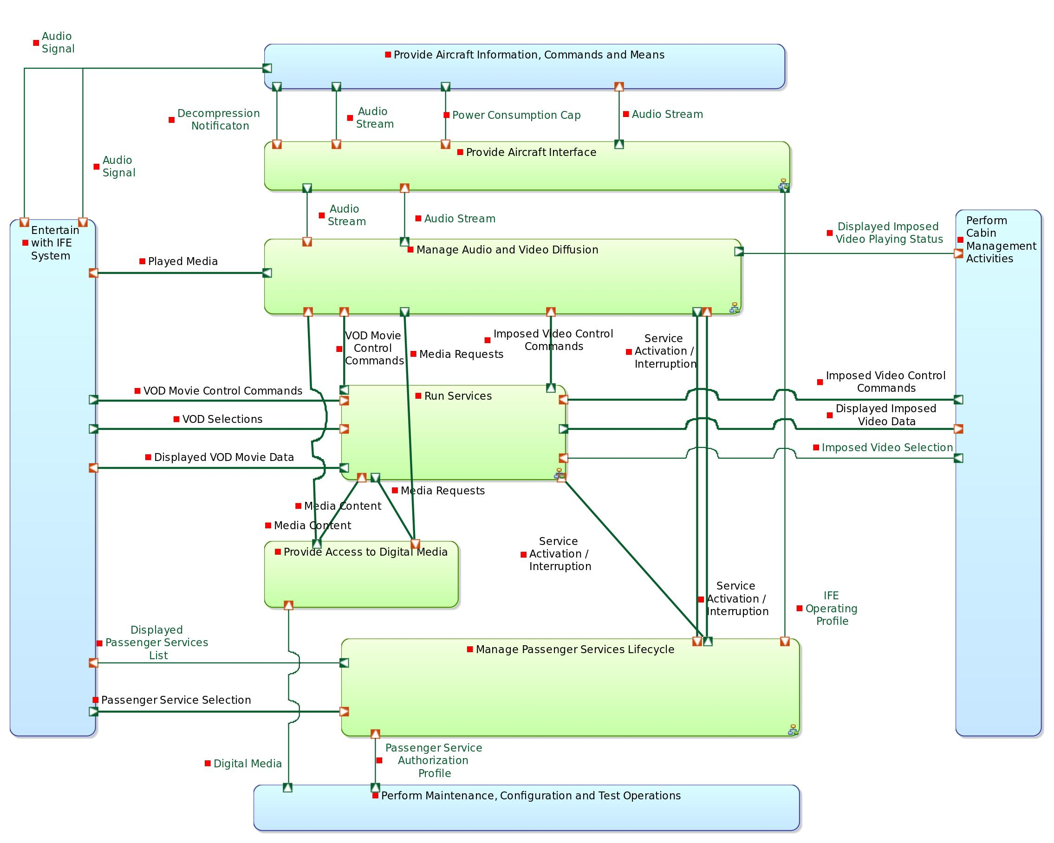

Parent / Children functions:

|  |  |  |
| --- | --- | --- |
| **Parent function** | **Current function** | **Children functions** |
| Logical Functions | Root Logical Function | * Perform Cabin Management Activities * Entertain with IFE System * Provide Aircraft Information, Commands and Means * Perform Maintenance, Configuration and Test Operations * IFE System |

List of inputs:

*No input*

List of outputs:

*No output*

Participation to functional chains:

*None*

Allocated to:

*Function not allocated*

## Function : Perform Cabin Management Activities

Description:

This function is a high-level function gathering all the what is performed by the ground operator actor.

Parent / Children functions:

|  |  |  |
| --- | --- | --- |
| **Parent function** | **Current function** | **Children functions** |
| Root Logical Function | Perform Cabin Management Activities | * Command Airline-Imposed Video Broadcast * Launch Pre-Flight Tests and Analyze Results |

List of inputs:

*No input*

List of outputs:

*No output*

Participation to functional chains:

*None*

Allocated to:

*Function not allocated*

## Function : Command Airline-Imposed Video Broadcast

Description:

This function consists in triggering the play of pre-recorded airline videos. In particular, these imposed videos inclure pre-flight safety instructions (detailed explanation given before takeoff to airline passengers about the safety features of a commercial aircraft). Such imposed videos can also be commercial ads.

Parent / Children functions:

|  |  |  |
| --- | --- | --- |
| **Parent function** | **Current function** | **Children functions** |
| Perform Cabin Management Activities | Command Airline-Imposed Video Broadcast | *No children function* |

List of inputs:

| **Incoming functional exchange** | **Exchanged items** |
| --- | --- |

|  |  |
| --- | --- |
| Displayed Imposed Video Description | *No exchanged item* |

|  |  |
| --- | --- |
| Displayed Imposed Videos List | *No exchanged item* |

|  |  |
| --- | --- |
| Displayed Imposed Video Playing Status | *No exchanged item* |

List of outputs:

| **Outgoing functional exchange** | **Exchanged items** |
| --- | --- |

|  |  |
| --- | --- |
| Imposed Video Play Selection | *No exchanged item* |

|  |  |
| --- | --- |
| Imposed Video Pause Selection | *No exchanged item* |

|  |  |
| --- | --- |
| Imposed Video Stop Selection | *No exchanged item* |

|  |  |
| --- | --- |
| Imposed Video Selection | *No exchanged item* |

Participation to functional chains:

* Watch Imposed Video on Cabin Screen
* Watch Imposed Video on Private Screen

Allocated to:

* Cabin Crew

## Function : Launch Pre-Flight Tests and Analyze Results

Description:

This function consists in triggering a series of system auto-tests before each flight.

Parent / Children functions:

|  |  |  |
| --- | --- | --- |
| **Parent function** | **Current function** | **Children functions** |
| Perform Cabin Management Activities | Launch Pre-Flight Tests and Analyze Results | *No children function* |

List of inputs:

*No input*

List of outputs:

*No output*

Participation to functional chains:

*None*

Allocated to:

* Cabin Crew

## Function : Entertain with IFE System

Description:

This function is a high-level function gathering all the what is performed by the passenger actor.

Parent / Children functions:

|  |  |  |
| --- | --- | --- |
| **Parent function** | **Current function** | **Children functions** |
| Root Logical Function | Entertain with IFE System | * Watch Movie on Private Screen * Watch Imposed Movie on Cabin Screen * Select Passenger Service * Command VOD Session * Listen to Audio Announcement |

List of inputs:

*No input*

List of outputs:

*No output*

Participation to functional chains:

*None*

Allocated to:

*Function not allocated*

## Function : Watch Movie on Private Screen

Description:

This function represents the fact that the passenger can watch a movie/video on a private screen (i.e. the in-seat TV).

Parent / Children functions:

|  |  |  |
| --- | --- | --- |
| **Parent function** | **Current function** | **Children functions** |
| Entertain with IFE System | Watch Movie on Private Screen | *No children function* |

List of inputs:

| **Incoming functional exchange** | **Exchanged items** |
| --- | --- |

|  |  |
| --- | --- |
| Played Audio Video | *No exchanged item* |

List of outputs:

*No output*

Participation to functional chains:

* Watch Imposed Video on Private Screen
* Start Playing VOD Movie
* Resume VOD Movie

Allocated to:

* Passenger

## Function : Watch Imposed Movie on Cabin Screen

Description:

This function represents the fact that the passenger can watch a video on a cabin screen (typically located in the ceiling).

Parent / Children functions:

|  |  |  |
| --- | --- | --- |
| **Parent function** | **Current function** | **Children functions** |
| Entertain with IFE System | Watch Imposed Movie on Cabin Screen | *No children function* |

List of inputs:

| **Incoming functional exchange** | **Exchanged items** |
| --- | --- |

|  |  |
| --- | --- |
| Audio Signal | *No exchanged item* |

|  |  |
| --- | --- |
| Played Video | *No exchanged item* |

List of outputs:

*No output*

Participation to functional chains:

* Watch Imposed Video on Cabin Screen

Allocated to:

* Passenger

## Function : Select Passenger Service

Description:

This function covers the selection by the passenger of a given IFE service (gaming, moving-map, VOD, etc.).

Parent / Children functions:

|  |  |  |
| --- | --- | --- |
| **Parent function** | **Current function** | **Children functions** |
| Entertain with IFE System | Select Passenger Service | *No children function* |

List of inputs:

| **Incoming functional exchange** | **Exchanged items** |
| --- | --- |

|  |  |
| --- | --- |
| Displayed Passenger Services List | *No exchanged item* |

List of outputs:

| **Outgoing functional exchange** | **Exchanged items** |
| --- | --- |

|  |  |
| --- | --- |
| VOD Service Selection | *No exchanged item* |

|  |  |
| --- | --- |
| Passenger Homepage Selection | *No exchanged item* |

Participation to functional chains:

*None*

Allocated to:

* Passenger

## Function : Command VOD Session

Description:

This function is dedicated to the interactions in the context of the VOD service: Selection of movies (and languages) and control on these movies (play, pause, stop, etc.).

Parent / Children functions:

|  |  |  |
| --- | --- | --- |
| **Parent function** | **Current function** | **Children functions** |
| Entertain with IFE System | Command VOD Session | *No children function* |

List of inputs:

| **Incoming functional exchange** | **Exchanged items** |
| --- | --- |

|  |  |
| --- | --- |
| Displayed Available Languages | *No exchanged item* |

|  |  |
| --- | --- |
| Displayed Movies List | *No exchanged item* |

|  |  |
| --- | --- |
| Displayed Movie Description | *No exchanged item* |

List of outputs:

| **Outgoing functional exchange** | **Exchanged items** |
| --- | --- |

|  |  |
| --- | --- |
| VOD Movie Stop Selection | *No exchanged item* |

|  |  |
| --- | --- |
| VOD Movie Play Selection | *No exchanged item* |

|  |  |
| --- | --- |
| VOD Movie Pause Selection | *No exchanged item* |

|  |  |
| --- | --- |
| VOD Movie Language Selection | *No exchanged item* |

|  |  |
| --- | --- |
| VOD Movie Selection | *No exchanged item* |

Participation to functional chains:

* Start Playing VOD Movie

Allocated to:

* Passenger

## Function : Listen to Audio Announcement

Description:

Audio announcements are information about the flight provided by the cabin crew or the captain (boarding, pre-flight announcements, captain's announcements, safety briefing, turbulence, take-off/ascent, descent/final, landing, etc.). The passenger can listen to these annoucements aither through the aircraft speakers either through the individual Seat TVs.

Parent / Children functions:

|  |  |  |
| --- | --- | --- |
| **Parent function** | **Current function** | **Children functions** |
| Entertain with IFE System | Listen to Audio Announcement | *No children function* |

List of inputs:

| **Incoming functional exchange** | **Exchanged items** |
| --- | --- |

|  |  |
| --- | --- |
| Audio Signal | *No exchanged item* |

|  |  |
| --- | --- |
| Displayed Audio Interruption Screen | *No exchanged item* |

|  |  |
| --- | --- |
| Audio Signal | *No exchanged item* |

List of outputs:

*No output*

Participation to functional chains:

* Broadcast Audio Announcement

Allocated to:

* Passenger

## Function : Provide Aircraft Information, Commands and Means

Description:

This function is a high-level function gathering all the what is performed by the aircraft actor.

Parent / Children functions:

|  |  |  |
| --- | --- | --- |
| **Parent function** | **Current function** | **Children functions** |
| Root Logical Function | Provide Aircraft Information, Commands and Means | * Provide Satellite Communication Means * Provide Navigation Data * Provide Electrical Power * Provide Exterior-View Videos * Send Audio Announcements * Play Audio on Cabin Aircraft Speakers * Send Decompression Notification |

List of inputs:

*No input*

List of outputs:

*No output*

Participation to functional chains:

*None*

Allocated to:

*Function not allocated*

## Function : Provide Satellite Communication Means

Description:

This function consists in providing satellite network, typically for telephony or in-cabin wifi systems.

Parent / Children functions:

|  |  |  |
| --- | --- | --- |
| **Parent function** | **Current function** | **Children functions** |
| Provide Aircraft Information, Commands and Means | Provide Satellite Communication Means | *No children function* |

List of inputs:

*No input*

List of outputs:

*No output*

Participation to functional chains:

*None*

Allocated to:

* Aircraft

## Function : Provide Navigation Data

Description:

Navigation is the determination of position and direction on or above the surface of the Earth. Avionics can use satellite-based systems (such as GPS and WAAS), ground-based systems (such as VOR or LORAN), or any combination thereof. The IFE system requires this data to run the moving-map service.

Parent / Children functions:

|  |  |  |
| --- | --- | --- |
| **Parent function** | **Current function** | **Children functions** |
| Provide Aircraft Information, Commands and Means | Provide Navigation Data | *No children function* |

List of inputs:

*No input*

List of outputs:

*No output*

Participation to functional chains:

*None*

Allocated to:

* Aircraft

## Function : Provide Electrical Power

Description:

This function is responsible for providing power consumption profiles. According to different flying conditions and phases, the power made available to the IFE system may differ.

Parent / Children functions:

|  |  |  |
| --- | --- | --- |
| **Parent function** | **Current function** | **Children functions** |
| Provide Aircraft Information, Commands and Means | Provide Electrical Power | *No children function* |

List of inputs:

*No input*

List of outputs:

| **Outgoing functional exchange** | **Exchanged items** |
| --- | --- |

|  |  |
| --- | --- |
| Power Consumption Cap | *No exchanged item* |

Participation to functional chains:

*None*

Allocated to:

* Aircraft

## Function : Provide Exterior-View Videos

Description:

This functions relays the videos captured external cameras, typically located on the tail or the nose of the plane.

Parent / Children functions:

|  |  |  |
| --- | --- | --- |
| **Parent function** | **Current function** | **Children functions** |
| Provide Aircraft Information, Commands and Means | Provide Exterior-View Videos | *No children function* |

List of inputs:

*No input*

List of outputs:

*No output*

Participation to functional chains:

*None*

Allocated to:

* Aircraft

## Function : Send Audio Announcements

Description:

Audio announcements include: boarding, pre-flight announcements, captain's announcements, safety briefing, turbulence, take-off/ascent, descent/final, landing, etc.

Parent / Children functions:

|  |  |  |
| --- | --- | --- |
| **Parent function** | **Current function** | **Children functions** |
| Provide Aircraft Information, Commands and Means | Send Audio Announcements | *No children function* |

List of inputs:

*No input*

List of outputs:

| **Outgoing functional exchange** | **Exchanged items** |
| --- | --- |

|  |  |
| --- | --- |
| Audio Stream | *No exchanged item* |

Participation to functional chains:

* Broadcast Audio Announcement

Allocated to:

* Aircraft

## Function : Play Audio on Cabin Aircraft Speakers

Description:

This function receives digital audio streams and play them on the aricraft speakers.

Parent / Children functions:

|  |  |  |
| --- | --- | --- |
| **Parent function** | **Current function** | **Children functions** |
| Provide Aircraft Information, Commands and Means | Play Audio on Cabin Aircraft Speakers | *No children function* |

List of inputs:

| **Incoming functional exchange** | **Exchanged items** |
| --- | --- |

|  |  |
| --- | --- |
| Audio Stream | *No exchanged item* |

List of outputs:

| **Outgoing functional exchange** | **Exchanged items** |
| --- | --- |

|  |  |
| --- | --- |
| Audio Signal | *No exchanged item* |

|  |  |
| --- | --- |
| Audio Signal | *No exchanged item* |

Participation to functional chains:

* Watch Imposed Video on Cabin Screen

Allocated to:

* Aircraft

## Function : Send Decompression Notification

Description:

If ever a decompression occurs, a notification is sent to the IFE system (which will automatically swtich to "Halted" mode.

Parent / Children functions:

|  |  |  |
| --- | --- | --- |
| **Parent function** | **Current function** | **Children functions** |
| Provide Aircraft Information, Commands and Means | Send Decompression Notification | *No children function* |

List of inputs:

*No input*

List of outputs:

| **Outgoing functional exchange** | **Exchanged items** |
| --- | --- |

|  |  |
| --- | --- |
| Decompression Notificaton | *No exchanged item* |

Participation to functional chains:

*None*

Allocated to:

* Aircraft

## Function : Perform Maintenance, Configuration and Test Operations

Description:

This function is a high-level function gathering all the what is performed by the aircraft actor.

Parent / Children functions:

|  |  |  |
| --- | --- | --- |
| **Parent function** | **Current function** | **Children functions** |
| Root Logical Function | Perform Maintenance, Configuration and Test Operations | * Update Media Content * Configure the System * Launch Tests and Analyze Results * Set Passenger Service Authorization |

List of inputs:

*No input*

List of outputs:

*No output*

Participation to functional chains:

*None*

Allocated to:

*Function not allocated*

## Function : Update Media Content

Description:

This function consists in updating the IFE media server with new content. Using a specific device, the ground operator can for example updload new movies/music and remove others.

Parent / Children functions:

|  |  |  |
| --- | --- | --- |
| **Parent function** | **Current function** | **Children functions** |
| Perform Maintenance, Configuration and Test Operations | Update Media Content | *No children function* |

List of inputs:

*No input*

List of outputs:

| **Outgoing functional exchange** | **Exchanged items** |
| --- | --- |

|  |  |
| --- | --- |
| Digital Media | *No exchanged item* |

Participation to functional chains:

*None*

Allocated to:

* Ground Operator

## Function : Configure the System

Description:

[Not covered in this version of the model]

Parent / Children functions:

|  |  |  |
| --- | --- | --- |
| **Parent function** | **Current function** | **Children functions** |
| Perform Maintenance, Configuration and Test Operations | Configure the System | *No children function* |

List of inputs:

*No input*

List of outputs:

*No output*

Participation to functional chains:

*None*

Allocated to:

* Ground Operator

## Function : Launch Tests and Analyze Results

Description:

[Not covered in the version of the model] This function consists in triggering system tests, typically during maintenance phases.

Parent / Children functions:

|  |  |  |
| --- | --- | --- |
| **Parent function** | **Current function** | **Children functions** |
| Perform Maintenance, Configuration and Test Operations | Launch Tests and Analyze Results | *No children function* |

List of inputs:

*No input*

List of outputs:

*No output*

Participation to functional chains:

*None*

Allocated to:

* Ground Operator

## Function : Set Passenger Service Authorization

Description:

The airline company may have specific business strategies: According to the class they are travelling in, passengers may benefit from different IFE services. This function consists in uploading a profile that describes the authorization schemes.

Parent / Children functions:

|  |  |  |
| --- | --- | --- |
| **Parent function** | **Current function** | **Children functions** |
| Perform Maintenance, Configuration and Test Operations | Set Passenger Service Authorization | *No children function* |

List of inputs:

*No input*

List of outputs:

| **Outgoing functional exchange** | **Exchanged items** |
| --- | --- |

|  |  |
| --- | --- |
| Passenger Service Authorization Profile | *No exchanged item* |

Participation to functional chains:

*None*

Allocated to:

* Ground Operator

## Function : IFE System

Description:

This function is a high-level function gathering all the what is performed by the IFE system.

Parent / Children functions:

|  |  |  |
| --- | --- | --- |
| **Parent function** | **Current function** | **Children functions** |
| Root Logical Function | IFE System | * Provide Aircraft Interface * Provide Access to Digital Media * Manage Audio and Video Diffusion * Run Services * Manage Passenger Services Lifecycle |

List of inputs:

*No input*

List of outputs:

*No output*

Participation to functional chains:

*None*

Allocated to:

*Function not allocated*

## Function : Provide Aircraft Interface

Description:

This functions regroups all the functions that interact directly with the aircraft.

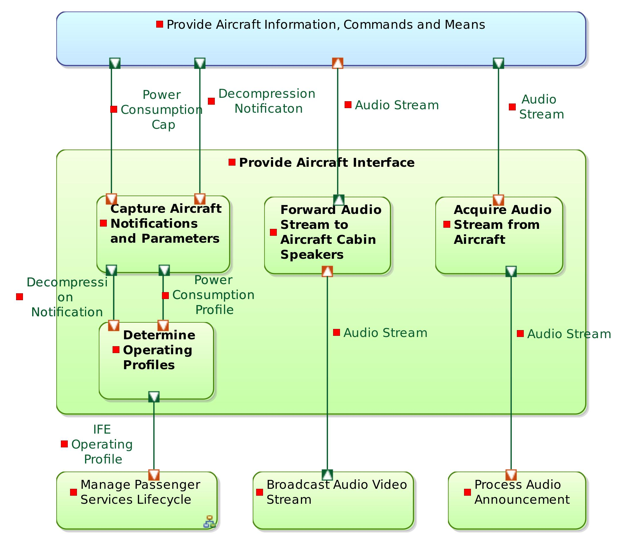

Parent / Children functions:

|  |  |  |
| --- | --- | --- |
| **Parent function** | **Current function** | **Children functions** |
| IFE System | Provide Aircraft Interface | * Capture Aircraft Notifications and Parameters * Determine Operating Profiles * Acquire Audio Stream from Aircraft * Forward Audio Stream to Aircraft Cabin Speakers |

List of inputs:

*No input*

List of outputs:

*No output*

Participation to functional chains:

*None*

Allocated to:

*Function not allocated*

## Function : Capture Aircraft Notifications and Parameters

Description:

This function is concentrating the reception of the messages / notifications sent by the aircraft. The implementation of this function is likely to be specific to each aircraft model: The format of the incoming messages is defined by the aircraft manufacturer.

Parent / Children functions:

|  |  |  |
| --- | --- | --- |
| **Parent function** | **Current function** | **Children functions** |
| Provide Aircraft Interface | Capture Aircraft Notifications and Parameters | *No children function* |

List of inputs:

| **Incoming functional exchange** | **Exchanged items** |
| --- | --- |

|  |  |
| --- | --- |
| Power Consumption Cap | *No exchanged item* |

|  |  |
| --- | --- |
| Decompression Notificaton | *No exchanged item* |

List of outputs:

| **Outgoing functional exchange** | **Exchanged items** |
| --- | --- |

|  |  |
| --- | --- |
| Decompression Notification | *No exchanged item* |

|  |  |
| --- | --- |
| Power Consumption Profile | *No exchanged item* |

Participation to functional chains:

*None*

Allocated to:

* Aircraft-Specific Aircraft Interface

## Function : Determine Operating Profiles

Description:

Based on the notifications it receives from the function interfacing with the aircraft, this function computes the mode in which the IFE system has to operate. For example, if the aircraft sends a power reduction request, the IFE may switch to a downgraded mode.

Parent / Children functions:

|  |  |  |
| --- | --- | --- |
| **Parent function** | **Current function** | **Children functions** |
| Provide Aircraft Interface | Determine Operating Profiles | *No children function* |

List of inputs:

| **Incoming functional exchange** | **Exchanged items** |
| --- | --- |

|  |  |
| --- | --- |
| Decompression Notification | *No exchanged item* |

|  |  |
| --- | --- |
| Power Consumption Profile | *No exchanged item* |

List of outputs:

| **Outgoing functional exchange** | **Exchanged items** |
| --- | --- |

|  |  |
| --- | --- |
| IFE Operating Profile | *No exchanged item* |

Participation to functional chains:

*None*

Allocated to:

* Core Aircraft Interface

## Function : Acquire Audio Stream from Aircraft

Description:

Audio announcements are performed through the aricraft built-in sound system (microphone, speakers, etc.). The IFE system is responsible for dispatching these announcements to each Seat TV. This function receives the audio streams from the aircraft and forwards it to the IFE applicative server. The implementation of this function is likely to be specific to each aircraft.

Parent / Children functions:

|  |  |  |
| --- | --- | --- |
| **Parent function** | **Current function** | **Children functions** |
| Provide Aircraft Interface | Acquire Audio Stream from Aircraft | *No children function* |

List of inputs:

| **Incoming functional exchange** | **Exchanged items** |
| --- | --- |

|  |  |
| --- | --- |
| Audio Stream | *No exchanged item* |

List of outputs:

| **Outgoing functional exchange** | **Exchanged items** |
| --- | --- |

|  |  |
| --- | --- |
| Audio Stream | *No exchanged item* |

Participation to functional chains:

* Broadcast Audio Announcement

Allocated to:

* Aircraft-Specific Aircraft Interface

## Function : Forward Audio Stream to Aircraft Cabin Speakers

Description:

This function receives the audio track of imposed videos and forward them to the aircraft. The video part is played on the Cabin Screen through another dedicated function.

Parent / Children functions:

|  |  |  |
| --- | --- | --- |
| **Parent function** | **Current function** | **Children functions** |
| Provide Aircraft Interface | Forward Audio Stream to Aircraft Cabin Speakers | *No children function* |

List of inputs:

| **Incoming functional exchange** | **Exchanged items** |
| --- | --- |

|  |  |
| --- | --- |
| Audio Stream | *No exchanged item* |

List of outputs:

| **Outgoing functional exchange** | **Exchanged items** |
| --- | --- |

|  |  |
| --- | --- |
| Audio Stream | *No exchanged item* |

Participation to functional chains:

* Watch Imposed Video on Cabin Screen

Allocated to:

* Aircraft-Specific Aircraft Interface

## Function : Provide Access to Digital Media

Description:

This functions gathers the functions related to the management of the digital media content of the IFE: load and storage.

Parent / Children functions:

|  |  |  |
| --- | --- | --- |
| **Parent function** | **Current function** | **Children functions** |
| IFE System | Provide Access to Digital Media | * Load Digital Media * Store Digital Media |

List of inputs:

*No input*

List of outputs:

*No output*

Participation to functional chains:

*None*

Allocated to:

*Function not allocated*

## Function : Load Digital Media

Description:

This function is responsible for receiving the media content uploaded by the ground operator and for moving it onto the IFE media storage unit.

Parent / Children functions:

|  |  |  |
| --- | --- | --- |
| **Parent function** | **Current function** | **Children functions** |
| Provide Access to Digital Media | Load Digital Media | *No children function* |

List of inputs:

| **Incoming functional exchange** | **Exchanged items** |
| --- | --- |

|  |  |
| --- | --- |
| Digital Media | *No exchanged item* |

List of outputs:

| **Outgoing functional exchange** | **Exchanged items** |
| --- | --- |

|  |  |
| --- | --- |
| Digital Media | *No exchanged item* |

Participation to functional chains:

*None*

Allocated to:

* Media Server

## Function : Store Digital Media

Description:

This function is responsible for the storage of audio and video files that will be streamed and of movie information such as metadata (pictures,description).

Parent / Children functions:

|  |  |  |
| --- | --- | --- |
| **Parent function** | **Current function** | **Children functions** |
| Provide Access to Digital Media | Store Digital Media | *No children function* |

List of inputs:

| **Incoming functional exchange** | **Exchanged items** |
| --- | --- |

|  |  |
| --- | --- |
| Media IDs | *No exchanged item* |

|  |  |
| --- | --- |
| Media Content Request | *No exchanged item* |

|  |  |
| --- | --- |
| Media Content Request | *No exchanged item* |

|  |  |
| --- | --- |
| Digital Media | *No exchanged item* |

List of outputs:

| **Outgoing functional exchange** | **Exchanged items** |
| --- | --- |

|  |  |
| --- | --- |
| Media Files | * Media Files |

|  |  |
| --- | --- |
| VOD Movies List | *No exchanged item* |

|  |  |
| --- | --- |
| VOD Movie Data | *No exchanged item* |

|  |  |
| --- | --- |
| Imposed Video Data | *No exchanged item* |

|  |  |
| --- | --- |
| Imposed Video List | *No exchanged item* |

Participation to functional chains:

* Watch Imposed Video on Cabin Screen
* Watch Imposed Video on Private Screen
* Start Playing VOD Movie
* Resume VOD Movie

Allocated to:

* Media Server

## Function : Manage Audio and Video Diffusion

Description:

This function is responsible for broadcasting audio and video streams, should they be VOD movies, imposed videos, on-demand or imposed music. This function also covers the transmission of audio announcements (coming from the aircraft) and the IFE passenger service interruptions triggered by these announcements.

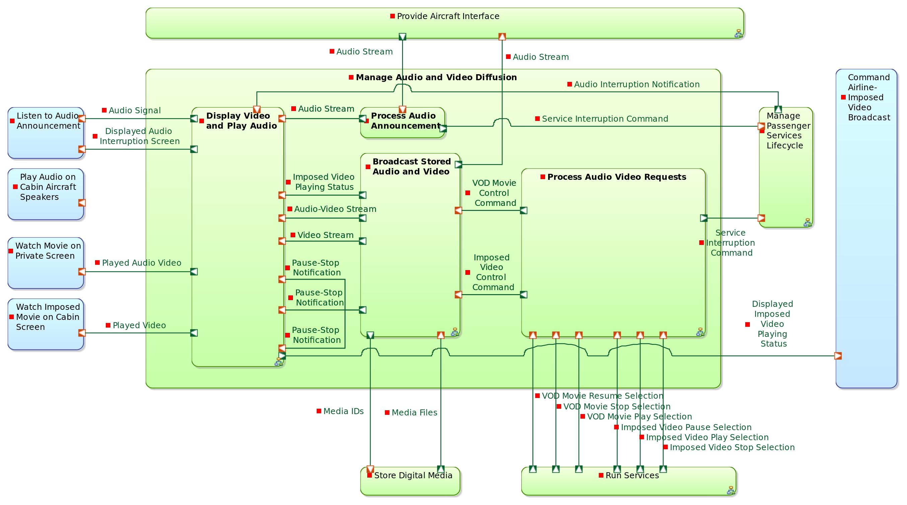

Parent / Children functions:

|  |  |  |
| --- | --- | --- |
| **Parent function** | **Current function** | **Children functions** |
| IFE System | Manage Audio and Video Diffusion | * Process Audio Video Requests * Broadcast Stored Audio and Video * Display Video and Play Audio * Process Audio Announcement |

List of inputs:

*No input*

List of outputs:

*No output*

Participation to functional chains:

*None*

Allocated to:

*Function not allocated*

## Function : Process Audio Video Requests

Description:

This function groups sub functions that are responsible for tranforming the end-user (passenger, cabin crew) selections in applicative commands.

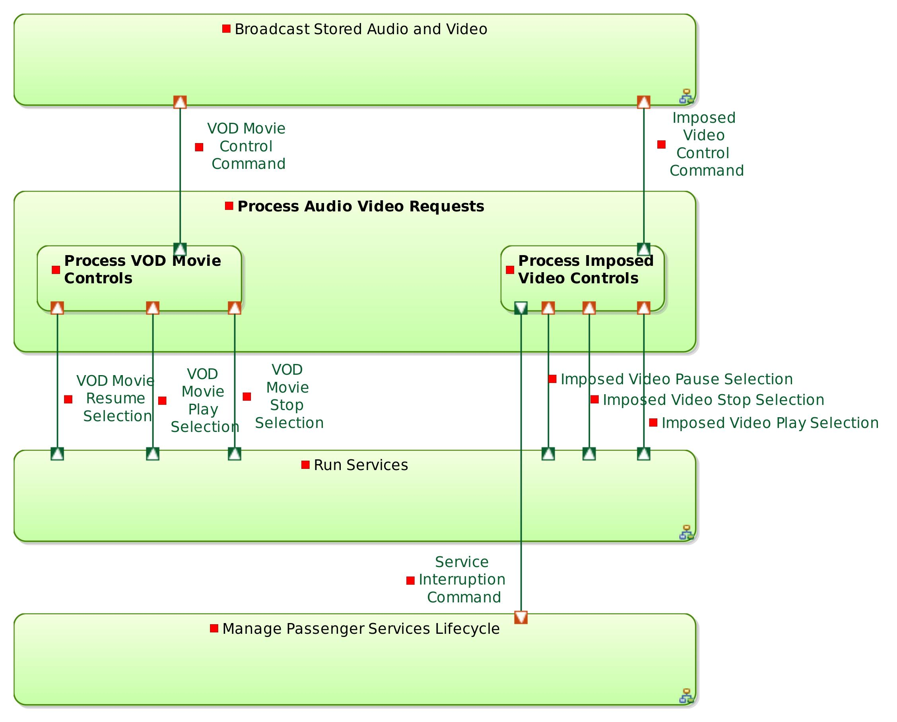

Parent / Children functions:

|  |  |  |
| --- | --- | --- |
| **Parent function** | **Current function** | **Children functions** |
| Manage Audio and Video Diffusion | Process Audio Video Requests | * Process VOD Movie Controls * Process Imposed Video Controls |

List of inputs:

*No input*

List of outputs:

*No output*

Participation to functional chains:

*None*

Allocated to:

*Function not allocated*

## Function : Process VOD Movie Controls

Description:

This function transforms the VOD Movie play/pause/stop selections into applicative commands. The information about which Seat TV is requesting is attached to the created command.

Parent / Children functions:

|  |  |  |
| --- | --- | --- |
| **Parent function** | **Current function** | **Children functions** |
| Process Audio Video Requests | Process VOD Movie Controls | *No children function* |

List of inputs:

| **Incoming functional exchange** | **Exchanged items** |
| --- | --- |

|  |  |
| --- | --- |
| VOD Movie Resume Selection | *No exchanged item* |

|  |  |
| --- | --- |
| VOD Movie Stop Selection | *No exchanged item* |

|  |  |
| --- | --- |
| VOD Movie Play Selection | * Passenger Selection |

List of outputs:

| **Outgoing functional exchange** | **Exchanged items** |
| --- | --- |

|  |  |
| --- | --- |
| VOD Movie Control Command | * VOD Control Command |

Participation to functional chains:

* Start Playing VOD Movie
* Resume VOD Movie

Allocated to:

* Seat TV Core Interactions Manager

## Function : Process Imposed Video Controls

Description:

This function transforms the Imposed Video play/pause/stop selections into applicative commands.

Parent / Children functions:

|  |  |  |
| --- | --- | --- |
| **Parent function** | **Current function** | **Children functions** |
| Process Audio Video Requests | Process Imposed Video Controls | *No children function* |

List of inputs:

| **Incoming functional exchange** | **Exchanged items** |
| --- | --- |

|  |  |
| --- | --- |
| Imposed Video Play Selection | *No exchanged item* |

|  |  |
| --- | --- |
| Imposed Video Stop Selection | *No exchanged item* |

|  |  |
| --- | --- |
| Imposed Video Pause Selection | *No exchanged item* |

List of outputs:

| **Outgoing functional exchange** | **Exchanged items** |
| --- | --- |

|  |  |
| --- | --- |
| Imposed Video Control Command | * Imposed Video Control Command |

|  |  |
| --- | --- |
| Service Interruption Command | *No exchanged item* |

Participation to functional chains:

* Watch Imposed Video on Cabin Screen
* Watch Imposed Video on Private Screen

Allocated to:

* Cabin Terminal Core Interactions Manager

## Function : Broadcast Stored Audio and Video

Description:

This function is responsible for broadcasting existing audio and video media. Transmitting audio and video streams means:

- Sending them to each passenger (on Seat TVs)

- Sending them to the cabin screens

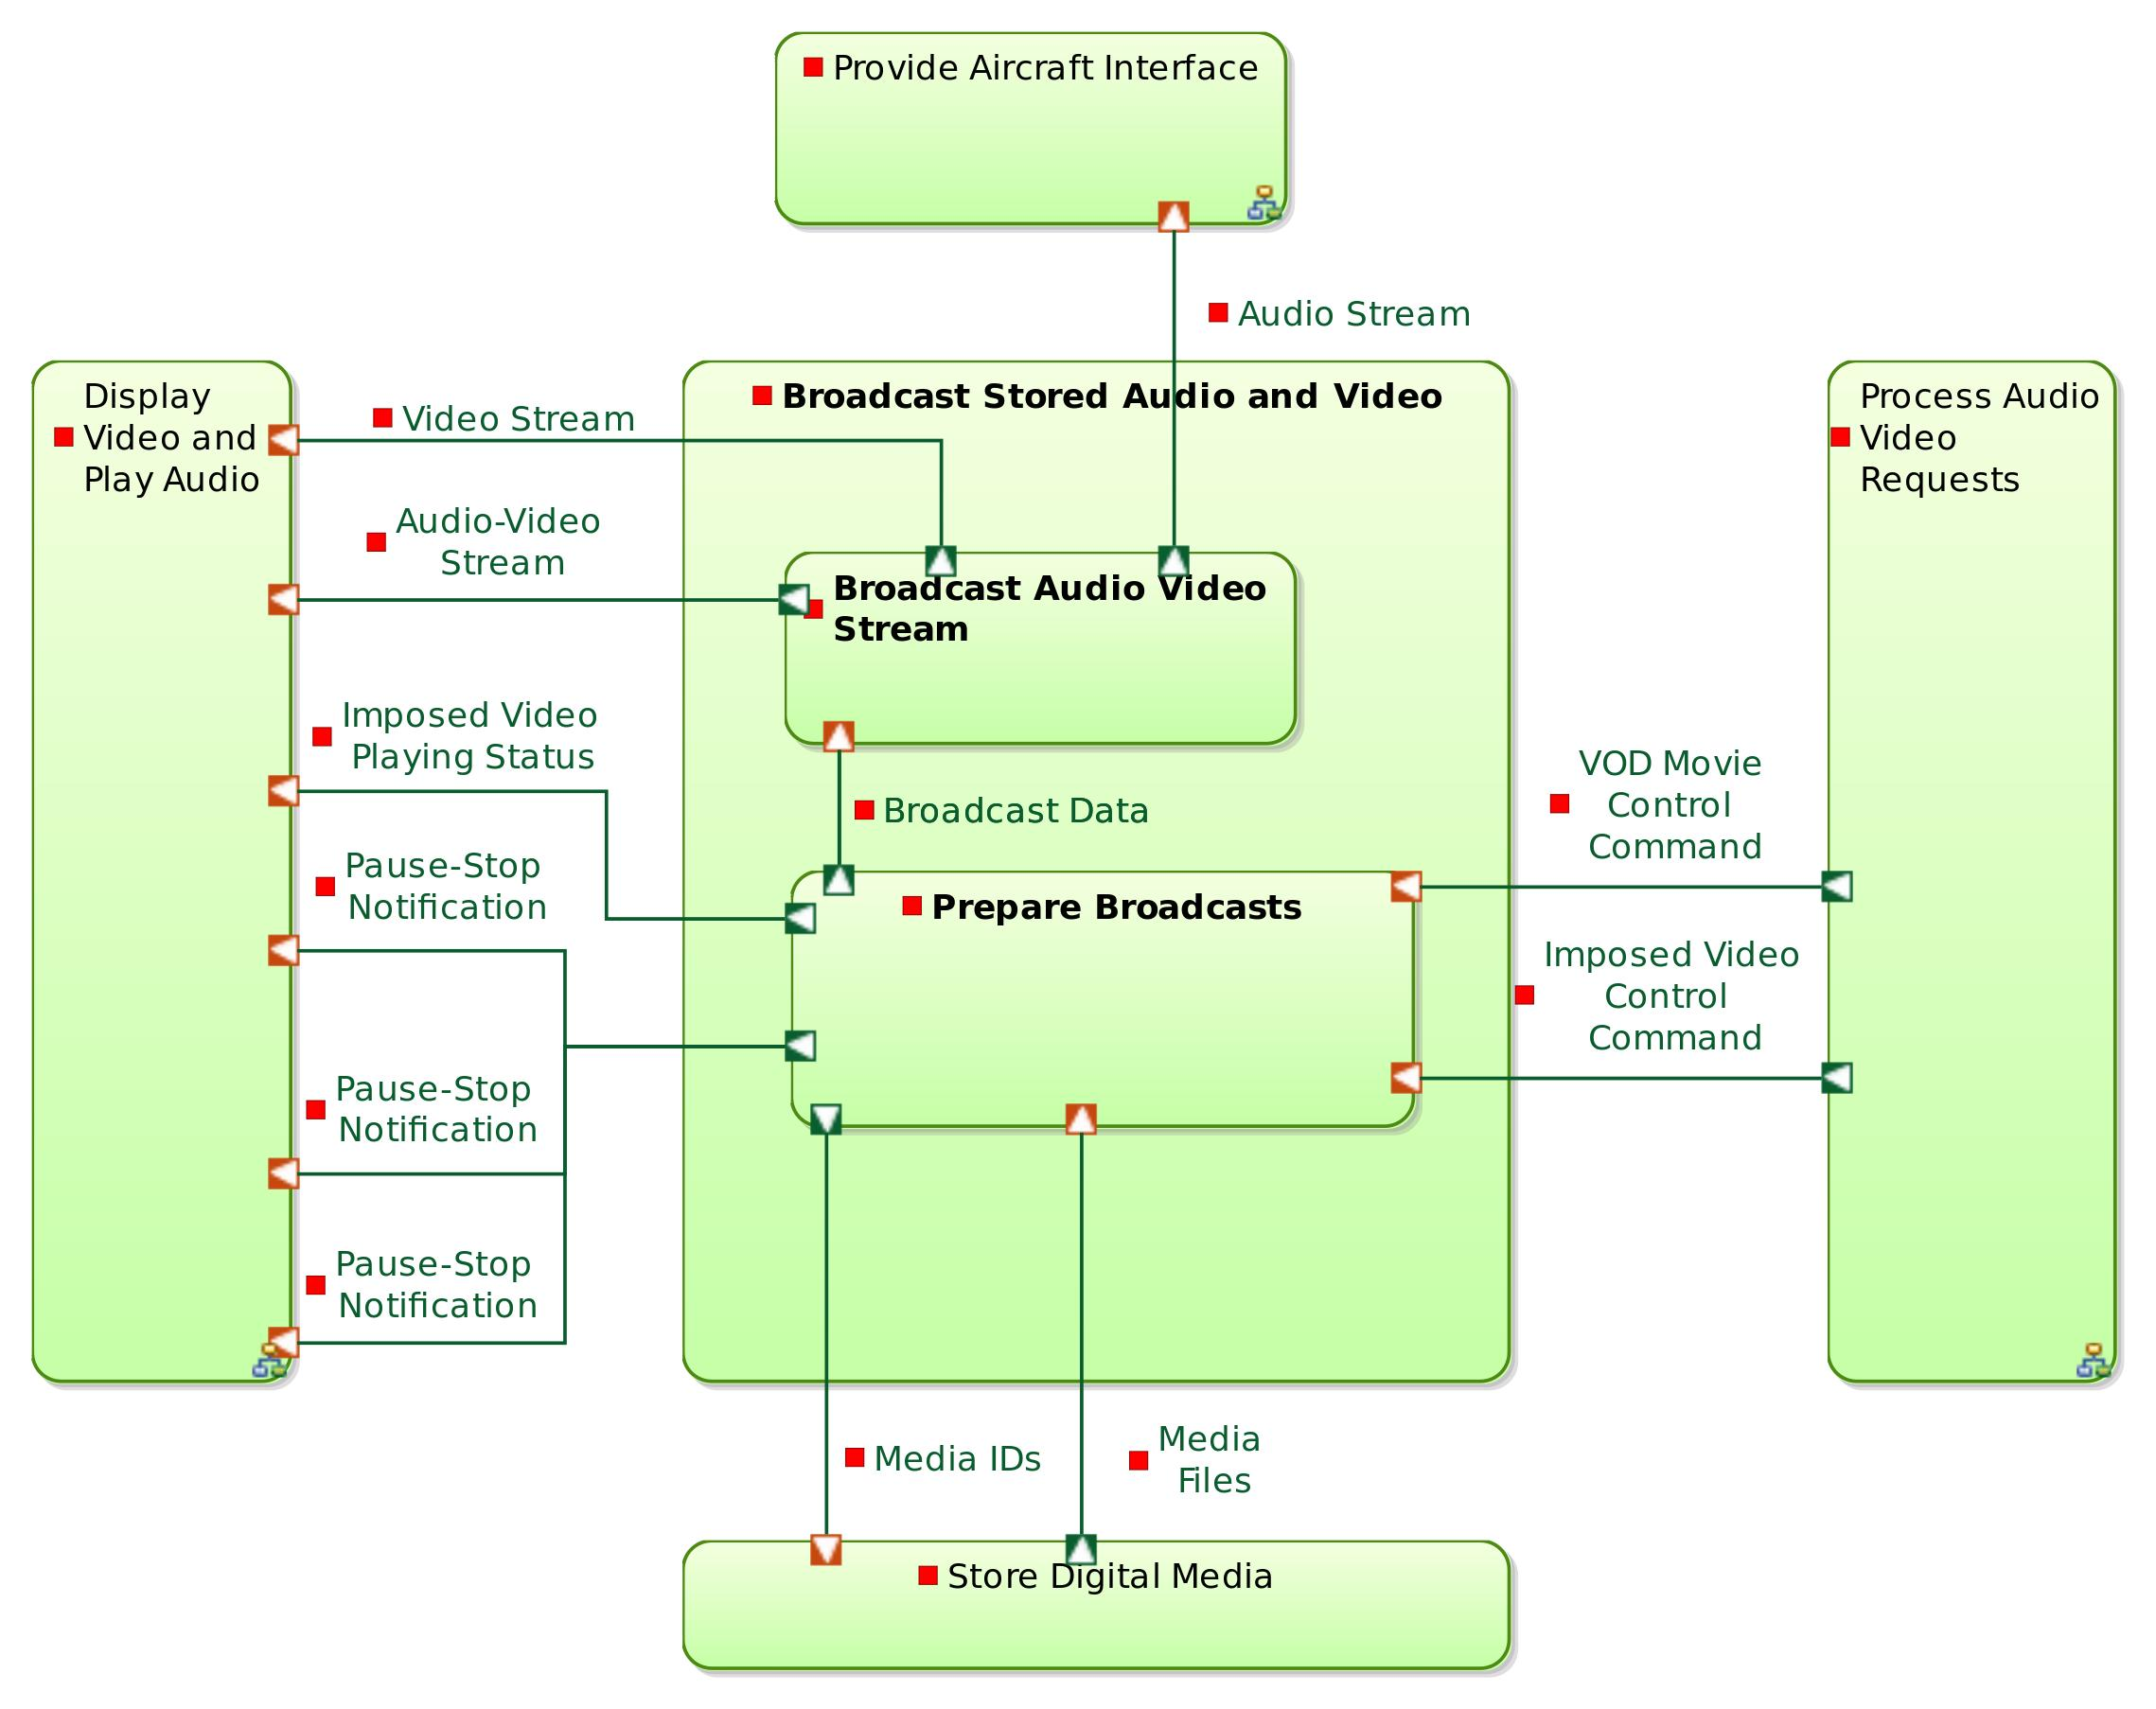

Parent / Children functions:

|  |  |  |
| --- | --- | --- |
| **Parent function** | **Current function** | **Children functions** |
| Manage Audio and Video Diffusion | Broadcast Stored Audio and Video | * Broadcast Audio Video Stream * Prepare Broadcasts |

List of inputs:

*No input*

List of outputs:

*No output*

Participation to functional chains:

*None*

Allocated to:

*Function not allocated*

## Function : Broadcast Audio Video Stream

Description:

This function consists in transmitting audio and video streams to one or several Seat TVs and or to the cabin screens. The implementation of this function is likely to be based on streaming solutions.

Parent / Children functions:

|  |  |  |
| --- | --- | --- |
| **Parent function** | **Current function** | **Children functions** |
| Broadcast Stored Audio and Video | Broadcast Audio Video Stream | *No children function* |

List of inputs:

| **Incoming functional exchange** | **Exchanged items** |
| --- | --- |

|  |  |
| --- | --- |
| Broadcast Data | * Audio-Video Broadcast Data |

List of outputs:

| **Outgoing functional exchange** | **Exchanged items** |
| --- | --- |

|  |  |
| --- | --- |
| Audio-Video Stream | * Audio-Video Stream |

|  |  |
| --- | --- |
| Video Stream | *No exchanged item* |

|  |  |
| --- | --- |
| Audio Stream | *No exchanged item* |

Participation to functional chains:

* Watch Imposed Video on Cabin Screen
* Watch Imposed Video on Private Screen
* Start Playing VOD Movie
* Resume VOD Movie

Allocated to:

* Streaming Server

## Function : Prepare Broadcasts

Description:

Thiis function is responsible for preparing broadcast material: Retrieving the digital content to be broadcasted from the storage unit and transmitting information about the target(s) of the broadcast.

Parent / Children functions:

|  |  |  |
| --- | --- | --- |
| **Parent function** | **Current function** | **Children functions** |
| Broadcast Stored Audio and Video | Prepare Broadcasts | *No children function* |

List of inputs:

| **Incoming functional exchange** | **Exchanged items** |
| --- | --- |

|  |  |
| --- | --- |
| Media Files | * Media Files |

|  |  |
| --- | --- |
| Imposed Video Control Command | * Imposed Video Control Command |

|  |  |
| --- | --- |
| VOD Movie Control Command | * VOD Control Command |

List of outputs:

| **Outgoing functional exchange** | **Exchanged items** |
| --- | --- |

|  |  |
| --- | --- |
| Broadcast Data | * Audio-Video Broadcast Data |

|  |  |
| --- | --- |
| Media IDs | *No exchanged item* |

|  |  |
| --- | --- |
| Imposed Video Playing Status | *No exchanged item* |

|  |  |
| --- | --- |
| Pause-Stop Notification | *No exchanged item* |

|  |  |
| --- | --- |
| Pause-Stop Notification | *No exchanged item* |

|  |  |
| --- | --- |
| Pause-Stop Notification | *No exchanged item* |

Participation to functional chains:

* Watch Imposed Video on Cabin Screen
* Watch Imposed Video on Private Screen
* Start Playing VOD Movie
* Resume VOD Movie

Allocated to:

* Streaming Server

## Function : Display Video and Play Audio

Description:

This function aggregates different display and media playing functions, which are typically allocated to different equiments: Seat TVs, Cabin Screens, etc.

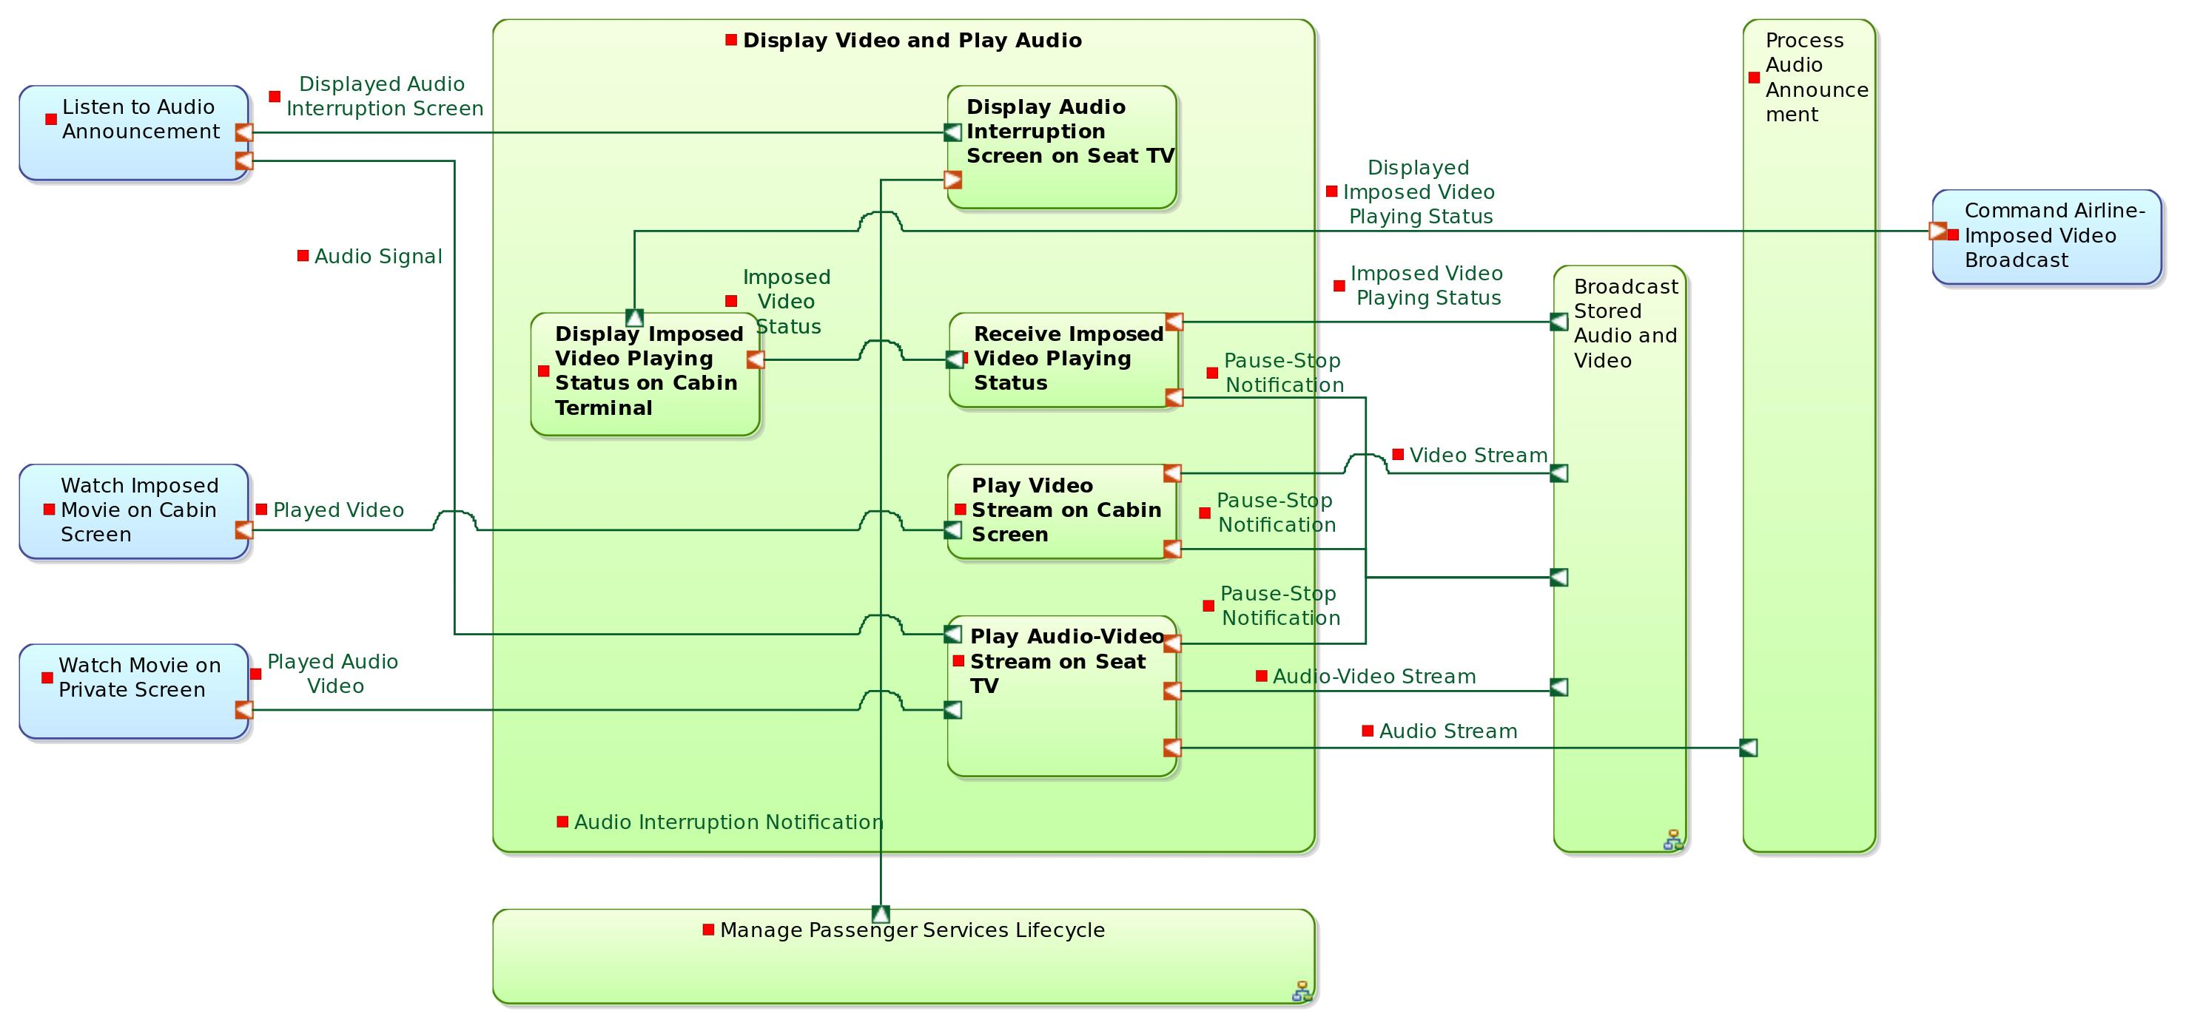

Parent / Children functions:

|  |  |  |
| --- | --- | --- |
| **Parent function** | **Current function** | **Children functions** |
| Manage Audio and Video Diffusion | Display Video and Play Audio | * Play Audio-Video Stream on Seat TV * Play Video Stream on Cabin Screen * Receive Imposed Video Playing Status * Display Imposed Video Playing Status on Cabin Terminal * Display Audio Interruption Screen on Seat TV |

List of inputs:

*No input*

List of outputs:

*No output*

Participation to functional chains:

*None*

Allocated to:

*Function not allocated*

## Function : Play Audio-Video Stream on Seat TV

Description:

This function receives a media stream (either synchronized video and audio either audio only) and restitutes it through the Seat TV.

Parent / Children functions:

|  |  |  |
| --- | --- | --- |
| **Parent function** | **Current function** | **Children functions** |
| Display Video and Play Audio | Play Audio-Video Stream on Seat TV | *No children function* |

List of inputs:

| **Incoming functional exchange** | **Exchanged items** |
| --- | --- |

|  |  |
| --- | --- |
| Audio-Video Stream | * Audio-Video Stream |

|  |  |
| --- | --- |
| Pause-Stop Notification | *No exchanged item* |

|  |  |
| --- | --- |
| Audio Stream | *No exchanged item* |

List of outputs:

| **Outgoing functional exchange** | **Exchanged items** |
| --- | --- |

|  |  |
| --- | --- |
| Played Audio Video | *No exchanged item* |

|  |  |
| --- | --- |
| Audio Signal | *No exchanged item* |

Participation to functional chains:

* Watch Imposed Video on Private Screen
* Broadcast Audio Announcement
* Start Playing VOD Movie
* Resume VOD Movie

Allocated to:

* Seat TV Audio Video Player

## Function : Play Video Stream on Cabin Screen

Description:

This function receives a video stream and restitutes it through the Cabin screens. The audio track associated to the video is forwarded to the aircraft through another function.

Parent / Children functions:

|  |  |  |
| --- | --- | --- |
| **Parent function** | **Current function** | **Children functions** |
| Display Video and Play Audio | Play Video Stream on Cabin Screen | *No children function* |

List of inputs:

| **Incoming functional exchange** | **Exchanged items** |
| --- | --- |

|  |  |
| --- | --- |
| Video Stream | *No exchanged item* |

|  |  |
| --- | --- |
| Pause-Stop Notification | *No exchanged item* |

List of outputs:

| **Outgoing functional exchange** | **Exchanged items** |
| --- | --- |

|  |  |
| --- | --- |
| Played Video | *No exchanged item* |

Participation to functional chains:

* Watch Imposed Video on Cabin Screen

Allocated to:

* Cabin Screen

## Function : Receive Imposed Video Playing Status

Description:

This function collects the status of the currently running imposed movie (ETA, etc.). This status is then transmitted to be displayed on the Cabin Management Terminal.

Parent / Children functions:

|  |  |  |
| --- | --- | --- |
| **Parent function** | **Current function** | **Children functions** |
| Display Video and Play Audio | Receive Imposed Video Playing Status | *No children function* |

List of inputs:

| **Incoming functional exchange** | **Exchanged items** |
| --- | --- |

|  |  |
| --- | --- |
| Pause-Stop Notification | *No exchanged item* |

|  |  |
| --- | --- |
| Imposed Video Playing Status | *No exchanged item* |

List of outputs:

| **Outgoing functional exchange** | **Exchanged items** |
| --- | --- |

|  |  |
| --- | --- |
| Imposed Video Status | *No exchanged item* |

Participation to functional chains:

* Watch Imposed Video on Cabin Screen
* Watch Imposed Video on Private Screen

Allocated to:

* Cabin Terminal Core Interactions Manager

## Function : Display Imposed Video Playing Status on Cabin Terminal

Description:

This function is responsible for displaying the status of the currently running imposed movie (ETA, etc.) on the Cabin Management Terminal.

Parent / Children functions:

|  |  |  |
| --- | --- | --- |
| **Parent function** | **Current function** | **Children functions** |
| Display Video and Play Audio | Display Imposed Video Playing Status on Cabin Terminal | *No children function* |

List of inputs:

| **Incoming functional exchange** | **Exchanged items** |
| --- | --- |

|  |  |
| --- | --- |
| Imposed Video Status | *No exchanged item* |

List of outputs:

| **Outgoing functional exchange** | **Exchanged items** |
| --- | --- |

|  |  |
| --- | --- |
| Displayed Imposed Video Playing Status | *No exchanged item* |

Participation to functional chains:

* Watch Imposed Video on Cabin Screen
* Watch Imposed Video on Private Screen

Allocated to:

* Cabin Terminal Airline-Specific Interactions Manager

## Function : Display Audio Interruption Screen on Seat TV

Description:

When an audio announcement is made, all IFE services on Seat TVs are interrupted. A message is then displayed on the screen, indicating that an audio annoucement is currently ongoing.

Parent / Children functions:

|  |  |  |
| --- | --- | --- |
| **Parent function** | **Current function** | **Children functions** |
| Display Video and Play Audio | Display Audio Interruption Screen on Seat TV | *No children function* |

List of inputs:

| **Incoming functional exchange** | **Exchanged items** |
| --- | --- |

|  |  |
| --- | --- |
| Audio Interruption Notification | *No exchanged item* |

List of outputs:

| **Outgoing functional exchange** | **Exchanged items** |
| --- | --- |

|  |  |
| --- | --- |
| Displayed Audio Interruption Screen | *No exchanged item* |

Participation to functional chains:

* Broadcast Audio Announcement

Allocated to:

* Seat TV Airline-Specific Interactions Manager

## Function : Process Audio Announcement

Description:

When an audio announcement is made (thoufh the aircraft equipment), the IFE system is responsible for forwarding the audio stream to all passengers. This function also triggers a passenger service interruption command

Parent / Children functions:

|  |  |  |
| --- | --- | --- |
| **Parent function** | **Current function** | **Children functions** |
| Manage Audio and Video Diffusion | Process Audio Announcement | *No children function* |

List of inputs:

| **Incoming functional exchange** | **Exchanged items** |
| --- | --- |

|  |  |
| --- | --- |
| Audio Stream | *No exchanged item* |

List of outputs:

| **Outgoing functional exchange** | **Exchanged items** |
| --- | --- |

|  |  |
| --- | --- |
| Audio Stream | *No exchanged item* |

|  |  |
| --- | --- |
| Service Interruption Command | *No exchanged item* |

Participation to functional chains:

* Broadcast Audio Announcement

Allocated to:

* Applications Server

## Function : Run Services

Description:

This function regroups all IFE services running functions.

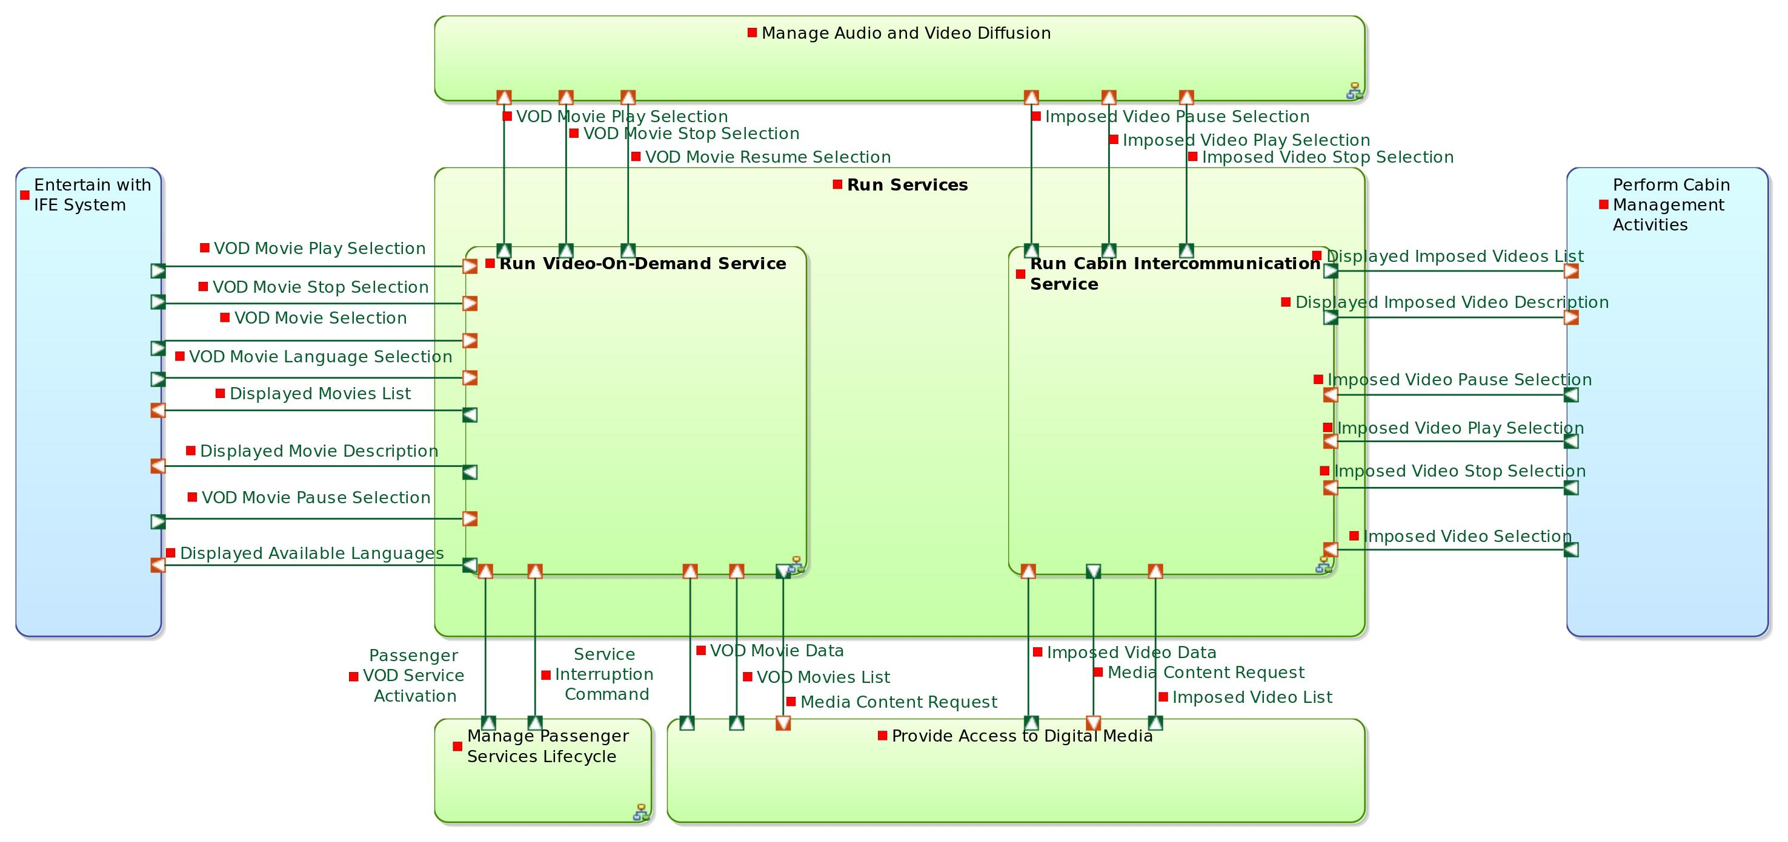

Parent / Children functions:

|  |  |  |
| --- | --- | --- |
| **Parent function** | **Current function** | **Children functions** |
| IFE System | Run Services | * Run Video-On-Demand Service * Run Cabin Intercommunication Service |

List of inputs:

*No input*

List of outputs:

*No output*

Participation to functional chains:

*None*

Allocated to:

*Function not allocated*

## Function : Run Video-On-Demand Service

Description:

VOD Service is a passenger service. This function gathers all functions in charge of managing the VOD-related interactions of the passenger (selection of movies, play/pause/stop controls, display of movie data, etc.).

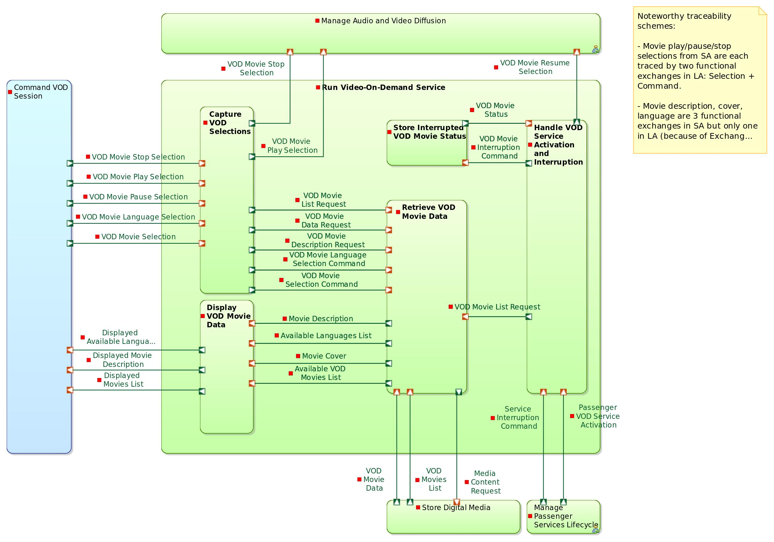

Parent / Children functions:

|  |  |  |
| --- | --- | --- |
| **Parent function** | **Current function** | **Children functions** |
| Run Services | Run Video-On-Demand Service | * Display VOD Movie Data * Capture VOD Selections * Retrieve VOD Movie Data * Handle VOD Service Activation and Interruption * Store Interrupted VOD Movie Status |

List of inputs:

*No input*

List of outputs:

*No output*

Participation to functional chains:

*None*

Allocated to:

*Function not allocated*

## Function : Display VOD Movie Data

Description:

This function is responsible for displaying all the VOD service information on the Seat TV.

Parent / Children functions:

|  |  |  |
| --- | --- | --- |
| **Parent function** | **Current function** | **Children functions** |
| Run Video-On-Demand Service | Display VOD Movie Data | *No children function* |

List of inputs:

| **Incoming functional exchange** | **Exchanged items** |
| --- | --- |

|  |  |
| --- | --- |
| Available Languages List | *No exchanged item* |

|  |  |
| --- | --- |
| Movie Description | *No exchanged item* |

|  |  |
| --- | --- |
| Movie Cover | *No exchanged item* |

|  |  |
| --- | --- |
| Available VOD Movies List | *No exchanged item* |

List of outputs:

| **Outgoing functional exchange** | **Exchanged items** |
| --- | --- |

|  |  |
| --- | --- |
| Displayed Movie Description | *No exchanged item* |

|  |  |
| --- | --- |
| Displayed Available Languages | *No exchanged item* |

|  |  |
| --- | --- |
| Displayed Movies List | *No exchanged item* |

Participation to functional chains:

*None*

Allocated to:

* Seat TV Airline-Specific Interactions Manager

## Function : Capture VOD Selections

Description:

This function handles the interactions with the passenger in the VOD service. The Seat TV displays interaction widgets (typically buttons and slide bars). This typically airline-specifc, because user interface typically is. This function is responsible for capturing these selections and forwarding them to a more generic function (a controler) that will transform the selection into an internal system command.

Parent / Children functions:

|  |  |  |
| --- | --- | --- |
| **Parent function** | **Current function** | **Children functions** |
| Run Video-On-Demand Service | Capture VOD Selections | *No children function* |

List of inputs:

| **Incoming functional exchange** | **Exchanged items** |
| --- | --- |

|  |  |
| --- | --- |
| VOD Movie Stop Selection | *No exchanged item* |

|  |  |
| --- | --- |
| VOD Movie Play Selection | *No exchanged item* |

|  |  |
| --- | --- |
| VOD Movie Pause Selection | *No exchanged item* |

|  |  |
| --- | --- |
| VOD Movie Language Selection | *No exchanged item* |

|  |  |
| --- | --- |
| VOD Movie Selection | *No exchanged item* |

List of outputs:

| **Outgoing functional exchange** | **Exchanged items** |
| --- | --- |

|  |  |
| --- | --- |
| VOD Movie Language Selection Command | *No exchanged item* |

|  |  |
| --- | --- |
| VOD Movie Selection Command | *No exchanged item* |

|  |  |
| --- | --- |
| VOD Movie Data Request | *No exchanged item* |

|  |  |
| --- | --- |
| VOD Movie Description Request | *No exchanged item* |

|  |  |
| --- | --- |
| VOD Movie List Request | *No exchanged item* |

|  |  |
| --- | --- |
| VOD Movie Play Selection | * Passenger Selection |

|  |  |
| --- | --- |
| VOD Movie Stop Selection | *No exchanged item* |

Participation to functional chains:

* Start Playing VOD Movie

Allocated to:

* Seat TV Airline-Specific Interactions Manager

## Function : Retrieve VOD Movie Data

Description:

This function consists in receiving media information requests (list of VOD movies, available languages, etc.) and returning the data corresponding to these requests. This data is retrieved from the digital media storage unit.

Parent / Children functions:

|  |  |  |
| --- | --- | --- |
| **Parent function** | **Current function** | **Children functions** |
| Run Video-On-Demand Service | Retrieve VOD Movie Data | *No children function* |

List of inputs:

| **Incoming functional exchange** | **Exchanged items** |
| --- | --- |

|  |  |
| --- | --- |
| VOD Movie Data Request | *No exchanged item* |

|  |  |
| --- | --- |
| VOD Movie Description Request | *No exchanged item* |

|  |  |
| --- | --- |
| VOD Movie List Request | *No exchanged item* |

|  |  |
| --- | --- |
| VOD Movies List | *No exchanged item* |

|  |  |
| --- | --- |
| VOD Movie Data | *No exchanged item* |

|  |  |
| --- | --- |
| VOD Movie Language Selection Command | *No exchanged item* |

|  |  |
| --- | --- |
| VOD Movie Selection Command | *No exchanged item* |

|  |  |
| --- | --- |
| VOD Movie List Request | *No exchanged item* |

List of outputs:

| **Outgoing functional exchange** | **Exchanged items** |
| --- | --- |

|  |  |
| --- | --- |
| Available VOD Movies List | *No exchanged item* |

|  |  |
| --- | --- |
| Movie Description | *No exchanged item* |

|  |  |
| --- | --- |
| Movie Cover | *No exchanged item* |

|  |  |
| --- | --- |
| Available Languages List | *No exchanged item* |

|  |  |
| --- | --- |
| Media Content Request | *No exchanged item* |

Participation to functional chains:

*None*

Allocated to:

* Seat TV Core Interactions Manager

## Function : Handle VOD Service Activation and Interruption

Description:

This function is responsible for managing the VOD Service activations / deactivation (first activation, service resume, external interruption, etc.). This function relies on another function in charge of storing the current status of the interrupted / deactivated service (in particular, the current selection movie and the current position in this movie).

Parent / Children functions:

|  |  |  |
| --- | --- | --- |
| **Parent function** | **Current function** | **Children functions** |
| Run Video-On-Demand Service | Handle VOD Service Activation and Interruption | *No children function* |

List of inputs:

| **Incoming functional exchange** | **Exchanged items** |
| --- | --- |

|  |  |
| --- | --- |
| Passenger VOD Service Activation | *No exchanged item* |

|  |  |
| --- | --- |
| Service Interruption Command | *No exchanged item* |

|  |  |
| --- | --- |
| VOD Movie Status | *No exchanged item* |

List of outputs:

| **Outgoing functional exchange** | **Exchanged items** |
| --- | --- |

|  |  |
| --- | --- |
| VOD Movie Resume Selection | *No exchanged item* |

|  |  |
| --- | --- |
| VOD Movie List Request | *No exchanged item* |

|  |  |
| --- | --- |
| VOD Movie Interruption Command | *No exchanged item* |

Participation to functional chains:

* Watch Imposed Video on Private Screen
* Broadcast Audio Announcement
* Resume VOD Movie

Allocated to:

* Seat TV Core Interactions Manager

## Function : Store Interrupted VOD Movie Status

Description:

This function is in charge of storing the current status of the interrupted / deactivated VOD service (in particular, the current selection movie and the current position in this movie).

Parent / Children functions:

|  |  |  |
| --- | --- | --- |
| **Parent function** | **Current function** | **Children functions** |
| Run Video-On-Demand Service | Store Interrupted VOD Movie Status | *No children function* |

List of inputs:

| **Incoming functional exchange** | **Exchanged items** |
| --- | --- |

|  |  |
| --- | --- |
| VOD Movie Interruption Command | *No exchanged item* |

List of outputs:

| **Outgoing functional exchange** | **Exchanged items** |
| --- | --- |

|  |  |
| --- | --- |
| VOD Movie Status | *No exchanged item* |

Participation to functional chains:

* Watch Imposed Video on Private Screen
* Broadcast Audio Announcement
* Resume VOD Movie

Allocated to:

* Seat TV Audio Video Player

## Function : Run Cabin Intercommunication Service

Description:

Cabin intercommunication is a cabin crew service. This function gathers all functions in charge of managing the interactions of the cabin crew related to imposed videos (selection of videos, play/pause/stop controls, display of video data, etc.).

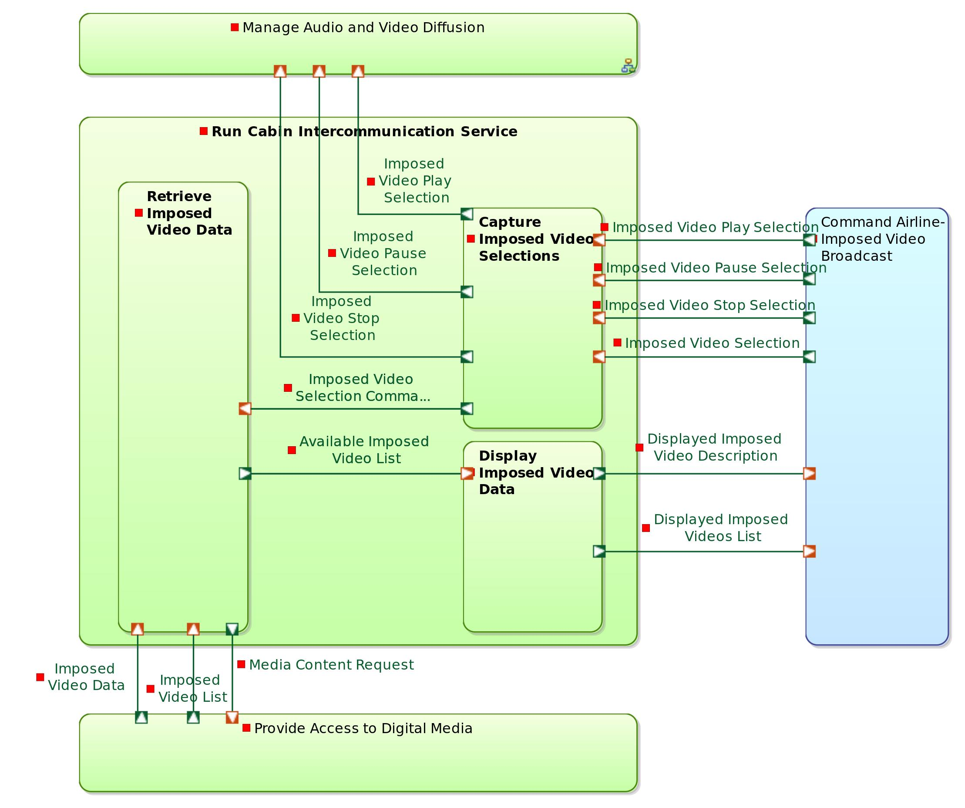

Parent / Children functions:

|  |  |  |
| --- | --- | --- |
| **Parent function** | **Current function** | **Children functions** |
| Run Services | Run Cabin Intercommunication Service | * Capture Imposed Video Selections * Retrieve Imposed Video Data * Display Imposed Video Data |

List of inputs:

*No input*

List of outputs:

*No output*

Participation to functional chains:

*None*

Allocated to:

*Function not allocated*

## Function : Capture Imposed Video Selections

Description:

This function handles the interactions with the cabin crew on the cabin management terminal. The terminal displays interaction widgets (typically buttons and slide bars). This typically airline-specifc, because user interface typically is. This function is responsible for capturing these selections and forwarding them to a more generic function (a controler) that will transform the selection into an internal system command.

Parent / Children functions:

|  |  |  |
| --- | --- | --- |
| **Parent function** | **Current function** | **Children functions** |
| Run Cabin Intercommunication Service | Capture Imposed Video Selections | *No children function* |

List of inputs:

| **Incoming functional exchange** | **Exchanged items** |
| --- | --- |

|  |  |
| --- | --- |
| Imposed Video Play Selection | *No exchanged item* |

|  |  |
| --- | --- |
| Imposed Video Pause Selection | *No exchanged item* |

|  |  |
| --- | --- |
| Imposed Video Stop Selection | *No exchanged item* |

|  |  |
| --- | --- |
| Imposed Video Selection | *No exchanged item* |

List of outputs:

| **Outgoing functional exchange** | **Exchanged items** |
| --- | --- |

|  |  |
| --- | --- |
| Imposed Video Selection Command | *No exchanged item* |

|  |  |
| --- | --- |
| Imposed Video Play Selection | *No exchanged item* |

|  |  |
| --- | --- |
| Imposed Video Pause Selection | *No exchanged item* |

|  |  |
| --- | --- |
| Imposed Video Stop Selection | *No exchanged item* |

Participation to functional chains:

* Watch Imposed Video on Cabin Screen
* Watch Imposed Video on Private Screen

Allocated to:

* Cabin Terminal Airline-Specific Interactions Manager

## Function : Retrieve Imposed Video Data

Description:

This function consists in receiving media information requests (list of imposed videos, available languages, etc.) and returning the data corresponding to these requests. This data is retrieved from the digital media storage unit.

Parent / Children functions:

|  |  |  |
| --- | --- | --- |
| **Parent function** | **Current function** | **Children functions** |
| Run Cabin Intercommunication Service | Retrieve Imposed Video Data | *No children function* |

List of inputs:

| **Incoming functional exchange** | **Exchanged items** |
| --- | --- |

|  |  |
| --- | --- |
| Imposed Video Selection Command | *No exchanged item* |

|  |  |
| --- | --- |
| Imposed Video Data | *No exchanged item* |

|  |  |
| --- | --- |
| Imposed Video List | *No exchanged item* |

List of outputs:

| **Outgoing functional exchange** | **Exchanged items** |
| --- | --- |

|  |  |
| --- | --- |
| Available Imposed Video List | *No exchanged item* |

|  |  |
| --- | --- |
| Media Content Request | *No exchanged item* |

Participation to functional chains:

*None*

Allocated to:

* Cabin Terminal Core Interactions Manager

## Function : Display Imposed Video Data

Description:

This function is responsible for displaying all the imposed video data on the cabin management terminal.

Parent / Children functions:

|  |  |  |
| --- | --- | --- |
| **Parent function** | **Current function** | **Children functions** |
| Run Cabin Intercommunication Service | Display Imposed Video Data | *No children function* |

List of inputs:

| **Incoming functional exchange** | **Exchanged items** |
| --- | --- |

|  |  |
| --- | --- |
| Available Imposed Video List | *No exchanged item* |

List of outputs:

| **Outgoing functional exchange** | **Exchanged items** |
| --- | --- |

|  |  |
| --- | --- |
| Displayed Imposed Videos List | *No exchanged item* |

|  |  |
| --- | --- |
| Displayed Imposed Video Description | *No exchanged item* |

Participation to functional chains:

*None*

Allocated to:

* Cabin Terminal Airline-Specific Interactions Manager

## Function : Manage Passenger Services Lifecycle

Description:

This function is responsible for controling the launch of services such as VOD, gaming, moving-map, etc. It determines the availability of the services given the airline company authorization scheme and the constraints received from the aircraft. This function provides means to select among a predefined list of services.

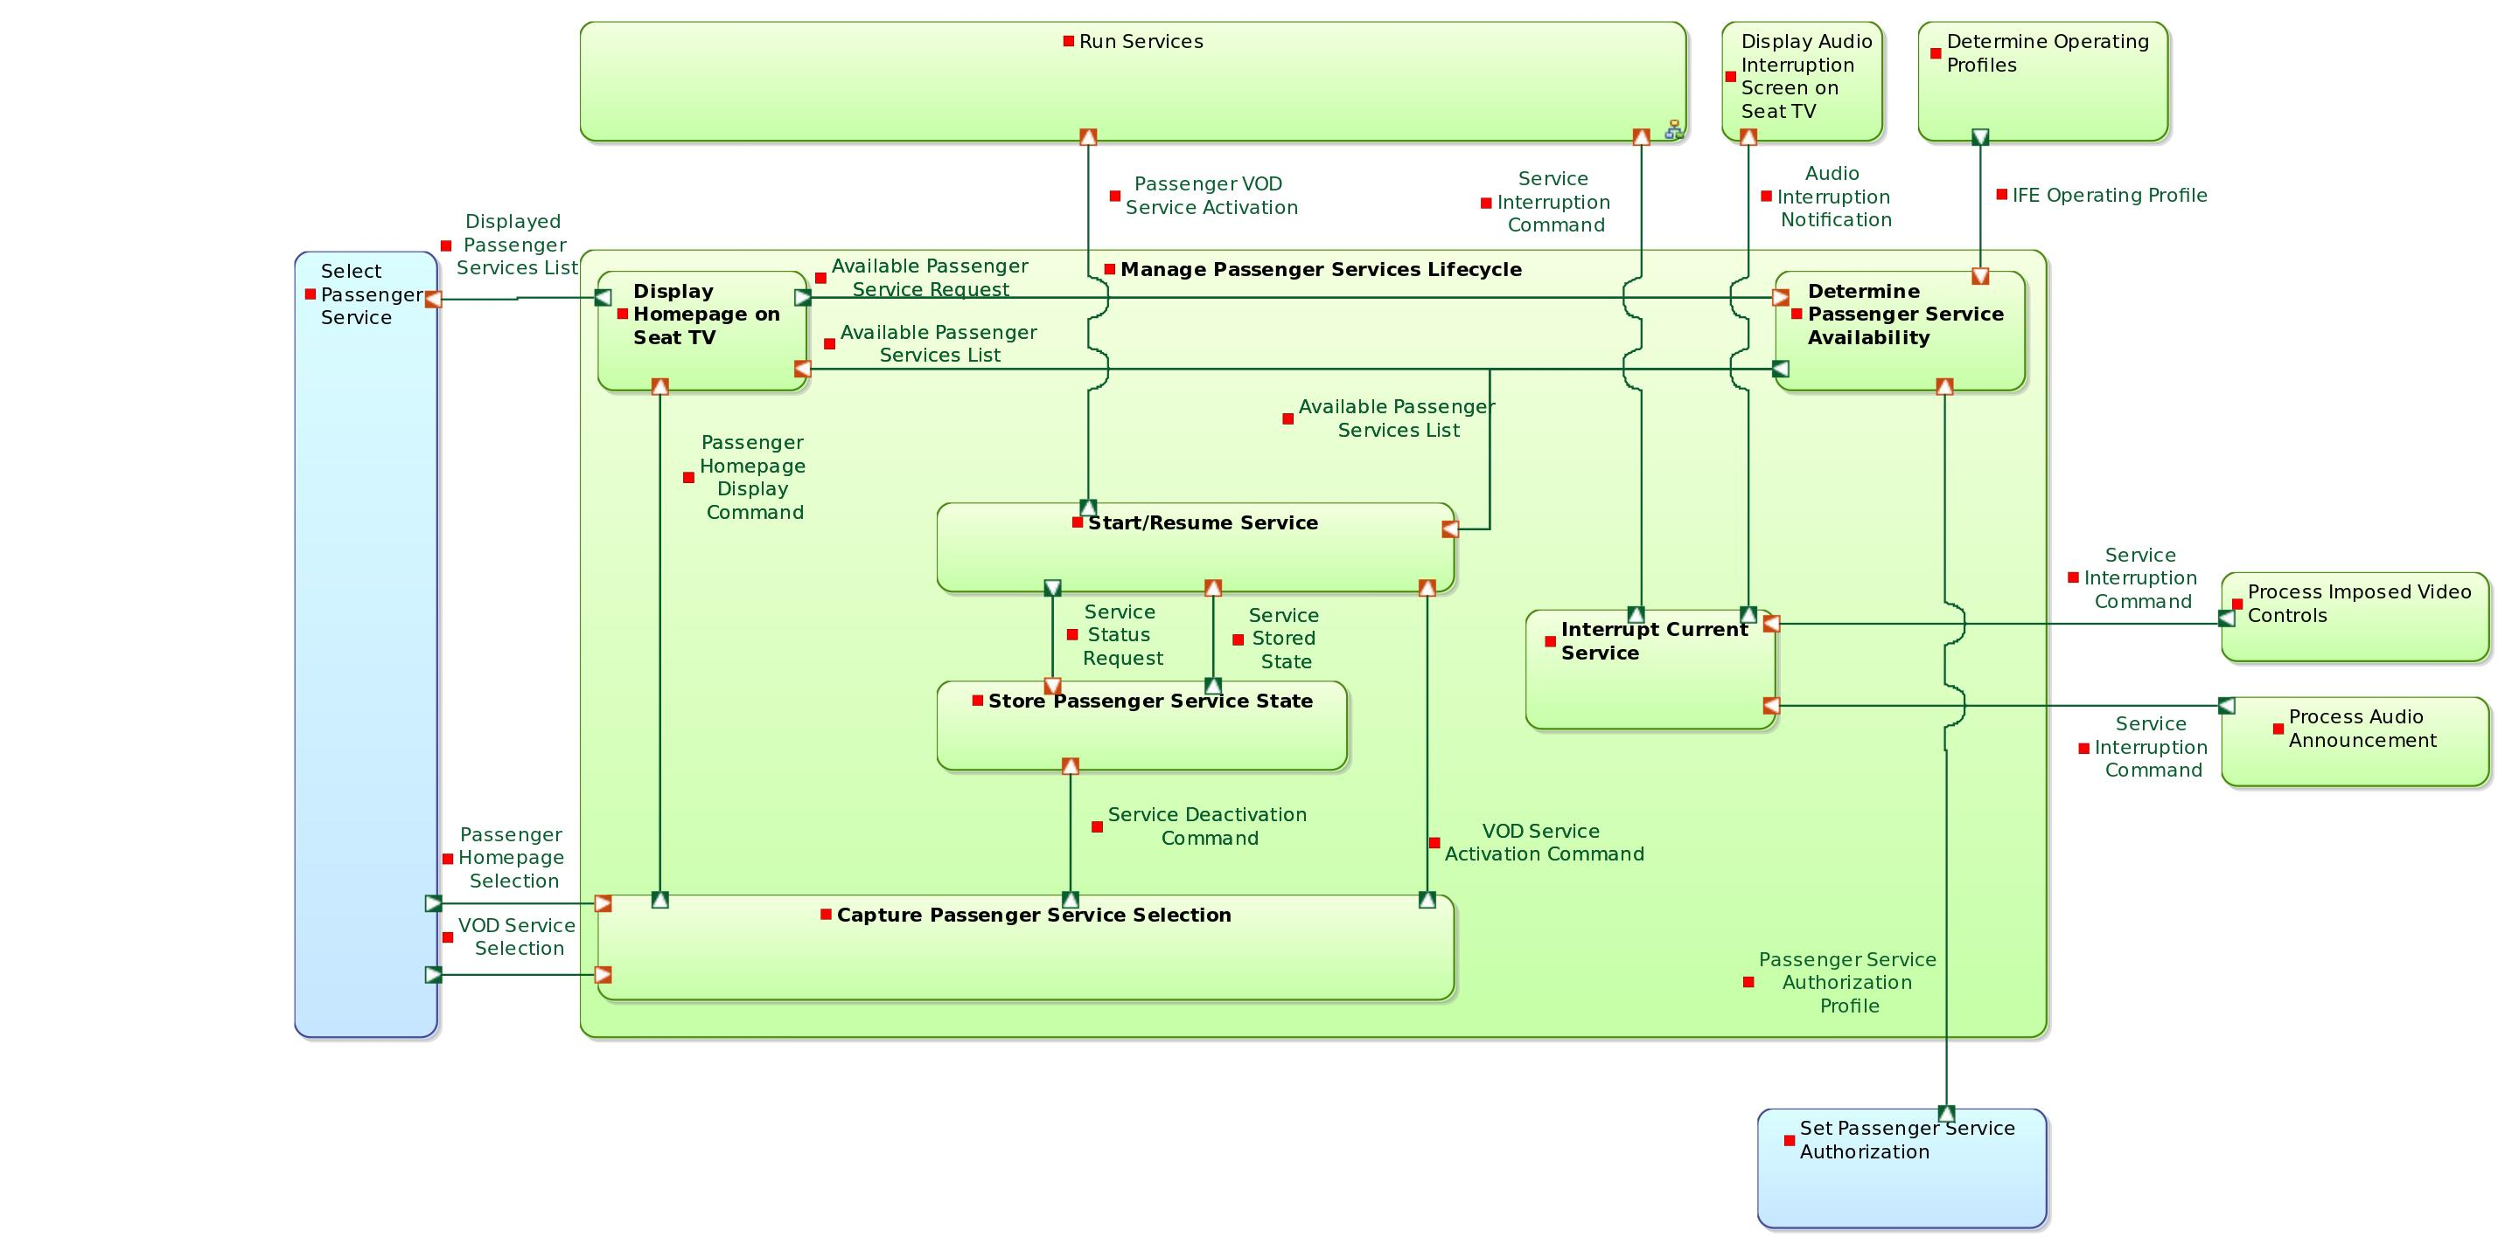

Parent / Children functions:

|  |  |  |
| --- | --- | --- |
| **Parent function** | **Current function** | **Children functions** |
| IFE System | Manage Passenger Services Lifecycle | * Display Homepage on Seat TV * Capture Passenger Service Selection * Determine Passenger Service Availability * Interrupt Current Service * Store Passenger Service State * Start/Resume Service |

List of inputs:

*No input*

List of outputs:

*No output*

Participation to functional chains:

*None*

Allocated to:

*Function not allocated*

## Function : Display Homepage on Seat TV

Description:

This function simply displays the Seat TV starting page, from where all services can be launched.

Parent / Children functions:

|  |  |  |
| --- | --- | --- |
| **Parent function** | **Current function** | **Children functions** |
| Manage Passenger Services Lifecycle | Display Homepage on Seat TV | *No children function* |

List of inputs:

| **Incoming functional exchange** | **Exchanged items** |
| --- | --- |

|  |  |
| --- | --- |
| Passenger Homepage Display Command | *No exchanged item* |

|  |  |
| --- | --- |
| Available Passenger Services List | *No exchanged item* |

List of outputs:

| **Outgoing functional exchange** | **Exchanged items** |
| --- | --- |

|  |  |
| --- | --- |
| Displayed Passenger Services List | *No exchanged item* |

|  |  |
| --- | --- |
| Available Passenger Service Request | *No exchanged item* |

Participation to functional chains:

*None*

Allocated to:

* Seat TV Airline-Specific Interactions Manager

## Function : Capture Passenger Service Selection

Description:

This function handles the general interactions with the passenger. The Seat TV displays interaction widgets (typically buttons and slide bars). This typically airline-specifc, because user interface typically is. This function is responsible for capturing the selections of services and forwarding them to a more generic function (a controler) that will transform the selections into an internal system commands (activation / de-activation).

Parent / Children functions:

|  |  |  |
| --- | --- | --- |
| **Parent function** | **Current function** | **Children functions** |
| Manage Passenger Services Lifecycle | Capture Passenger Service Selection | *No children function* |

List of inputs:

| **Incoming functional exchange** | **Exchanged items** |
| --- | --- |

|  |  |
| --- | --- |
| Passenger Homepage Selection | *No exchanged item* |

|  |  |
| --- | --- |
| VOD Service Selection | *No exchanged item* |

List of outputs:

| **Outgoing functional exchange** | **Exchanged items** |
| --- | --- |

|  |  |
| --- | --- |
| Passenger Homepage Display Command | *No exchanged item* |

|  |  |
| --- | --- |
| Service Deactivation Command | *No exchanged item* |

|  |  |
| --- | --- |
| VOD Service Activation Command | *No exchanged item* |

Participation to functional chains:

*None*

Allocated to:

* Seat TV Airline-Specific Interactions Manager

## Function : Determine Passenger Service Availability

Description:

This function is responsible for computing the availability of passenger services based on the authorization scheme (airline business strategy) and the aircraft contraints.

Parent / Children functions:

|  |  |  |
| --- | --- | --- |
| **Parent function** | **Current function** | **Children functions** |
| Manage Passenger Services Lifecycle | Determine Passenger Service Availability | *No children function* |

List of inputs:

| **Incoming functional exchange** | **Exchanged items** |
| --- | --- |

|  |  |
| --- | --- |
| Passenger Service Authorization Profile | *No exchanged item* |

|  |  |
| --- | --- |
| IFE Operating Profile | *No exchanged item* |

|  |  |
| --- | --- |
| Available Passenger Service Request | *No exchanged item* |

List of outputs:

| **Outgoing functional exchange** | **Exchanged items** |
| --- | --- |

|  |  |
| --- | --- |
| Available Passenger Services List | *No exchanged item* |

|  |  |
| --- | --- |
| Available Passenger Services List | *No exchanged item* |

Participation to functional chains:

*None*

Allocated to:

* Applications Server

## Function : Interrupt Current Service

Description:

This function is responsible for triggering passenger service interruptions as soon as an imposed video is played or an audio announcement is performed. When a VOD movie is running, this means for example that the movie as to be automatically paused and the current position stored.

Parent / Children functions:

|  |  |  |
| --- | --- | --- |
| **Parent function** | **Current function** | **Children functions** |
| Manage Passenger Services Lifecycle | Interrupt Current Service | *No children function* |

List of inputs:

| **Incoming functional exchange** | **Exchanged items** |
| --- | --- |

|  |  |
| --- | --- |
| Service Interruption Command | *No exchanged item* |

|  |  |
| --- | --- |
| Service Interruption Command | *No exchanged item* |

List of outputs:

| **Outgoing functional exchange** | **Exchanged items** |
| --- | --- |

|  |  |
| --- | --- |
| Service Interruption Command | *No exchanged item* |

|  |  |
| --- | --- |
| Audio Interruption Notification | *No exchanged item* |

Participation to functional chains:

* Watch Imposed Video on Private Screen
* Broadcast Audio Announcement

Allocated to:

* Seat TV Services Manager

## Function : Store Passenger Service State

Description:

Whenever a service is interrupted, its current state has to be saved, in order to be able to resume it later on in the same state. This function typically delegates this action to the functions directly responsible for running each passenger service.

Parent / Children functions:

|  |  |  |
| --- | --- | --- |
| **Parent function** | **Current function** | **Children functions** |
| Manage Passenger Services Lifecycle | Store Passenger Service State | *No children function* |

List of inputs:

| **Incoming functional exchange** | **Exchanged items** |
| --- | --- |

|  |  |
| --- | --- |
| Service Status Request | *No exchanged item* |

|  |  |
| --- | --- |
| Service Deactivation Command | *No exchanged item* |

List of outputs:

| **Outgoing functional exchange** | **Exchanged items** |
| --- | --- |

|  |  |
| --- | --- |
| Service Stored State | *No exchanged item* |

Participation to functional chains:

*None*

Allocated to:

* Seat TV Services Manager

## Function : Start/Resume Service

Description:

This function displays the available services and trigger service activations when applicable.

Parent / Children functions:

|  |  |  |
| --- | --- | --- |
| **Parent function** | **Current function** | **Children functions** |
| Manage Passenger Services Lifecycle | Start/Resume Service | *No children function* |

List of inputs:

| **Incoming functional exchange** | **Exchanged items** |
| --- | --- |

|  |  |
| --- | --- |
| VOD Service Activation Command | *No exchanged item* |

|  |  |
| --- | --- |
| Service Stored State | *No exchanged item* |

|  |  |
| --- | --- |
| Available Passenger Services List | *No exchanged item* |

List of outputs:

| **Outgoing functional exchange** | **Exchanged items** |
| --- | --- |

|  |  |
| --- | --- |
| Service Status Request | *No exchanged item* |

|  |  |
| --- | --- |
| Passenger VOD Service Activation | *No exchanged item* |

Participation to functional chains:

*None*

Allocated to:

* Seat TV Core Interactions Manager

# Descriptions of Interfaces and Data

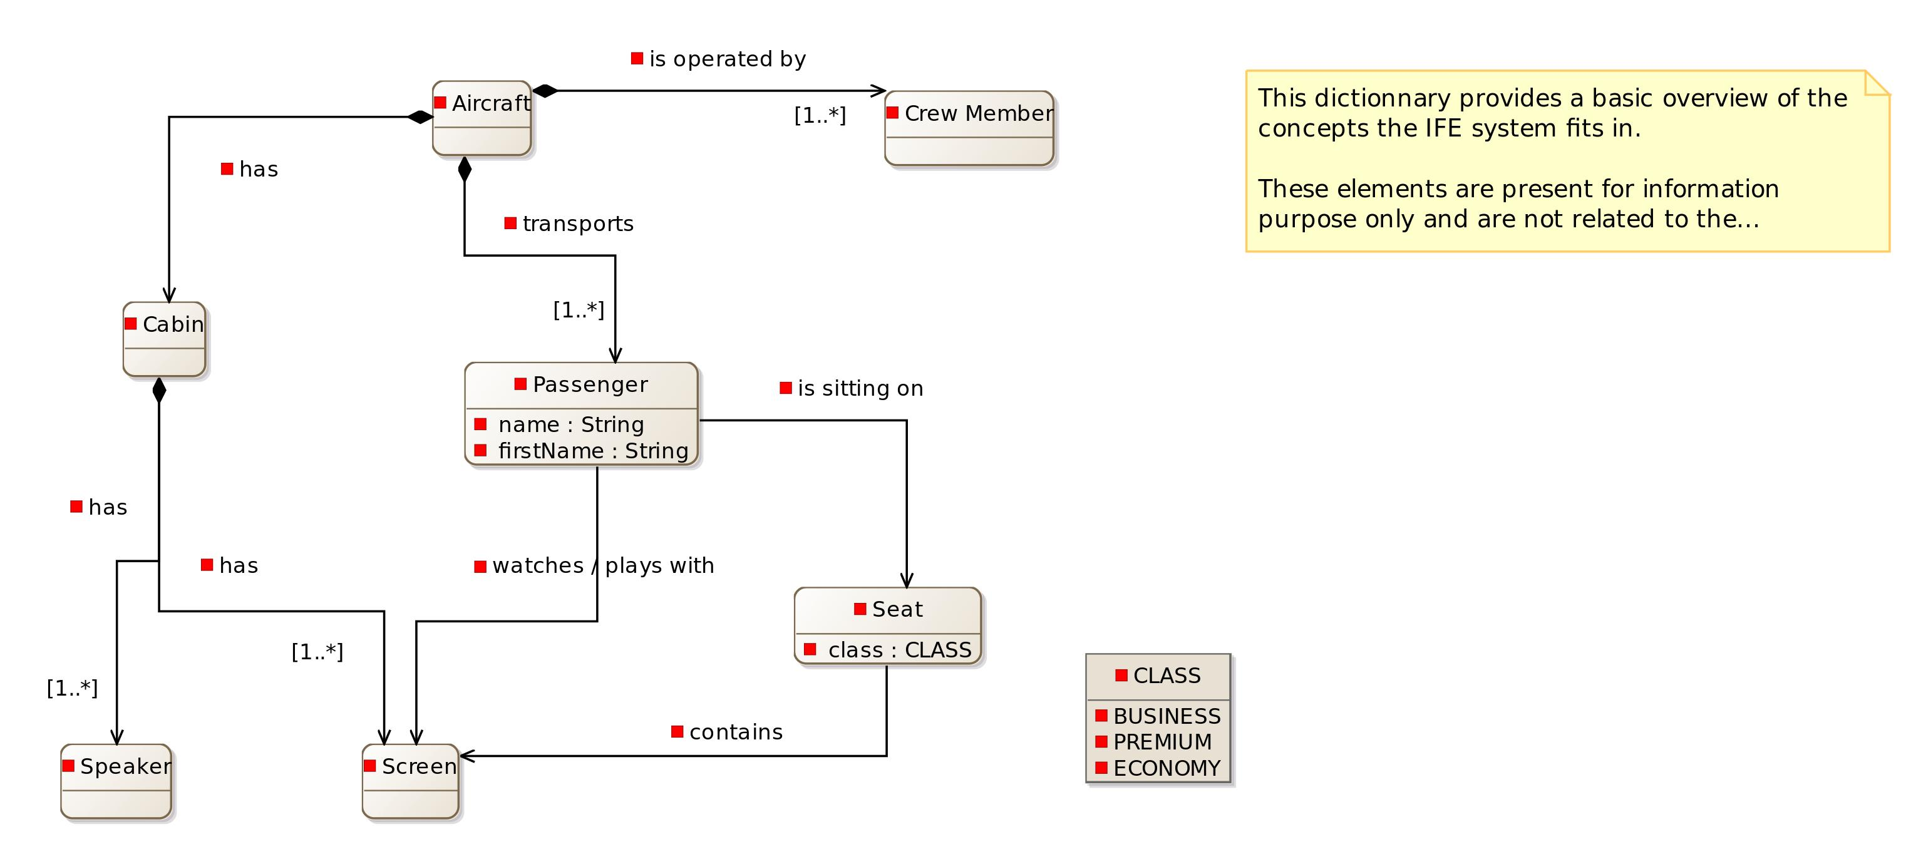

## Data

## Common

Data types definition:

* String
* Boolean

## BusinessEntity

Classes definition:

Seat

|  |  |
| --- | --- |
| **Contained property** | **Property type** |

|  |  |
| --- | --- |
| class | [CLASS] |

|  |  |
| --- | --- |
|  | [Screen] |

Passenger

|  |  |
| --- | --- |
| **Contained property** | **Property type** |

|  |  |
| --- | --- |
| seat | [Seat] |

|  |  |
| --- | --- |
| name | [String] |

|  |  |
| --- | --- |
| firstName | [String] |

|  |  |
| --- | --- |
|  | [Seat] |

|  |  |
| --- | --- |
|  | [Screen] |

Cabin

|  |  |
| --- | --- |
| **Contained property** | **Property type** |

|  |  |
| --- | --- |
| crew | [Crew Member] |

|  |  |
| --- | --- |
| passenger | [Passenger] |

|  |  |
| --- | --- |
|  | [Speaker] |

|  |  |
| --- | --- |
|  | [Screen] |

Aircraft

|  |  |
| --- | --- |
| **Contained property** | **Property type** |

|  |  |
| --- | --- |
| cabin | [Cabin] |

|  |  |
| --- | --- |
|  | [Cabin] |

|  |  |
| --- | --- |
|  | [Passenger] |

|  |  |
| --- | --- |
|  | [Crew Member] |

Crew Member

*No contained property*

Speaker

*No contained property*

Screen

*No contained property*

Data types definition:

* CLASS