A simple demonstration of a query :

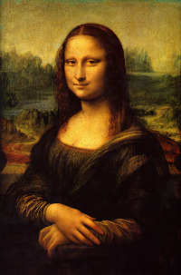

***~~Figure: Mona Lisa~~***

First Paragraph.  
  
An other paragraph

* Item1
* Item2
* Item3

|  |  |  |  |  |  |  |  |  |
| --- | --- | --- | --- | --- | --- | --- | --- | --- |
| ***~~M~~***[link](https://www.obeo.fr) | ***~~Col3~~*** (*) | ***~~Col4~~*** | ***~~Col5~~*** | ***~~Col6~~*** | ***~~Col7~~*** | ***~~Col8~~*** | ***~~Col9~~*** | ***~~Col10~~*** |
| ***~~1~~*** M | 1/2 | 1/2 | 1/2 | 2 | 2 | 2 | 1/2 | 1/2 |
| ***~~2~~*** M | 1/2 | 1/2 | 1/2 | 1 | 2 | 2 | 1/2 | 1/2 |
| ***~~3~~*** M | 1/2 | 1/2 | 1/2 | 2 | 1 | 2 | 1/2 | 1/2 |
| ***~~4~~*** M | 2(**) | 1/2 | 2 | 2 | 2 | 1 | 2 | 1/2 |

yet an other text  
  
  
and one more text.

End of demonstration.