This demonstrate the simple usage of asImageByRepresentationName service :

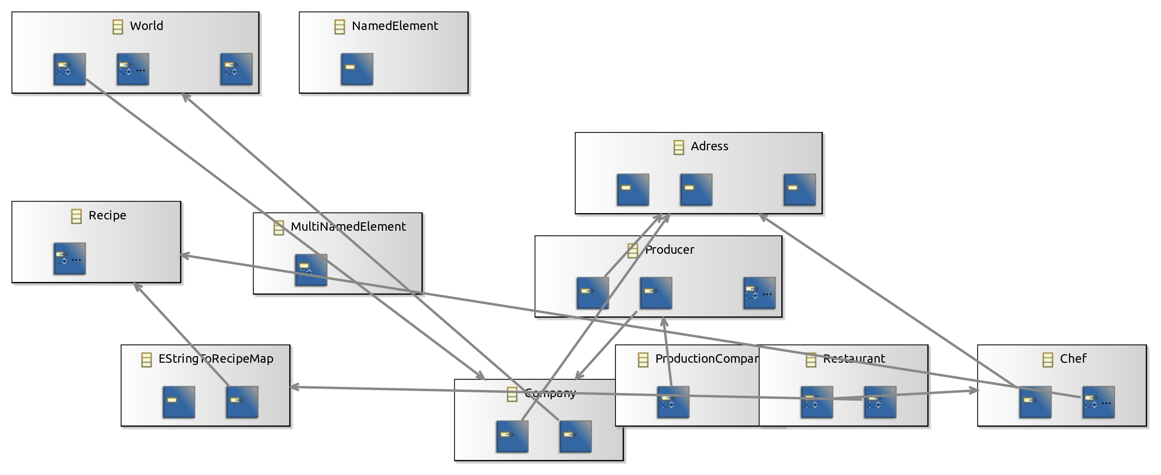

End of demonstration.