A simple demonstration of a template :

{m: 'dh1.gif'.myTemplate()}

End of demonstration.

{m:template myTemplate(name:String)}

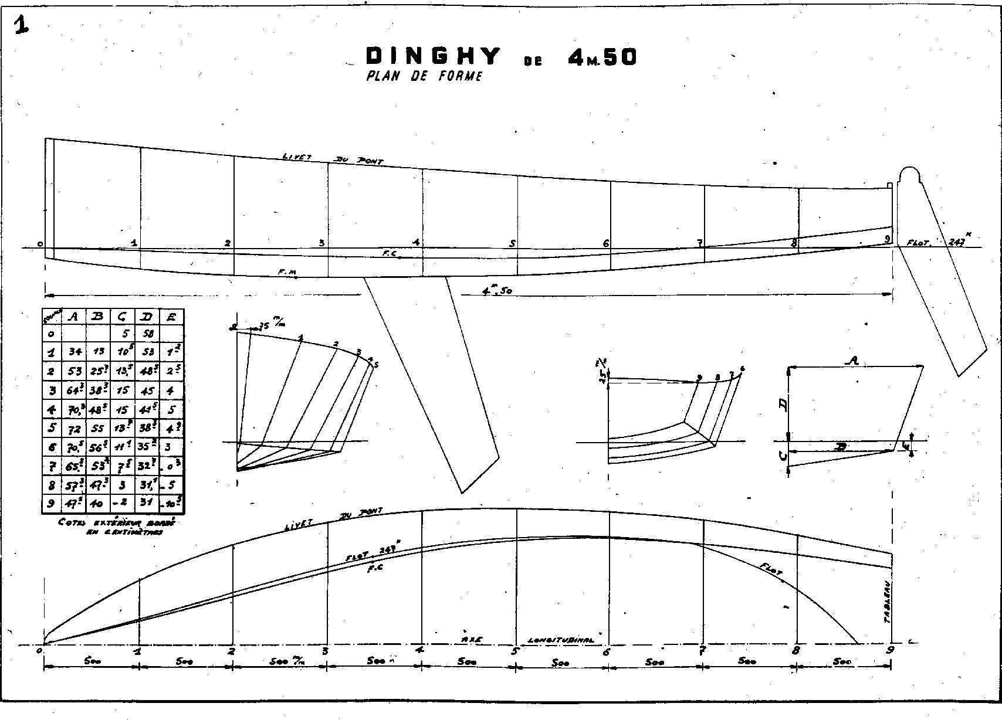{m:endtemplate}