Checks ImageServices registration :

Some text

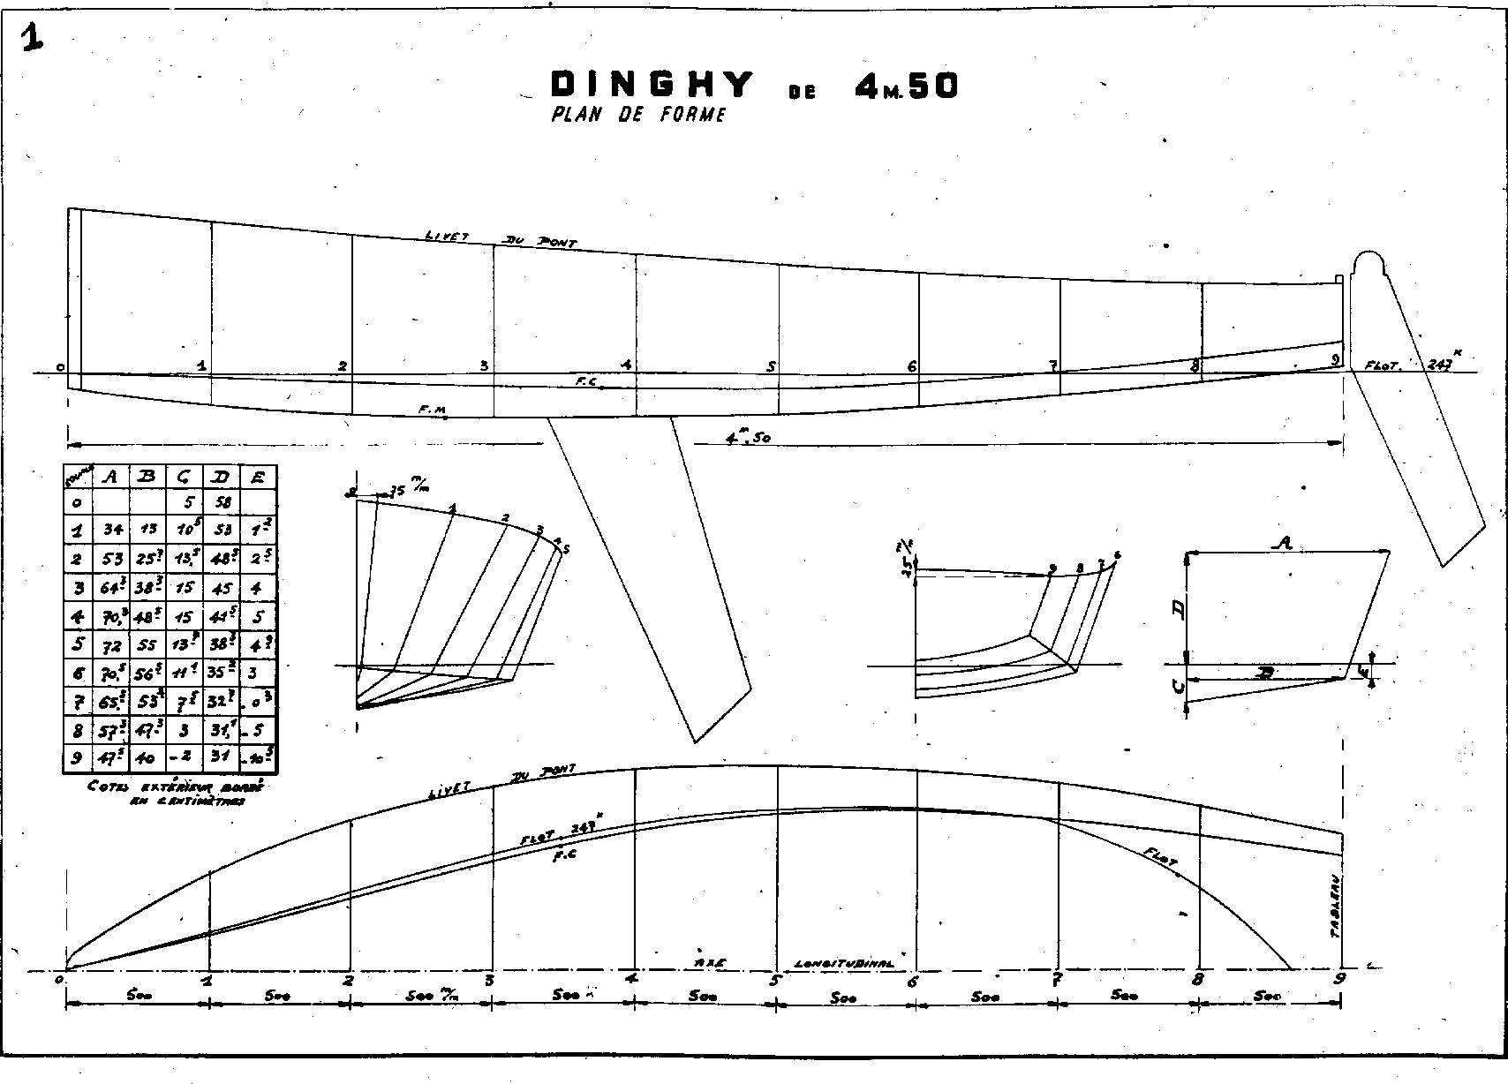

More text

End of demonstration.