A simple demonstration of a static text :

Some text.

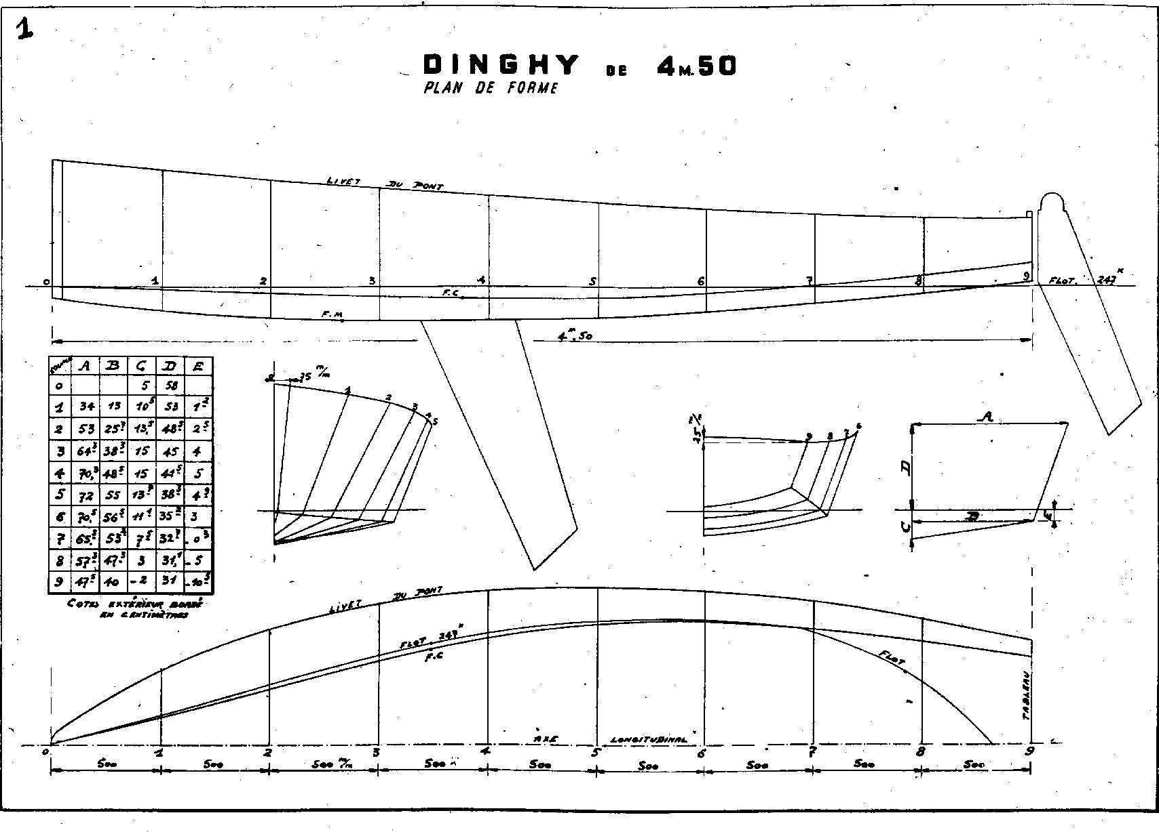

End of demonstration.